Additional file 5. Reporting bias assessment
Funnel plot
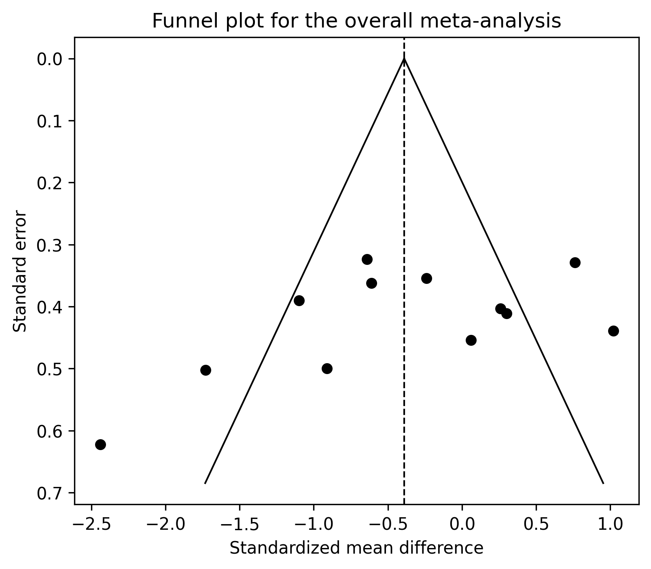
Funnel plot of the 12 studies included in the overall meta-analysis. The vertical dashed line indicates the pooled random-effects estimate; diagonal lines represent pseudo 95% confidence limits.
Egger's regression test
Parameter | Result
Number of studies | 12
Egger intercept | -5.60
Standard error | 3.49
95% CI | -13.39 to 2.19
t statistic | t(10) = -1.60
Two-sided p value | 0.140
Interpretation | No statistically significant evidence of funnel plot asymmetry or small-study effects; interpret cautiously because the number of studies was limited and heterogeneity was substantial.

