Aluminum-modified silica achieves efficient removal of low fluoride wastewater by inducing crystallization

Supplementary information

Shida Zhang ^{ab}, Zhen Qi ^{ab}, Fengke Dou ^{c}, Weijie Zhong ^{c}, Yingqiang Li ^{ab}, Zheyu Wang ^{ab}, Cui Zhen Sun, Feiyong Chen ª, Xue Shen ª*, Rupeng Liu ª*
ª Institute of Resources and Environment Innovation, Shandong Jianzhu University, Jinan 250101, P.R. China
^{b} School of Municipal and Environmental Engineering, Shandong Jianzhu University, Jinan 250101, P.R. China
^{c} Shandong Coal Field Geological Survey and Research Institute, Jinan 250101, P.R. China

* Corresponding author
Xue Shen, E-mail: shenxue20@sdjzu.edu.cn; Tel: +86-17862922336;
Rupeng Liu, E-mail: liurupeng@sdjzu.edu.cn; Tel: +86-13305310386.
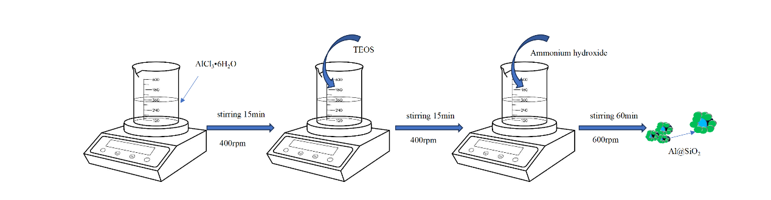
Fig. S1. The schematic diagram of the production route of Al@SiO₂.
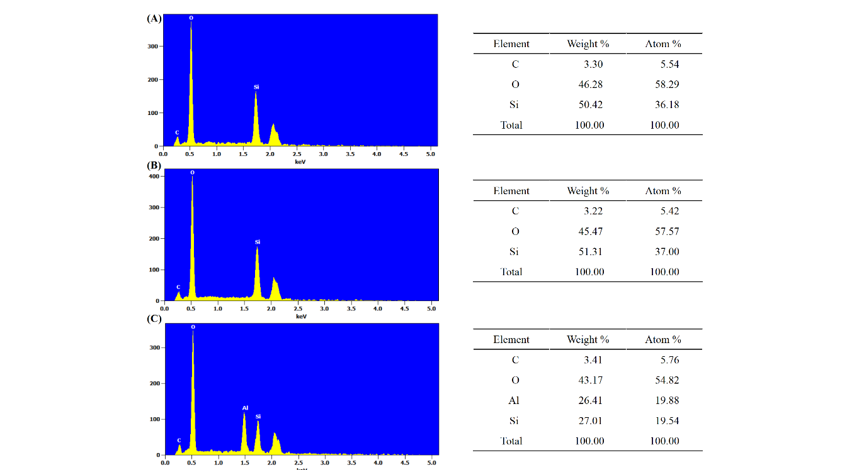
Fig. S2. EDS spectrum diagram of quartz sand (A), SiO₂ (B), and Al@SiO₂ (C).

Table S1. Orthogonal experimental factor level setting.
 | A | B | C | D
Factor level | Dosage (g/L) | P: F | Ca/ F | Time (min)
1 | 2.4 | 7 | 12 | 80
2 | 2 | 5 | 10 | 60
3 | 1.6 | 3 | 8 | 40

Table S2. Orthogonal experimental design scheme and results.
Number | A | B | C | D | Removal (%)
1 | 1.6 | 3 | 10 | 60 |  | 74.32
2 | 2.4 | 3 | 10 | 60 |  | 81.32
3 | 1.6 | 7 | 10 | 60 |  | 77.55
4 | 2.4 | 7 | 10 | 60 |  | 81.77
5 | 2 | 5 | 8 | 40 |  | 80.15
6 | 2 | 5 | 12 | 40 |  | 82.78
7 | 2 | 5 | 8 | 80 |  | 80.45
8 | 2 | 5 | 12 | 80 |  | 84.55
9 | 1.6 | 5 | 10 | 40 |  | 73.24
10 | 2.4 | 5 | 10 | 40 |  | 79.46
11 | 1.6 | 5 | 10 | 80 |  | 76.24
12 | 2.4 | 5 | 10 | 80 |  | 82.93
13 | 2 | 3 | 8 | 60 |  | 78.74
14 | 2 | 7 | 8 | 60 |  | 82.44
15 | 2 | 3 | 12 | 60 |  | 84.47
16 | 2 | 7 | 12 | 60 |  | 84.35
17 | 1.6 | 5 | 8 | 60 |  | 73.48
18 | 2.4 | 5 | 8 | 60 |  | 82.72
19 | 1.6 | 5 | 12 | 60 |  | 80.23
20 | 2.4 | 5 | 12 | 60 |  | 82.85
21 | 2 | 3 | 10 | 40 |  | 78.23
22 | 2 | 7 | 10 | 40 |  | 79.11
23 | 2 | 3 | 10 | 80 |  | 79.13
24 | 2 | 7 | 10 | 80 |  | 83.92
25 | 2 | 5 | 10 | 60 |  | 86.67
26 | 2 | 5 | 10 | 60 |  | 85.98
27 | 2 | 5 | 10 | 60 |  | 86.63
28 | 2 | 5 | 10 | 60 |  | 85.89

Table S3. Analysis of variance results.
Source | Sum of Squares | df | Mean Square | F-value | p-value | Significant
Model | 387.66 | 14 | 27.69 | 70.15 | <0.0001 | Significant
A-dosage | 107.94 | 1 | 107.94 | 273.18 | < 0.0001
B-P:F | 13.93 | 1 | 13.93 | 35.26 | < 0.0001
C-Ca:F | 37.63 | 1 | 37.63 | 95.24 | < 0.0001
D-time | 16.92 | 1 | 16.92 | 42.83 | < 0.0001
AB | 1.93 | 1 | 1.93 | 4.89 | 0.0455
AC | 10.96 | 1 | 10.96 | 27.73 | 0.0002
AD | 0.0552 | 1 | 0.0552 | 0.1398 | 0.7145
BC | 3.65 | 1 | 3.65 | 9.23 | 0.0095
BD | 3.82 | 1 | 3.82 | 9.67 | 0.0083
CD | 0.5402 | 1 | 0.5402 | 1.37 | 0.2633
A² | 154.05 | 1 | 154.05 | 389.88 | < 0.0001
B² | 42.52 | 1 | 42.52 | 107.61 | < 0.0001
C² | 8.35 | 1 | 8.35 | 21.13 | 0.0005
D² | 65.62 | 1 | 65.62 | 166.08 | < 0.0001
Residual | 5.14 | 13 | 0.3951
Lack of Fit | 4.62 | 10 | 0.4621 | 2.69 | 0.2251 | Not significant
Pure Error | 5.14 | 13 | 0.3951
Cor Total | 392.69 | 27

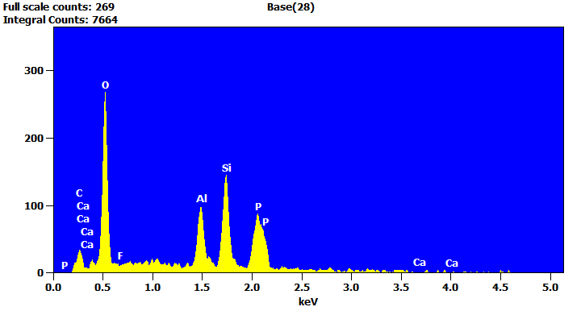 Fig. S3. EDS spectrum diagram of Al@SiO₂ after reaction.
Fig. S4. The full spectrum of the XPS scan before the reaction.

