Accelerated early phase glutathione S-transferase A2 (GSTA2) augments the risk of hepatocellular carcinoma recurrence after liver transplantation through modulating reactive oxygen species metabolism

Kevin Tak-Pan Ng*, Oscar Wai-Ho Yeung, Yin Fan Lam, Jiang Liu, Hui Liu, Li Pang, Xin Xiang Yang, Jiye Zhu, Weiyi Zhang, Matthew YH Lau, Wen Qi Qiu, Hoi Chung Shiu, Man Kit Lai, Chung Mau Lo, Kwan Man*

Supplementary Figures

Fig. S1. Polymorphic amino acid residues in GSTA2 protein in the transplanted liver of HCC recipients.
Fig. S2. The expression level of tumor GSTA2 mRNA between advanced stage and early stage HCC patients.
Fig. S3. The expression of GSTA2 in HCC cell lines.
Fig.S4. The expression level of GSTA2 mRNA and protein in GSTA2-overexpressing HCC cells.
Fig.S5. Correlation analysis of the expression level of GSTA2 mRNA and differentially ROS-associated genes.

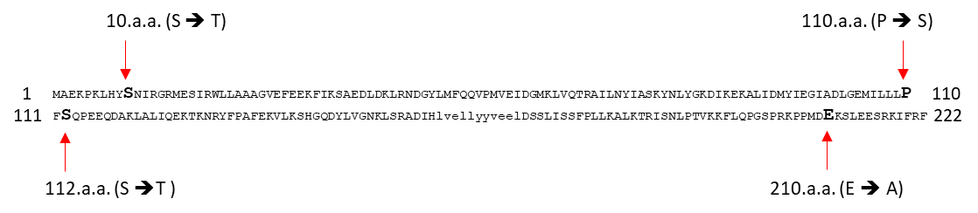

Fig. S1. Polymorphic amino acid residues in GSTA2 protein in the transplanted liver of HCC recipients. Sanger sequencing analysis of polymorphism of GSTA2 coding sequencing revealed four non-synonymous SNPs in the GSTA2 amino acid sequence: S10T, P110S, S112T, and E210A.

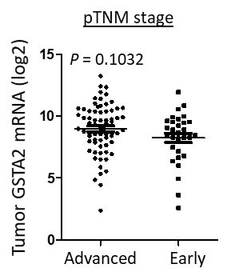

Fig. S2. The expression level of tumor GSTA2 mRNA between advanced stage and early stage HCC patients.

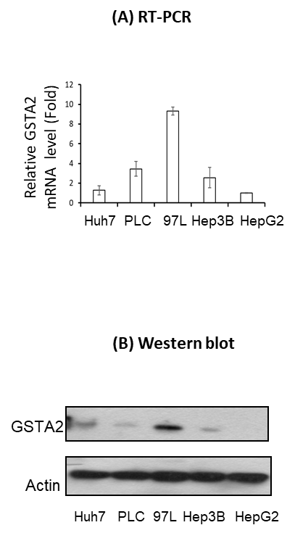

Fig. S3. The expression of GSTA2 in HCC cell lines. RT-PCR and Western blot analyses of GSTA2 mRNA and protein respectively in the GSTA2-overexpressing and control Hep3B cells, by (A) RT-PCR and (B) Western blot, respectively.

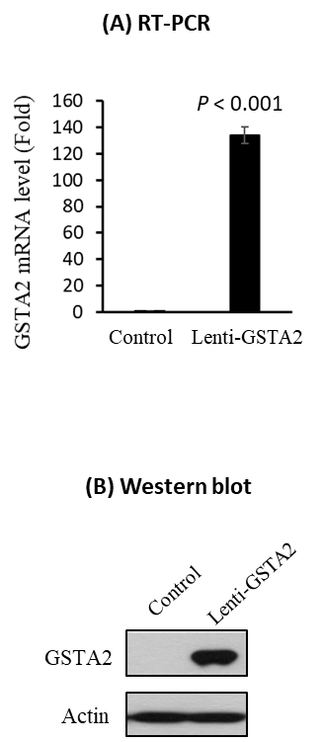

Fig.S4. The expression level of GSTA2 mRNA and protein in GSTA2-overexpressing HCC cells. Control, Hep3B-control cells; Lenti-GSTA2, Hep3B-LentiGSTA2 cells

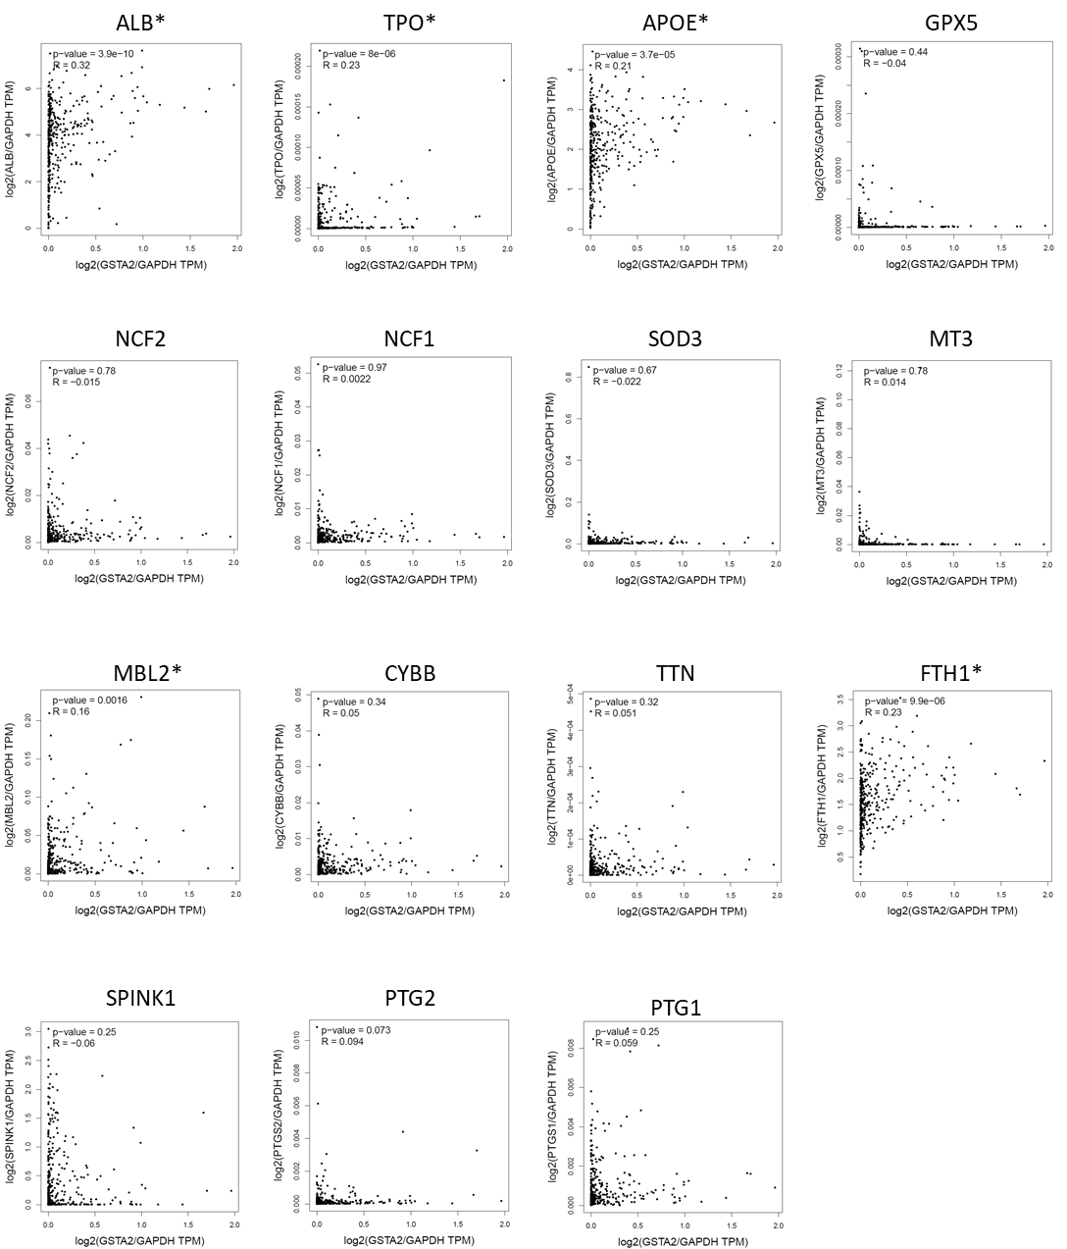

Fig.S5. Correlation analysis of the expression level of GSTA2 mRNA and differentially ROS-associated genes. *, genes significantly correlated with the expression of GSTA2.

