Accelerated early phase glutathione S-transferase A2 (GSTA2) augments the risk of hepatocellular carcinoma recurrence after liver transplantation through modulating reactive oxygen species metabolism

Kevin Tak-Pan Ng*, Oscar Wai-Ho Yeung, Yin Fan Lam, Jiang Liu, Hui Liu, Li Pang, Xin Xiang Yang, Jiye Zhu, Weiyi Zhang, Matthew YH Lau, Wen Qi Qiu, Hoi Chung Shiu, Man Kit Lai, Chung Mau Lo, Kwan Man*

Supplementary Tables

Table S1 List of primers and sequences
Table S2 Differentially upregulated early-phase genes in HCC recipients with post-transplantation HCC recurrence

Table S3. Summary of SNPs in GSTA2 transcripts between recipients with (N=6) and without (N=5) post-LT HCC recurrence by RNA-sequencing analysis

Table S1 List of primers and sequences
Gene | Forward primer (5’ to 3’) | Reverse primer (5’ to 3’) | PCR size
GSTA2 | GACCCTTCTTTCAGTGGGAGG | CTGGAGGTTTCTCTAAGCTTTGTT | 126 bp
TNF-alpha | GCCCATGTTGTAGCAAACCC | GGTTATCTCTCAGCTCCACGC | 100bp
IL-6 | GACCCAACCACAAATGCCAG | GTGCCCATGCTACATTTGCC | 147
TGF-beta1 | GGTGGAAACCCACAACGAAAT | GAGCAACACGGGTTCAGGTA | 112
SOD3 | AGCTGGAAAGGTGCCCGA | CTTGGCGTACATGTCTCGGAT | 149
NCF1 | CCCACGGACAACCAGACAAA | CGGTACGTCTGCAGGATGAT | 104
NCF2 | GGTGCCCCTTTCAGAAGACA | GAAAGCCTTGGTCACCCACT | 101
NRF2 | ACTTCTGTTGCTCAGGTAGCC | TAAGACACTGTAACTCAGGAATGG | 103
GPx2 | AGCATGCCTTCAGGAGACAC | AACCAGAGGGTTGGGAGAGG | 118
GPx3 | GGGGATGTCAATGGAGAGAA | TTCATGGGTTCCCAGAAGAG | 113
18S | CTCTTAGCTGAGTGTCCCGC | CTGATCGTCTTCGAACCTCC | 294
Actin | CTCTTCCAGCCTTCCTTCCT | AGCACTGTGTTGGCGTACAG | 116
GSTA2(rat) | TGACATGTACACCGAAGGCA | CCATGGCTCTTCAACACCTTT | 156
Actin (rat) | AGCCATGTACGTAGCCATCC | ACCCTCATAGATGGGCACAG | 115

Table S2 Differentially upregulated early-phase genes in HCC recipients with post-transplantation HCC recurrence

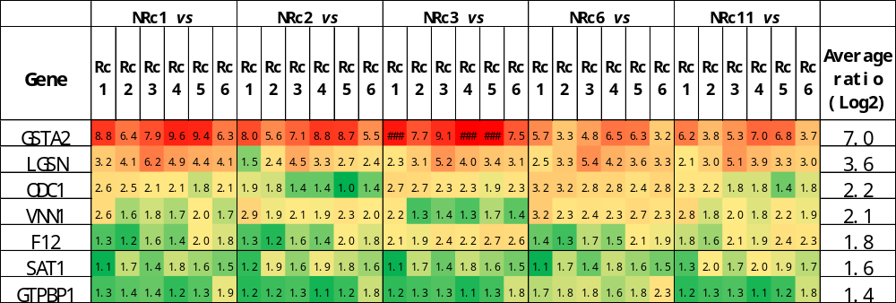
(NRc: Non-Recurrent HCC recipient; Rc: Recurrence HCC recipient)

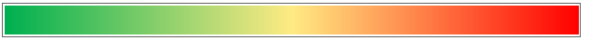
Table S3 Summary of SNPs in GSTA2 transcripts between recipients with (N=6) and without (N=5) post-LT HCC recurrence by RNA-sequencing analysis
Degree of upregulation in recurrent HCC recipients
High
Low
Chr | Coordinate | Ref | Alleles | Marker  type | HCC Recurrent  recipients  (n) | Non-HCC Recurrent  recipients  (n) | Function / amino acid  (mRNA sequence)
6 | 52,614,957 | T | C/T | Het | 2 | 0 | 3-UTR
6 | 52,614,978 | T | C/T | Het | 1 | 0 | 3-UTR
6 | 52,615,415 | T | T/G | Het | 3 | 0 | 210 | GAG > GCG | E 210 A | Non-synonymous
6 | 52,617,731 | C | G/G | Hom | 1 | 2 | 112 | AGT > ACT | S 112 T | Non-synonymous
6 | 52,617,731 | C | C/G | Het | 5 | 0 | 112 | AGT > ACT | S 112 T | Non-synonymous
6 | 52,617,738 | G | A/G | Het | 2 | 0 | 110 | CCC > TCC | P 110 S | Non-synonymous
6 | 52,617,745 | A | A/G | Het | 0 | 1 | 107 | CTT > CTC | L | synonymous
6 | 52,622,717 | G | A/G | Het | 0 | 1 | 10 | TCC > TTC | S 10 F | Non-synonymous
6 | 52,622,747 | G | A/A | Hom | 0 | 1 | 5-UTR
6 | 52,622,747 | G | G/A | Het | 1 | 0 | 5-UTR
6 | 52,622,755 | C | C/G | Het | 2 | 0 | 5-UTR
6 | 52,628,277 | C | T/C | Het | 1 | 0 | 5-UTR

