Supplementary Materials

Fig. S1 A schematic diagram of the setup for artificial light exposure at night.

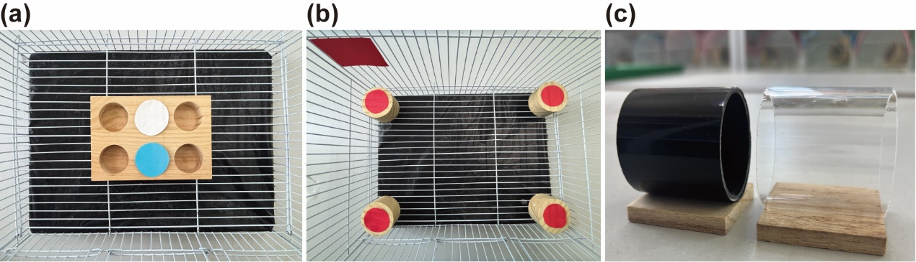
Fig. S2 The test apparatuses used to test cognitive abilities in Java Sparrows: (a) Grid and coloured lids used in the colour-association task, (b) A cage set up for the spatial learning task. Four individual wells were fixed in each corner of the cage, and a red cue card (5.7 cm × 8.9 cm) was placed at the left rear corner to provide a spatial reference, (c) The opaque cylinder (both ends open) used during the habituation and training phases of the detour-reaching task, the transparent cylinder (both ends open) used during the testing phase of the detour-reaching task.

