Supporting Information
Interpretable Machine Learning for Stability Screening of Mn(II) Amino Complexes with DFT Validation

Haizhen Song; Xin Zeng; Yumei Yang; Xuesong Xu; Yan Zhang; Yichao Wang; Hongming Yin*
School of Science, Dalian Maritime University, Dalian, Liaoning 116026, P. R. China
* Corresponding authors.
E-mail address: hmyin@dlmu.edu.cn (H. Yin).

Fig.S1 Displays the complete molecular structure diagrams of 500 listed amino ligands, in the order: aromatic amines, heterocyclic amines, and aliphatic amines (divided into straight chain and branched-chain)
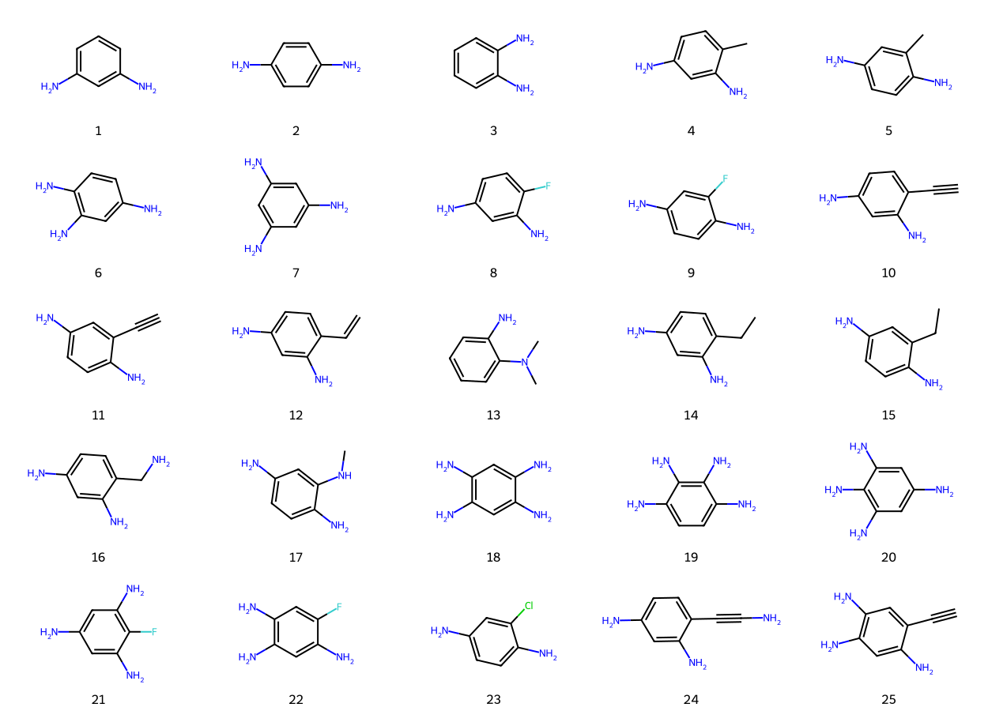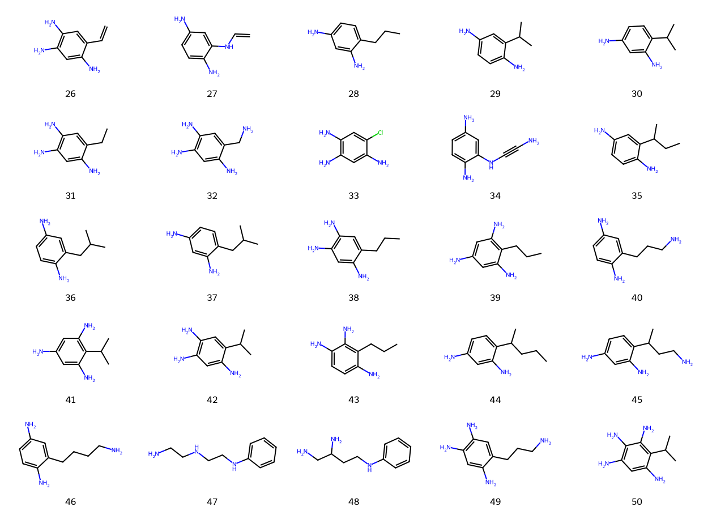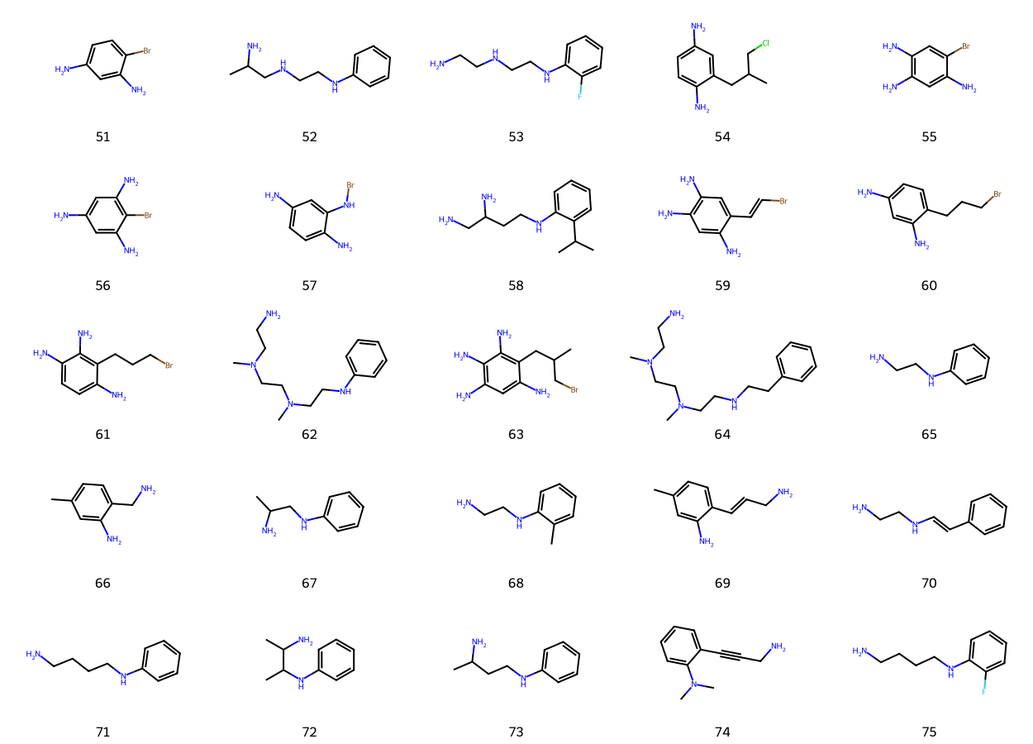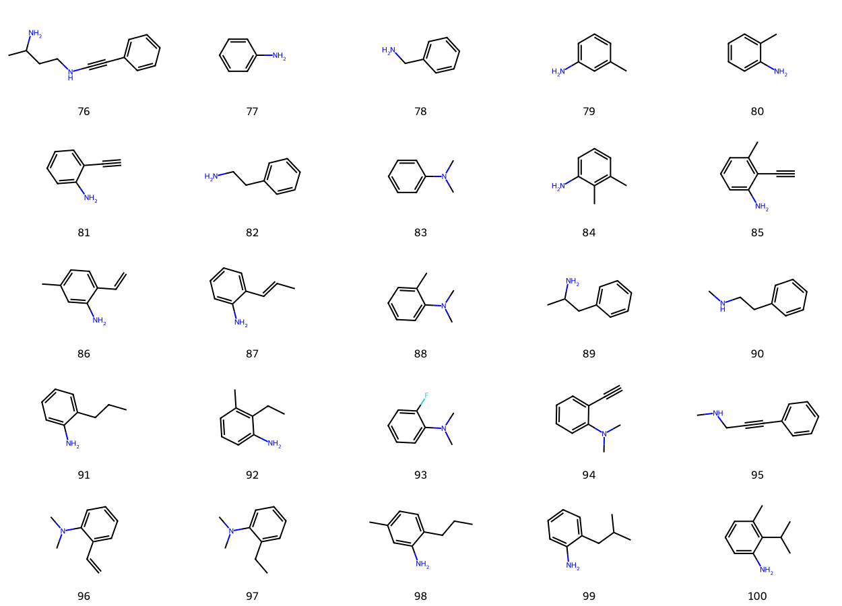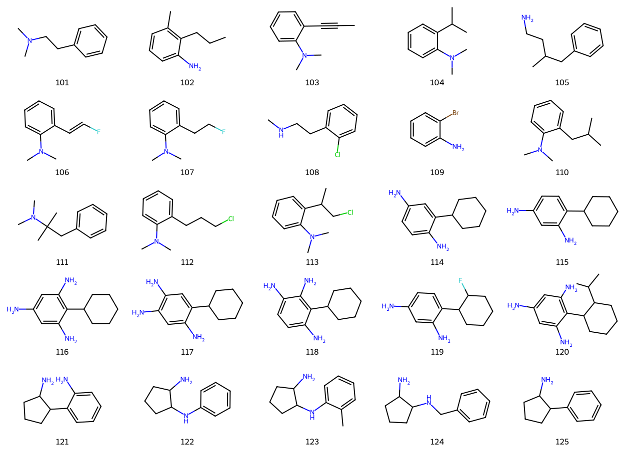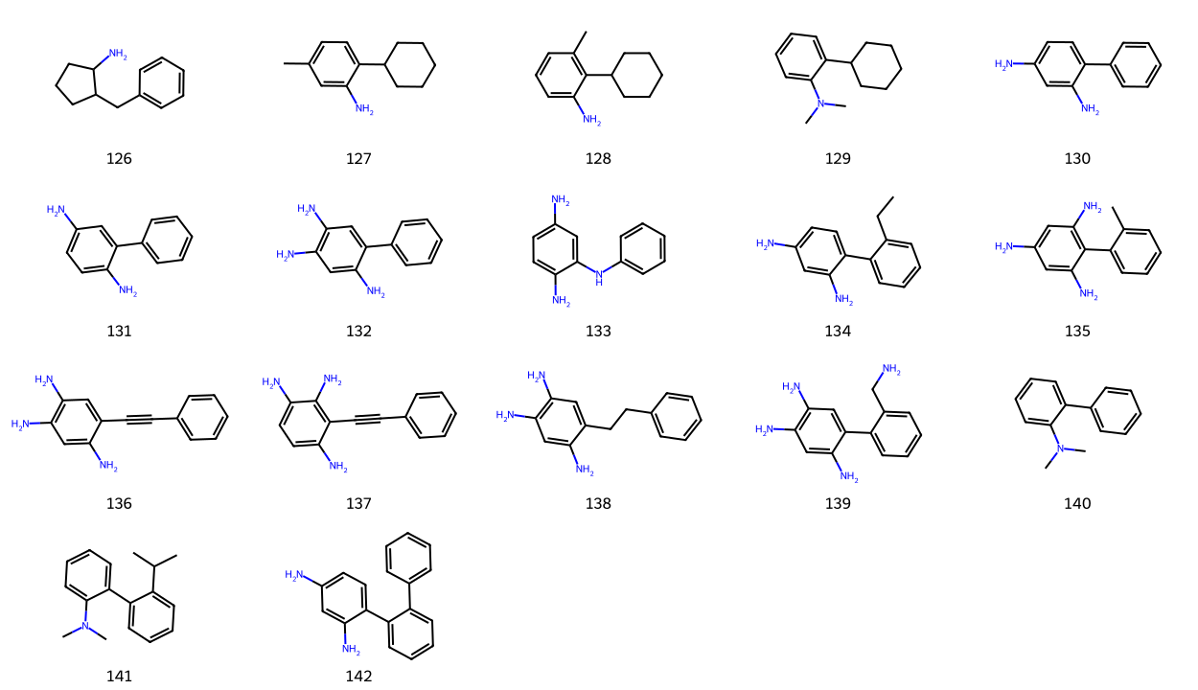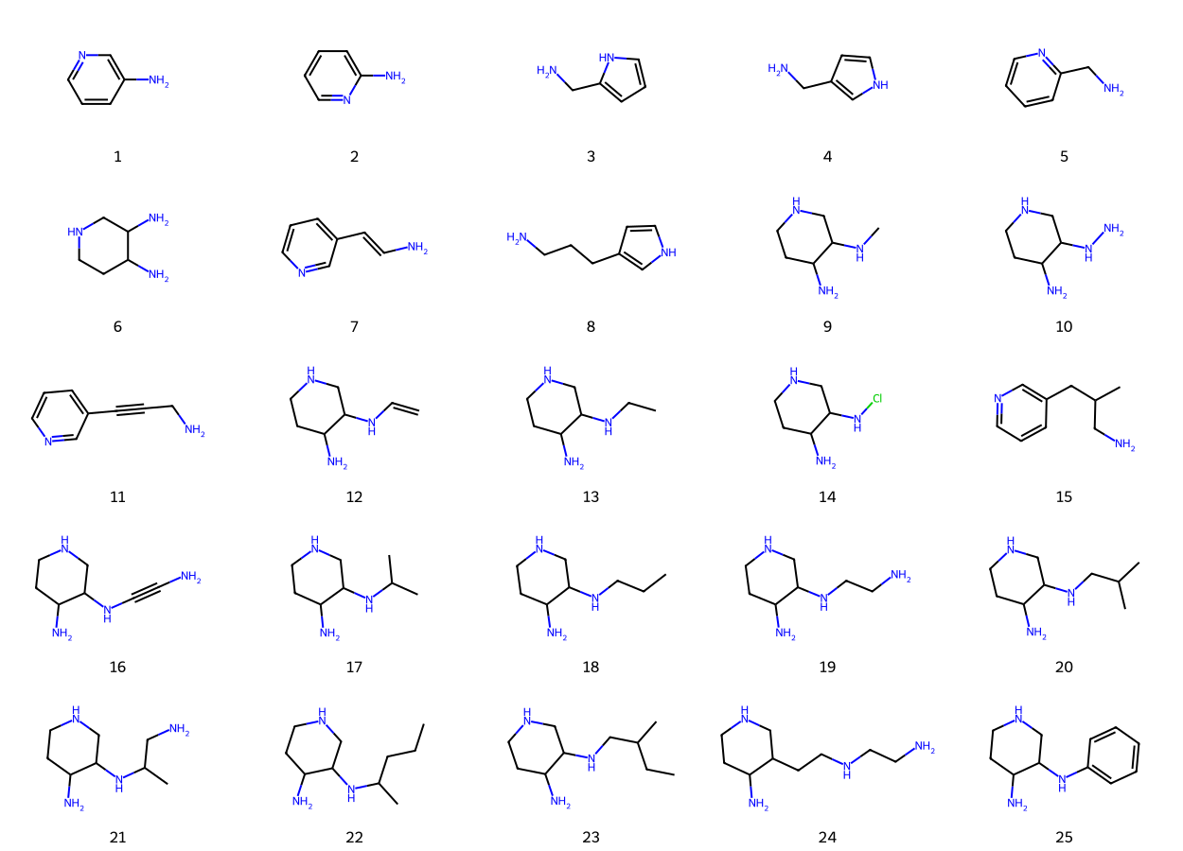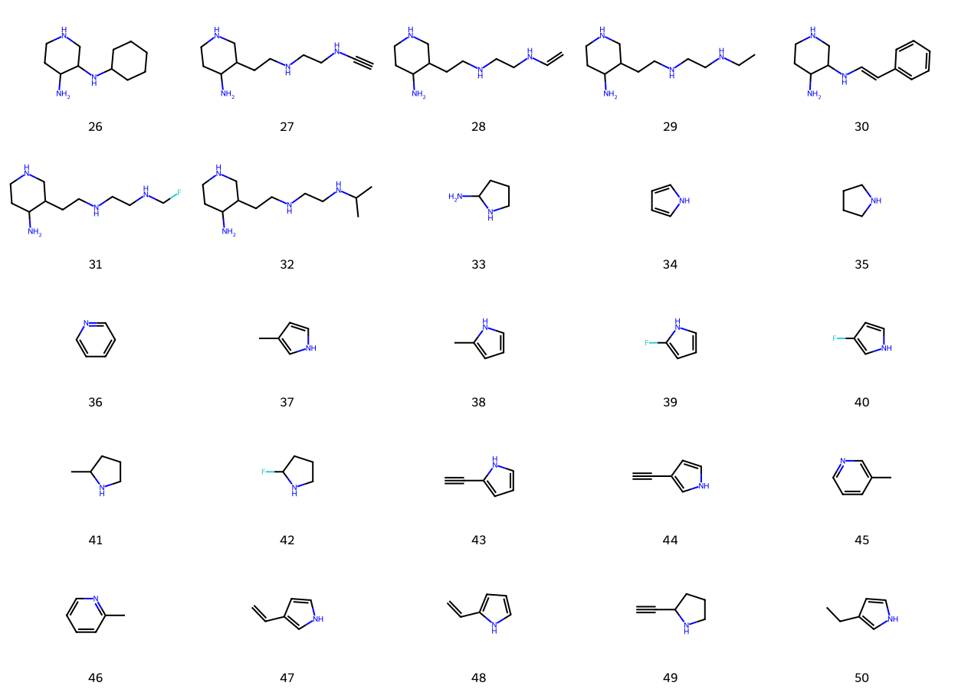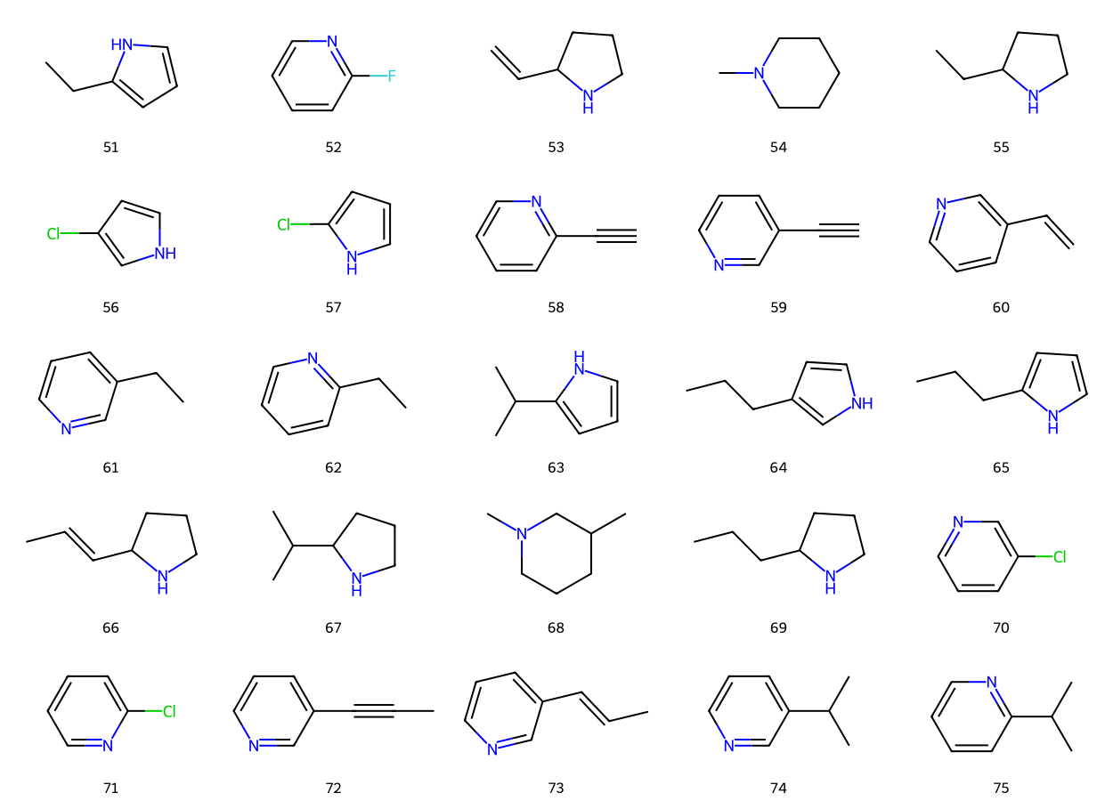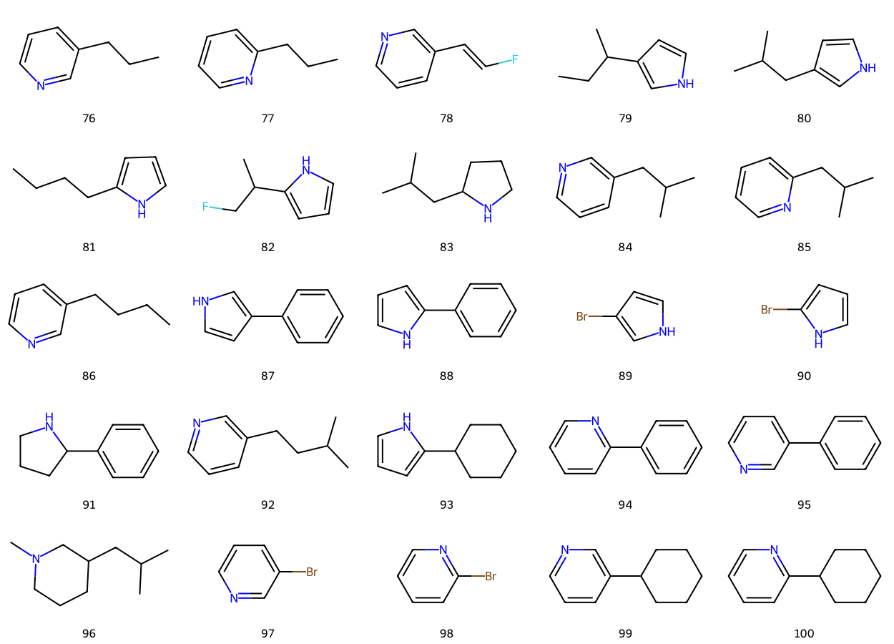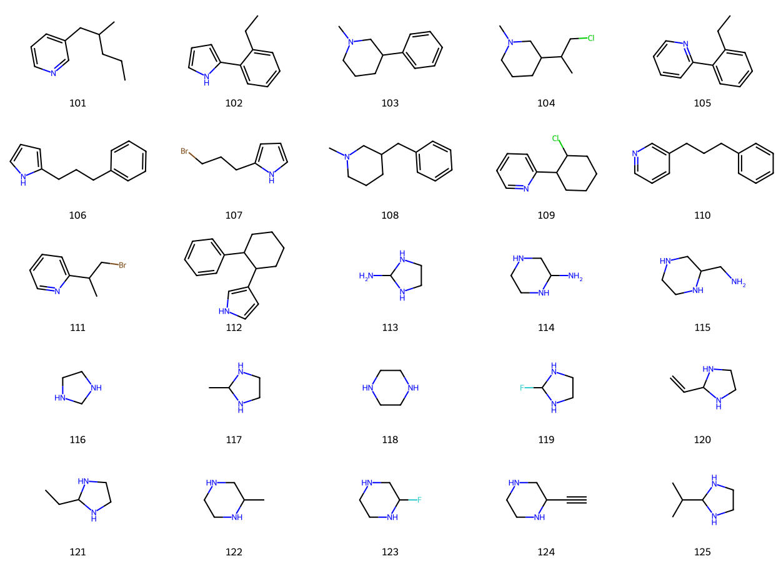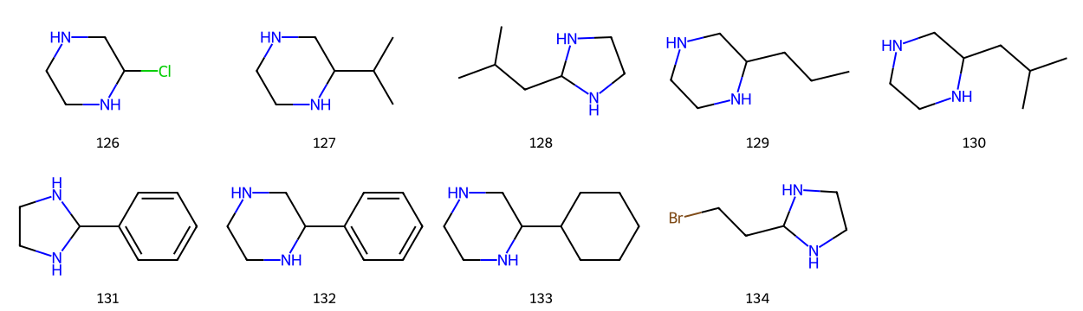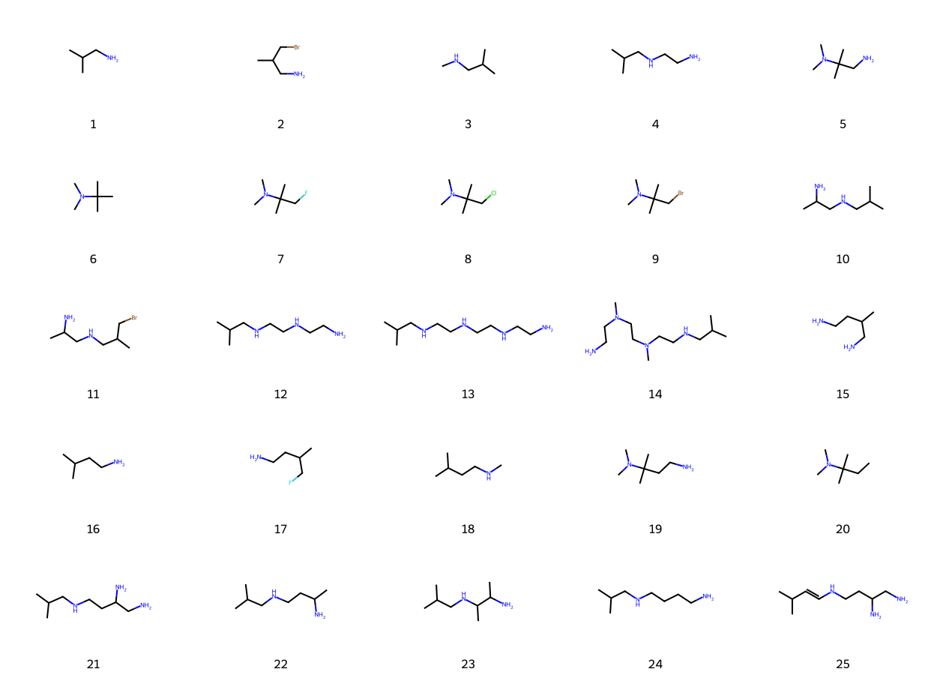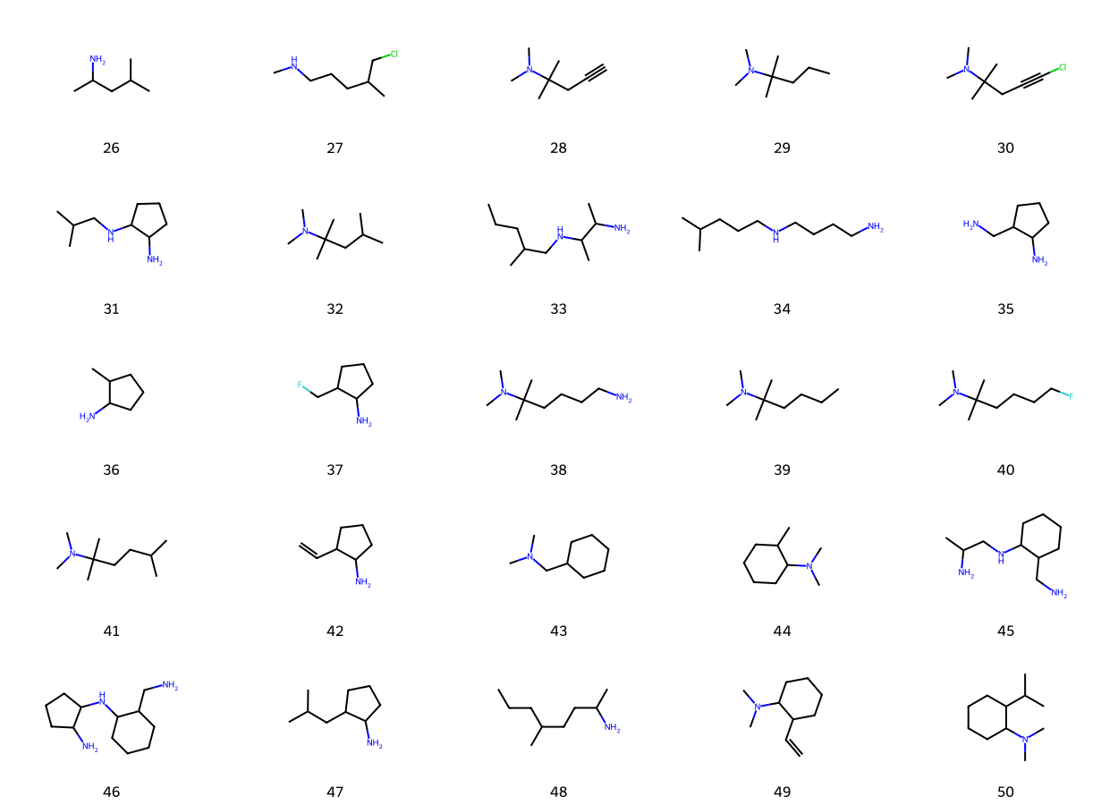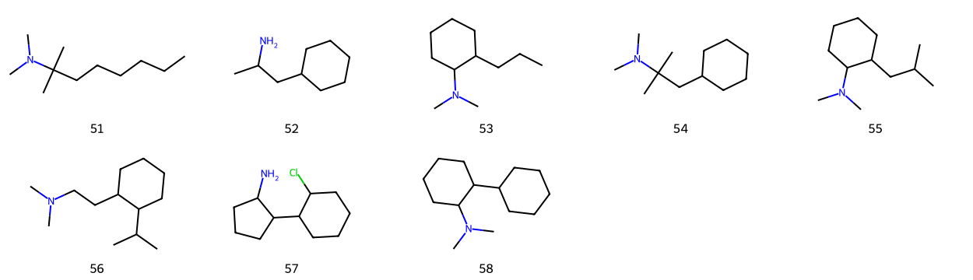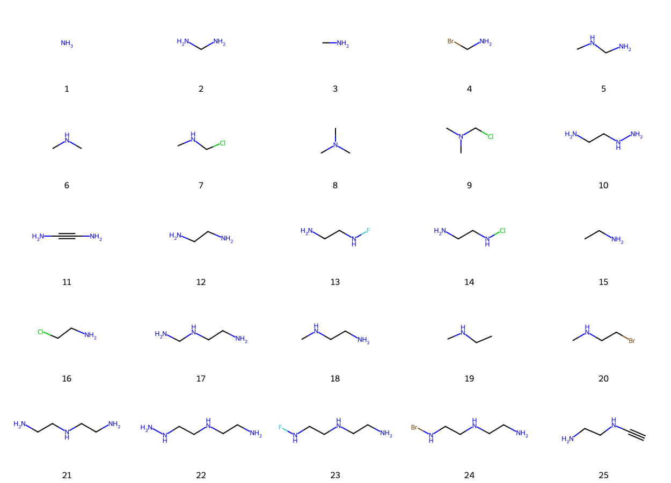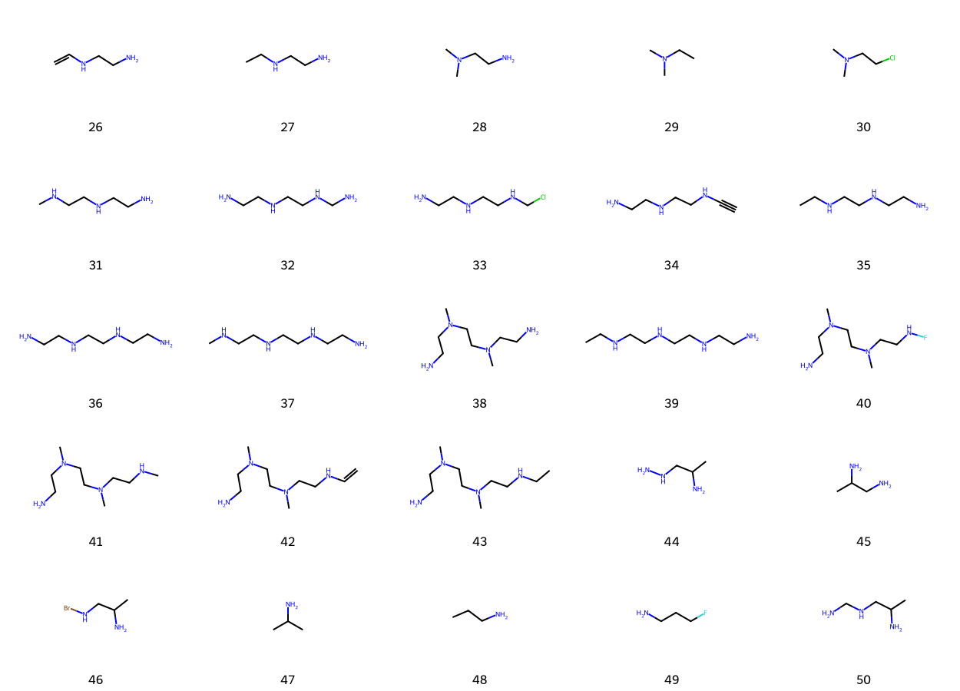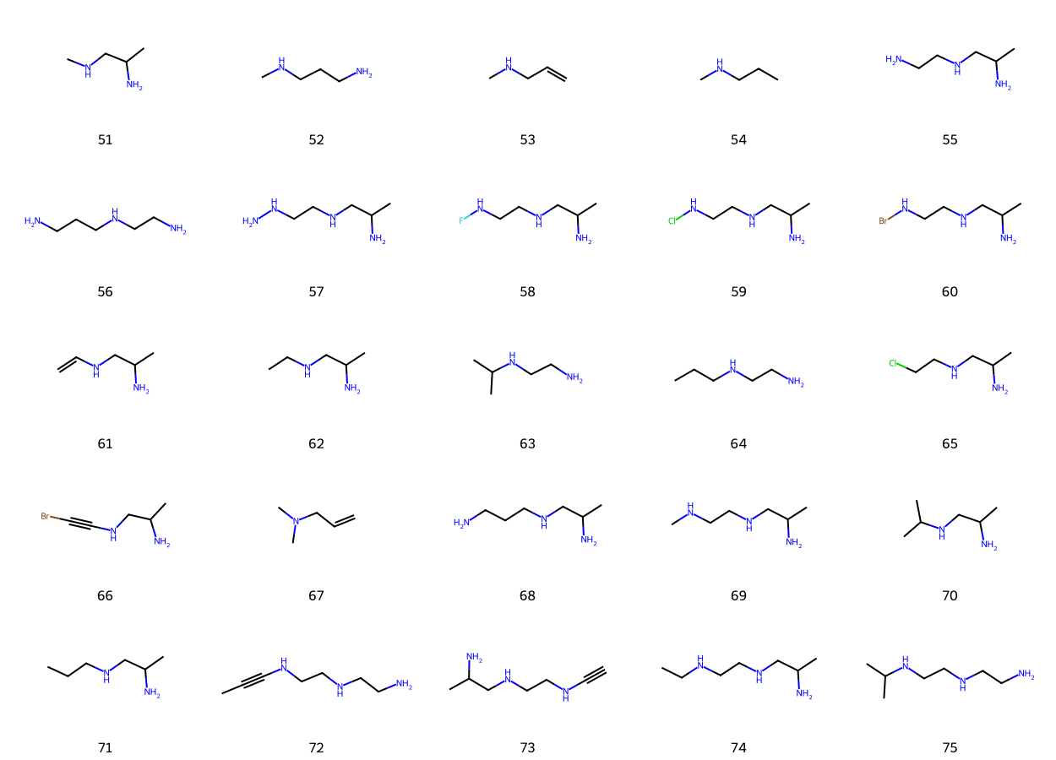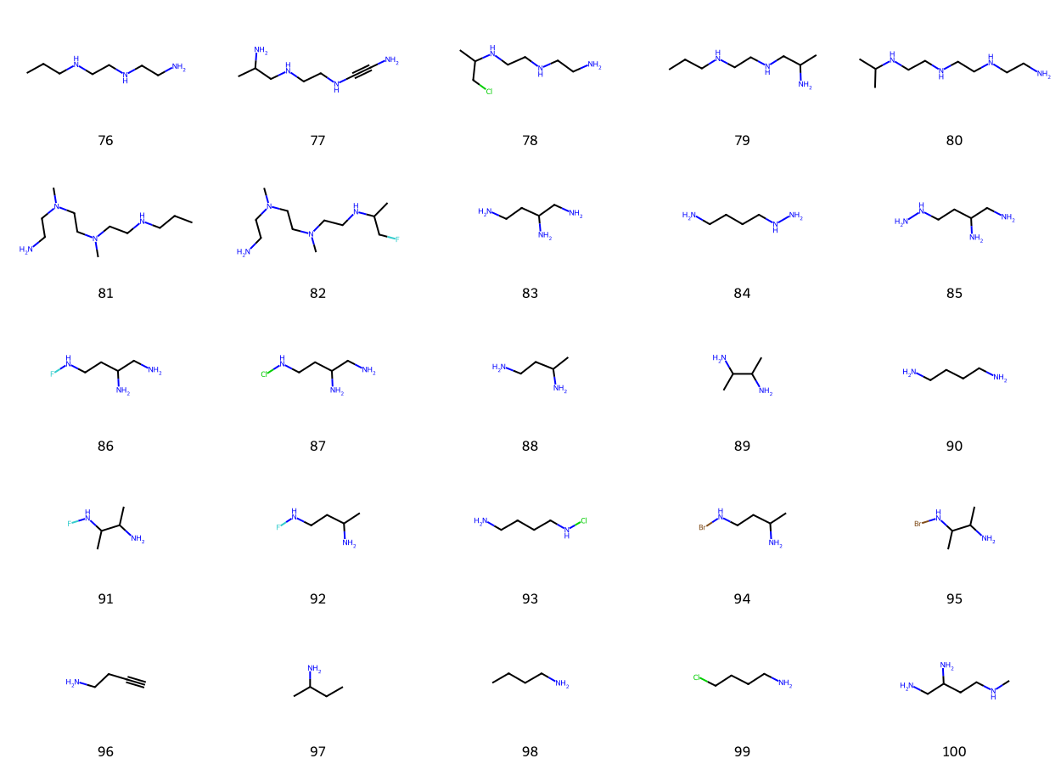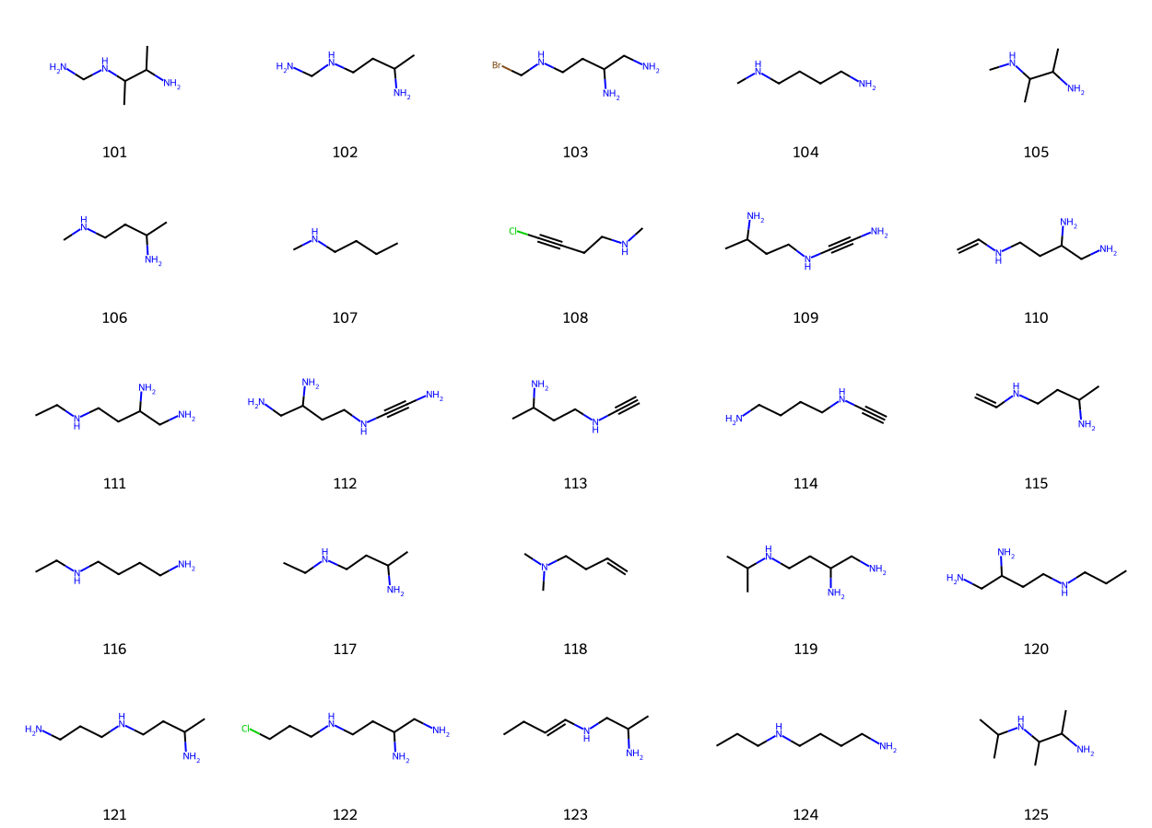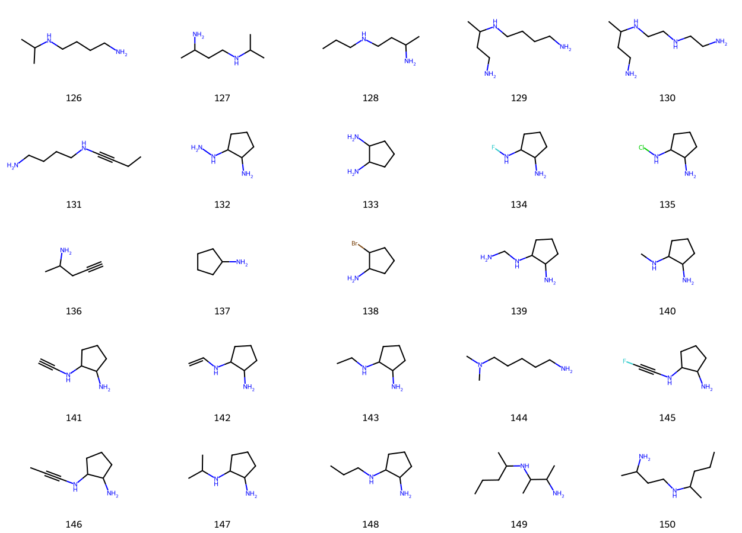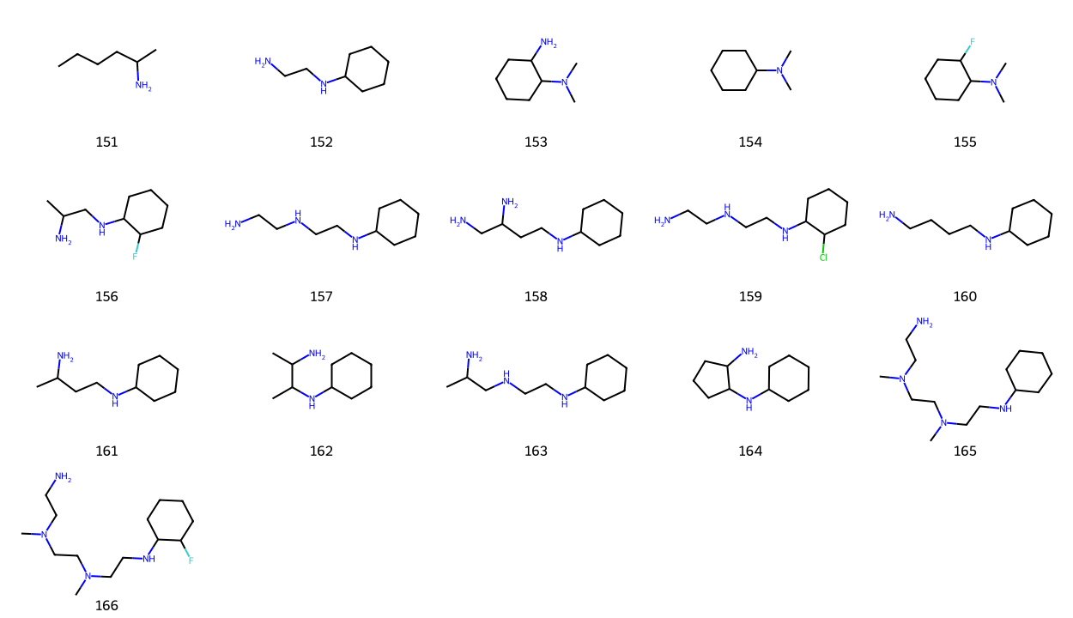

Table S1 Full list of 49 descriptors with their physical meanings. Entries 1–16 are the final features selected for the XGBoost model, ranked in descending order of global SHAP importance (from highest to lowest). The remaining descriptors (17–49) are listed in the order of original generation
ID | Feature Name | Description | Unit / Type
1 | Mn_Ow_cv | Coefficient of variation of Mn–Ow coordination distances | unitless
2 | Mn_Ow_mean | Mean Mn–Ow coordination distance | Å
3 | best_mnN_from_prev | Optimal Mn–N coordination distance determined from previous screening | Å
4 | MolWt_per_N | Molecular weight per nitrogen atom | g/mol·N⁻¹
5 | Mn_LigHeavy_mean | Average distance from Mn to heavy atoms (non-H) of the ligand | Å
6 | LogP_TPSA_balance | Balance index between hydrophobicity (LogP) and polar surface area (TPSA) | unitless (custom composite)
7 | MolLogP | Calculated logarithm of octanol/water partition coefficient (logP) | unitless
8 | N_over_MnNmean | Ratio of number of N atoms to mean Mn–N distance | composite ratio
9 | LigandHeavy_RadiusMean | Average distance from ligand heavy atoms to ligand geometric center | Å
10 | ASA_per_heavy | Approximate surface area per heavy atom | Å² / heavy atom
11 | RotBonds_per_heavy | Number of rotatable bonds per heavy atom | count / heavy atom
12 | Centroid_to_MnN_ratio | Normalized ratio of distance from ligand centroid to Mn–N coordination center | unitless
13 | MolWt_per_heavy | Molecular weight per heavy atom | g/mol / heavy atom
14 | Flexibility_sp3_balance | Balance index between rotatable bonds and fraction of sp³ carbons | unitless (custom composite)
15 | BalabanJ | Balaban’s J topological index | unitless
16 | Kappa2 | Kier’s second-order shape index | unitless
17 | MolWt | Molecular weight | g/mol
18 | TPSA | Topological polar surface area | Å²
19 | FractionCSP3 | Fraction of sp³ hybridized carbons among all carbons | ratio (0–1)
20 | NumHAcceptors | Number of hydrogen bond acceptors | count
21 | NumHDonors | Number of hydrogen bond donors | count
22 | NumRotatableBonds | Number of rotatable bonds | count
23 | RingCount | Total number of rings | count
24 | AromaticRingCount | Number of aromatic rings | count
25 | AliphaticRingCount | Number of aliphatic rings | count
26 | NumN | Number of nitrogen atoms | count
27 | NumHalogen | Number of halogen atoms (F, Cl, Br, I) | count
28 | BertzCT | Bertz molecular complexity index | unitless
29 | Kappa3 | Kier’s third-order shape index | unitless
30 | PEOE_VSA1 | Sum of van der Waals surface areas of atoms with PEOE partial charges in interval 1 | Å²
31 | PEOE_VSA2 | Sum of van der Waals surface areas of atoms with PEOE partial charges in interval 2 | Å²
32 | PEOE_VSA3 | Sum of van der Waals surface areas of atoms with PEOE partial charges in interval 3 | Å²
33 | PEOE_VSA4 | Sum of van der Waals surface areas of atoms with PEOE partial charges in interval 4 | Å²
34 | PEOE_VSA5 | Sum of van der Waals surface areas of atoms with PEOE partial charges in interval 5 | Å²
35 | SMR_VSA1 | Sum of van der Waals surface areas of atoms with molar refractivity contributions in interval 1 | Å²
36 | SMR_VSA3 | Sum of van der Waals surface areas of atoms with molar refractivity contributions in interval 3 | Å²
37 | SlogP_VSA1 | Sum of van der Waals surface areas of atoms with atomic LogP contributions in interval 1 | Å²
38 | SlogP_VSA2 | Sum of van der Waals surface areas of atoms with atomic LogP contributions in interval 2 | Å²
39 | SlogP_VSA3 | Sum of van der Waals surface areas of atoms with atomic LogP contributions in interval 3 | Å²
40 | flag_many_N | Binary flag: whether the ligand contains many N atoms (heuristic) | 0/1
41 | flag_has_H_donor | Binary flag: whether the ligand has hydrogen bond donor(s) | 0/1
42 | flag_high_TPSA | Binary flag: whether TPSA is high (heuristic threshold) | 0/1
43 | flag_aliphatic_rich | Binary flag: whether the ligand is rich in aliphatic moieties | 0/1
44 | flag_polyamine_like | Binary flag: whether the ligand resembles a polyamine structure | 0/1
45 | Mn_N_2nd_gap | Difference between second-nearest and nearest Mn–N distances | Å
46 | HAccceptor_per_N | Number of hydrogen bond acceptors per nitrogen atom | count / N
47 | TPSA_per_N | Topological polar surface area per nitrogen atom | Å² / N
48 | Ring_per_heavy | Number of rings per heavy atom | count / heavy atom
49 | Aromatic_ring_fraction | Ratio of aromatic rings to total rings | ratio (0–1)

Table S2 Optimized hyperparameters of the XGBoost model
Parameter | Value | Description / Tuning Method
n_estimators | 200 | Number of boosting rounds
learning_rate | 0.0193 | Step size shrinkage
max_depth | 5 | Maximum tree depth
subsample | 0.708 | Fraction of samples used per tree
colsample_bytree | 0.755 | Fraction of features used per tree
reg_alpha | 0.375 | L1 regularization on weights
reg_lambda | 1.423 | L2 regularization on weights

