Table S1 Tandem mass spectrometry parameters used for multiple reaction monitoring (m/z: mass to charge ratio).
Precursor ion  ( m/z ) | Product ions  ( m/z ) | Retention time  ( min ) | Tube Lens ( V ) | Collision energy ( eV )
282.2 | 212.2 | 7.56 | 100 | 17
282.2 | 194.1 | 7.56 | 100 | 10

Table S2 Primer Sequence List.
Primer pair | Sequence | PCR annealing and  extension temp (°C) | Amplicon size  (bp)
28s-FW | CCACTTATCCTACACCTCTC | 60 | 136
28s-RV | CACTGTCCCTGTCTACTATC | 60 | 136
CL7006.Contig1-FW | CAACCATCAAGACGAAGAG | 56 | 82
CL7006.Contig1-RV | GGTGCCTGATAGTTAATTCC | 56 | 82
CL17489.Contig1-FW | CATTGGCAAGGAGATTGTC | 59 | 95
CL17489.Contig1-RV | AGGAGTGGAAGATAAGGAAG | 59 | 95
Unigene28871-FW | CCTACACCAACCTCAACA | 59 | 83
Unigene28871-RV | CACATTCAGAGCACCATC | 59 | 83
Unigene38694-FW | CCACTTATACCAACCTGAAC | 57 | 107
Unigene38694-RV | CCACTTATACCAACCTGAAC | 57 | 107
Unigene39213-FW | GTGGATTATGGCAAGAAGTC | 54 | 64
Unigene39213-RV | CTGTAGATACCTGAGGAGAG | 54 | 64

Table S3 The amino acid composition, physical, and chemical characteristics of α-tubulin. Note: pI: Isoelectric point. GRAVY: Grand average of hydropathicity. The unit of molecular weight is kD.
 | Number of amino acid | Molecular weight | pI | Instability  index | Aliphatic  index | GRAVY
AtTUA1 | 450 | 49.8001 | 4.92 | 40.92 | 81.86 | -0.194
Unigene28871_H1A | 286 | 31.9529 | 4.69 | 41.37 | 81.40 | -0.204
Unigene1894_H1A | 264 | 29.0548 | 5.22 | 34.40 | 95.23 | -0.028
Unigene33980_H1A | 227 | 25.5481 | 5.59 | 45.84 | 79.47 | -0.167
CL7006.Contig1_H1A | 322 | 35.6162 | 4.87 | 42.43 | 83.82 | -0.157
Unigene39213_H1A | 192 | 21.0709 | 5.94 | 33.24 | 104.06 | 0.021
Unigene38694_H1A | 448 | 49.5232 | 4.96 | 38.26 | 87.90 | -0.115
CL17489.Contig1_H1A | 366 | 40.8533 | 5.09 | 34.19 | 83.69 | -0.189
CL17215.Contig2_H1A | 188 | 20.3067 | 4.92 | 23.14 | 90.69 | -0.142
Unigene39214_H1A | 356 | 38.9544 | 6.00 | 37.07 | 87.58 | -0.057

Table S4 Secondary structure of α-tubulin.
 | Alpha helix | Extended strand | Random coil
AtTUA1 | 22.44 | 20.00 | 57.56
Unigene28871_H1A | 32.89 | 17.83 | 49.30
Unigene1894_H1A | 25.00 | 15.53 | 59.47
Unigene33980_H1A | 35.24 | 16.30 | 48.46
CL7006.Contig1_H1A | 28.88 | 17.70 | 53.42
Unigene39213_H1A | 30.73 | 15.10 | 54.17
Unigene38694_H1A | 31.49 | 17.19 | 51.34
CL17489.Contig1_H1A | 34.97 | 17.49 | 47.54
CL17215.Contig2_H1A | 28.72 | 19.68 | 51.60
Unigene39214_H1A | 25.00 | 18.26 | 56.74

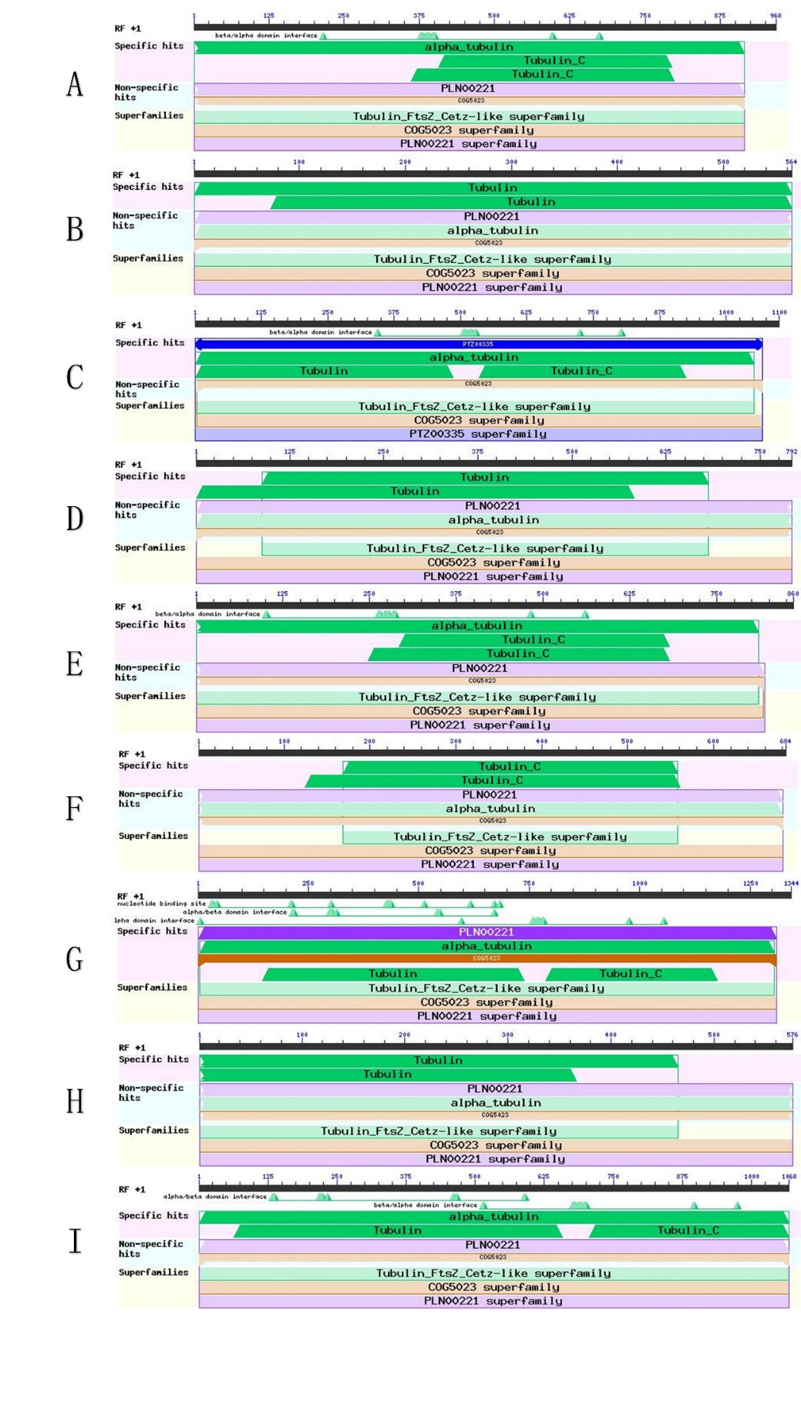

Figure S1 The conserved domains of α-tubulin.
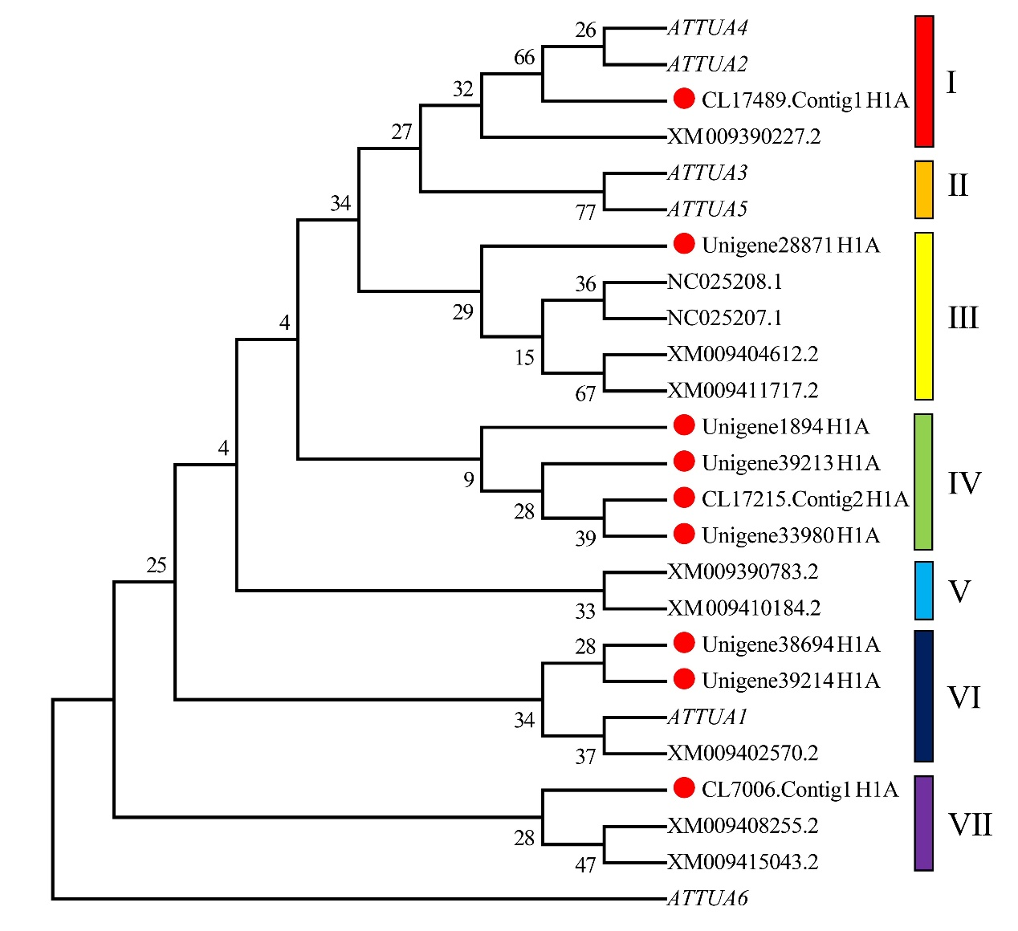

Figure S2 Phylogenetic tree of α-tubulin.

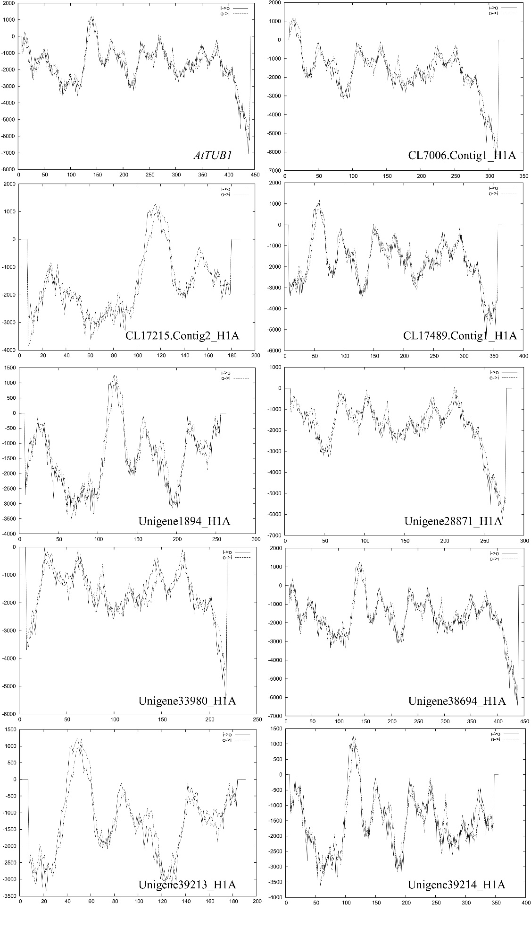

Figure S3 The transmembrane region of α-tubulin

