Supplemental Table 1
Glyvance™ | ADA
Breakfast
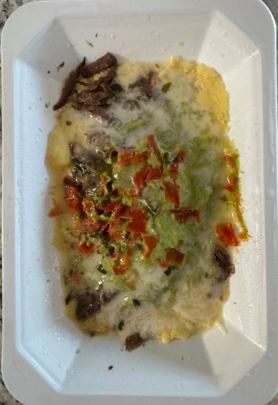  Eggs with Pico de Gallo Sauce | 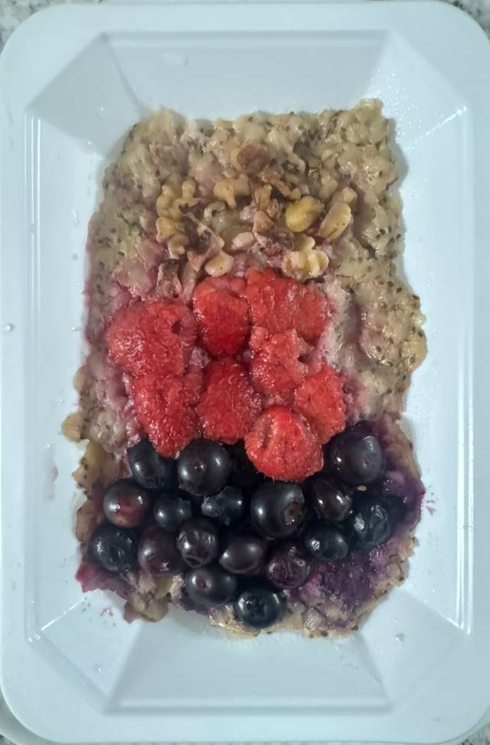  Oatmeal and Berries
Lunch
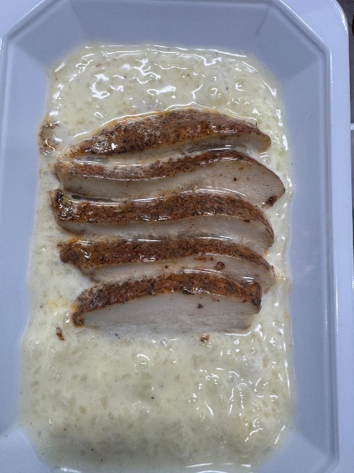  Chicken Alfredo with Cauliflower Risotto | 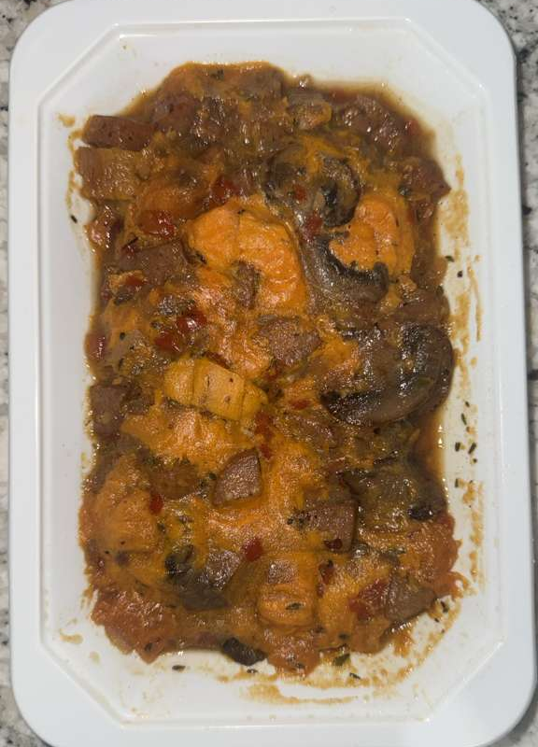  Chicken Sausage Hash
Dinner
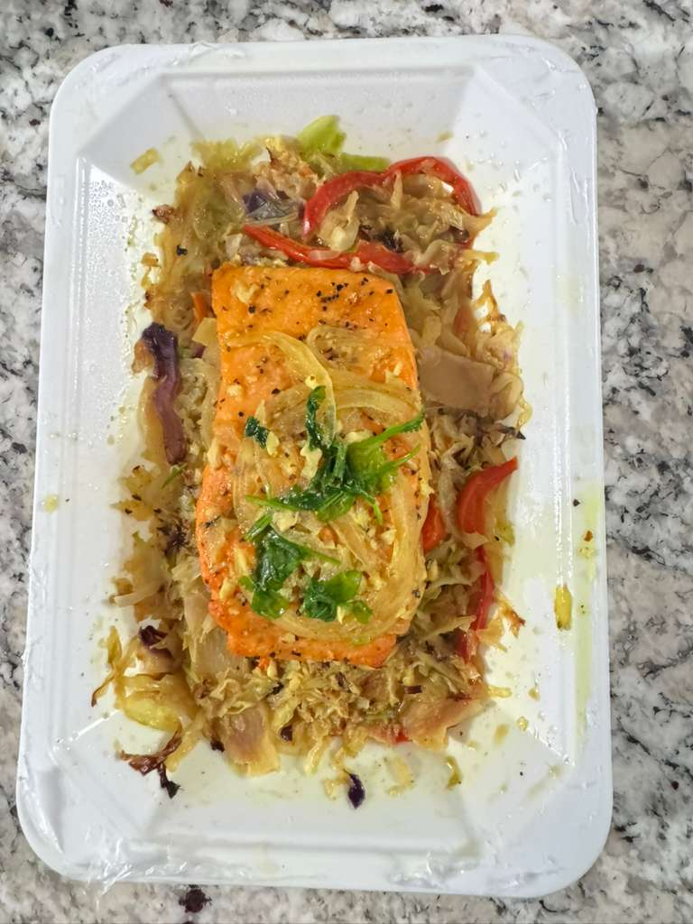  Mediterranean Style Salmon | 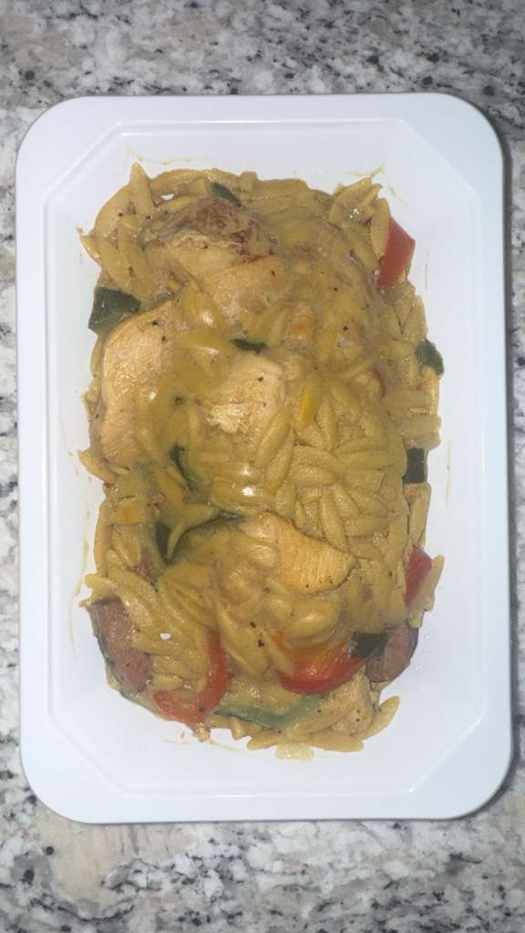  Chicken and Pepper Paella
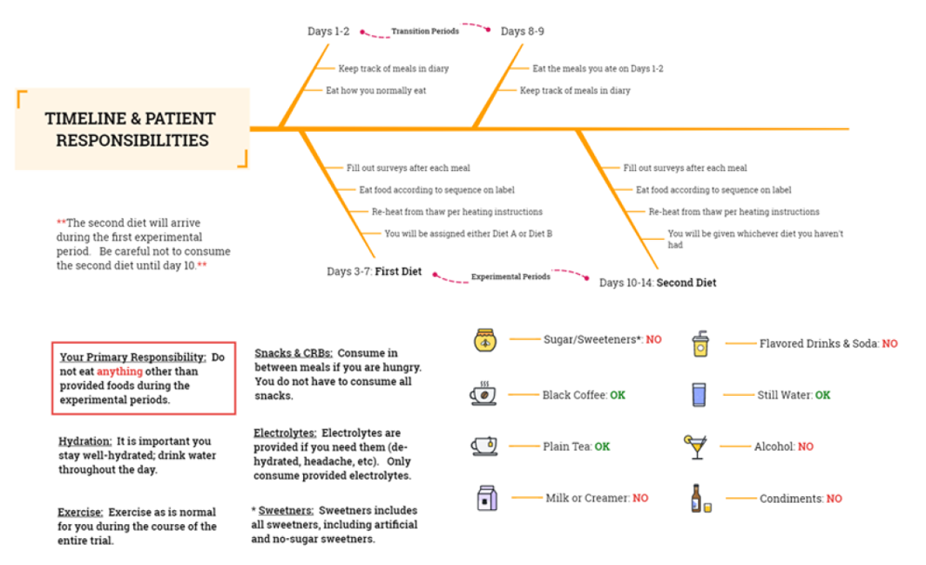
Supplemental Figure 1

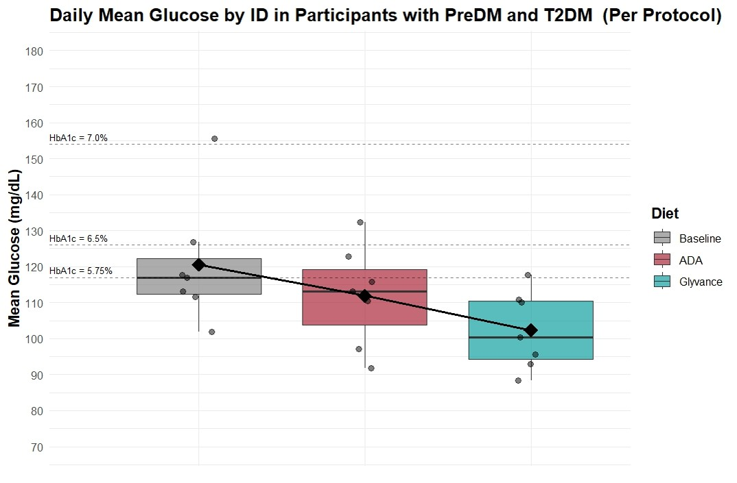
Supplemental Figure 2A

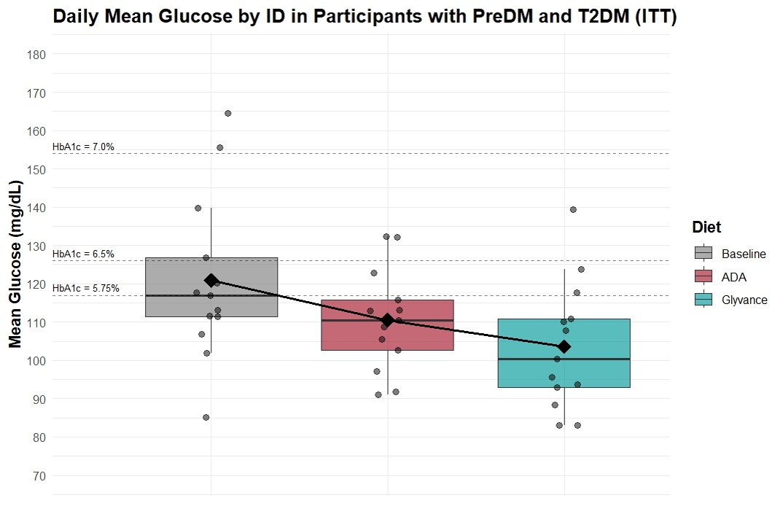
Supplemental Figure 2B

