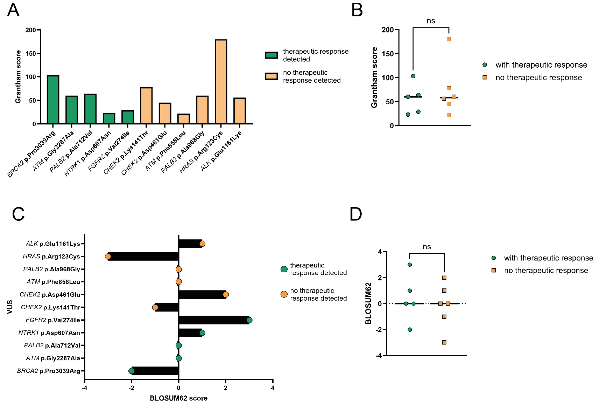

Supplementary Fig. 3: Correlative Analysis of therapeutic response and amino acid similarities in the identified VUS
A Grantham Scoring of VUS identified in the 11 cases tested for therapeutic response. B Statistical analysis of Grantham scoring between VUS with and without therapeutic response in the RESOLVE-VUS platform, t-Test p>0.05. C BLOSUM62 scores of identified VUS in the tested cases. D Statistical analysis of BLOSUM62 scores between tested VUS with and without therapeutic response, t-Test p>0.05.

