Name, Surname | Birth Date | Case ID Number | Sample received | Report completed
xxx | xxx | xxx | 10th May 2024 | 15th June 2024
RESOLVE-VUS Molecular Report Nr. XXXX/24 (OC03)

Tumor Entity | Sample type | Sample Volume | Additional remarks
High-grade serous ovarian carcinoma | Ascites | 16 ml | Yellow, clear

A. PDO Establishment
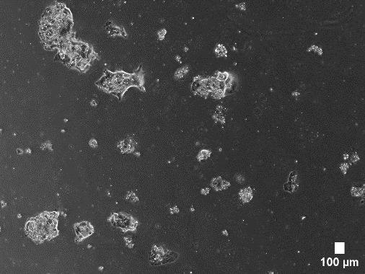
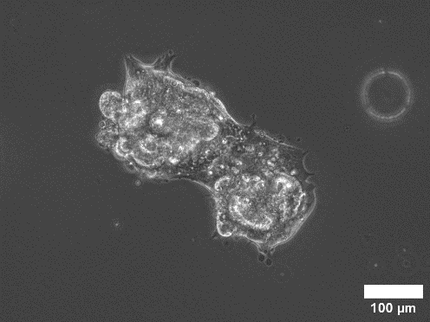
P0 Day 7
P1 Day 7

PDOs were successfully established and culture is stable over at least three passages.

B. NGS Results
NGS Sequencing was performed using PDO-derived tumor cell DNA. The following genetic variants were identified:
Gene Name | Transcript | Variant |  | Allele frequency | Clinical Relevance
Gene Name | Transcript | HGVSC | HGVSP | Allele frequency | Clinical Relevance
TP53 | ENST00000269305.9 | c.652_659dup | p.Tyr220* | 51,50% | Pathogenic, Loss-of-Function
BRCA2 | ENST00000544455 | c.9116C>G | p.Pro3039Arg | 42,83 | Variant of uncertain significance

A genetic variant of uncertain significance (VUS) in BRCA2 was detected in the examined gene regions. BRCA2 mutations reportedly confer susceptibility to PARP-inhibitors such as Olaparib or Niraparib, which therefore could potentially represent suitable therapy options.

C. In-vitro Therapeutic screening
Based on the detected VUS in BRCA2, the targeted drugs Olaparib and Niraparib were tested in vitro. Organoids were seeded into a 96-well plate, and the respective drugs were added in triplicates. Cisplatin served as a positive control. We obtained the following results:
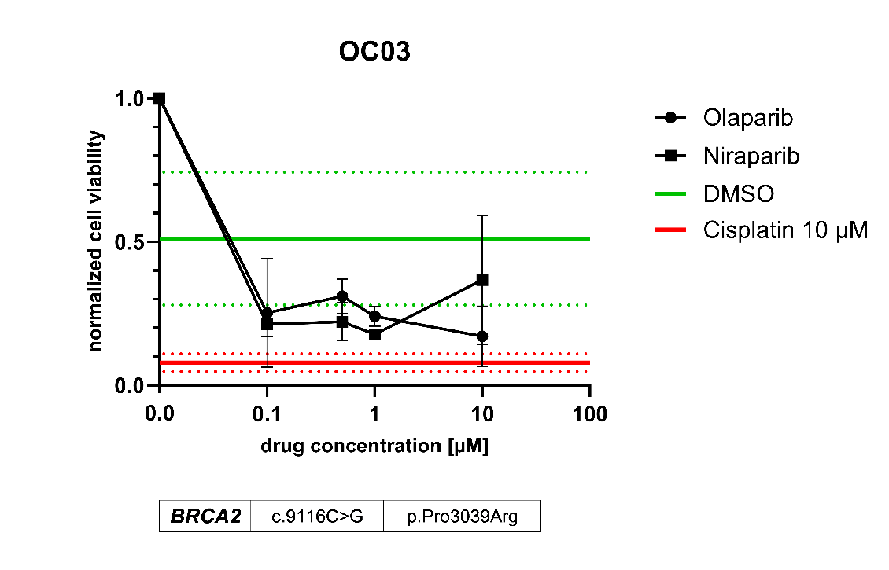

The obtained results show a moderate response to olaparib. Response to niraparib is considered questionable, as a cell viability of 66.58% was measured at a concentration of 10 µM, which was higher compared to lower drug concentrations. A possible explanation could be the presence of single very large organoids in one of the three wells.

D. Recommendation
The obtained results demonstrated a good therapeutic response of the patient-derived tumor organoids to treatment with olaparib. A similarly strong, however inconsistent response was observed with niraparib.
We therefore recommend olaparib as the preferred therapy option.

