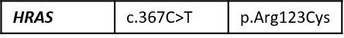
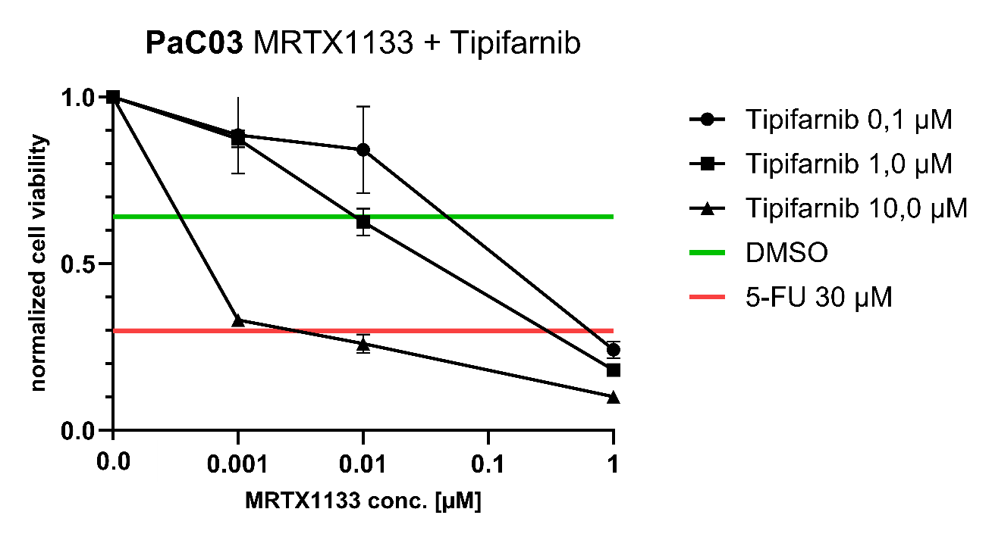

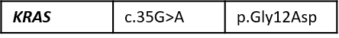

Supplementary Figure 1: Combination testing of Tipifarnib and MRTX1133 in an HRAS-VUS and KRAS G12D mutation containing pancreatic carcinoma sample reveals no synergistic therapeutic effect between the two small molecule inhibitors

