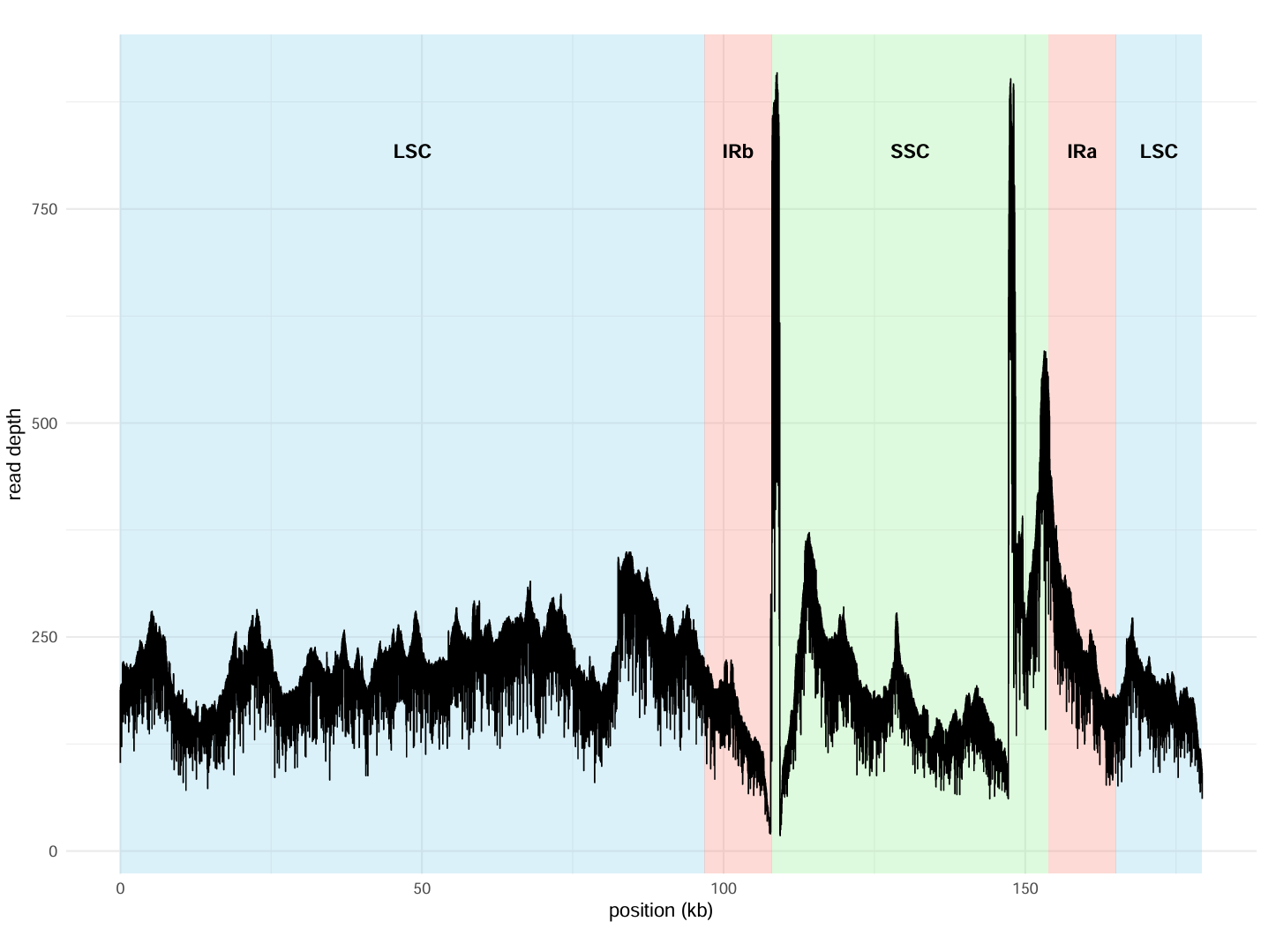
Figure S1. Depth and distribution of the chloroplast genome PacBio reads mapped against the published Thalassia testudinum sequenced.
Table S1. List of genes in the chloroplast genomes of Thalassia testudinum (Guánica, Puerto Rico), Thalassia testudinum (Florida, U.S.), Thalassia hemprichii (South China Sea) (Ch1), and Thalassia hemprichii (China) (Ch2).

GENE GROUP | THALASSIA TESTUDINUM,  GUÁNICA, P.R. | THALASSIA TESTUDINUM, FLORIDA, U.S. | THALASSIA HEMPRICHII,  CHINA (CH1) | THALASSIA HEMPRICHII,  CHINA (CH2)
PHOTOSYSTEM I | psaB, psaA, psaI, psaJ, psaC | psaJ, psaI, psaA, psaB, psaC | psaB, psaA, psaI, psaJ, psaC | psaB, psaA, psaI, psaJ, psaC
PHOTOSYSTEM II | psbA, psbK, psbI, psbM, psbD, psbC, psbZ, psbJ, psbL, psbF, psbE, psbB, psbT, psbH | psbH, psbT, psbB, psbE, psbF, psbL, psbJ, psbZ, psbC, psbD, psbM, psbI, psbK, psbA | psbA, psbK, psbI, psbM, psbD, psbC, psbZ, psbJ, psbL, psbF, psbB, psbT, psbN, psbH | psbA, psbK, psbI, psbM, psbD, psbC(2), psbZ, psbJ, psbL, psbF, psbE, psbB, psbT, psbH
SUBUNITS OF ATP SYNTHASE | atpA, atpF#, atpH, atpI, atpE, atpB | atpB, atpE, atpI, atpH, atpF#, atpA | atpA, atpF#, atpH, atpI, atpE, atpB | atpA, atpF#, atpH, atpI, atpE, atpB
SUBUNITS OF NADPH DEHYDROGENASE | ndhJ(2), ndhK, ndhC, ndhB(2)#, ndhH(4), ndhA(2), ndhI(2), ndhG, ndhE, ndhD | ndhC, ndhK, ndhJ(2), ndhB(2)#, ndhH(4), ndhA(2), ndhI(2), ndhD, ndhE, ndhG | ndhJ, ndhK#, ndhC(2), ndhB(2)#, ndhH(2), ndhA(2)#, ndhI(2), ndhE | ndhJ(2), ndhK, ndhC(2), ndhB(2)#, ndhH(2), ndhA(2), ndhI(2), ndhD, ndhE, ndhG
SUBUNITS OF THE CYTOCHROME B/F COMPLEX | petN, petA, petL, petG, petB#, petD# | petD#, petB#, petG, petL, petA, petN | petN, petA, petL, petG, petB, petD | petN, petA, petL, petG, petB#, petD(2)#
C-TYPE CYTOCHROME SYNTHESIS GENE | ccsA | ccsA | ccsA | ccsA
LARGE SUBUNIT OF RUBISCO | rbcL | rbcL | rbcL | rbcL
SMALL RIBOSOMAL UNITS | rps12(2)##, rps16#, rps2, rps14, rps4, rps18, rps11(2), rps8(2), rps3(2), rps19(2), rps7(2), rps15(2) | rps12(3)##, rps18, rps4, rps14, rps2, rps16#, rps11(2), rps8(2), rps3(2), rps19(2), rps7(2), rps15(2) | rps12#, rps16#, rps2, rps14, rps4, rps18, rps11(2), rps8(2), rps3(2), rps19(2), rps7(2), rps15(2) | rps12(2)##, rps16#, rps2, rps14, rps4, rps18, rps11(2), rps8(2), rps3(2), rps19(2), rps7(2), rps15(2)
LARGE RIBOSOMAL UNITS | rpl33, rpl20, rpl36(2), rpl14(2), rpl16(3)#, rpl22(2), rpl2#, rpl23(2), rpl32(2), rpl2, rpl2-fragment | rpl20, rpl33, rpl36(2), rpl14(2), rpl16(2)#, rpl22(2), rpl2(2)#, rpl23(2), rpl32(2) | rpl33, rpl20, rpl36(2), rpl14(2), rpl16(2), rpl22(2), rpl2(2)#, rpl23(2), rpl32(2) | rpl33, rpl20, rpl36(2), rpl14(2), rpl16(2)#, rpl22(2), rpl2(2)#, rpl23(2), rpl32(2)
RNA POLYMERASE SUBUNITS | rpoC2, rpoC1#, rpoB(2), rpoA(2) | rpoB(2), rpoC1#, rpoC2, rpoA(2) | rpoC2, rpoC1#, rpoB, rpoA(2) | rpoC2, rpoC1#, rpoB(2), rpoA(2)
RIBOSOMAL RNAS | rrn23, rrn23-fragment(3), rrn4.5(2), rrn5(2), rrn16-fragment, rrn16 | rrn16(2), rrn16-fragment(2), rrn23(2), rrn23-fragment(2), rrn4.5(2), rrn5(2) | - | rrn16(2), rrn16-fragment(2), rrn23(2), rrn23-fragment(2), rrn4.5(2), rrn5(2)
TRANSFER RNAS | tRNA-His(GTG), trnQ-UUG, tRNA-Gln(TTG), trnS-GCU, tRNA-Ser(GCT), trnR-UCU, tRNA-Arg(TCT), trnC-GCA, tRNA-Cys(GCA), trnD-GUC, tRNA-Asp(GTC), trnY-GUA, tRNA-Tyr(GTA), trnE-UUC, tRNA-Glu(TTC), trnT-GGU, tRNA-Thr(GGT), tRNA-Ser(TGA), trnS-UGA, trnG-GCC, tRNA-Gly(GCC), trnM-CAU, trnS-GGA, tRNA-Ser(GGA), trnT-UGU, tRNA-Thr(TGT), trnF-GAA, tRNA-Phe(GAA), tRNA-Met(CAT)(3), trnW-CCA, tRNA-Trp(CCA), trnP-UGG, tRNA-Pro(TGG), trnL-CAA, tRNA-Leu(CAA)(2), trnV-GAC, tRNA-Val(GAC)(2), trnI-GAU(2), trnA-UGC(2), trnR-ACG, tRNA-Arg(ACG)(2), trnN-GUU, tRNA-Asn(GTT)(2), trnL-UAG, tRNA-Leu(TAG) | trnP-UGG, tRNA-Pro(TGG), trnW-CCA, tRNA-Trp(CCA), trnM-CAU, tRNA-Met(CAT)(3), trnF-GAA, tRNA-Phe(GAA), trnT-UGU, tRNA-Thr(TGT), trnS-GGA, tRNA-Ser(GGA), trnG-GCC, tRNA-Gly(GCC), tRNA-Ser(TGA), trnS-UGA, trnT-GGU, tRNA-Thr(GGT), trnE-UUC, tRNA-Glu(TTC), trnY-GUA, tRNA-Tyr(GTA), trnD-GUC, tRNA-Asp(GTC), trnC-GCA, tRNA-Cys(GCA), trnR-UCU, tRNA-Arg(TCT), trnS-GCU, tRNA-Ser(GCT), trnQ-UUG, tRNA-Gln(TTG), tRNA-His(GTG), trnH-GUG, trnL-CAA, tRNA-Leu(CAA)(2), trnV-GAC, tRNA-Val(GAC)(2), trnI-GAU(2), trnA-UGC(2), trnR-ACG, tRNA-Arg(ACG)(2), trnN-GUU, tRNA-Asn(GTT)(2), trnL-UAG, tRNA-Leu(TAG) | tRNA-His(GTG), tRNA-Gln(TTG), tRNA-Ser(GCT), tRNA-Arg(TCT), tRNA-Cys(GCA), tRNA-Asp(GTC), tRNA-Tyr(GTA), tRNA-Glu(TTC), tRNA-Thr(GGT), tRNA-Ser(TGA), tRNA-Gly(GCC), tRNA-Ser(GGA), tRNA-Thr(TGT), tRNA-Phe(GAA), tRNA-Met(CAT)(3), tRNA-Trp(CCA), tRNA-Pro(TGG), tRNA-Leu(CAA)(2), tRNA-Val(GAC)(2), tRNA-Arg(ACG)(2), tRNA-Asn(GTT)(2), tRNA-Leu(TAG) | trnH-GUG, tRNA-His(GTG), trnH-GUG(2)#, trnK-UUU#, trnQ-UUG, tRNA-Gln(TTG), trnS-GCU, tRNA-Ser(GCT), trnR-UCU, tRNA-Arg(TCT), trnC-GCA, tRNA-Cys(GCA), trnT-GGU(2)#, trnD-GUC, tRNA-Asp(GTC), trnY-GUA, tRNA-Tyr(GTA), trnE-UUC(3)#, trnE-UUC, tRNA-Glu(TTC), trnT-GGU, tRNA-Thr(GGT), tRNA-Ser(TGA), trnS-UGA, trnG-GCC, tRNA-Gly(GCC), trnM-CAU(4), trnS-GGA, tRNA-Ser(GGA), trnT-UGU, tRNA-Thr(TGT), trnL-UAA#, trnF-GAA, tRNA-Phe(GAA), trnTERM-UUA#, trnM-CAU, tRNA-Met(CAT)(3), trnW-CCA, tRNA-Trp(CCA), trnP-UGG, tRNA-Pro(TGG), trnL-CAA(2), trnL-CAA, tRNA-Leu(CAA)(2), trnV-GAC, tRNA-Val(GAC)(2), trnI-GAU(2), trnA-UGC(4)#, trnR-ACG(2), trnR-ACG, tRNA-Arg(ACG)(2), trnN-GUU(2), trnN-GUU, tRNA-Asn(GTT)(2), trnL-UAG, tRNA-Leu(TAG)
ENVELOPE MEMBRANE PROTEIN | cemA | cemA | cemA | cemA
PROTEASE | clpP1 | clpP1 | clpP | clpP1
MATURASE | matK | matK | matK | matK
CONSERVED OPEN READING FRAMES | ycf2(2), ycf1(2) | ycf2(2), ycf1(2) | ycf3##, ycf4, ycf2(2), ycf1(2) | ycf2, ycf1(4), ycf2-fragment
SUBUNIT OF ACETYL-COA-CARBOXYLASE | accD# | accD# | accD# | accD#
TRANSLATION INITIATION FACTOR | infA-fragment(2), infA(2) | infA-fragment(2), infA(2) | infA(2) | infA-fragment(2), infA(2)
ORFS | orf105, orf132, orf162, orf128, orf104, orf123, orf124(2), orf124-fragment(2), orf119(2), orf116(2), orf80(2), orf110(2), orf109(2), orf101(2), orf147-fragment, orf468(2), orf127(2), orf147 | orf123, orf104, orf128, orf162, orf132, orf106, orf105, orf124(2), orf124-fragment(2), orf119(2), orf116(2), orf80(2), orf110(2), orf109(2), orf101(2), orf147(2), orf468(2), orf127(2) | orf105, orf106, orf132, orf162, orf128, orf104, orf123, orf108, orf124(2), orf119(2), orf116(2), orf110(2), orf109(2), orf101(2), orf147(2), orf468(2), orf127(2), orf80 | orf105, orf106, orf132, orf162, orf128, orf104, orf123, orf124(2), orf124-fragment(2), orf119(2), orf116(2), orf80(2), orf110(2), orf109(2), orf101(2), orf147(2), orf468(2), orf127(2)
OTHERS | pafI##, pafII, pbf1, 23S-rRNA, 23S-rRNA-fragment(2), 5S-rRNA(2), 16S-rRNA | pbf1, pafII, pafI##, 16S-rRNA(2), 23S-rRNA(2), 5S-rRNA(2) | 16S-rRNA(2), 23S-rRNA(2), 4.5S-rRNA(2), 5S-rRNA(2) | pafI##, pafII, pbf1, 16S-rRNA(2), 23S-rRNA(2), 5S-rRNA(2)
# - Number of intron-containing genes

