Supplementary material 1

Fig. 1. Gross and microscopic lesions of group C pigs. (a) Cyanosis on the tip of ears. (b) Cyanosis on the tip of the legs. (c) Multiple ulcerations on the tonsils. (d) Kidney ecchymosis. (e) Ileocecal valve hemorrhage and ulceration. (f) Mesenteric lymph nodes hemorrhage and enlargement. (g) Disseminated intravascular coagulation (DIC) on the skin of the ear. (h) Tonsil ulceration and lymphoid depletion. (i) Non-purulent encephalitis, cuffing and gliosis, cerebrum. (j) Non-purulent nephritis, DIC and mononuclear inflammatory cell infiltration. (k) Spleen focal necrosis. (l) Lymph node, lymphoid depletion, and hemorrhage.
(a) | (b) | (c)
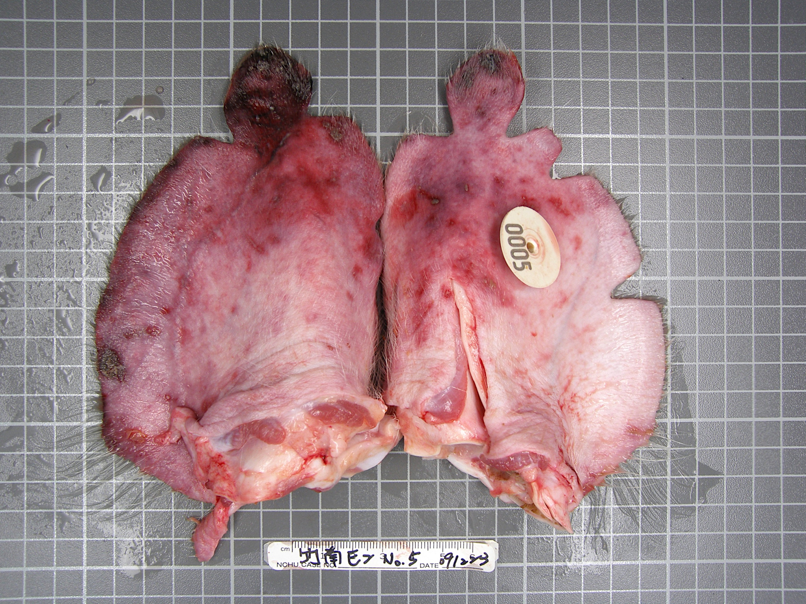 | 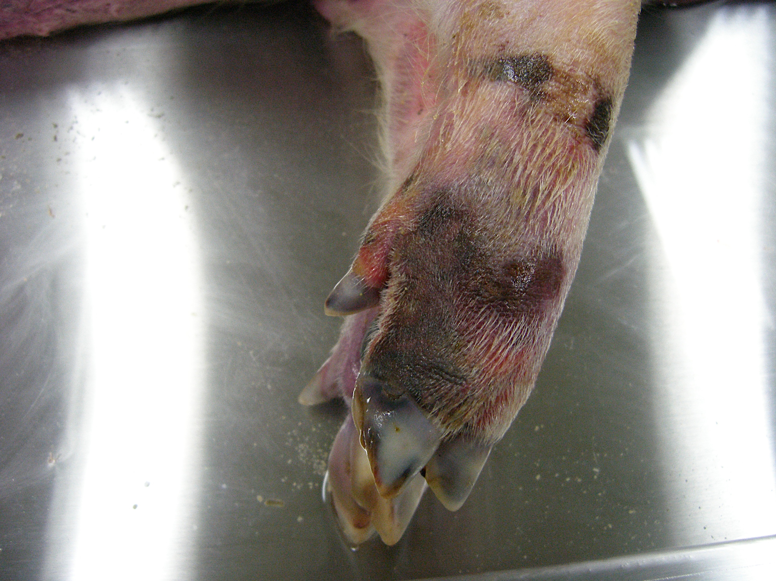 | 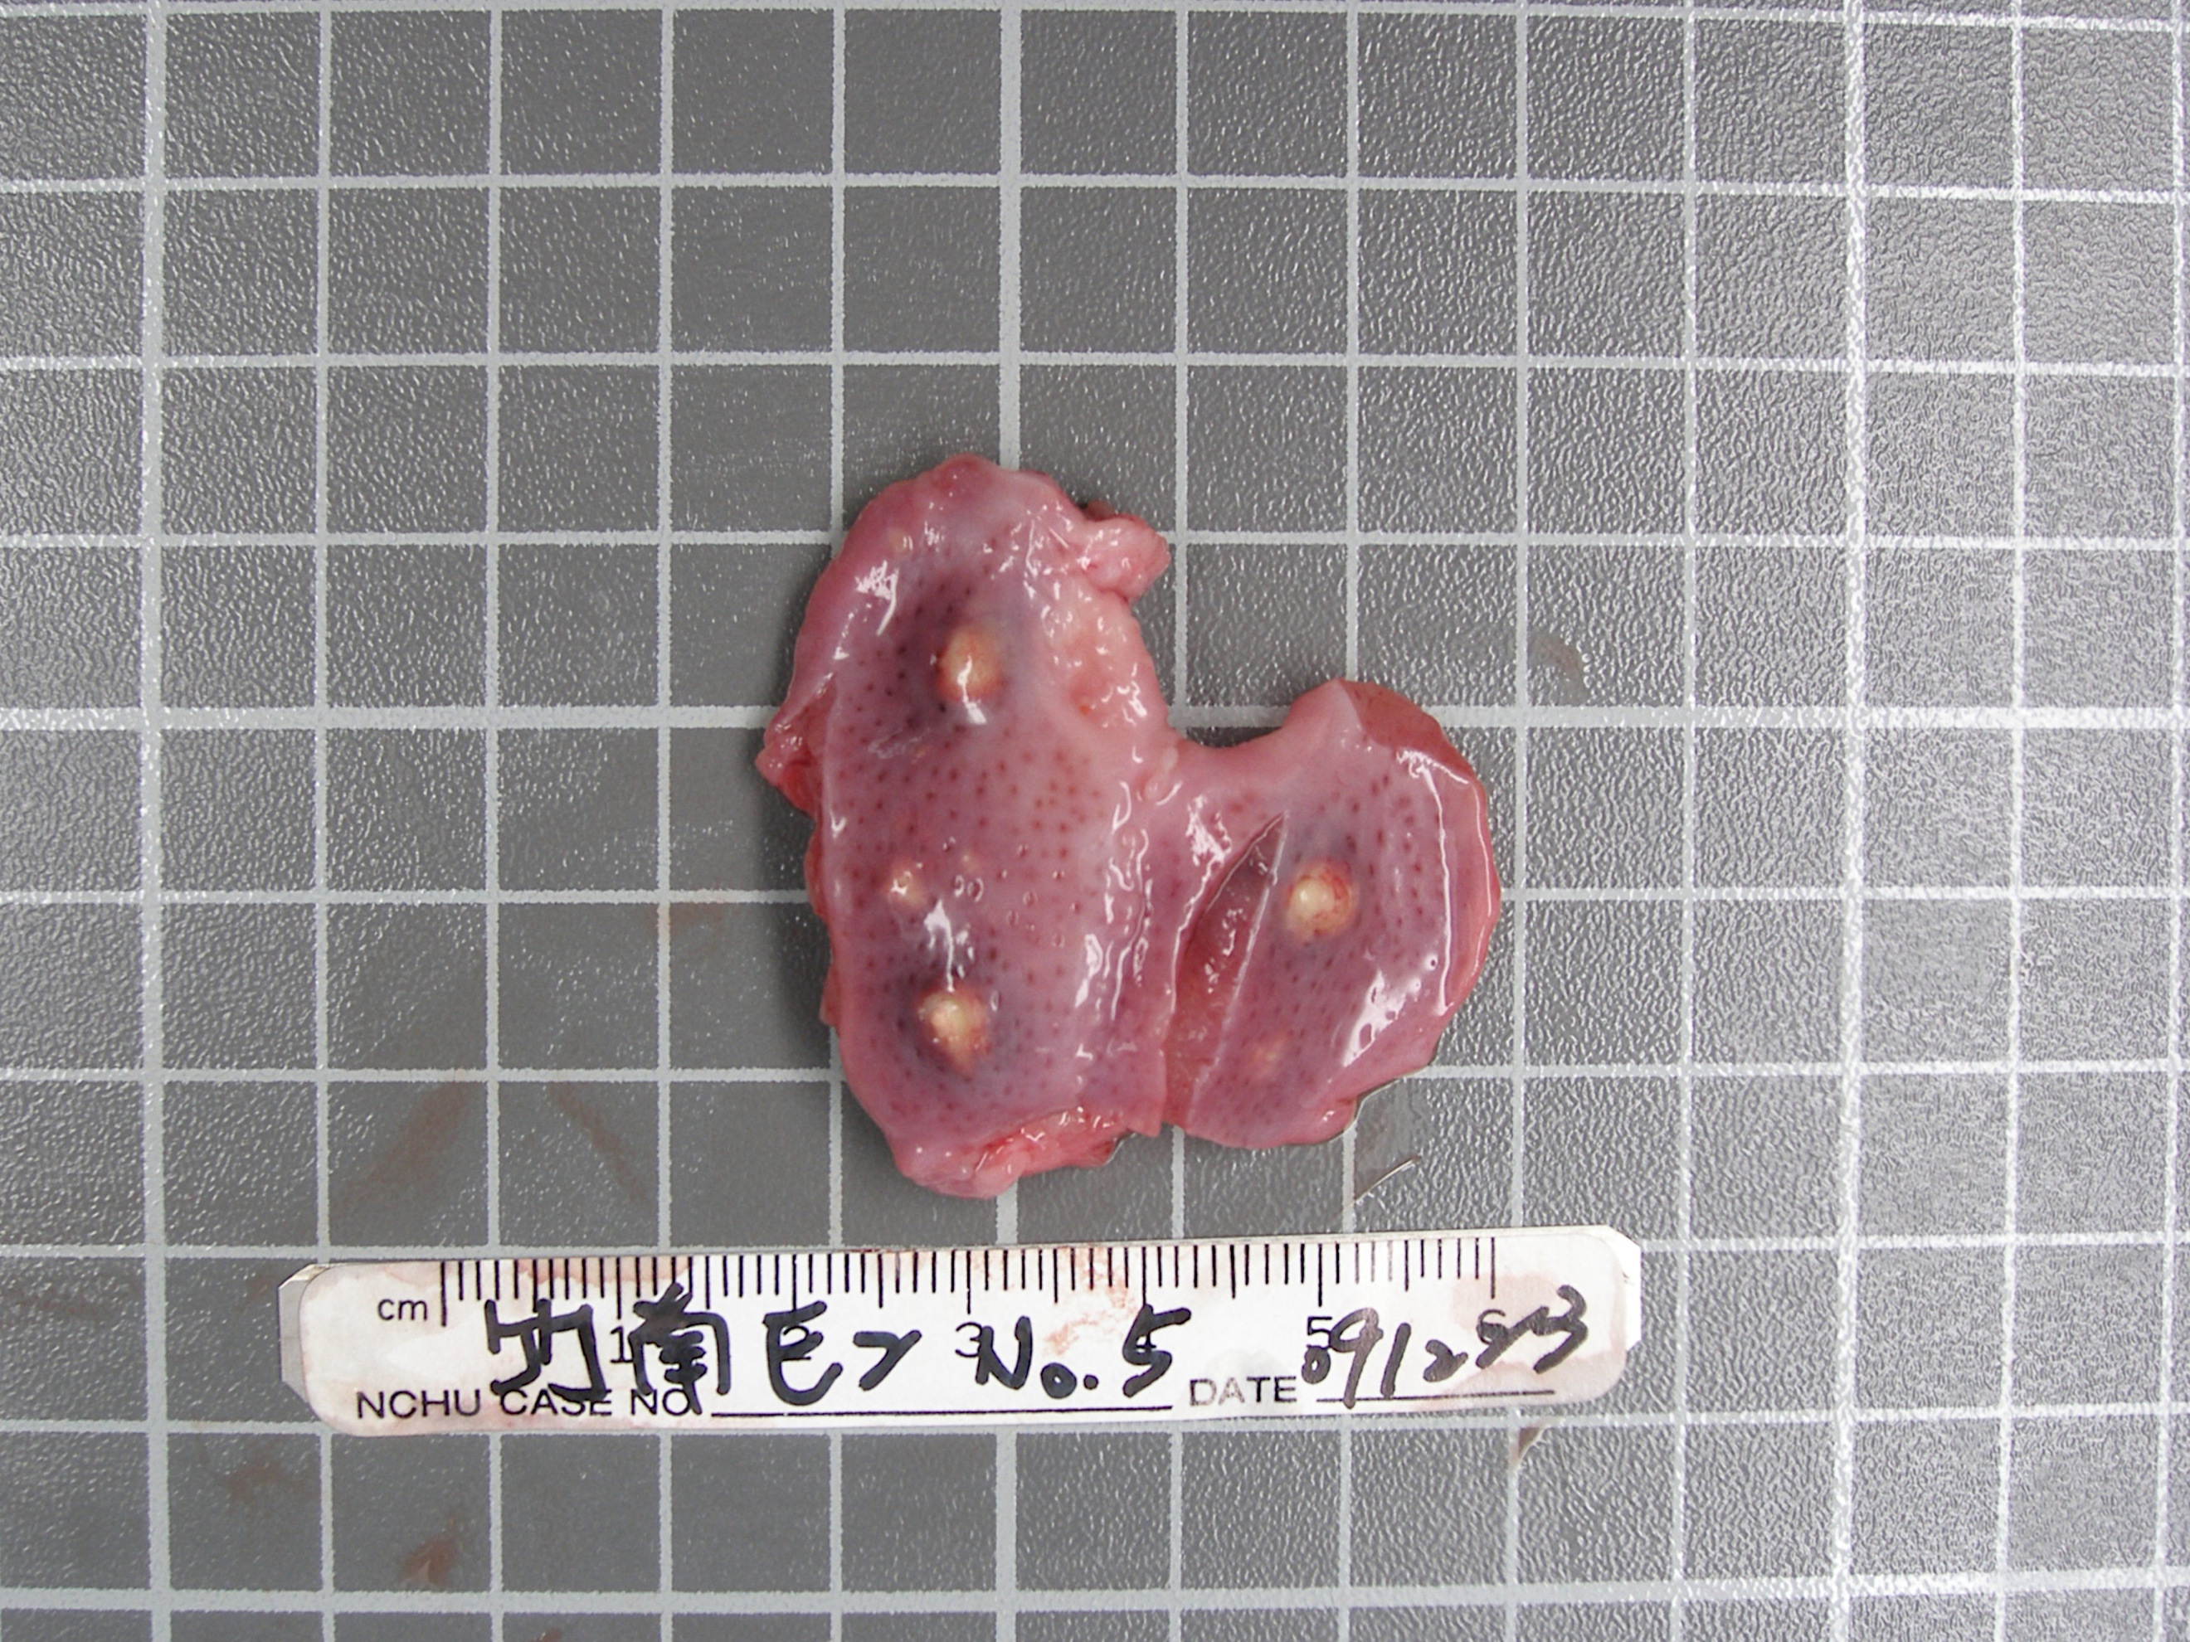
(d) | (e) | (f)
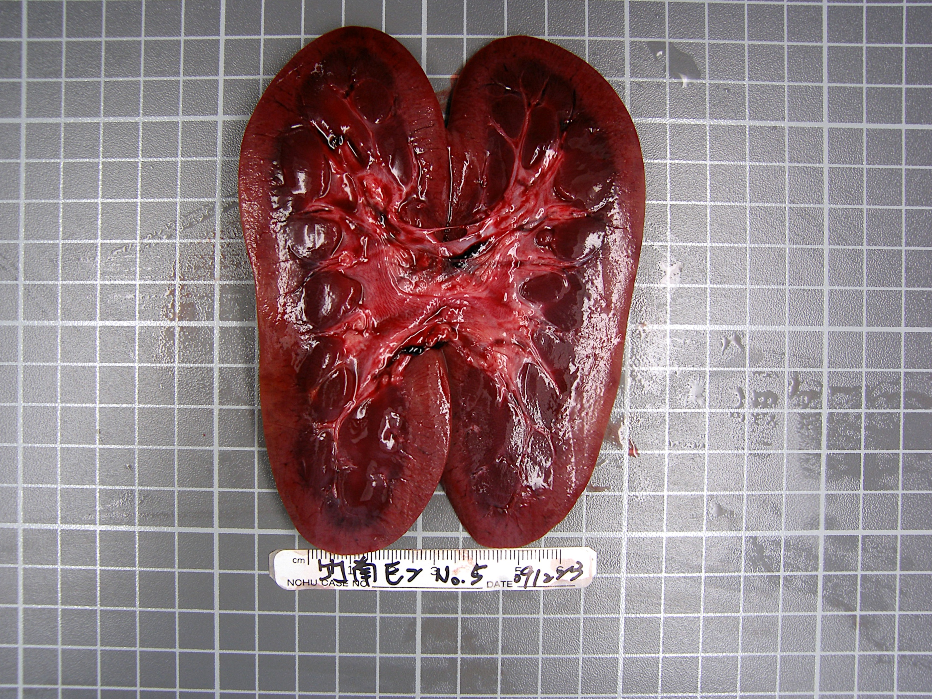 | 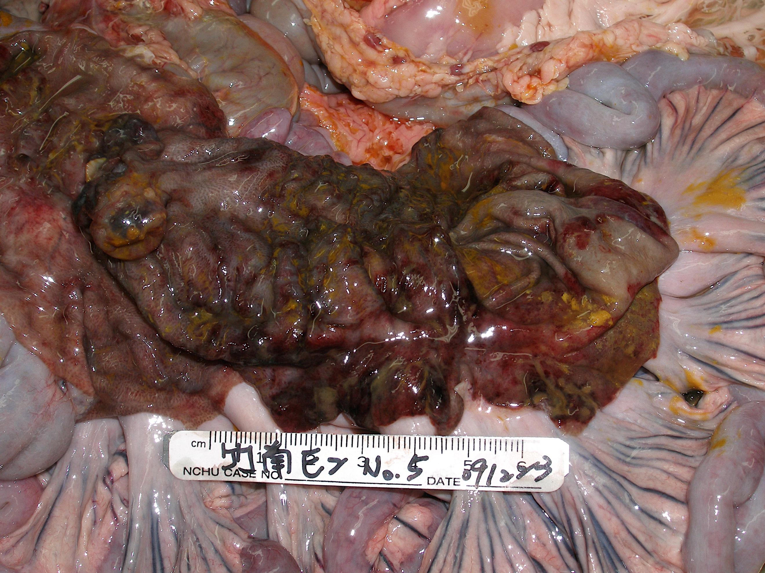 | 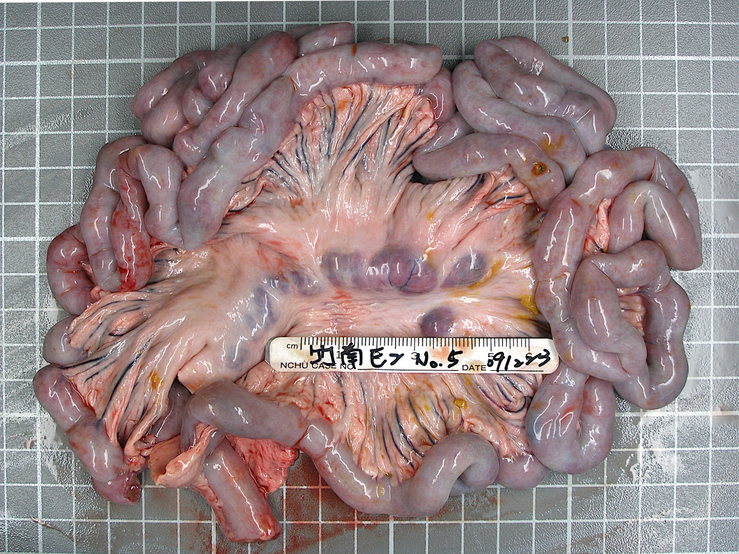
(g) | (h) | (i)
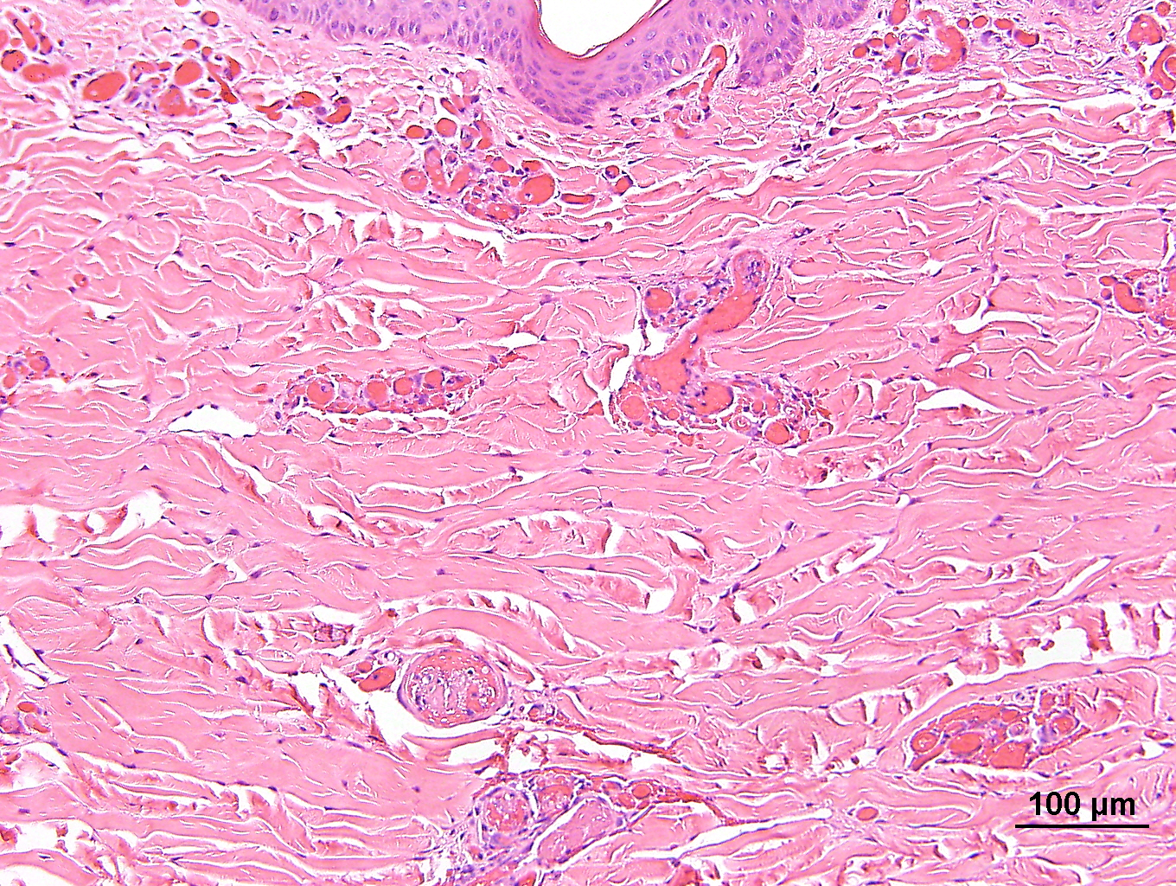 | 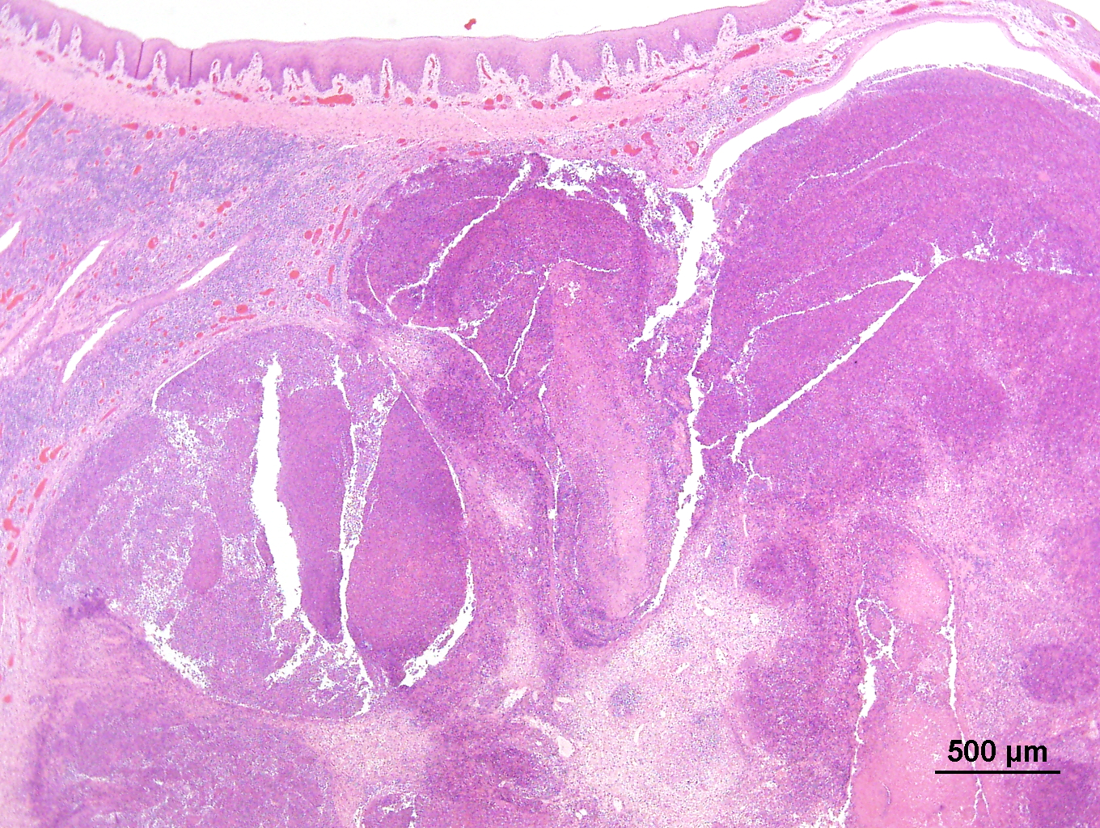 | 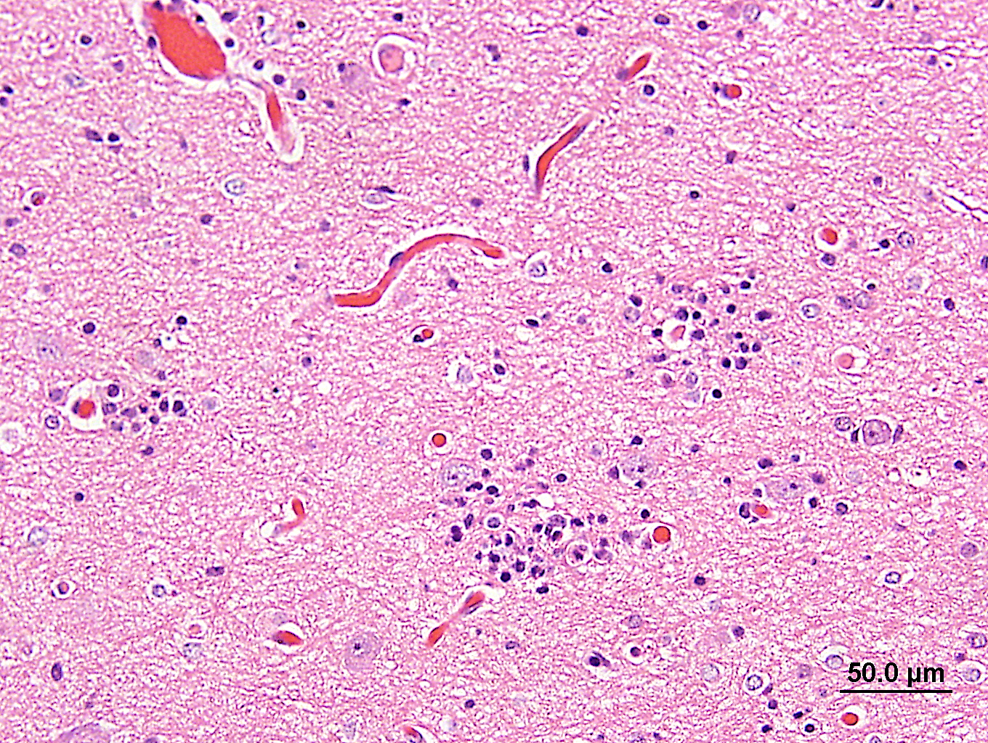
(j) | (k) | (l)
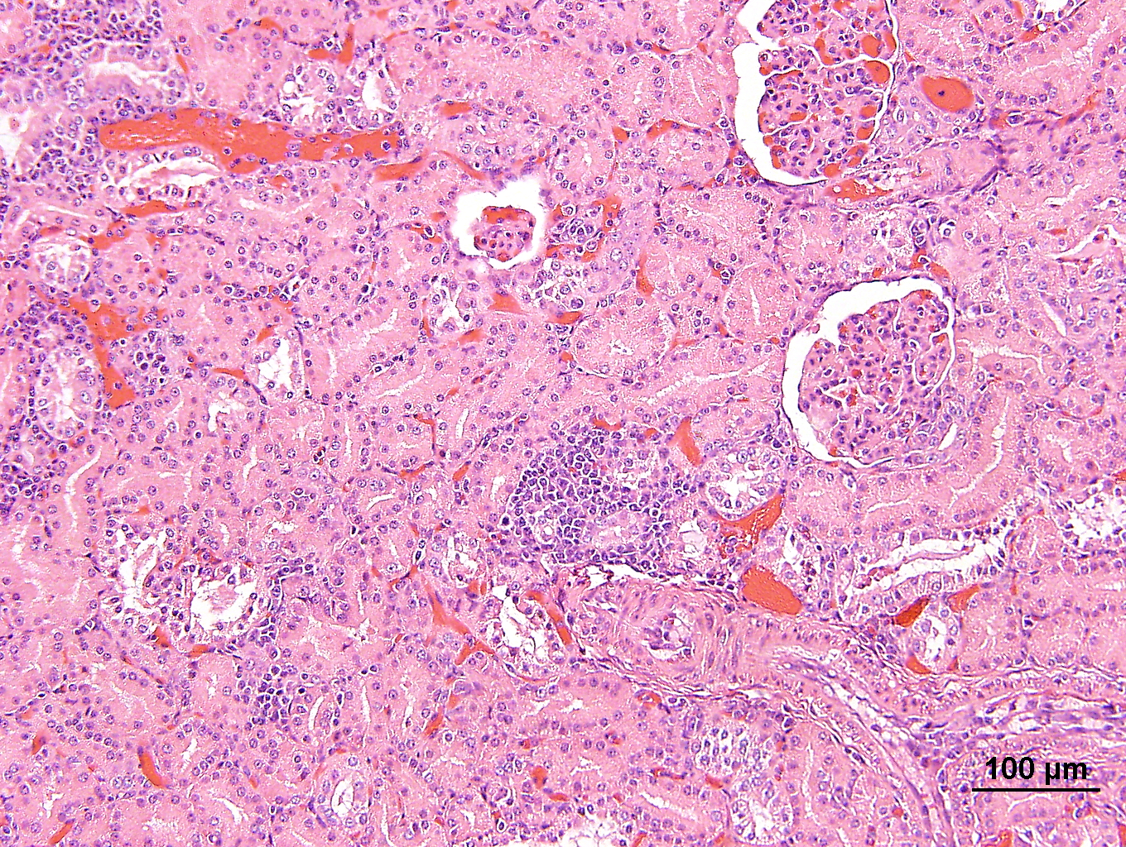 | 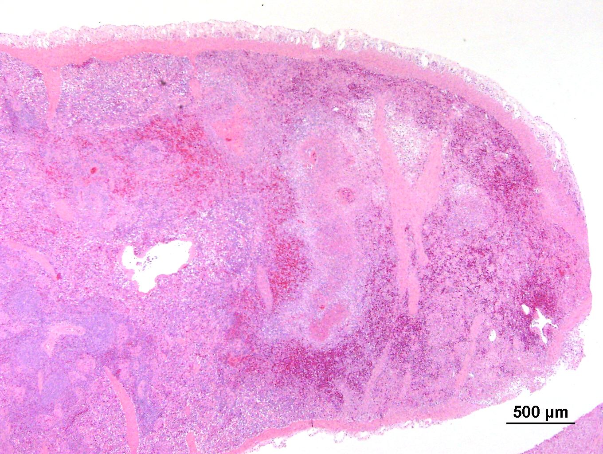 | 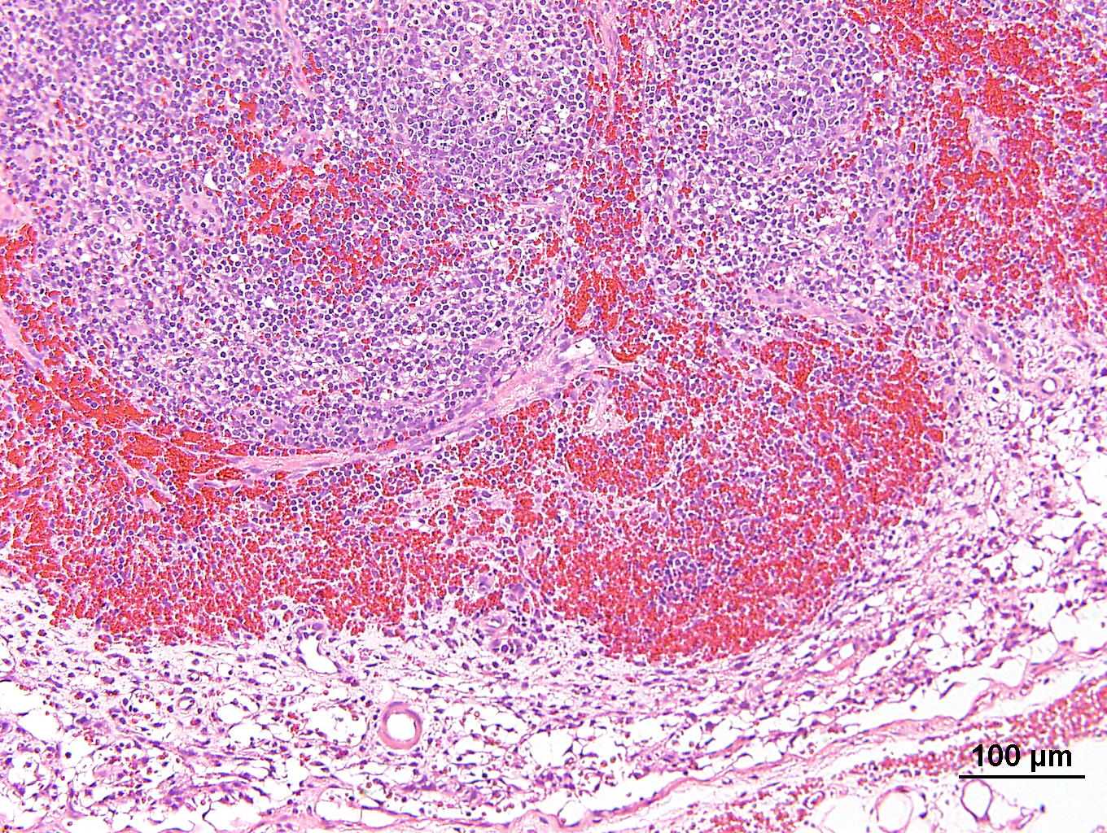

Fig. 2. Detecting of CSFV infection in tissues. The CSFV antigen was detected using immunohistochemical staining with WH303 monoclonal antibody (PA0826, Veterinary Laboratories Agency, Weybridge, UK) (1:1000). The cells that were positive for viral antigen appear dark-brown. (a) Non-purulent encephalitis, Cerebrum. (b) Interstitial pneumonia with DIC, Lung. (c) Hepatitis, mononuclear inflammatory cells infiltration at portal triad, Liver. (d) Lymph node with lymphoid depletion.
(a) | 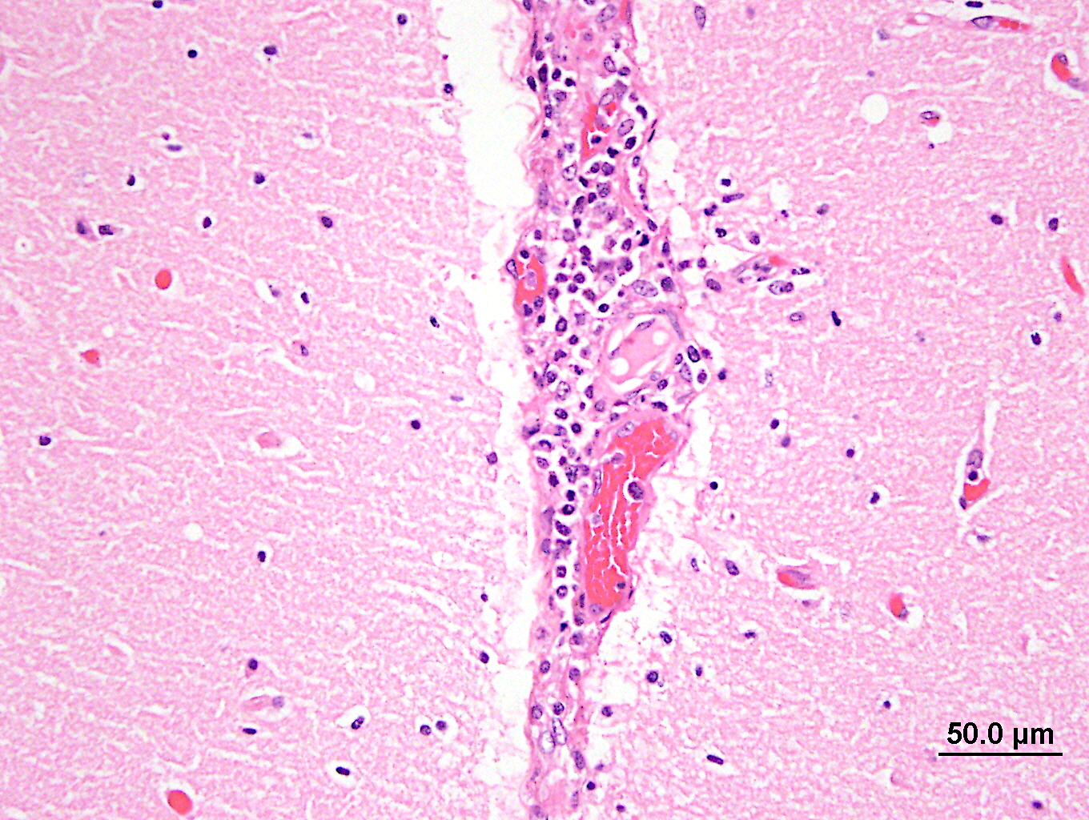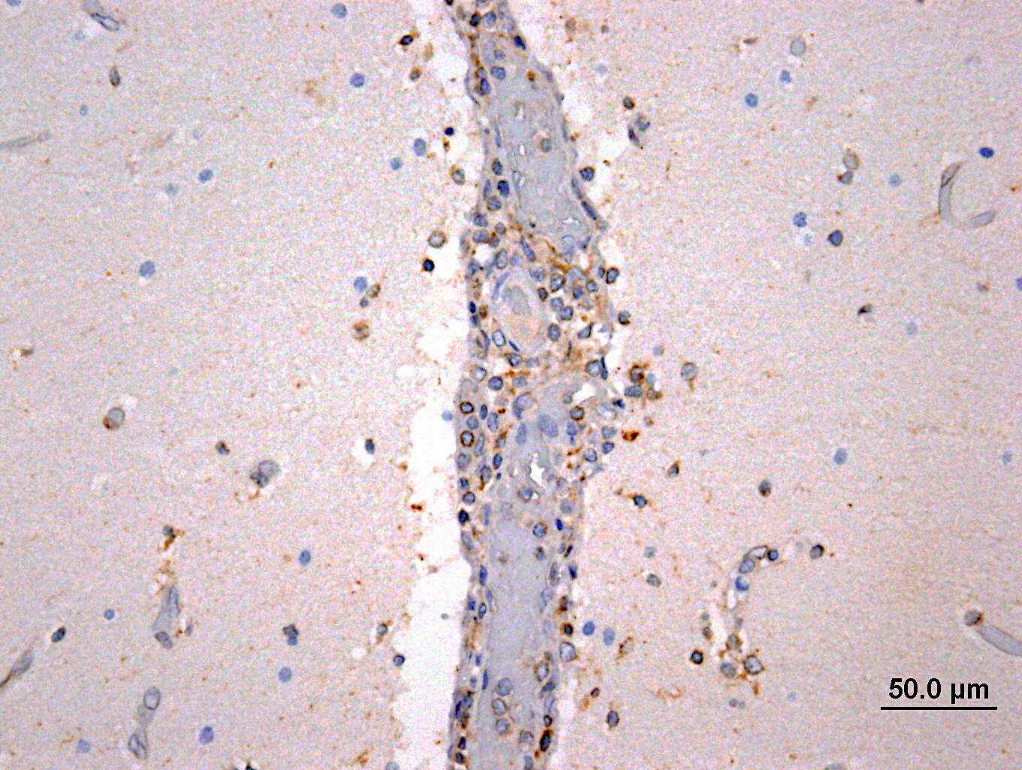 | (b) | 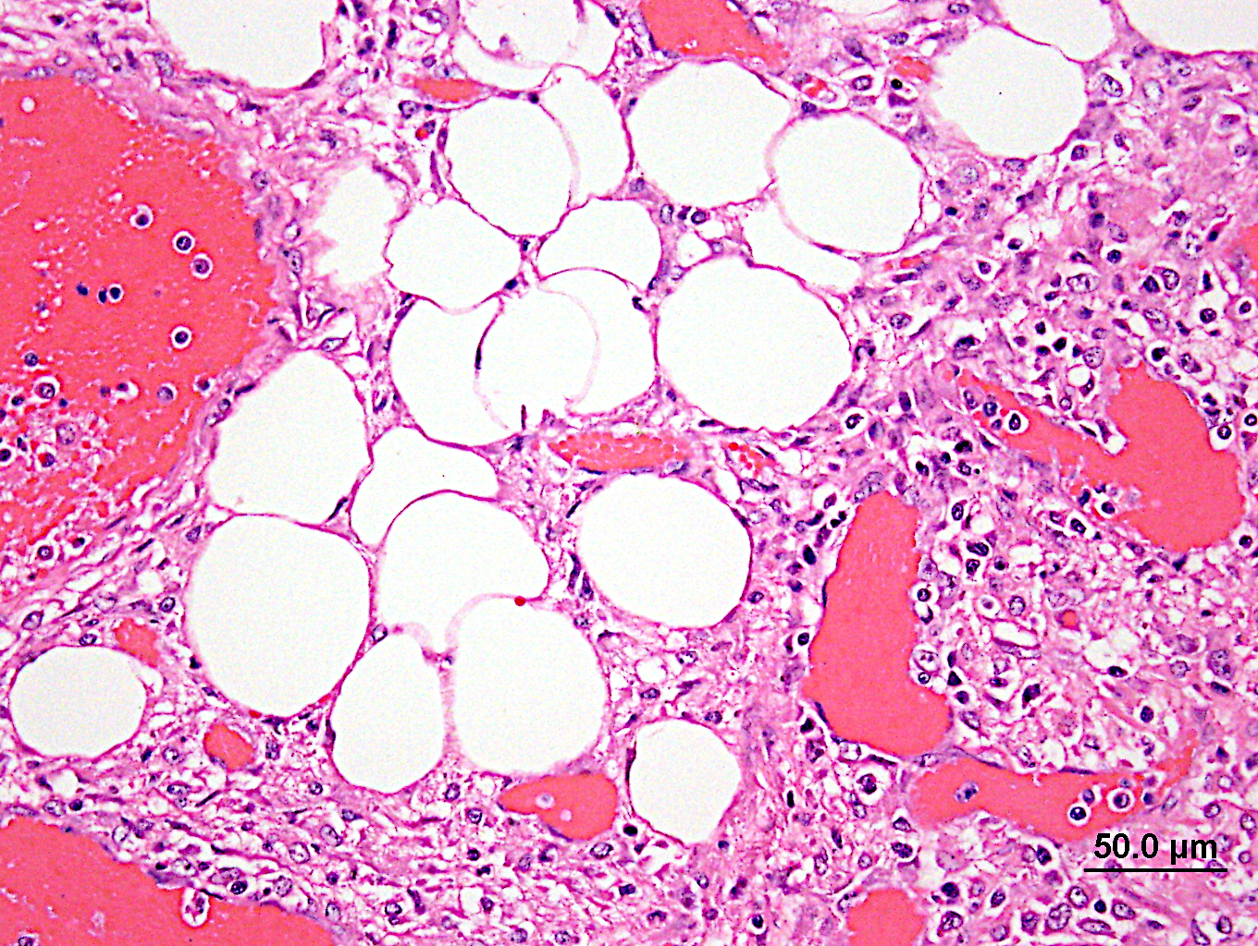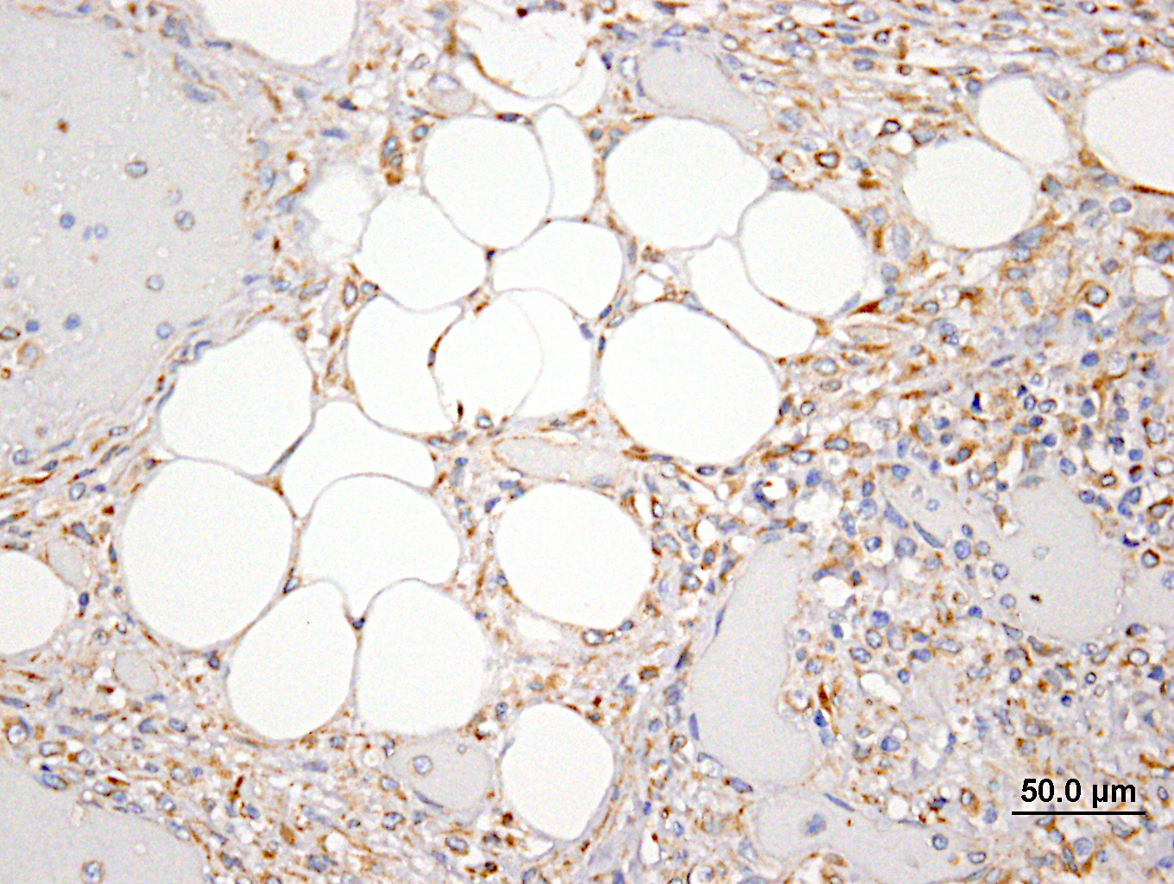
(c) | 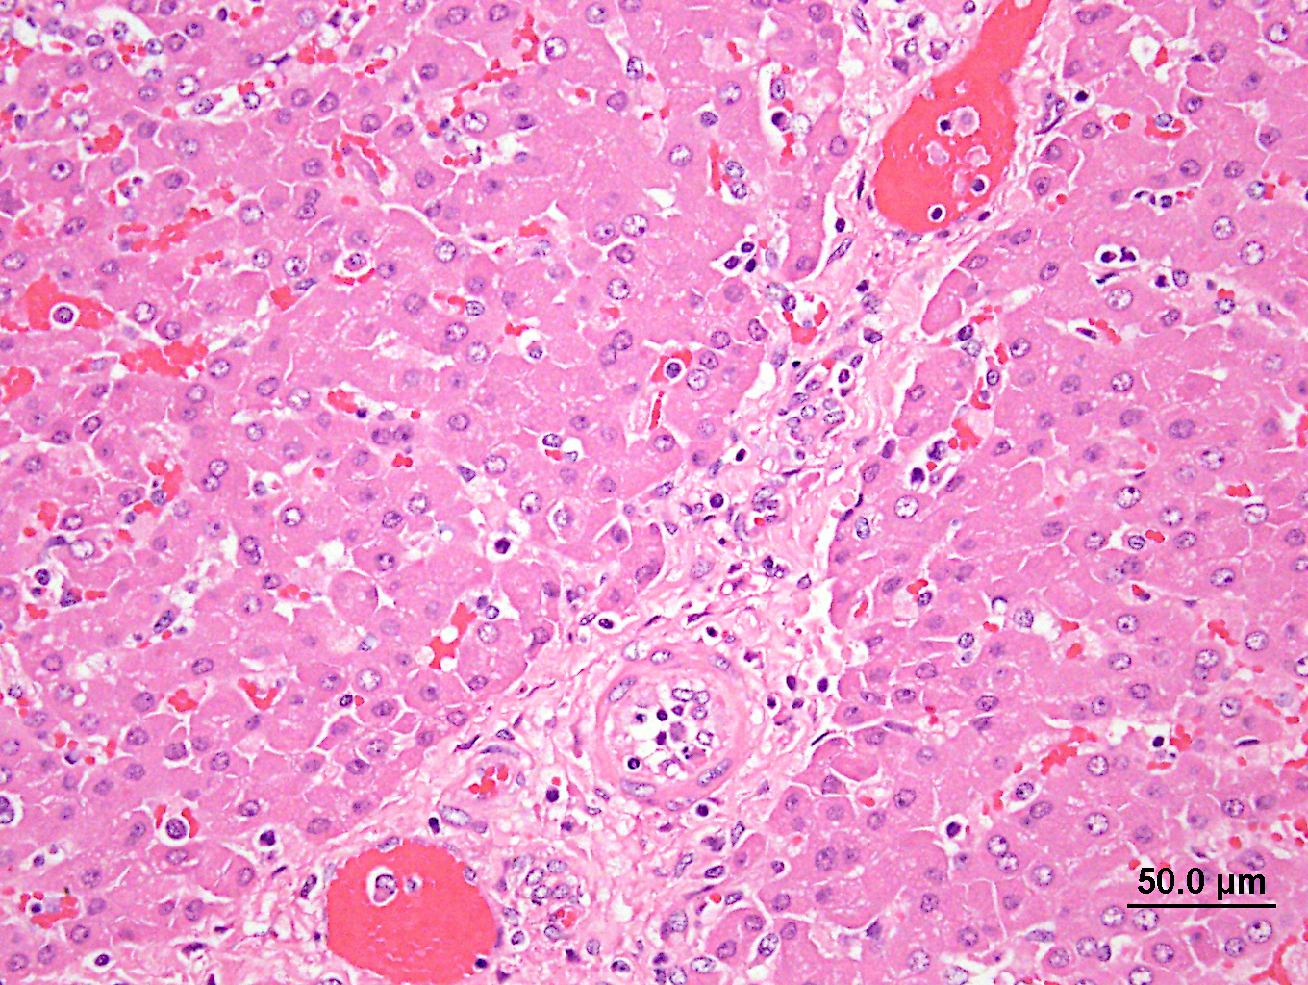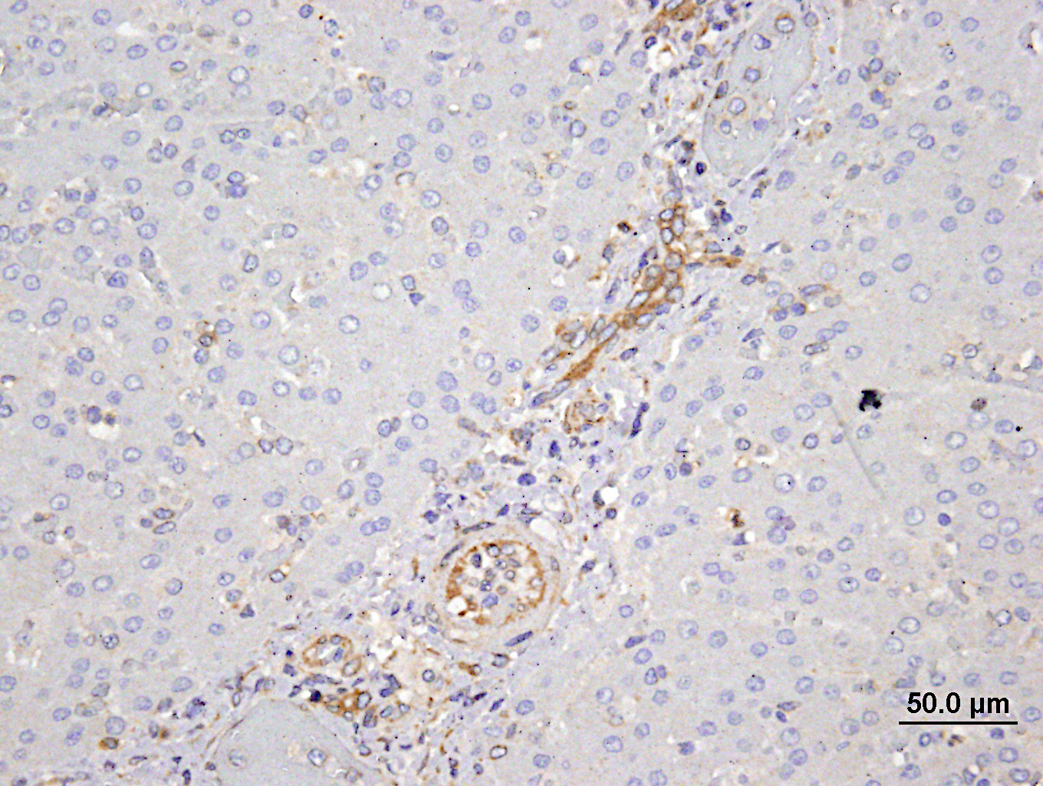 | (d) | 