Additional file 1: Supplementary materials

Supplementary Table 1 DeLong test results for AUC comparisons among the three models
Model comparison | AUC 1 | AUC 2 | Z value | P value
Combined model vs Clinicopathological model | 0.910 | 0.880 | 2.270 | 0.023
Combined model vs Imaging-report model | 0.910 | 0.703 | 5.141 | <0.001
Clinicopathological model vs Imaging-report model | 0.880 | 0.703 | 3.624 | <0.001
Abbreviations: AUC, area under the curve; pCR, pathological complete response; MRI, magnetic resonance imaging.

Supplementary Figure 1 Overall Hallmark GSEA ridgeplot of pCR versus non-pCR in GSE194040
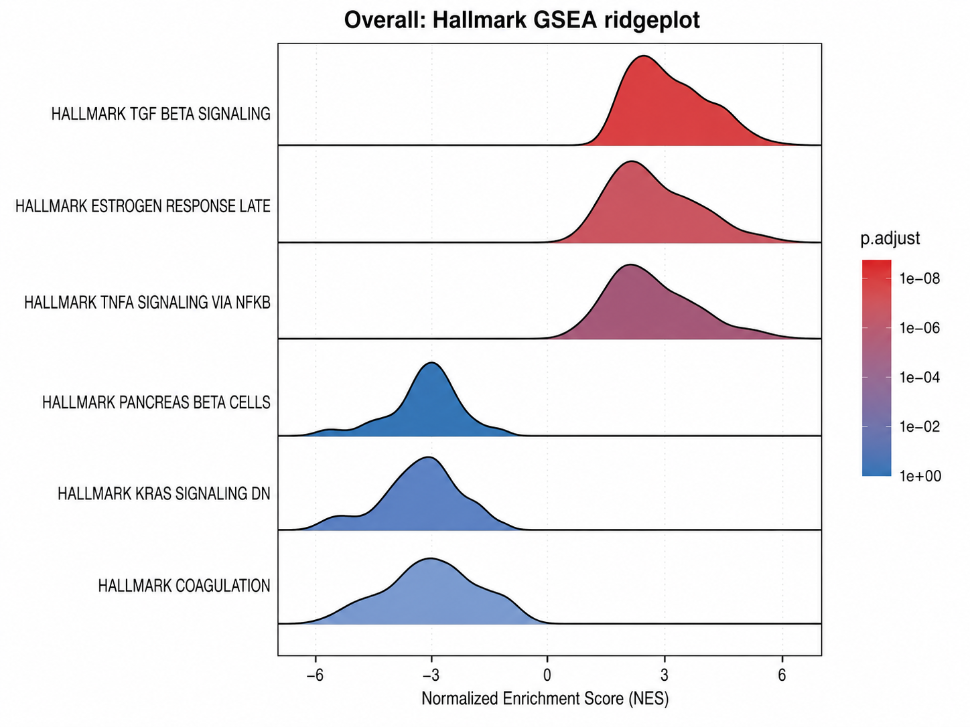
Each ridgeline represents the distribution of a significantly enriched Hallmark pathway between the pCR and non-pCR groups. Color indicates the adjusted P value (p.adjust), and the x-axis represents the normalized enrichment score (NES). pCR, pathological complete response; GSEA, gene set enrichment analysis; NES, normalized enrichment score.

Supplementary Figure 2 Subgroup Hallmark GSEA ridgeplots of pCR versus non-pCR in GSE194040
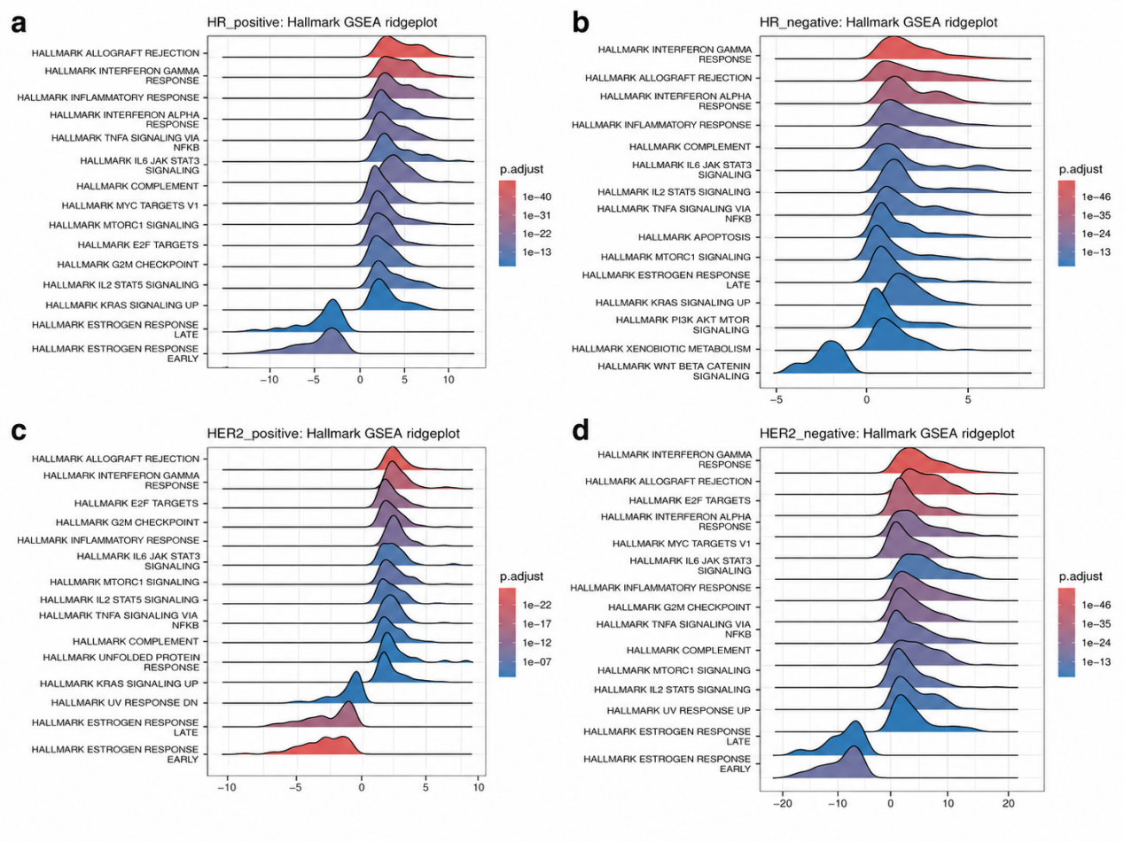
a HR-positive subgroup; b HR-negative subgroup; c HER2-positive subgroup; d HER2-negative subgroup. Ridgeplots show the distribution of ranked genes in enriched Hallmark pathways within each subgroup. The color gradient represents the adjusted P value. pCR, pathological complete response; GSEA, gene set enrichment analysis; HR, hormone receptor; HER2, human epidermal growth factor receptor 2.

