SUPPLEMENTAL MATERIAL

Supplemental Methods
ESR Measurements
Erythrocyte sedimentation rate was measured using the Westergren method[1]. Anticoagulated whole blood was drawn into a standardized Westergren tube and kept in a vertical position for 1 hour. ESR was defined as the distance from the upper level of the plasma column to the upper level of the sedimented erythrocytes and was expressed in mm/h.
Coronary CTA
Before the examination, contraindications were assessed and heart rate was controlled. Electrocardiographically gated acquisition was performed with scan coverage of the entire heart. Scanning was generally triggered using automatic bolus tracking, with prospective electrocardiographic gating at 75% of the R-R interval. Images were reconstructed with thin slices, and iterative reconstruction was applied when necessary. Image acquisition followed the Journal of Cardiovascular Computed Tomography scanning guidelines[2].
The original CCTA data were transferred to a dedicated postprocessing workstation for coronary analysis using commercially available software, syngo.via, developed by Siemens Healthineers, system version VA50, released in July 2025. The syngo.via CT Coronary Vessel Evaluation workflow was used for semiautomated coronary tree extraction and centerline tracking, followed by segment-by-segment assessment on curved multiplanar reformations. All imaging analyses were performed independently by 2 board-certified radiologists with more than 5 years of experience in cardiovascular imaging. The readers were blinded to laboratory results and clinical outcomes. Discrepancies were resolved by joint review to reach a consensus.
Assessment of FAI on CCTA
Perivascular fat attenuation index (FAI) was measured on postprocessed CCTA images according to the method originally described by Antonopoulos et al[3]. and subsequently adopted in the CRISP-CT study[4]. The analyzed segments included the proximal right coronary artery from 10 to 50 mm and the proximal left anterior descending and left circumflex arteries from 0 to 40 mm. Using the outer vessel wall as the boundary, adipose tissue voxels were sampled within a radial distance from the vessel wall equal to the local vessel diameter. Fat voxels were defined by a CT attenuation range of −190 to −30 HU, and the weighted mean attenuation within the sampled volume was calculated as the FAI for each vessel segment. To minimize contamination from non-adipose structures, regions adjacent to large side branches, coronary veins, or other surrounding tissues likely to affect attenuation measurements were avoided during sampling. Areas with marked calcium blooming, motion artifacts, or poorly defined vessel boundaries were likewise not used for measurement.
Plaque characteristics on CCTA
Quantitative plaque features and high-risk plaque characteristics were assessed according to contemporary coronary CTA consensus recommendations[5]. Minimum lumen area (MLA) was obtained by identifying the cross-sectional image with the smallest luminal area within the target lesion on curved multiplanar reformations and measuring the lumen area on that slice; Plaque burden (PB) was defined as 100%× (plaque volume/vessel volume); The eccentricity index (EI) was calculated as (maximum plaque thickness − minimum plaque thickness) / maximum plaque thickness. Positive remodeling (RI) was defined as the ratio of lesion diameter and reference diameter≥1.1; Low-attenuation plaque was defined as plaque density (a region of interest was placed on at least 5 randomly selected points within each plaque and the lowest density was defined as the plaque density) ≤30 Hounsfield units [HU].

References:
1. Kratz, A., et al., ICSH recommendations for modified and alternate methods measuring the erythrocyte sedimentation rate. International Journal of Laboratory Hematology, 2017. 39(5): p. 448–457.
2. Abbara, S., et al., SCCT guidelines for the performance and acquisition of coronary computed tomographic angiography: A report of the Society of Cardiovascular Computed Tomography Guidelines Committee: Endorsed by the North American Society for Cardiovascular Imaging (NASCI). Journal of Cardiovascular Computed Tomography, 2016. 10(6): p. 435–449.
3. Antonopoulos, A.S., et al., Detecting human coronary inflammation by imaging perivascular fat. Sci Transl Med, 2017. 9(398).
4. Oikonomou, E.K., et al., Non-invasive detection of coronary inflammation using computed tomography and prediction of residual cardiovascular risk (the CRISP CT study): a post-hoc analysis of prospective outcome data. The Lancet, 2018. 392(10151): p. 929–939.
5. Nieman, K., et al., Standards for quantitative assessments by coronary computed tomography angiography (CCTA): An expert consensus document of the society of cardiovascular computed tomography (SCCT). Journal of Cardiovascular Computed Tomography, 2024. 18(5): p. 429–443.

Supplemental Figures, Figure Legends and Tables
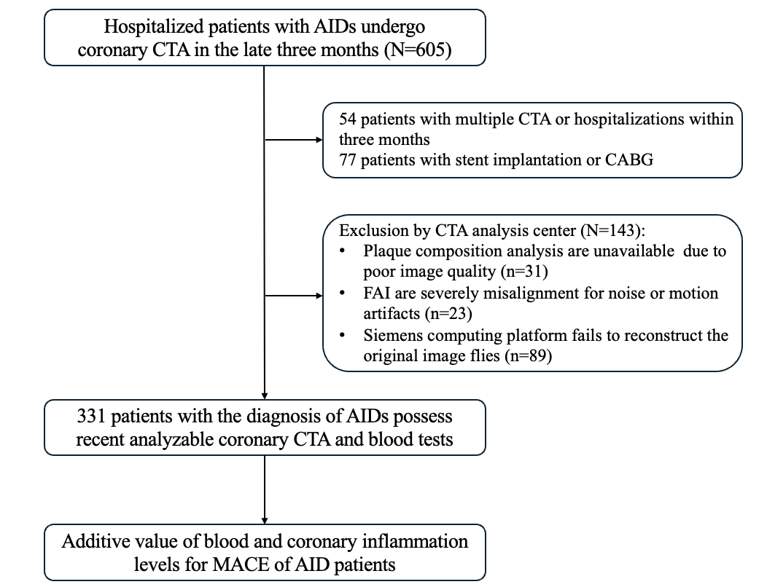

Figure S1. Study Flowchart. Among the 331 patients with AIDs included in the final analysis, the most common disease category was vasculitis (n = 119), including Takayasu arteritis (n = 82) and ANCA-associated vasculitis (n = 11). Other disease categories included systemic lupus erythematosus (n = 56), Sjögren’s syndrome (n = 35), inflammatory arthritis (n = 34; mainly ankylosing spondylitis, n = 23), Behçet’s disease (n = 20), myositis (n = 16), inflammatory bowel disease (n = 12; including ulcerative colitis and Crohn’s disease), and undifferentiated connective tissue disease (n = 12). The remaining 27 cases were classified as other AIDs, each with fewer than 5 cases. The diagnosis of AIDs was established according to the currently accepted clinical guidelines for each disease.
Abbreviations: AIDs=Autoimmune Diseases; CTA=Computed Tomographic Angiography; CABG= Coronary Artery Bypass Grafting; FAI=Fat Attenuation Index; MACE= Major Adverse Cardiovascular Events;

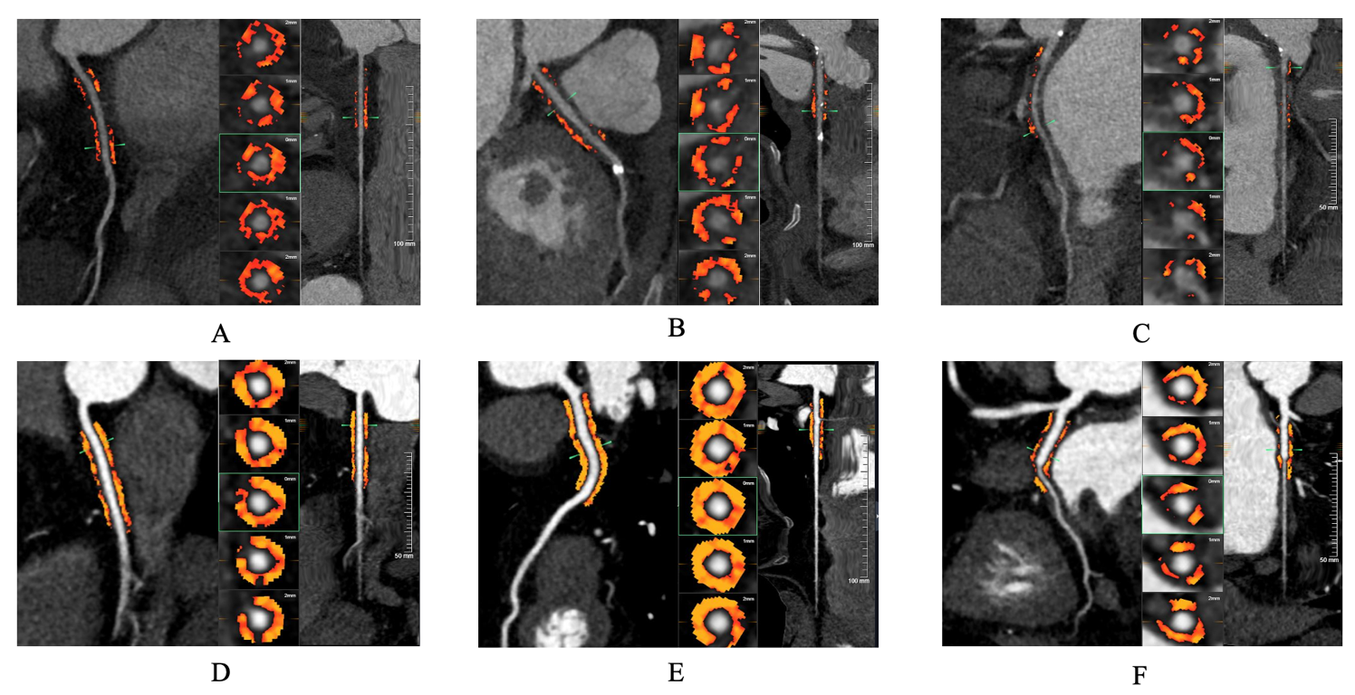

Figure S2 Representative cases. Panels A–C show a representative case with a high inflammatory burden. This 64-year-old woman had an elevated ESR (38 mm/h) and high FAI values in all three coronary arteries (A: RCA-FAI = −53.14 HU; B: LAD-FAI = −58.16 HU; C: LCX-FAI = −56.42 HU). She developed myocardial infarction at 37 months after treatment. Panels D–F show a 66-year-old woman with a normal ESR (6 mm/h) and FAI values within the normal range in all three coronary arteries (D: RCA-FAI = −90.50 HU; E: LAD-FAI = −101.17 HU; F: LCX-FAI = −92.92 HU). No cardiovascular event occurred during follow-up.

Table S1 Associations of ESR and RCA-FAI with relative plaque morphology indicators
Plaque morphology (n=229) | ESR |  |  | RCA-FAI
Plaque morphology (n=229) | Pearson r | p value | q value (FDR-BH) | Pearson r | p value | q value (FDR-BH)
PB (%) | 0.032 | 0.628 | 0.837 | 0.149 | 0.023 | 0.058
CPV (%) | -0.076 | 0.252 | 0.504 | -0.136 | 0.040 | 0.058
LPV (%) | -0.039 | 0.559 | 0.837 | -0.006 | 0.925 | 0.924
RI (%) | 0.011 | 0.873 | 0.925 | 0.133 | 0.044 | 0.058
Pearson correlation analysis was performed to assess the associations of ESR and RCA-FAI with relative plaque morphology indicators, with effect sizes expressed as Pearson’s correlation coefficients (r). False discovery rate correction was applied using the Benjamini–Hochberg (FDR-BH) procedure, and adjusted q values are presented.
Abbreviations: PB, plaque burden; CPV, calcified plaque volume; LPV, lipid-rich plaque volume; RI, remodeling index; ESR, erythrocyte sedimentation rate; FAI, fat attenuation index; RCA, right coronary artery.

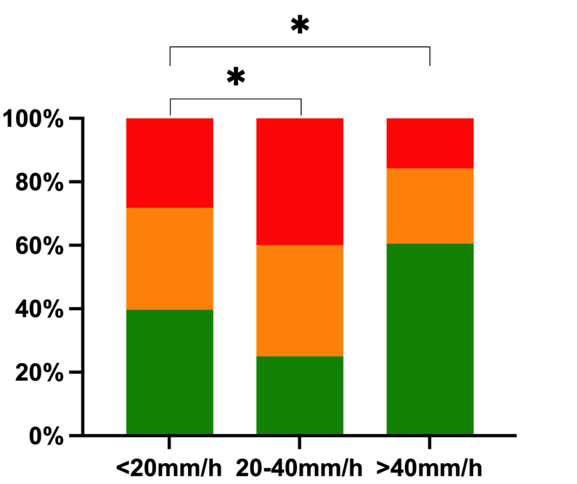

2 HRPCs
≥3 HRPCs
≤1 HRPC

Figure S3 Association between ESR and HRA. Stacked bar chart showing the proportion of patients with ≤1, 2, and ≥3 HRPCs across ESR categories (<20 mm/h, 20-40 mm/h, and >40 mm/h).
Abbreviations: ESR, erythrocyte sedimentation rate; HRPC, high-risk plaque characteristics. * indicates p < 0.05 based on chi-square tests for 3×3 contingency tables.
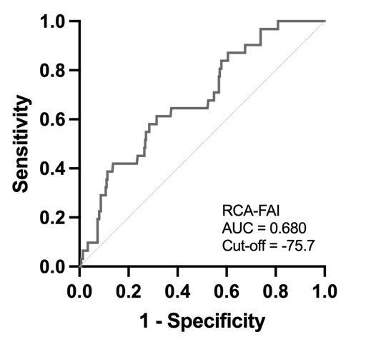
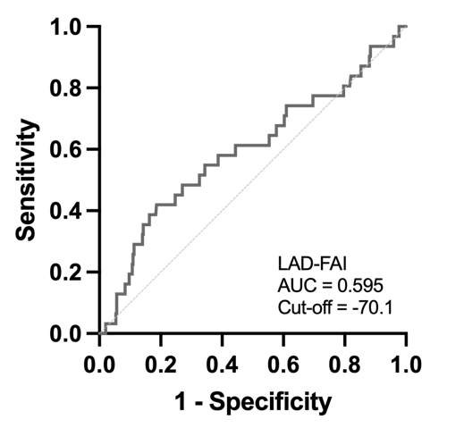
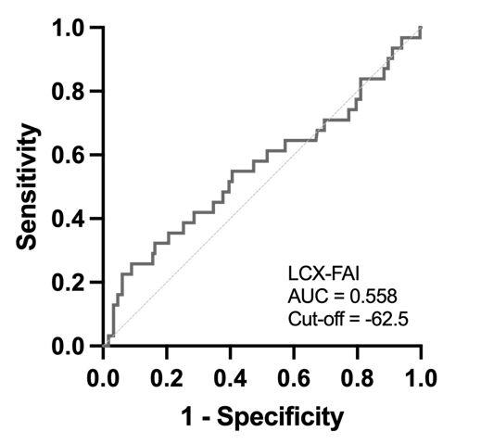
A
C
B

Figure S4 Receiver operating characteristic (ROC) curves of perivascular FAI in the RCA, LAD, and LCX for predicting MACEs. ROC curve analysis showed that RCA-FAI had the highest discriminative performance for MACEs among the three vessels (AUC = 0.680; optimal cut-off = −75.7 HU), followed by LAD-FAI (AUC = 0.595; optimal cut-off = −70.1 HU) and LCX-FAI (AUC = 0.558; optimal cut-off = −62.5 HU). Panels A, B, and C represent the ROC curves for RCA-FAI, LAD-FAI, and LCX-FAI, respectively.
Abbreviations: FAI, fat attenuation index; MACE, major adverse cardiovascular events; AUC = area under curve.

Figure S5. Mediation analysis of FAI in the association between ESR and MACE. The mediation model assessed whether RCA-FAI mediated the association between ESR and MACE after adjustment for clinical risk factors. ESR was modeled per 10-mm/h increase. ** indicates p < 0.01 based on multivariable linear regression for the ESR–FAI path and multivariable logistic regression for paths involving MACE.
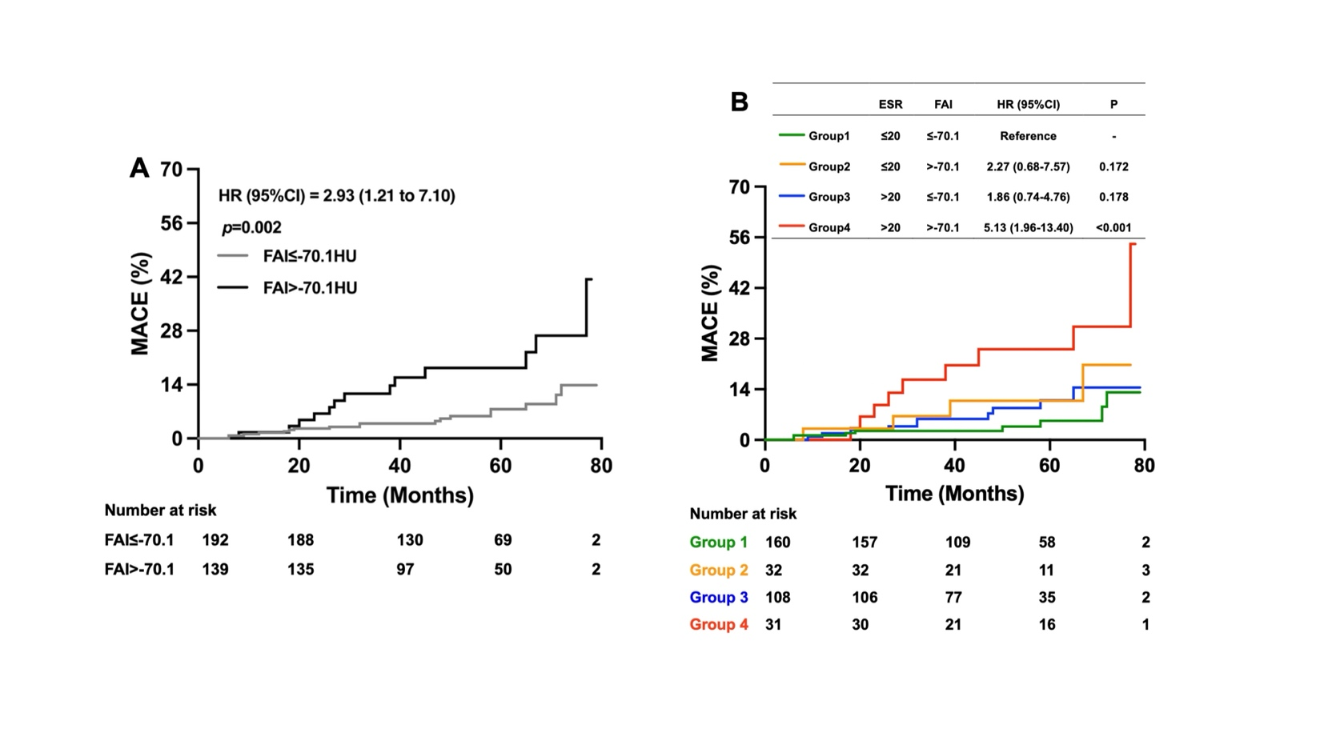

Figure S6 Applicating -70.1 to group RCA-FAI to explore predictive value. Kaplan–Meier analysis using the CRISP-derived cut-off of −70.1 HU, with additional sensitivity analysis combined with ESR.
Abbreviations: CI indicates confidence interval; HR, hazard ratio; and MACE, major adverse cardiovascular event.

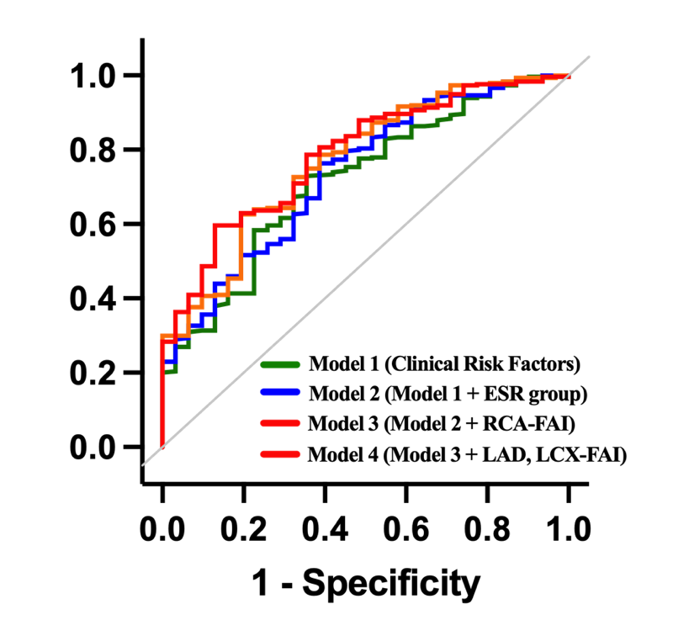

 | AUC (95%CI) | ∆AUC | p value | NRI | p value | IDI | p value
Model 1 | 0.72 (0.62-0.81) | Reference |  | Reference |  | Reference
Model 2 | 0.73 (0.64-0.83) | 0.018 | 0.368 | 0.426 | 0.022 | 0.017 | 0.025
Model 3 | 0.77 (0.68-0.86) | 0.053 | 0.086 | 0.381 | 0.041 | 0.052 | <0.001
Model 4 | 0.78 (0.70-0.87) | 0.067 | 0.049 | 0.544 | 0.003 | 0.057 | <0.001
Figure S7 Prognostic values of models predicting MACE
Model 1: clinical variables of age, sex, hypertension, diabetes, low density lipoprotein cholesterol, glucocorticoid use;
Model 2: Model 1 + ESR classification;
Model 3: Model 2 + RCA-FAI;
Model 4: Model 3 + LAD-FAI + LCX-FAI.
ESR classification refers to the increase or decrease of ESR with 20mm/h as the boundary.
Abbreviations: FAI =fat attenuation index; AUC = area under curve; NRI = net reclassification index; IDI = integrated discrimination index; RCA=right coronary artery; LAD=left anterior descending artery; LCX=Left circumflex artery.

