Supplementary material


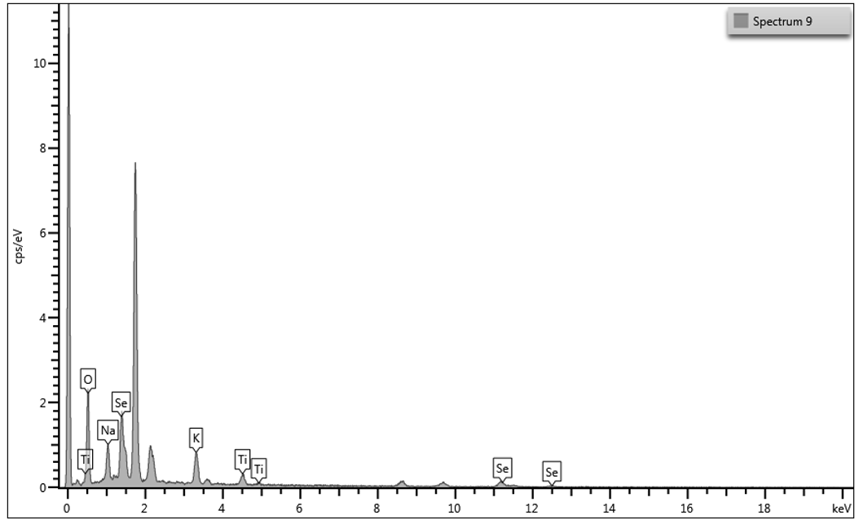
B

A

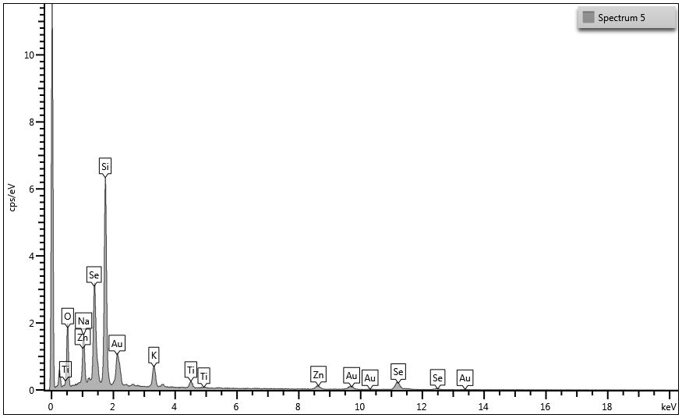
Figure 1S. Results from Scanning Electronic Microscopy with EDS analysis of the nanoparticles present in VB5 (A) and GRU33 (B) cultures treated with 128 mM of sodium selenite.

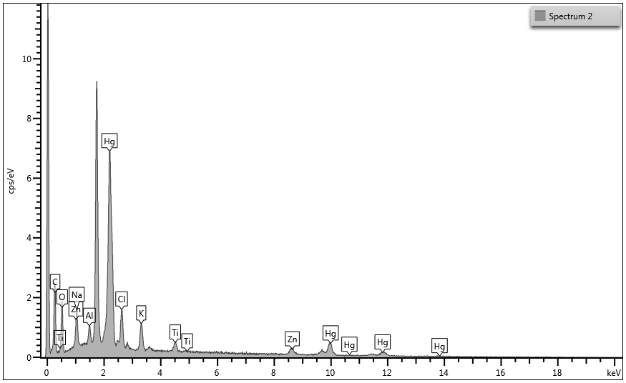
A

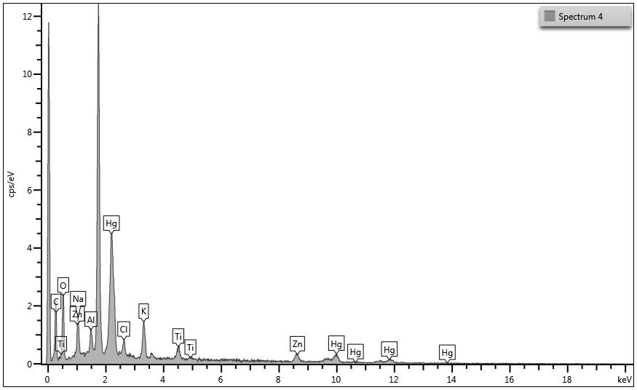
B

Figure 2S. Results from Scanning Electronic Microscopy with EDS analysis of the particles present in MD330.11 (A) and MET16 (B) cultures treated with 0.06 mM of mercury acetate. The high silicon peak is probably from the coverslip used to fix the samples. The potassium peak was due to the presence of this element in the buffer used for the preparation of the samples.

Table S1. Isolates from the Guarani Aquifer System (GAS) and Rio Grande Cone (RGC) that were investigated for the presence of selenium or mercury resistant genes, respectively. The isolates that had positive PCR results are indicated in grey for the respective genes. Values of minimum inhibitory concentrations (MIC) of selenium (Se) and mercury (Hg) obtained for each isolate (from Tables 2 and 3) are also indicated.
 | GAS  Isolates | Taxonomic  identification | Se MIC  (mM) | selD | RGC  Isolates | Taxonomic  identification | Hg MIC  (mM) | merA
 | VB5 | Bacillus | 256 |  | MD330.6 | Pseudomonas sp. | 0.06
 | GRU33 | Lysinibacillus | 256 |  | MD330.9 | Pseudomonas sp. | 0.06
 | MEL13 | Unsup. Lysinibacillus | 128 |  | MD330.11 | Pseudomonas sp. | 0.125
 | NSP5 | Unidentified | 128 |  | MD332.8 | Pseudomonas sp. | 0.125
 | CAP3 | Unidentified | 128 |  | MET16 | Paenibacillus sp. | 0.125
 |  |  |  |  | MR06 | Bacillus megaterium | 0.125
 |  |  |  |  | MR29 | Bacillus sp. | 0.125
 |  |  |  |  | MR38 | Bacillus sp. | 0.125

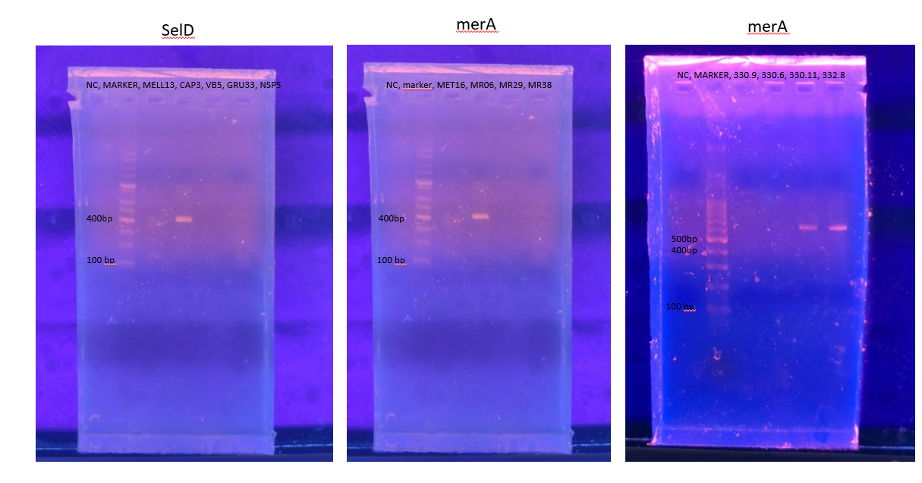
A
B
C
Figure 3S. Conventional PCR results (in agarose gels) of metal-resistance genes amplification. Results of selD gene from GAS isolates MELL13, CAP3, VB5, GRU33 and NSP5, in which only CAP3 presented a positive amplification (A); Results of merA gene from RGC isolates MET16, MR29, MR38, MD330.9, MD330.6, MD330.11 and MD332.8, with positive amplifications for MR06 (B), MD330.11 and MD332.8 (C).

