Supplementary Information

Computation of CAP Dynamics
To characterize the temporal properties of brain state dynamics, we calculated five metrics based on the CAP state time series. Let $T=[t_{1},t_{2},…,t_{N}]$ represent the sequence of CAP states assigned to each volume, where $N$ is the total number of volumes and $M$ is the total number of CAP categories. For a specific CAP state $c∈\{1,…,M\}$, the metrics are defined as follows:

Temporal Fraction
Temporal Fraction represents the proportion of the total scanning duration that the system spends in a specific state $c$. It is calculated as the ratio of the total number of occurrences of state $c$ to the total sequence length:
$$Temporal Fraction\left(c\right)=\frac{\sum_{i=1}^{N}{I}(t_{i}=c)}{N}$$
where $I(⋅)$ is the indicator function that equals 1 if the condition is met and 0 otherwise.

Persistence
Persistence (also referred to as Dwell Time) measures the average duration that a state remains active before a transition occurs. To express this in units of time (seconds), the average number of consecutive frames is multiplied by the temporal resolution ($TR$):
$$Persistence(c)=\left(\frac{\sum_{j=1}^{K_{c}}{d_{c,j}}}{K_{c}}\right)×TR$$
$K_{c}$: The total number of continuous epochs of state $c$.
$d_{c,j}$: The number of frames in the $j$-th continuous epoch of state $c$.
$TR$: The repetition time of the fMRI acquisition.

Counts
Counts (State Initiations) quantifies the total number of times a specific state $c$ is activated or initialized throughout the run. This metric counts the entry into a state rather than its duration:
$$Counts(c)=\sum_{i=1}^{N}{I}(t_{i}=c\text{ and }t_{i-1}≠c)$$
For the calculation, we assume an empty boundary condition $t_{0}=∅$. If the first frame ($t_{1}$) is state $c$, it is counted as the first initiation.

Transition Frequency
Transition Frequency is a global metric representing the total number of state changes (from any state A to a different state B) occurring across the entire time series:
$$Transition Frequency=\sum_{i=1}^{N-1}{I}(t_{i}≠t_{i+1})$$
The logic involves iterating through the sequence and incrementing the count whenever the state of the current frame differs from the state of the subsequent frame.

Transition Probability
Transition Probability describes the likelihood of the system shifting from state $i$ to state $j$ (including remaining in the same state) in successive time points:
$$P(j|i)=\frac{N_{i→j}}{\sum_{k=1}^{M}{N_{i→k}}}$$
$N_{i→j}$: The number of observed instances where state $i$ is immediately followed by state $j$.
$\sum_{k=1}^{M}{N_{i→k}}$: The sum of all transitions originating from state $i$, which corresponds to the total occurrences of state $i$ (excluding the final frame of the sequence).
$M$: The total number of CAP categories identified.

Table 1 Sociodemographic and clinical variables in Responder and Non-responder
Features | Responder-OFF(N=144) | Non-responder-OFF(N=93) | p (OFF) | Responder-ON(N=144) | Non-responder-ON(N=93) | p (ON)
Age(years) | 59.74 ± 10.98 | 61.85 ± 10.15 | 0.144 | - | - | -
Gender(M/F) | 70/74 | 61/32 | 0.011 | - | - | -
Years of Education(years) | 10.67 ± 6.48 | 11.08 ± 4.83 | 0.162 | - | - | -
Course of Disease(years) | 5.48 ± 4.30 | 5.32 ± 5.55 | 0.275 | - | - | -
LEDD(mg) | 664.79 ± 357.73 | 602.98 ± 386.86 | 0.13 | - | - | -
H-Y(OFF) | 2.43 ± 0.89 | 2.39 ± 0.89 | 0.804 | - | - | -
UPDRS-III(OFF) | 33.12 ± 14.51 | 33.61 ± 14.03 | 0.602 | - | - | -
H-Y(ON) | - | - | - | 1.89 ± 0.71 | 1.97 ± 0.78 | 0.388
UPDRS-III(ON) | - | - | - | 19.26 ± 9.42 | 26.90 ± 10.99 | <0.001
Values are presented as mean ± standard deviation for continuous variables and as frequencies (Male/Female) for categorical variables. The p (OFF) values indicate the statistical comparison between the Responder-OFF and Non-responder-OFF groups. The p (ON) values indicate the statistical comparison between the Responder-ON and Non-responder-ON groups. Continuous variables were analyzed using the Mann–Whitney U test, and the categorical variable (Gender) was analyzed using Fisher’s exact test. Dashes (-) indicate that the measurement is not applicable for that clinical state. Abbreviations: H-Y = Hoehn and Yahr stage; LEDD = levodopa equivalent daily dose; M/F = male/female; N = number of subjects; UPDRS-III = Unified Parkinson’s Disease Rating Scale Part III; OFF = off-medication state; ON = on-medication state. Statistical significance: p < 0.05.
Table 2 Head motion across study groups and clinical states
Group | Mean_FD | 95% CI_low | 95% CI_high | p
PD(N=337) | 0.1986 ± 0.0853 | 0.1895 | 0.2078 | -
HC(N=141) | 0.1650 ± 0.0720 | 0.153 | 0.1769 | -
PD vs. HC | - | - | - | <0.001
PD-OFF(N=235) | 0.1961 ± 0.0802 | 0.1858 | 0.2064 | -
PD-ON(N=235) | 0.2107 ± 0.0897 | 0.1991 | 0.2222 | -
PD-OFF vs. PD-ON | - | - | - | 0.002
Responder-OFF(N=142) | 0.1946 ± 0.0773 | 0.1818 | 0.2074 | -
Non-responder-OFF(N=93) | 0.1985 ± 0.0847 | 0.181 | 0.2159 | -
Responder-OFF vs. Non-responder-OFF | - | - | - | 0.929
Responder-ON(N=142) | 0.2042 ± 0.0829 | 0.1905 | 0.218 | -
Non-responder-ON(N=93) | 0.2205 ± 0.0989 | 0.2001 | 0.2408 | -
Responder-ON vs. Non-responder-ON | - | - | - | 0.314
Values are presented as mean ± standard deviation alongside 95% confidence intervals (CI_low, CI_high). Statistical comparisons between independent groups (PD vs. HC, and Responder vs. Non-responder in both OFF and ON states) were performed using the Mann–Whitney U test. Comparisons between paired clinical states (PD-OFF vs. PD-ON) were performed using the Wilcoxon signed-rank test. Two subjects in the Responder group were excluded from this analysis because their scrubbed frames in the ON state exceeded 30%, which also disqualified them from subsequent neuroimaging analyses. Dashes (-) indicate that the metric or comparison is not applicable for that specific row. Abbreviations: CI = confidence interval; FD = framewise displacement; HC = healthy control; N = number of subjects; OFF = off-medication state; ON = on-medication state; PD = Parkinson’s disease. Statistical significance: p < 0.05.
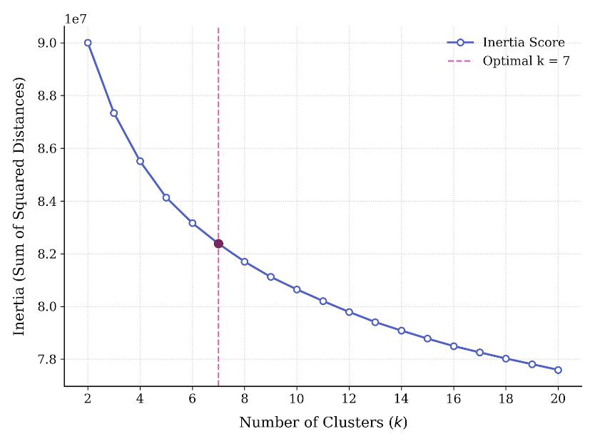
Fig. 1 Selection of the optimal number of clusters (k) using the elbow method. The clustering performance was evaluated for a range of cluster numbers from k = 2 to 20. The y-axis represents the inertia score, defined as the sum of squared distances of samples to their closest cluster center. The optimal number of clusters was determined using the elbow criterion, identified as the point where the marginal gain of adding another cluster significantly diminishes. The vertical dashed line indicates the elbow point at k = 7, which was selected as the optimal cluster count for subsequent co-activation pattern (CAP) identification.
Table 3 Bootstrap clustering stability metrics for the seven co-activation patterns (CAPs)
Features | Mean | Median | Std | 95%_CI_Low | 95%_CI_High
CAP-1 Correlation | 0.994940997 | 0.998774838 | 0.041912006 | 0.994015 | 0.999732
CAP-2 Correlation | 0.994770121 | 0.998577314 | 0.04188403 | 0.992531 | 0.99969
CAP-3 Correlation | 0.998277856 | 0.999327736 | 0.009517758 | 0.996241 | 0.99983
CAP-4 Correlation | 0.999780297 | 0.999879679 | 0.000812985 | 0.999538 | 0.99996
CAP-5 Correlation | 0.999768508 | 0.999874881 | 0.000862612 | 0.999421 | 0.999956
CAP-6 Correlation | 0.997513019 | 0.999502188 | 0.020697258 | 0.99673 | 0.999903
CAP-7 Correlation | 0.999290248 | 0.999572309 | 0.001578669 | 0.997772 | 0.999899
Adjusted Rand Index (ARI) | 0.944326948 | 0.949689156 | 0.04137327 | 0.903209 | 0.972844
Values are presented as the mean, median, standard deviation (Std), and 95% confidence intervals (CI) derived from 1,000 bootstrap iterations. "CAP Correlation" represents the spatial Pearson correlation coefficient between the reference cluster centroids ($k=7$) and the centroids generated from the bootstrap resampling. The Adjusted Rand Index (ARI) evaluates the temporal assignment consistency of the functional frames across different resampling iterations. The exceptionally high median values (> 0.99 for spatial correlations and ~0.95 for ARI) demonstrate the excellent spatial robustness and temporal reproducibility of the identified neurophysiological states. Abbreviations: CAP = co-activation pattern; CI = confidence interval; Std = standard deviation.
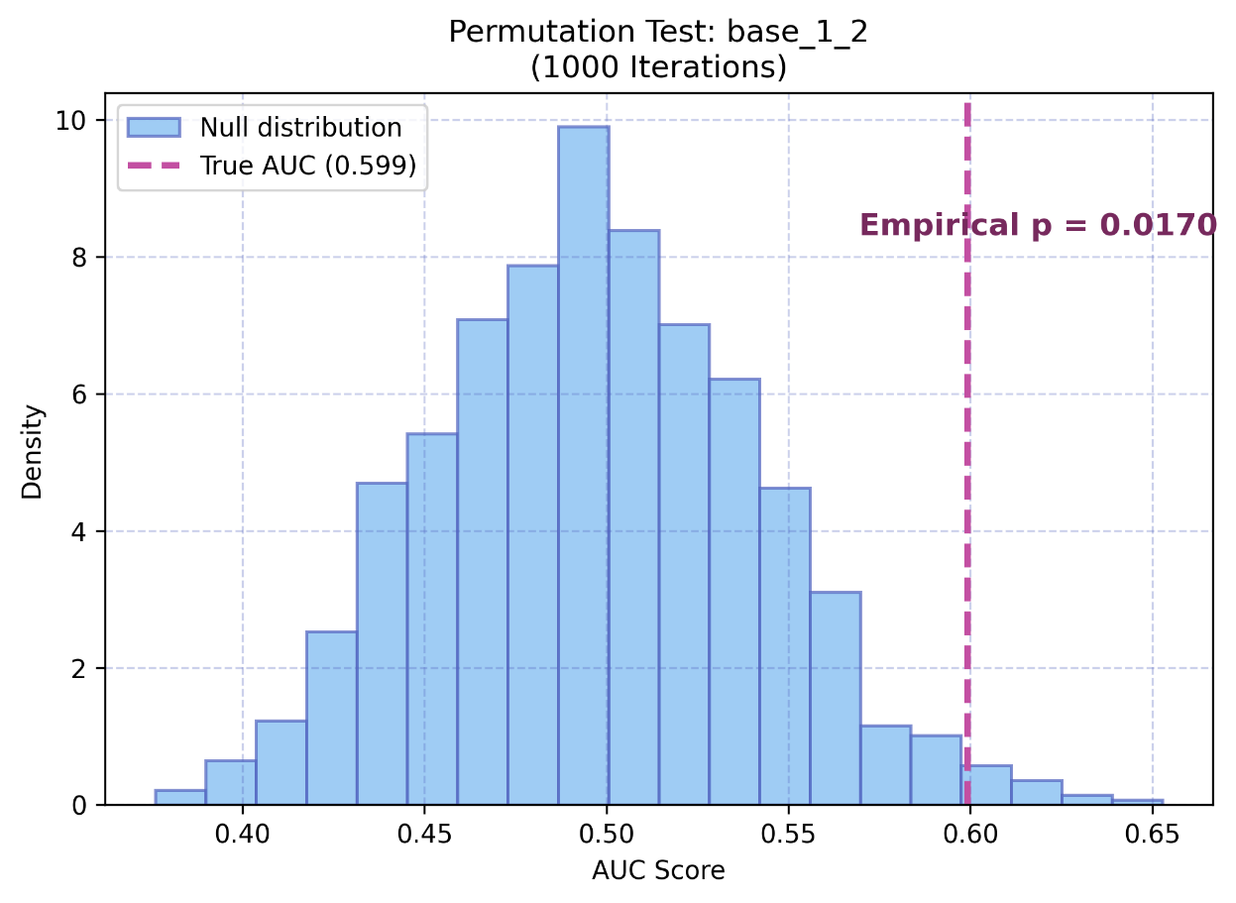
Fig. 2 Null distribution of the integrated SVM model evaluated via permutation testing. To verify the absolute predictive validity of the integrated model (combining baseline clinical characteristics with CAP-2 dynamic features), a permutation test comprising 1000 iterations was conducted. The blue histogram represents the null distribution of AUC scores obtained by randomly shuffling the patient response labels, illustrating the theoretical model performance when driven solely by chance. The red vertical dashed line indicates the true predictive performance (AUC = 0.599) achieved under the matching cross-validation framework used for this test. The highly significant empirical p-value (p = 0.017) demonstrates that the true model performance falls well outside the 95% confidence interval of the null distribution, confirming that the incorporated functional dynamic features capture underlying pathophysiological signals rather than random noise.

