Supplementary Materials:

Effect of different sweeteners on the oral microbiota and immune system of Sprague Dawley rats
Xi Cheng^{1，2}, Xiurong Guo², Feihong Huang², Hui Lei², Quan Zhou², Can Song²*

1.Department of Stomatology, People’s Hospital of Leshan, Leshan, 614000, Sichuan, China
2.School of Pharmacy, Southwest Medical University, Luzhou, 646000, Sichuan, China
*Corresponding: cansong@swmu.edu.cn (Can Song)

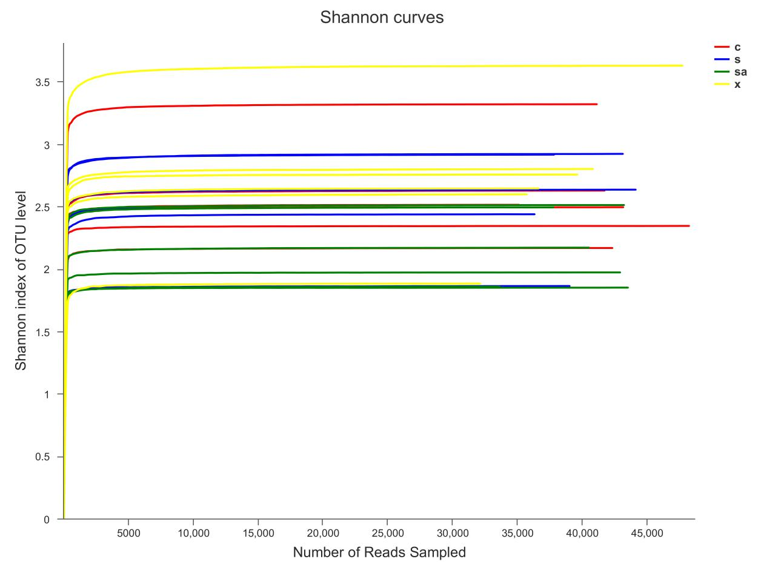

Figure.S1 Shannon index of oral microbiota in four groups rats

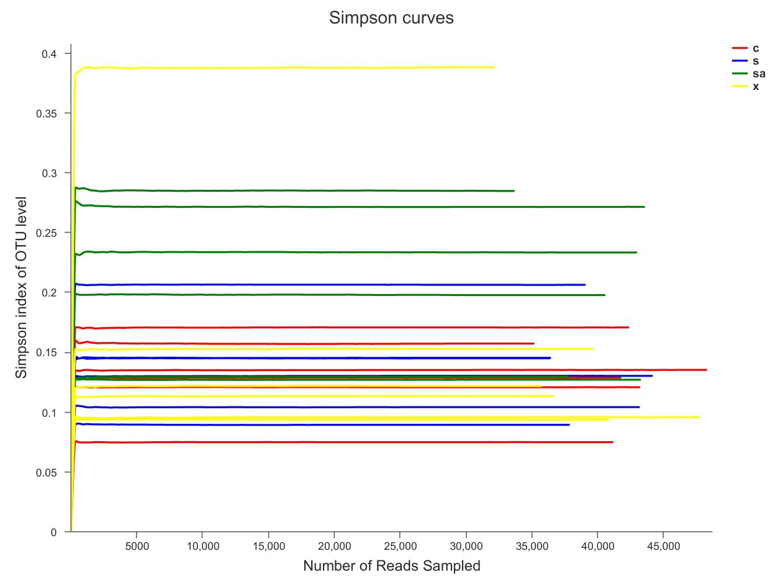

Figure.S2 Simpson index of oral microbiota in four groups rats

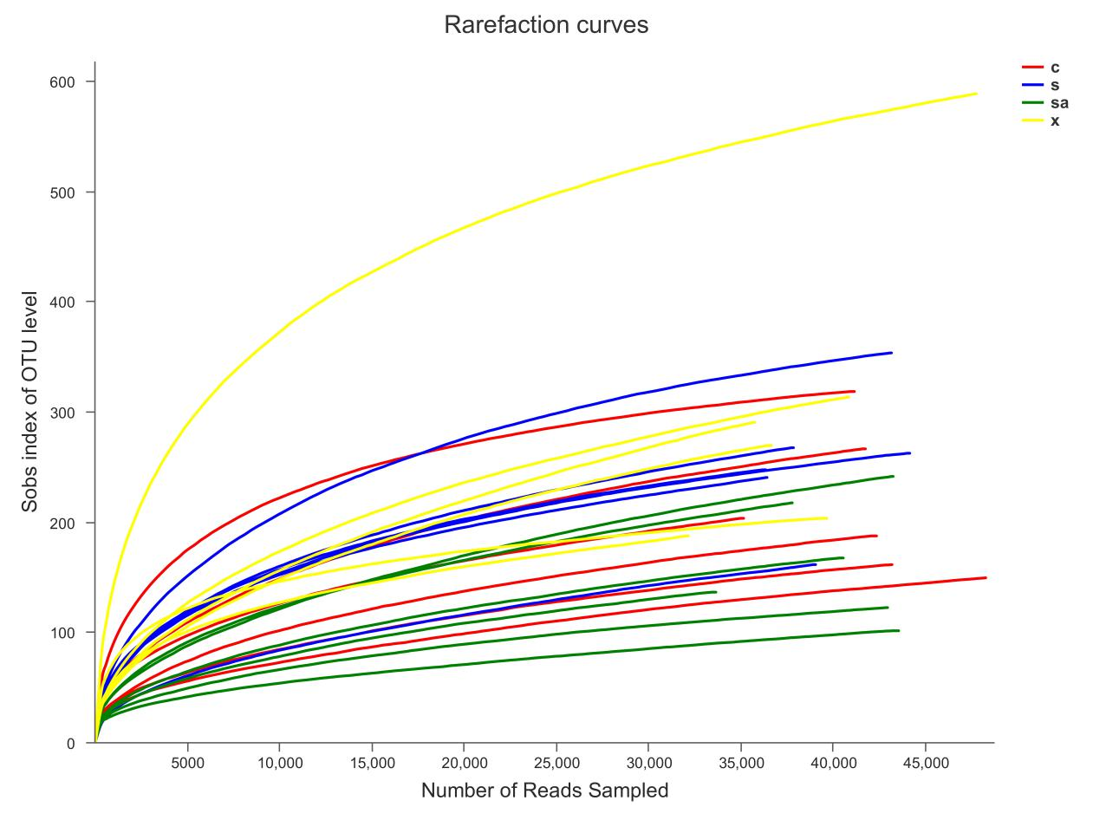

Figure.S3 Chao index of oral microbiota in four groups rats
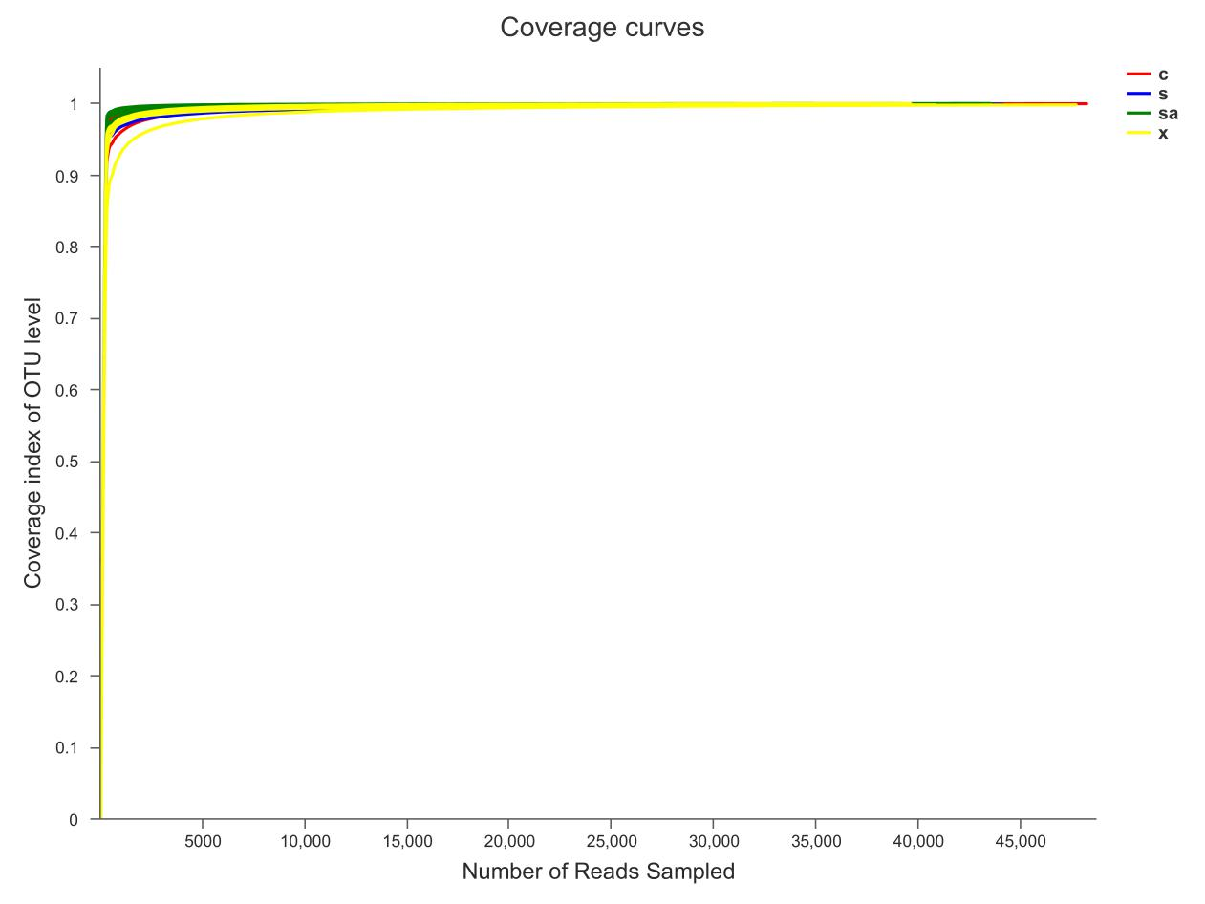

Figure.S4 Coverage index of oral microbiota in four groups rats

Table. S1 Four group rats diversity Index Table

