Table S1. PRISMA checklist.
Section and Topic | Item # | Checklist item | Location where item is reported
TITLE
Title | 1 | Identify the report as a systematic review. | p. 1
ABSTRACT
Abstract | 2 | See the PRISMA 2020 for Abstracts checklist. | p. 2.
INTRODUCTION
Rationale | 3 | Describe the rationale for the review in the context of existing knowledge. | pp. 2-3.
Objectives | 4 | Provide an explicit statement of the objective(s) or question(s) the review addresses. | p. 3.
METHODS
Eligibility criteria | 5 | Specify the inclusion and exclusion criteria for the review and how studies were grouped for the syntheses. | pp. 4-5 and pp. 6-8.
Information sources | 6 | Specify all databases, registers, websites, organisations, reference lists and other sources searched or consulted to identify studies. Specify the date when each source was last searched or consulted. | p. 4 and pp. 6-7.
Search strategy | 7 | Present the full search strategies for all databases, registers and websites, including any filters and limits used. | p. 4 and pp. 6-7
Selection process | 8 | Specify the methods used to decide whether a study met the inclusion criteria of the review, including how many reviewers screened each record and each report retrieved, whether they worked independently, and if applicable, details of automation tools used in the process. | pp. 4-5 and p. 7 and Figure 1.
Data collection process | 9 | Specify the methods used to collect data from reports, including how many reviewers collected data from each report, whether they worked independently, any processes for obtaining or confirming data from study investigators, and if applicable, details of automation tools used in the process. | p. 5.
Data items | 10a | List and define all outcomes for which data were sought. Specify whether all results that were compatible with each outcome domain in each study were sought (e.g. for all measures, time points, analyses), and if not, the methods used to decide which results to collect. | p. 5 and Supplementary Table S2, pp. 8-9.
Data items | 10b | List and define all other variables for which data were sought (e.g. participant and intervention characteristics, funding sources). Describe any assumptions made about any missing or unclear information. | p. 5 and p. 7; Table 1, pp. 19-20; Table 2, pp. 24-28.
Study risk of bias assessment | 11 | Specify the methods used to assess risk of bias in the included studies, including details of the tool(s) used, how many reviewers assessed each study and whether they worked independently, and if applicable, details of automation tools used in the process. | pp. 5-6; Supplementary Tables S3-S4, pp. 9-12.
Effect measures | 12 | Specify for each outcome the effect measure(s) (e.g. risk ratio, mean difference) used in the synthesis or presentation of results. | p. 6 and pp. 8-9.
Synthesis methods | 13a | Describe the processes used to decide which studies were eligible for each synthesis (e.g. tabulating the study intervention characteristics and comparing against the planned groups for each synthesis (item #5)). | pp. 4-6 and p. 7.
Synthesis methods | 13b | Describe any methods required to prepare the data for presentation or synthesis, such as handling of missing summary statistics, or data conversions. | p. 5 and p. 6.
Synthesis methods | 13c | Describe any methods used to tabulate or visually display results of individual studies and syntheses. | p. 6; Tables 1-2 and Figures 1-4, pp. 18-28; Supplementary Figures S1-S7.
Synthesis methods | 13d | Describe any methods used to synthesize results and provide a rationale for the choice(s). If meta-analysis was performed, describe the model(s), method(s) to identify the presence and extent of statistical heterogeneity, and software package(s) used. | p. 6 and pp. 8-9.
Synthesis methods | 13e | Describe any methods used to explore possible causes of heterogeneity among study results (e.g. subgroup analysis, meta-regression). | p. 6 and pp. 8-9.
Synthesis methods | 13f | Describe any sensitivity analyses conducted to assess robustness of the synthesized results. | p. 6, p. 9 and Supplementary Figures S4-S7.
Reporting bias assessment | 14 | Describe any methods used to assess risk of bias due to missing results in a synthesis (arising from reporting biases). | p. 6
Certainty assessment | 15 | Describe any methods used to assess certainty (or confidence) in the body of evidence for an outcome. | Not related.
RESULTS
Study selection | 16a | Describe the results of the search and selection process, from the number of records identified in the search to the number of studies included in the review, ideally using a flow diagram. | p. 7 and p. 18.
Study selection | 16b | Cite studies that might appear to meet the inclusion criteria, but which were excluded, and explain why they were excluded. | p. 7 and p. 18.
Study characteristics | 17 | Cite each included study and present its characteristics. | p. 7 pp and 19-20.
Risk of bias in studies | 18 | Present assessments of risk of bias for each included study. | 7-8, pp. 19-20 Supplementary Tables S3-S4, and pp. 9-12.
Results of individual studies | 19 | For all outcomes, present, for each study: (a) summary statistics for each group (where appropriate) and (b) an effect estimate and its precision (e.g. confidence/credible interval), ideally using structured tables or plots. | Figures 2-4, pp. 21-23, Table 2, and pp. 24-28.
Results of syntheses | 20a | For each synthesis, briefly summarise the characteristics and risk of bias among contributing studies. | pp. 7-8 and pp. 19-20.
Results of syntheses | 20b | Present results of all statistical syntheses conducted. If meta-analysis was done, present for each the summary estimate and its precision (e.g. confidence/credible interval) and measures of statistical heterogeneity. If comparing groups, describe the direction of the effect. | pp. 8-9, 2-4, pp. 21-23.
Results of syntheses | 20c | Present results of all investigations of possible causes of heterogeneity among study results. | pp. 8-9 and Supplementary Figures S1-S3.
Results of syntheses | 20d | Present results of all sensitivity analyses conducted to assess the robustness of the synthesized results. | p. 9 and Supplementary Figures S4-S7.
Reporting biases | 21 | Present assessments of risk of bias due to missing results (arising from reporting biases) for each synthesis assessed. | p. 6
Certainty of evidence | 22 | Present assessments of certainty (or confidence) in the body of evidence for each outcome assessed. | Not related.
DISCUSSION
Discussion | 23a | Provide a general interpretation of the results in the context of other evidence. | pp. 9-10.
Discussion | 23b | Discuss any limitations of the evidence included in the review. | p. 11.
Discussion | 23c | Discuss any limitations of the review processes used. | p. 11.
Discussion | 23d | Discuss implications of the results for practice, policy, and future research. | p. 11 and pp. 11-12.
OTHER INFORMATION
Registration and protocol | 24a | Provide registration information for the review, including register name and registration number, or state that the review was not registered. | p. 4, and p. 14.
Registration and protocol | 24b | Indicate where the review protocol can be accessed, or state that a protocol was not prepared. | p. 4, and p. 14.
Registration and protocol | 24c | Describe and explain any amendments to information provided at registration or in the protocol. | Not reported
Support | 25 | Describe sources of financial or non-financial support for the review, and the role of the funders or sponsors in the review. | p. 13.
Competing interests | 26 | Declare any competing interests of review authors. | p. 14.
Availability of data, code and other materials | 27 | Report which of the following are publicly available and where they can be found: template data collection forms; data extracted from included studies; data used for all analyses; analytic code; any other materials used in the review. | p. 13.

Table S2. Search Strategy
PubMed | ( "Rectal Neoplasms"[Mesh] OR rectal cancer*[tiab] OR rectal neoplasm*[tiab] OR rectal tumor*[tiab] OR rectal tumour*[tiab] OR rectal carcinoma*[tiab] OR rectal adenocarcinoma*[tiab] OR "low rectal cancer"[tiab] OR "lower rectal cancer"[tiab] OR "ultralow rectal cancer"[tiab] OR "ultra-low rectal cancer"[tiab] OR "distal rectal cancer"[tiab] ) AND ( "intersphincteric resection"[tiab] OR "intersphincteric rectal resection"[tiab] OR "intersphincteric dissection"[tiab] OR "intersphincteric excision"[tiab] OR ISR[tiab] OR "internal sphincter resection"[tiab] OR "internal anal sphincter resection"[tiab] OR "total intersphincteric resection"[tiab] OR "partial intersphincteric resection"[tiab] OR "subtotal intersphincteric resection"[tiab] OR "coloanal anastomosis"[tiab] OR "hand-sewn coloanal anastomosis"[tiab] OR "handsewn coloanal anastomosis"[tiab] ) AND ( "low anterior resection syndrome"[tiab] OR LARS[tiab] OR "LARS score"[tiab] OR "bowel dysfunction"[tiab] OR "bowel function"[tiab] OR "defecatory dysfunction"[tiab] OR "defecation dysfunction"[tiab] OR "defecation function"[tiab] OR "anorectal function"[tiab] OR "anal function"[tiab] OR continence[tiab] OR incontinence[tiab] OR "fecal incontinence"[tiab] OR "faecal incontinence"[tiab] OR urgency[tiab] OR clustering[tiab] OR "functional outcome"[tiab] OR "functional outcomes"[tiab] )
Embase | ('rectum cancer'/exp OR 'rectal cancer':ti,ab,kw OR 'rectal neoplasm*':ti,ab,kw OR 'rectal tumor*':ti,ab,kw OR 'rectal tumour*':ti,ab,kw OR 'rectal carcinoma*':ti,ab,kw OR 'rectal adenocarcinoma*':ti,ab,kw OR 'low rectal cancer':ti,ab,kw OR 'lower rectal cancer':ti,ab,kw OR 'ultralow rectal cancer':ti,ab,kw OR 'ultra-low rectal cancer':ti,ab,kw OR 'distal rectal cancer':ti,ab,kw) AND ('intersphincteric resection':ti,ab,kw OR 'intersphincteric rectal resection':ti,ab,kw OR 'intersphincteric dissection':ti,ab,kw OR 'intersphincteric excision':ti,ab,kw OR isr:ti,ab,kw OR 'internal sphincter resection':ti,ab,kw OR 'internal anal sphincter resection':ti,ab,kw OR 'total intersphincteric resection':ti,ab,kw OR 'partial intersphincteric resection':ti,ab,kw OR 'subtotal intersphincteric resection':ti,ab,kw OR 'coloanal anastomosis':ti,ab,kw OR 'hand-sewn coloanal anastomosis':ti,ab,kw OR 'handsewn coloanal anastomosis':ti,ab,kw) AND ('low anterior resection syndrome':ti,ab,kw OR lars:ti,ab,kw OR 'lars score':ti,ab,kw OR 'bowel dysfunction':ti,ab,kw OR 'bowel function':ti,ab,kw OR 'defecatory dysfunction':ti,ab,kw OR 'defecation dysfunction':ti,ab,kw OR 'defecation function':ti,ab,kw OR 'anorectal function':ti,ab,kw OR 'anal function':ti,ab,kw OR continence:ti,ab,kw OR incontinence:ti,ab,kw OR 'fecal incontinence':ti,ab,kw OR 'faecal incontinence':ti,ab,kw OR urgency:ti,ab,kw OR clustering:ti,ab,kw OR 'functional outcome*':ti,ab,kw)
Scopus | TITLE-ABS-KEY ( ( "rectal cancer" OR "rectal neoplasm" OR "rectal neoplasms" OR "rectal tumor" OR "rectal tumors" OR "rectal tumour" OR "rectal tumours" OR "rectal carcinoma" OR "rectal adenocarcinoma" OR "low rectal cancer" OR "lower rectal cancer" OR "ultralow rectal cancer" OR "ultra-low rectal cancer" OR "distal rectal cancer" ) AND ( "intersphincteric resection" OR "intersphincteric rectal resection" OR "intersphincteric dissection" OR "intersphincteric excision" OR ISR OR "internal sphincter resection" OR "internal anal sphincter resection" OR "total intersphincteric resection" OR "partial intersphincteric resection" OR "subtotal intersphincteric resection" OR "coloanal anastomosis" OR "hand-sewn coloanal anastomosis" OR "handsewn coloanal anastomosis" ) AND ( "low anterior resection syndrome" OR LARS OR "LARS score" OR "bowel dysfunction" OR "bowel function" OR "defecatory dysfunction" OR "defecation dysfunction" OR "defecation function" OR "anorectal function" OR "anal function" OR continence OR incontinence OR "fecal incontinence" OR "faecal incontinence" OR urgency OR clustering OR "functional outcome" OR "functional outcomes" ) )
WOS | TS= ( ( "rectal cancer" OR "rectal neoplasm*" OR "rectal tumor*" OR "rectal tumour*" OR "rectal carcinoma*" OR "rectal adenocarcinoma*" OR "low rectal cancer" OR "lower rectal cancer" OR "ultralow rectal cancer" OR "ultra-low rectal cancer" OR "distal rectal cancer" ) AND ( "intersphincteric resection" OR "intersphincteric rectal resection" OR "intersphincteric dissection" OR "intersphincteric excision" OR ISR OR "internal sphincter resection" OR "internal anal sphincter resection" OR "total intersphincteric resection" OR "partial intersphincteric resection" OR "subtotal intersphincteric resection" OR "coloanal anastomosis" OR "hand-sewn coloanal anastomosis" OR "handsewn coloanal anastomosis" ) AND ( "low anterior resection syndrome" OR LARS OR "LARS score" OR "bowel dysfunction" OR "bowel function" OR "defecatory dysfunction" OR "defecation dysfunction" OR "defecation function" OR "anorectal function" OR "anal function" OR continence OR incontinence OR "fecal incontinence" OR "faecal incontinence" OR urgency OR clustering OR "functional outcome*" ) )
Cochrane Library | ("intersphincteric resection" OR "intersphincteric dissection" OR "internal sphincter resection") AND ("rectal cancer" OR "low rectal cancer" OR "ultra-low rectal cancer" OR "ultralow rectal cancer")

Table S2. Low Anterior Resection Syndrome (LARS) Score Questionnaire.
Item | Question | Response option | Score
Q1 | Do you ever have occasions when you cannot control your flatus (wind)? | □ No, never | 0
Q1 |  | □ Yes, less than once per week | 4
Q1 |  | □ Yes, at least once per week | 7
Q2 | Do you ever have any accidental leakage of liquid stool? | □ No, never | 0
Q2 | Do you ever have any accidental leakage of liquid stool? | □ Yes, less than once per week | 3
Q2 | Do you ever have any accidental leakage of liquid stool? | □ Yes, at least once per week | 3
Q3 | How often do you open your bowels? | □ More than 7 times per day (24 hours) | 4
Q3 | How often do you open your bowels? | □ 4–7 times per day (24 hours) | 2
Q3 | How often do you open your bowels? | □ 1–3 times per day (24 hours) | 0
Q3 | How often do you open your bowels? | □ Less than once per day (24 hours) | 5
Q4 | Do you ever have to open your bowels again within one hour of the last bowel opening? | □ No, never | 0
Q4 |  | □ Yes, less than once per week | 9
Q4 |  | □ Yes, at least once per week | 11
Q5 | Do you ever have such a strong urge to open your bowels that you have to rush to the toilet? | □ No, never | 0
Q5 |  | □ Yes, less than once per week | 11
Q5 |  | □ Yes, at least once per week | 16
Total score: add the scores from all five selected answers. |  |  | 0–42
Interpretation: 0–20 = No LARS; 21–29 = Minor LARS; 30–42 = Major LARS.
Abbreviations: LARS, low anterior resection syndrome. Reference: Emmertsen KJ, Laurberg S. Low Anterior Resection Syndrome Score: Development and Validation of a Symptom-Based Scoring System for Bowel Dysfunction After Low Anterior Resection for Rectal Cancer. Ann Surg. 2012;255(5):922–928.
Table S3. risk of bias assessment of prevalence studies using the QUIPS tool.
Study | Q1 | Q2 | Q3 | Q4 | Q5 | Q6 | Q7 | Q8 | Q9 | Overall
Alvandipour  (2022) (1) | Y | U | N | Y | Y | Y | Y | Y | Y | Moderate
Beppu  (2015) (2) | Y | U | U | Y | Y | Y | Y | Y | Y | Moderate
Gori  (2021) (3) | Y | U | U | Y | Y | Y | Y | Y | Y | Moderate
He  (2023) (4) | Y | U | U | Y | Y | Y | Y | Y | Y | Moderate
Jia  (2025) (5) | Y | Y | Y | Y | Y | Y | Y | Y | Y | Low
Kazi  (2023) (6) | Y | U | Y | Y | Y | Y | Y | Y | Y | Moderate
Kiyozumi  (2023) (7) | Y | Y | U | Y | Y | Y | Y | Y | Y | Low
Kupsch  (2018) (8) | Y | U | U | Y | U | Y | Y | Y | U | Moderate
Liu  (2022) (9) | Y | U | U | Y | Y | Y | Y | Y | Y | Moderate
López-Kostner  (2019) (10) | Y | U | N | Y | U | Y | Y | U | U | High
Luca  (2016) (11) | Y | U | N | Y | Y | Y | Y | U | Y | Moderate
Paku  (2022) (12) | Y | U | N | U | Y | Y | Y | U | Y | Moderate
Pan  (2023) (13) | Y | U | Y | Y | U | Y | Y | Y | N | Moderate
Shen  (2023) (14) | Y | U | U | Y | Y | Y | Y | Y | Y | Moderate
Sun  (2024) (15) | Y | U | Y | Y | Y | Y | Y | Y | Y | Moderate
Toyoshima  (2025) (16) | Y | U | U | U | Y | Y | Y | U | Y | Moderate
Zhang  (2026) (17) | Y | U | Y | Y | Y | Y | Y | Y | Y | Low
Zhu 2025 | Y | U | U | Y | Y | Y | Y | Y | Y | Moderate
Y = Yes; U = Unclear; N = No;
Q1 Was the sample frame appropriate to address the target population?
Q2 Were study participants sampled in an appropriate way?
Q3 Was the sample size adequate?
Q4 Were study subjects and setting described in detail?
Q5 Was data analysis conducted with sufficient coverage of the identified sample?
Q6 Were valid methods used for identification of the condition?
Q7 Was the condition measured in a standard, reliable way for all participants?
Q8 Was there appropriate statistical analysis?
Q9 Was the response rate adequate, and if not, was the low response rate managed appropriately?
Table S4. risk of bias assessment of determinant studies using the QUIPS tool.
Study | Participation | Attrition | Determinant measurement | Outcome measurement | Confounding | Analysis/  reporting | Overall ROB
Alvandipour  (2022) (1) | Low | Moderate | Low | Moderate | Moderate | Moderate | Moderate
Kiyozumi  (2023) (7) | Low | Moderate | Low | Low | Moderate | Low | Moderate
Ota et  (2024) (18) | Low | Moderate | Low | Low | Moderate | Low | Moderate
Paku  (2022) (12) | Low | Moderate | Low | Low | Moderate | Low | Moderate
Pan  (2023) (13) | Low | Moderate | Low | Low | Moderate | Low | Moderate
Sun  (2023) (19) | Moderate | Moderate | Low | Moderate | Moderate | Moderate | Moderate
Trenti  (2018) (20) | Moderate | Moderate | Low | Low | Moderate | Moderate | Moderate
Zakaria  (2024) (21) | Moderate | Moderate | Moderate | Low | Moderate | Moderate | Moderate
Beppu  (2015) (2) | Moderate | Moderate | Low | Low | Moderate | Moderate | Moderate
Suraga  (2026) (22) | Moderate | Moderate | Low | Low | High | Moderate | High
Toyoshima  (2025) (16) | Moderate | Moderate | Low | Low | Moderate | Moderate | Moderate
Kupsch  (2018) (8) | Moderate | Moderate | Low | Low | Moderate | Moderate | Moderate
Gori  (2021) (3) | Moderate | Moderate | Moderate | Low | Moderate | Moderate | Moderate
Rubinkiewicz  (2018) (23) | Moderate | Moderate | Moderate | Low | High | Moderate | High
Shen  (2023) (14) | Low | Moderate | Low | Low | Moderate | Moderate | Moderate
Farouk  (2024) (24) | Moderate | Moderate | Moderate | Moderate | Moderate | Moderate | Moderate
Kitaguchi  (2019) (25) | Moderate | Moderate | Low | Moderate | Moderate | Moderate | Moderate
Luca  (2016) (11) | Moderate | Moderate | Low | Moderate | High | Moderate | High
Yan  (2025) (26) | Low | Moderate | Low | Moderate | Moderate | Low | Moderate
Bo  (2025) (27) | Moderate | Moderate | Low | Low | High | Moderate | High
Kazi  (2023) (6) | Low | Moderate | Low | Low | Moderate | Low | Moderate
Zhu  (2025) (28) | Moderate | Moderate | Low | Low | Moderate | Moderate | Moderate
Sun  (2024) (15) | Moderate | Moderate | Moderate | Low | Moderate | Moderate | Moderate
López-Kostner  (2019) (10) | Moderate | Moderate | Low | Low | Moderate | Moderate | Moderate
Mahalingam  (2017) (29) | High | Moderate | Moderate | Moderate | High | Moderate | High
Jia  (2025) (5) | Low | Moderate | Low | Low | Moderate | Low | Moderate
Liao  (2023) (30) | High | Moderate | Moderate | Moderate | High | Moderate | High
Zhang  (2026) (17) | Moderate | Moderate | Moderate | Moderate | High | Moderate | Moderate
Kitaguchi  (2023) (31) | Low | Moderate | Low | Low | Moderate | Low | Moderate
Singh  (2025) (32) | Low | Moderate | Low | Low | Moderate | Low | Moderate

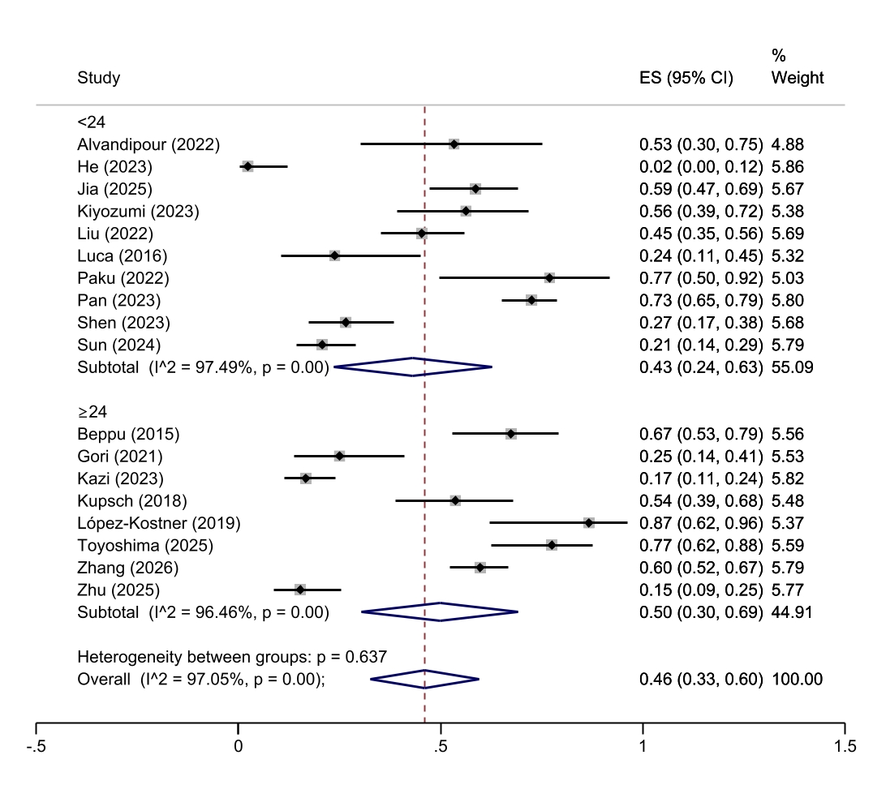 Figure S1. Subgroup analysis for major LARS according to timing of LARS assessment after ISR.
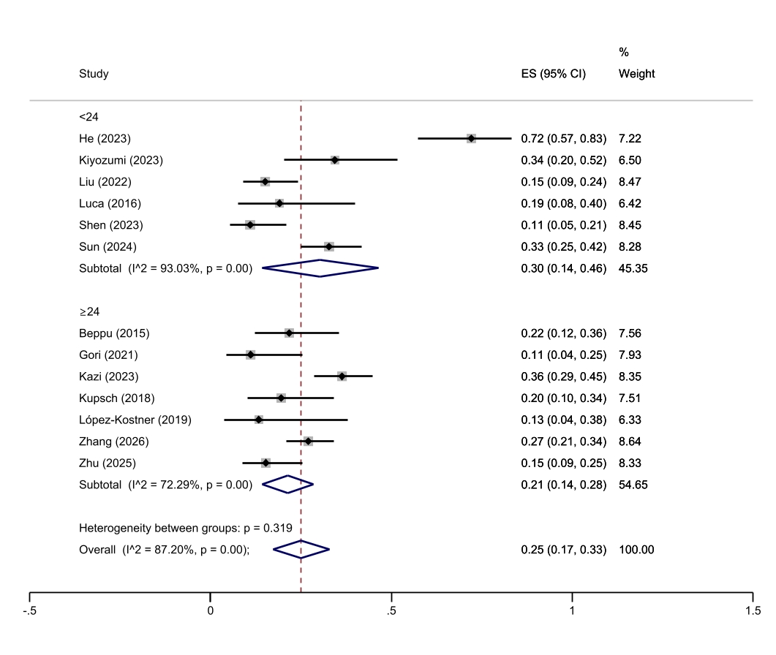 Figure S2. Subgroup analysis for minor LARS according to timing of LARS assessment after ISR.
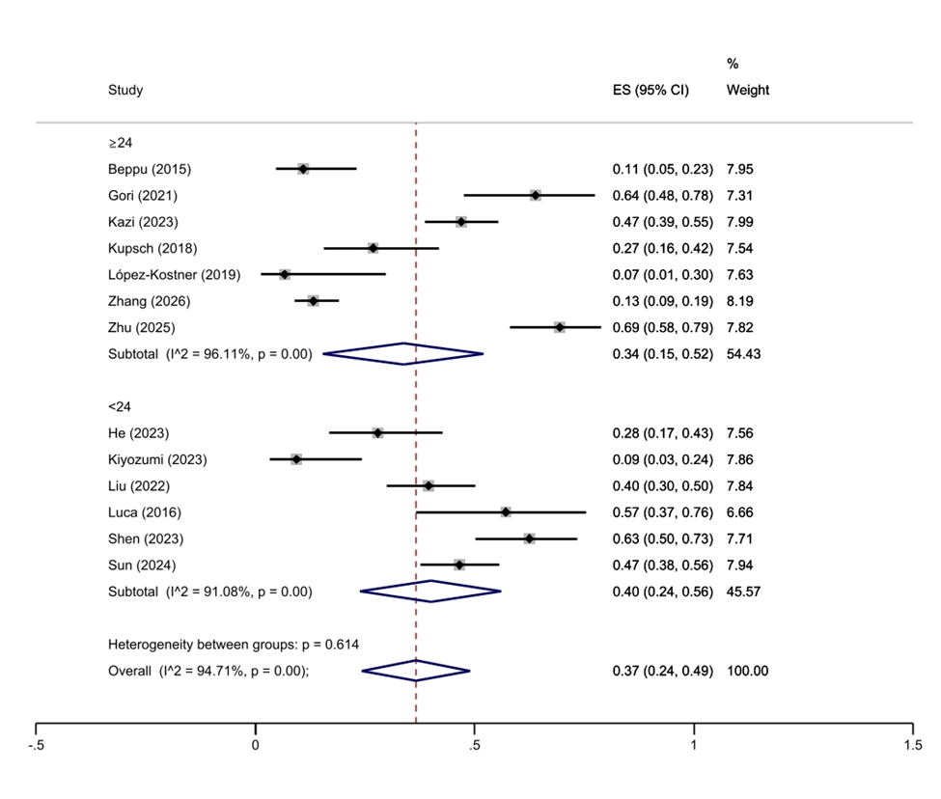 Figure S3. Subgroup analysis for no LARS according to timing of LARS assessment after ISR.

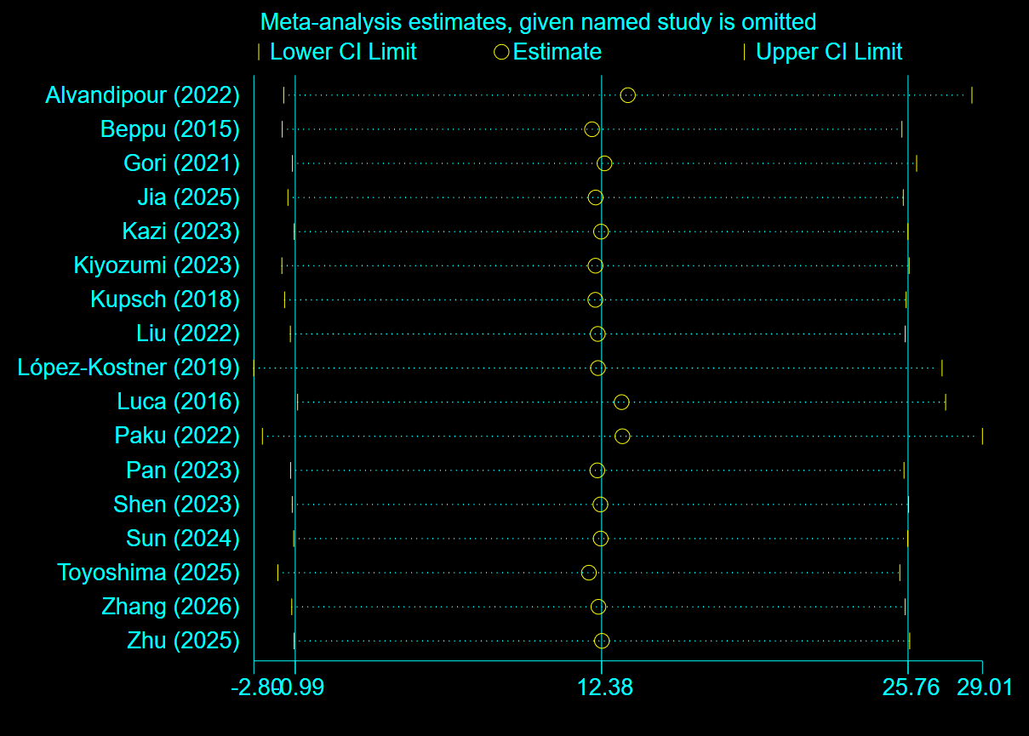
Figure S4. Leave-one-out sensitivity analysis for pooled major LARS prevalence
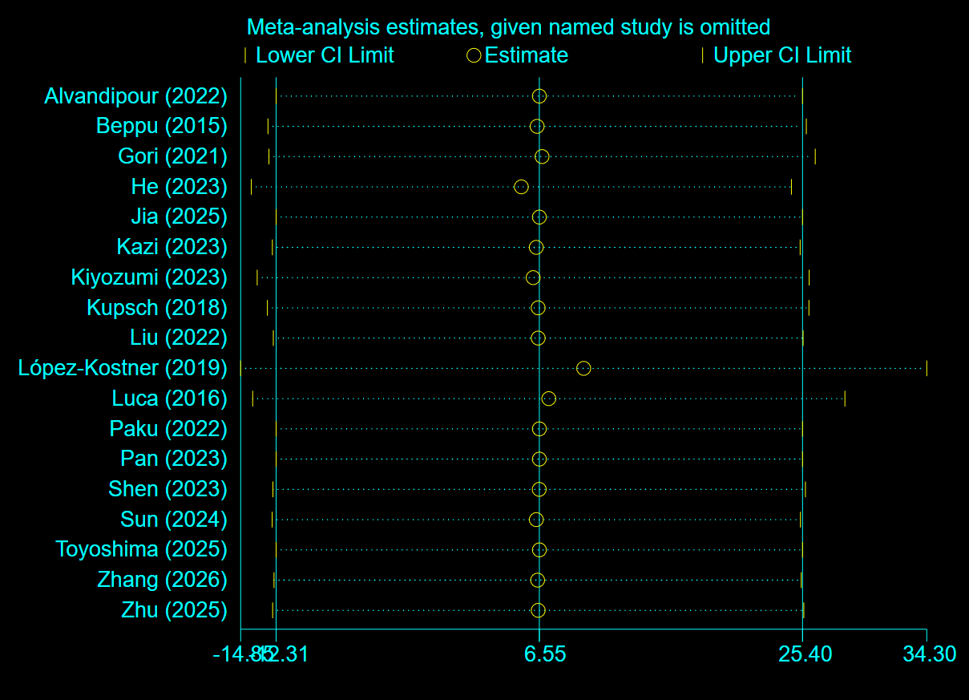
Figure S5. Leave-one-out sensitivity analysis for pooled minor LARS prevalence.
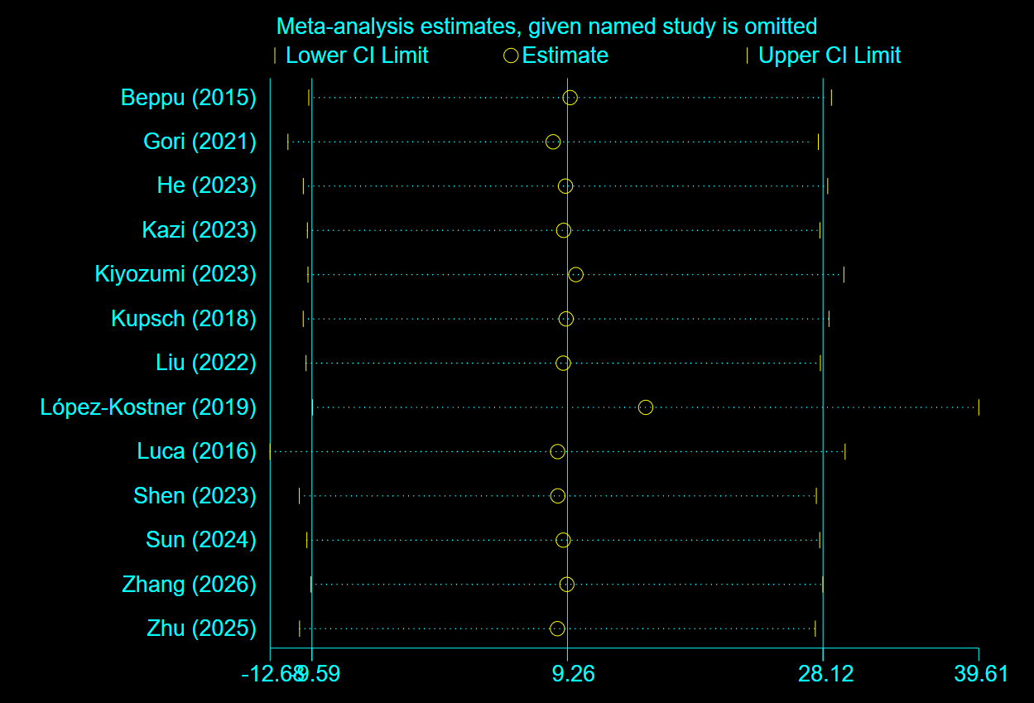
Figure S6. Leave-one-out sensitivity analysis for pooled prevalence of no LARS.

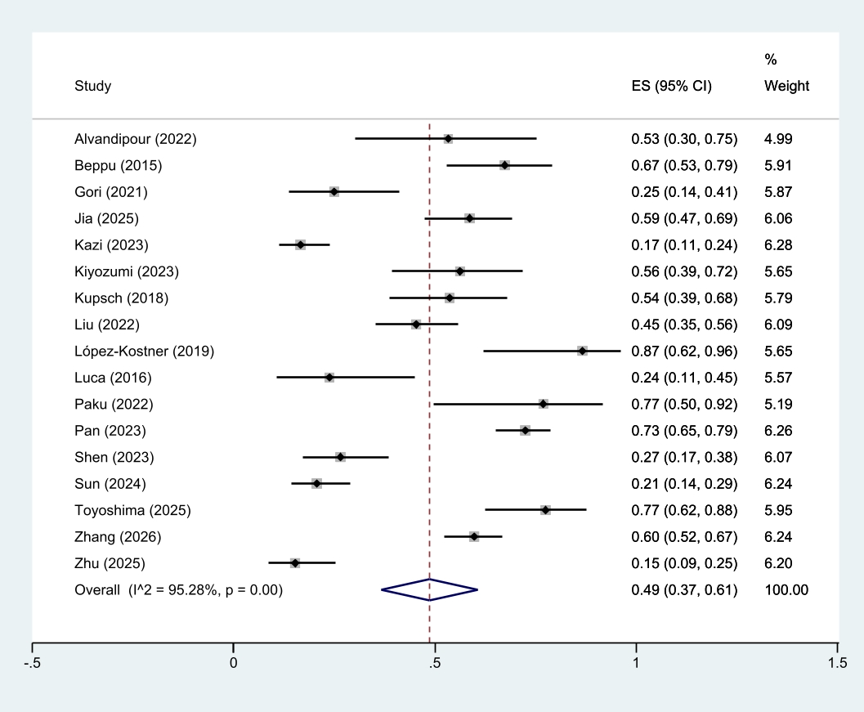
Figure S7. Sensitivity analysis of major LARS prevalence after excluding He (2023).

1. Alvandipour M, Karami MY, Azadfar M, Charati JY. Inter sphincter rectal resection with and without Malone ante grade continence enema in cases with low rectal cancer: A randomized, prospective, single-blind, clinical trial. Caspian Journal of Internal Medicine. 2022;13(3):546-54.
2. Beppu N, Kimura H, Matsubara N, Tomita N, Yanagi H, Yamanaka N. Long-Term Functional Outcomes of Total Mesorectal Excision Following Chemoradiotherapy for Lower Rectal Cancer: Stapled Anastomosis versus Intersphincteric Resection. Digestive Surgery. 2016;33(1):33-42.
3. Gori J, Kazi M, Rajkumar B, Bhuta P, Ankathi SK, Desouza A, et al. Comparative study of functional outcomes between ultra-low anterior resection and inter-sphincteric resection: a propensity matched analysis. ANZ Journal of Surgery. 2022;92(1-2):151-6.
4. He Z, Peng B, Chen W, Zhu J, Chen B, Li G, et al. Clinical Efficacy of Intersphincteric Resection for Low Rectal Cancer Compared With Abdominoperineal Resection: A Single-Center Retrospective Study. American Surgeon. 2023;89(4):1009-17.
5. Jia Y, Zhang B, Zhao Y, Zhuo G, Song X, Xiang J, et al. Functional outcomes and quality of life after intersphincteric resection with transverse coloplasty pouch anastomosis for ultralow rectal cancer: a prospective cohort study. Techniques in Coloproctology. 2025;29(1).
6. Kazi M, Jajoo B, Rohila J, Dohale S, Bhuta P, Desouza A, et al. Functional outcomes after robotic or laparoscopic intersphincteric resection - An inverse probability weighting analysis. Eur J Surg Oncol. 2023;49(1):196-201.
7. Kiyozumi Y, Nagasaki T, Matsui S, Mukai T, Hiyoshi Y, Yamaguchi T, et al. The evaluation of postoperative bowel dysfunction in Japanese patients with rectal cancer. Surgery Today. 2023;53(5):596-604.
8. Kupsch J, Jackisch T, Matzel KE, Zimmer J, Schreiber A, Sims A, et al. Outcome of bowel function following anterior resection for rectal cancer-an analysis using the low anterior resection syndrome (LARS) score. Int J Colorectal Dis. 2018;33(6):787-98.
9. Liu ZH, Zeng ZW, Jie HQ, Huang L, Luo SL, Liang WF, et al. Transanal total mesorectal excision combined with intersphincteric resection has similar long-term oncological outcomes to laparoscopic abdominoperineal resection in low rectal cancer: A propensity score-matched cohort study. Gastroenterology Report. 2022;10.
10. Francisco LK, Carlos MF, Alejandro ZC, Claudio WG, Udo K, Alejandra PF. Long-term results of patients with adenocarcinoma of the lower rectum treated with anterior intersphinteric ultra-low-resection. Revista de Cirugia. 2019;71(3):238-44.
11. Luca F, Valvo M, Guerra-Cogorno M, Simo D, Blesa-Sierra E, Biffi R, et al. Functional results of robotic total intersphincteric resection with hand-sewn coloanal anastomosis. European Journal of Surgical Oncology. 2016;42(6):841-7.
12. Paku M, Miyoshi N, Fujino S, Hata T, Ogino T, Takahashi H, et al. Development and evaluation of a Japanese prediction model for low anterior resection syndrome after rectal cancer surgery. BMC Gastroenterology. 2022;22(1).
13. Pan H, Zhao Z, Deng Y, Zheng Z, Huang Y, Chi P, et al. Transverse Coloplasty Pouch versus Straight Coloanal Anastomosis Following Intersphincteric Resection for Low Rectal Cancer: the Functional Benefits May Emerge After Two Years. Journal of Gastrointestinal Surgery. 2023;27(11):2526-37.
14. Shen Y, Yang T, Zeng H, Meng W, Deng X, Wei M, et al. Low anterior resection syndrome and quality of life after intersphincteric resection for rectal cancer: a propensity score-matched study. Techniques in Coloproctology. 2023;27(12):1307-17.
15. Sun L, Zhou J, Ji L, Zhao S, Li R, Fu Y, et al. Sphincter-preserving effect of robotic-assisted intersphincteric resection for ultra-low rectal cancer: a propensity score matching analysis. Journal of Robotic Surgery. 2024;18(1).
16. Toyoshima A, Nishizawa T, Toyoshima O, Akai R, Kaneko M, Sasaki S. Impact of low anterior resection syndrome after rectal surgery on sleep quality. Surgery Today. 2025;55(12):1868-74.
17. Zhang B, Zou CC, Ma HT, Zhao YJ, Zhuo GZ, Xiang JB, et al. Association of symptom complexes with consequence severity in low anterior resection syndrome after intersphincteric resection for ultralow rectal cancer: An exploratory cross-sectional study. J Gastrointest Surg. 2026:102421.
18. Ota E, Nagasaki T, Akiyoshi T, Mukai T, Hiyoshi Y, Yamaguchi T, et al. Incidence and risk factors of bowel dysfunction after minimally invasive rectal cancer surgery and discrepancies between the Wexner score and the low anterior resection syndrome (LARS) score. Surg Today. 2024;54(7):763-70.
19. Sun G, Zang Y, Ding H, Chen Y, Groothof D, Gong H, et al. Comparison of anal function and quality of life after conformal sphincter preservation operation and intersphincteric resection of very low rectal cancer: a multicenter, retrospective, case–control analysis. Techniques in Coloproctology. 2023;27(12):1275-87.
20. Trenti L, Galvez A, Biondo S, Solis A, Vallribera-Valls F, Espin-Basany E, et al. Quality of life and anterior resection syndrome after surgery for mid to low rectal cancer: A cross-sectional study. EJSO. 2018;44(7):1031-9.
21. Zakaria R, Amin MM. Incidence and risk factors of low anterior resection syndrome with validation of low anterior resection syndrome score questionnaire among the Egyptian patients. EGYPTIAN JOURNAL OF SURGERY. 2024;43(4):1511-9.
22. Suraga B, Nayak SP, Gangadhara B, Reddy S, Khan A, Munisiddaiah D, et al. Low anterior resection syndrome after sphincter-preserving surgery for rectal cancer: predictive factors and impact on perceived functional satisfaction. Discover Oncology. 2026.
23. Rubinkiewicz M, Zarzycki P, Czerwińska A, Wysocki M, Gajewska N, Torbicz G, et al. A quest for sphincter-saving surgery in ultralow rectal tumours - A single-centre cohort study. World Journal of Surgical Oncology. 2018;16(1).
24. Farouk A, Hamdy E, Fouad A, Hamed H. Oncological and functional outcomes of sphincter saving procedures versus abdominoperineal resection for low rectal cancer: A comparative prospective cohort study. EGYPTIAN JOURNAL OF SURGERY. 2024;43(4):1247-57.
25. Kitaguchi D, Nishizawa Y, Sasaki T, Tsukada Y, Ito M. Clinical benefit of high resolution anorectal manometry for the evaluation of anal function after intersphincteric resection. Colorectal Dis. 2019;21(3):335-41.
26. Yan S, Zhou M, Zhou Y, Zhou Z, Tan D, Li Z, et al. Intersphincteric complex a potential metastasis niche in ultralow rectal cancer and prognostic significance of its complete excision following intersphincteric resection - a prospective cohort study. Int J Surg. 2025;111(7):4434-42.
27. Bo Y, Wang YG, Zheng MY, Zhao J, Li YX. Long-term functional and prognostic outcomes of robotic intersphincteric resection for treating low rectal cancer: a single-center retrospective study. INTERNATIONAL JOURNAL OF COLORECTAL DISEASE. 2025;40(1).
28. Zhu H, Zou J, Pan H, Huang Y, Chi P. Comparison of laparoscopic versus robot-assisted sugery for rectal cancer after neo-adjuvant therapy: a large volume single center experience. BMC Surgery. 2025;25(1).
29. Mahalingam S, Seshadri RA, Veeraiah S. Long-Term Functional and Oncological Outcomes Following Intersphincteric Resection for Low Rectal Cancers. Indian Journal of Surgical Oncology. 2017;8(4):457-61.
30. Liao J, Qin H, Wang Z, Meng L, Wang W, Liu J, et al. Mesorectal reconstruction with pedicled greater omental transplantation to relieve low anterior resection syndrome following total intersphincteric resection in patients with ultra-low rectal cancer. BMC Surg. 2023;23(1):236.
31. Kitaguchi D, Hasegawa H, Ando K, Ikeda K, Tsukada Y, Nishizawa Y, et al. Can the Single-stapling Technique Following Intersphincteric Resection with Transanal Total Mesorectal Excision Become the New Standard Anastomosis? J Anus Rectum Colon. 2023;7(4):232-40.
32. Singh S, Kaderi ASA, Kazi M, Desouza A, Sharma A, Ankathi SK, et al. Sphincter-saving surgery for failed organ preservation after a neoadjuvant therapy and radiation boost: A surgeon's perspective. BMC Gastroenterol. 2025;25(1):384.

