Supplementary material for:
“Climate change impacts on the climatic suitability of major tree species across an Alpine gradient”

Matteo Gecchelin^{1,2}, Sebastian Marzini¹, Enrico Tomelleri³, Marco Mina^{1*}

¹ Institute for Alpine Environment, Eurac Research, Viale Druso 1, I-39100 Bolzano/Bozen, Italy
² TESAF Department, University of Padova, Viale dell’Universitá 16, Legnaro 35020, PD, Italy
³ Faculty of Agricultural, Environmental and Food Sciences, Free University of Bolzano, Piazza Università 5, 39100 Bolzano/Bozen, Italy

Contents
Additional figures and tables 2
Multivariate Environmental Similarity Surfaces analysis 12
References 14

Additional figures and tables

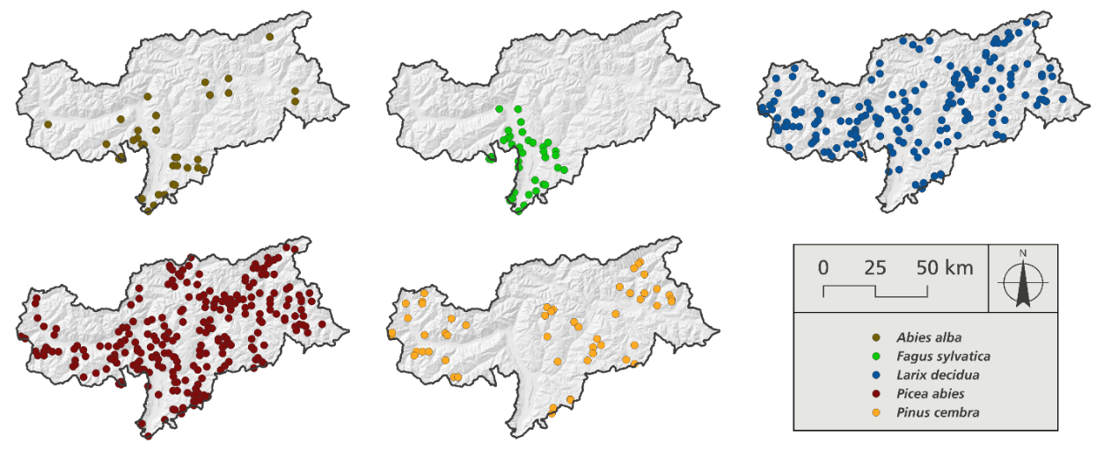
Figure S1. Location of the presence data points by species used as input in MaxEnt. Silver fir (Abies alba) 36 points, European beech (Fagus sylvatica) 37 points, European larch (Larix decidua) 169 points, Norway spruce (Picea abies) 245 points, Swiss stone pine (Pinus cembra) 53 points. As in Figure 1, points retrieved from the Italian NFI are visualized as the coordinates of the southwestern corner of the 1 km grid for privacy restrictions.
Table S1. Final list of environmental predictors used for the modelling.
Code | Environmental variable | Description | Unit
Bio1 | Mean Annual Air Temperature | Mean annual temperature calculated as the average of mean monthly temperatures over the year | °C
Bio12 | Annual Precipitation amount | Sum of monthly precipitation totals across the year | mm
Bio15 | Precipitation Seasonality | Coefficient of variation (100 × SD ÷ mean) of monthly precipitation totals | mm
scd | Snow Cover Days | Number of days per year with snow cover present at the surface | days
elevation | Elevation | Vertical elevation above mean sea level | m a.s.l.
north | Northness | Values between 1 (due north) and -1 (due south). Calculated with the formula cos(aspect*pi/180) | unitless
east | Eastness | Values between 1 (east) and -1 (west). Calculated with the formula: sin(aspect*pi/180) | unitless
slope | Slope | Gradient or steepness from each cell of a raster | degrees
geo | Geological unit | Main geological type (39 units) | categorical

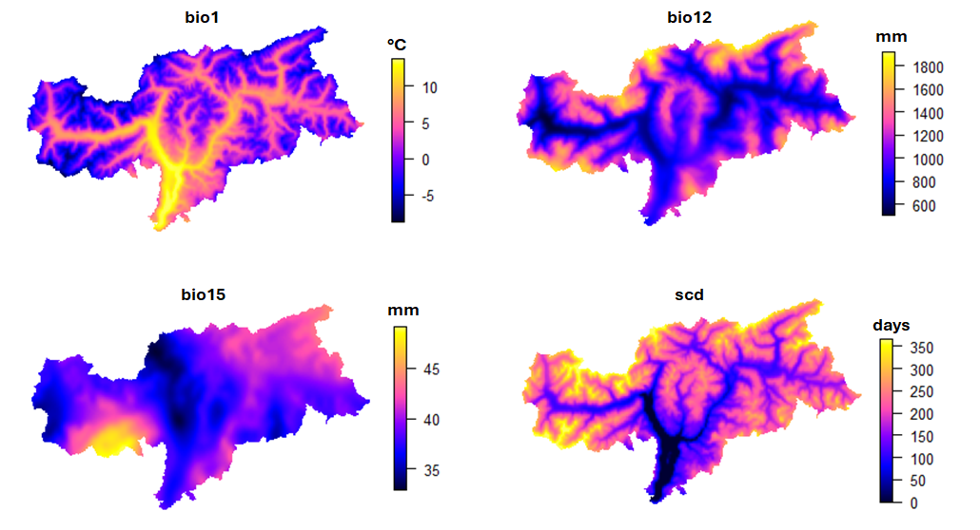
Figure S2. The variability of the four climatic variables across the study region at a spatial resolution of 10 m (bio1: mean annual temperature; bio12: annual precipitation amount; bio15: precipitation seasonality; scd: snow cover days). Values represent the mean over the reference period (1981-2010).

Table S2. Land-use classes from the map by (Marsoner et al., 2023) used to post-process model outputs. Classes not belonging to the list in the table were masked out as non-suitable for the establishment of vegetation.
EUSALP Code | EUSALP Label | Harmonized Class
23100 | Managed grassland - Pastures | Alpine Grasslands
23200 | Seminatural grassland - Meadows | Alpine Grasslands
31100 | Broadleaf tree cover | Forests
31102 | Broadleaf tree cover 30-60% | Forests
31103 | Broadleaf tree cover 60-100% | Forests
31200 | Coniferous tree cover | Forests
31202 | Coniferous tree cover 30-60% | Forests
31203 | Coniferous tree cover 60-100% | Forests
31300 | Mixed tree cover | Forests
31400 | Tree cover in agricultural context | Forests
31500 | Green linear elements - linear woody features | Forests
31600 | Patchy woody features | Forests
31610 | Additional woody features | Forests
32000 | Scrub and shrubland | Shrublands
32100 | Alpine and sub-alpine natural grassland | Alpine Grasslands
32200 | Moors and heathland - other scrubland | Shrublands
32300 | Sclerophyllous vegetation | Shrublands
33200 | Bare rocks and rock debris | Bare Rocks
33300 | Sparsely vegetated land | Sparsely Vegetated
33500 | Permanent snow covered surfaces | Permanent Snow

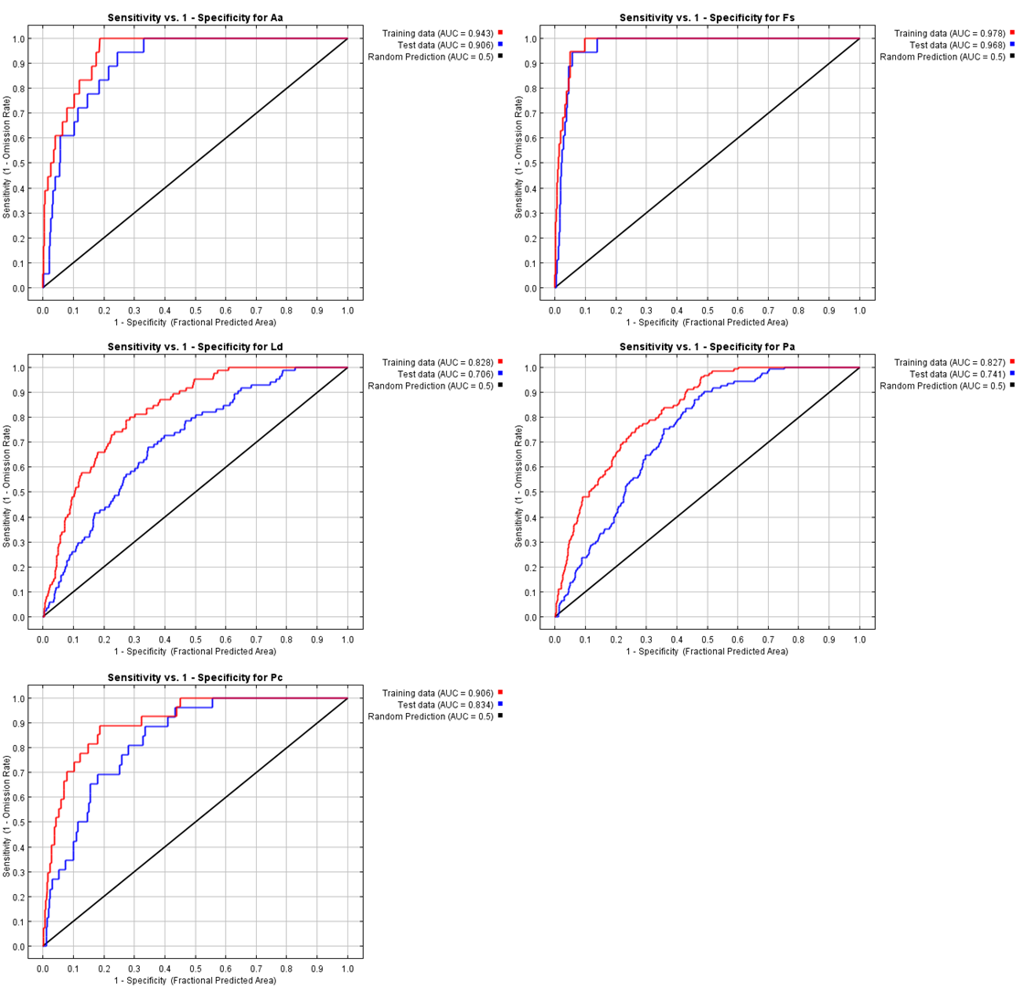Figure S3. ROC curves of the MaxEnt models for the current distribution of the five selected tree species (Aa=Abies alba/silver fir; Pa= Picea abies/Norway spruce; Fs= Fagus sylvatica/European beech, Ld= Larix decidua/European larch; Pc= Pinus cembra/Swiss stone pine). AUC value <0.5 indicates model performance worse than random, 0.5 not better than random, 0.5-0.7 poor performance, 0.7-0.9 good performance, > 0.9 very high performance. AUC values for the five models are also reported in Table A2.

Table S3. AUC values under the ROC curves for the five models obtained comparing sensitivity vs 1-specificity reported from Figure S4. Accuracy levels are reported according to (Phillips et al., 2006): poor 0.5-0.6, fair 0.6-0.7, good 0.7-0.8, very good 0.8-0.9, excellent 0.9-1.
Species | Training data | Test data | Accuracy
Silver fir | 0.943 | 0.906 | Excellent
European beech | 0.978 | 0.968 | Excellent
European larch | 0.828 | 0.706 | Good
Norway spruce | 0.827 | 0.741 | Good
Swiss stone pine | 0.906 | 0.834 | Very good

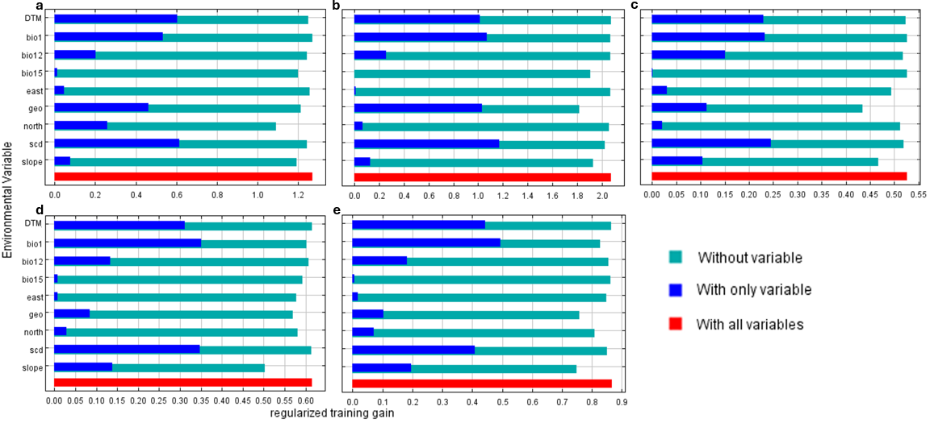
Figure S4. Contribution of the environmental predictors detected using the jackknife test for the five species: a. silver fir, b. European beech, c. European larch, d. Norway spruce, and e. Swiss stone pine. Beware of the different scale of x-axis across the panels.

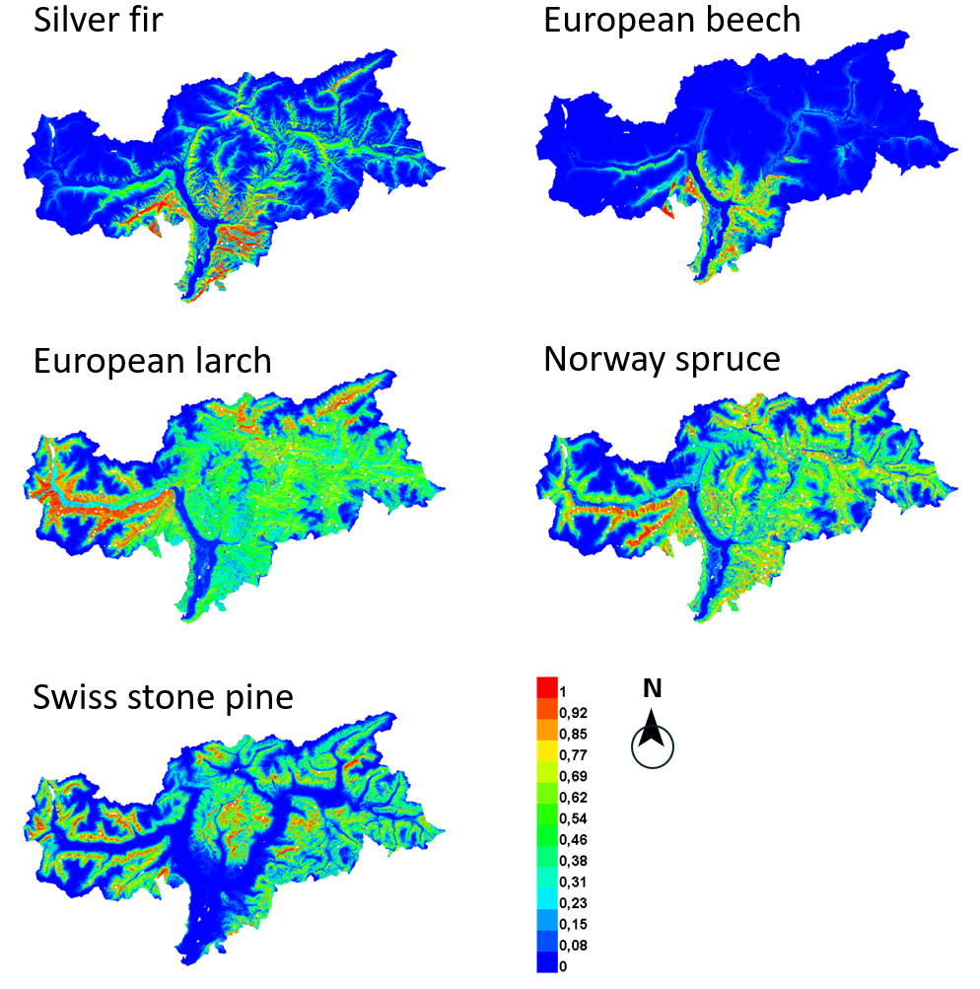
Figure S5. Current climate suitability (1980-2010) of the five tree species displayed as continuous probability as obtained by MaxEnt modelling. Differently from the binarized maps shown in Figure 3 in the main manuscript, continuous probability maps allow to detect fine-scale variation of habitat suitability across space, helping identify core suitable areas (e.g., probability > 0.8) or transition zones rather than displaying a presence/absence cutoff.

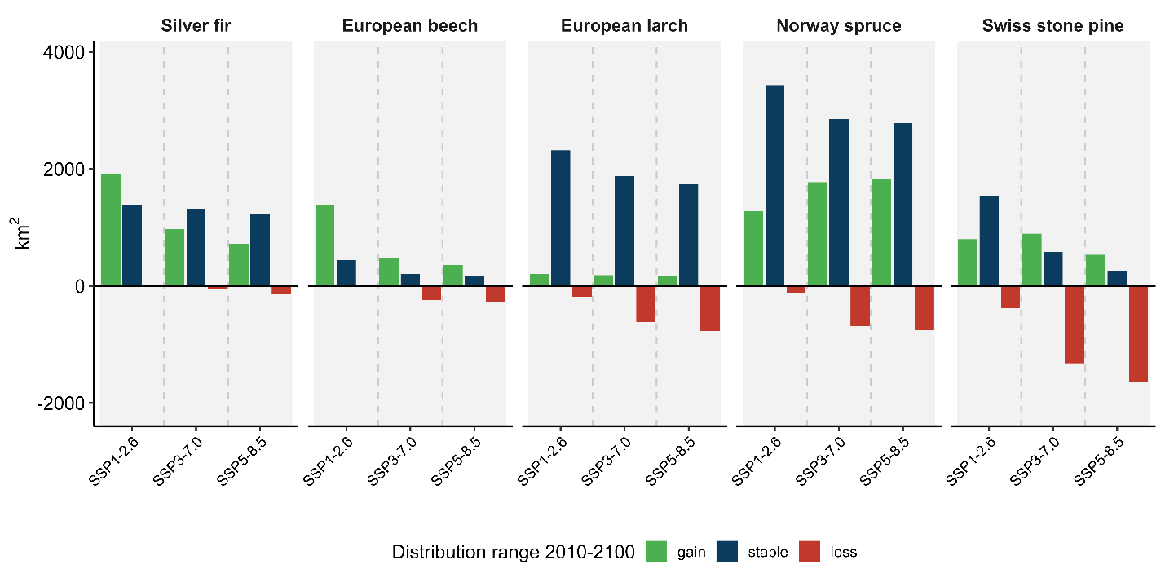
Figure S6. Suitability distribution area of the five species in 2100 under climate change scenarios. Bars indicate the amount of area (km²) that was gained (green), lost (red) or remained stable (blue) in the 2100 compared to current period. Because values are expressed as absolute area (km²), differences in bar height reflect species’ current range size.

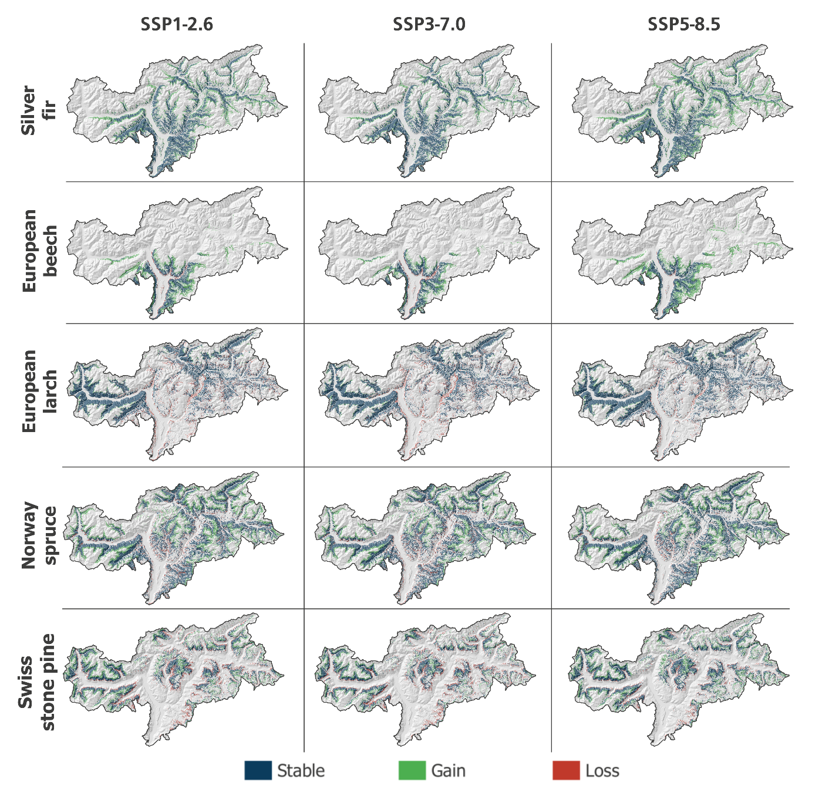
Figure S7. Projected changes in climatic suitability between current (2010) and the period 2011-2040 displayed as stable areas (blue), gain areas (green) and loss areas (red) for the five tree species under the three future climate scenarios (SSP1, SSP3 and SSP5).

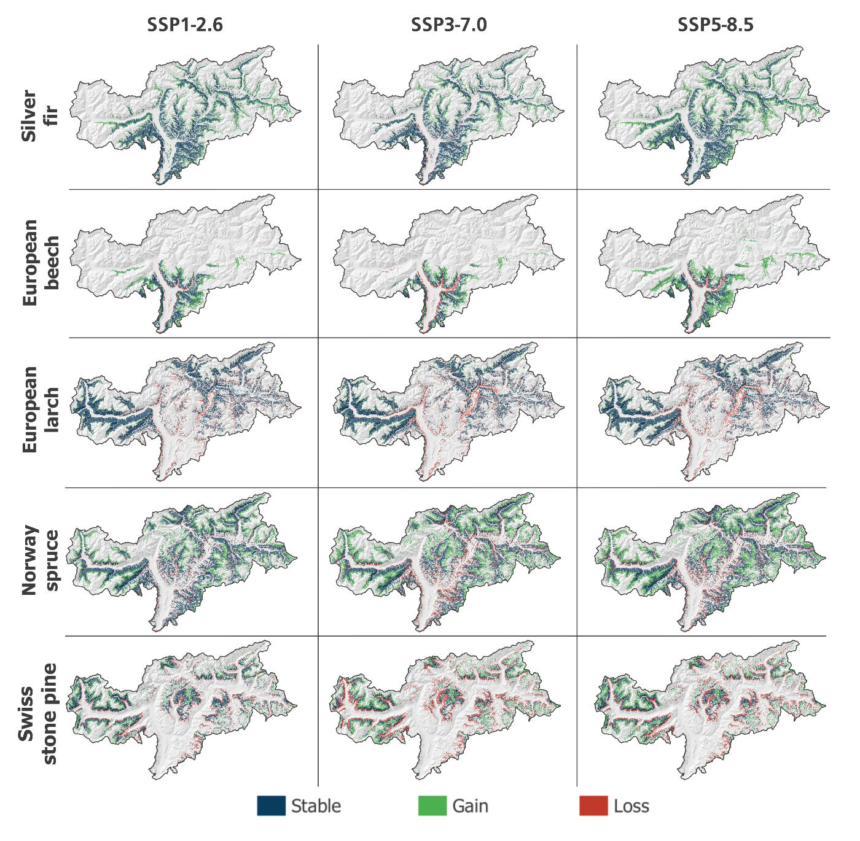
Figure S8. Projected changes in climatic suitability between current (2010) and the period 2041-2070 displayed as stable areas (blue), gain areas (green) and loss areas (red) for the five tree species under the three future climate scenarios (SSP1, SSP3 and SSP5).

Table S4. Mean elevation and percentile values (10th and 90th) for the modelled species under the different climate scenarios for the period 2011-2040.
Species | Scenario | Mean elevation (m a.s.l.) | 10th percentile  (m a.s.l.) | 90th percentile  (m a.s.l.)
Silver fir | SSP1-2.6 | 1369 | 900 | 1800
Silver fir | SSP3-7.0 | 1346 | 900 | 1700
Silver fir | SSP5-8.5 | 1400 | 900 | 1800
European beech | SSP1-2.6 | 1225 | 900 | 1600
European beech | SSP3-7.0 | 1200 | 900 | 1500
European beech | SSP5-8.5 | 1240 | 800 | 1600
European larch | SSP1-2.6 | 1634 | 1100 | 2100
European larch | SSP3-7.0 | 1635 | 1100 | 2100
European larch | SSP5-8.5 | 1624 | 1100 | 2100
Norway spruce | SSP1-2.6 | 1727 | 1200 | 2200
Norway spruce | SSP3-7.0 | 1711 | 1200 | 2100
Norway spruce | SSP5-8.5 | 1693 | 1200 | 2100
Swiss stone pine | SSP1-2.6 | 2152 | 1800 | 2500
Swiss stone pine | SSP3-7.0 | 2127 | 1800 | 2400
Swiss stone pine | SSP5-8.5 | 2105 | 1800 | 2400

Table S5. Mean elevation and percentile values (10th and 90th) for the modelled species under the different climate scenarios for the period 2041-2070.
Species | Scenario | Mean elevation (m a.s.l.) | 10th percentile  (m a.s.l.) | 90th percentile  (m a.s.l.)
Silver fir | SSP1-2.6 | 1369 | 900 | 1800
Silver fir | SSP3-7.0 | 1396 | 1000 | 1800
Silver fir | SSP5-8.5 | 1440 | 1000 | 1900
European beech | SSP1-2.6 | 1241 | 900 | 1600
European beech | SSP3-7.0 | 1282 | 1000 | 1600
European beech | SSP5-8.5 | 1349 | 1000 | 1700
European larch | SSP1-2.6 | 1636 | 1100 | 2100
European larch | SSP3-7.0 | 1710 | 1200 | 2200
European larch | SSP5-8.5 | 1690 | 1200 | 2200
Norway spruce | SSP1-2.6 | 1749 | 1300 | 2200
Norway spruce | SSP3-7.0 | 1864 | 1400 | 2300
Norway spruce | SSP5-8.5 | 1863 | 1300 | 2300
Swiss stone pine | SSP1-2.6 | 2173 | 1900 | 2500
Swiss stone pine | SSP3-7.0 | 2302 | 2000 | 2600
Swiss stone pine | SSP5-8.5 | 2285 | 2000 | 2600

Multivariate Environmental Similarity Surfaces analysis
The MESS analysis (Elith et al., 2010) showed that most future projections remained within climatic conditions comparable to those represented in the reference period, although the degree of extrapolation increased toward the end of the century and under more severe climate scenarios. Negative MESS values indicate non-analog climatic conditions, where at least one predictor falls outside the environmental range represented in the reference period used for model calibration. (Fig. S9). Since MESS was calculated from the same set of climatic predictors and over the same projection extent for all species, the percentage of climatically novel conditions is reported by period and scenario rather than separately for each species.
In the near future, the percentage of the study region characterized by non-analog climatic conditions was low, ranging from 3.56% under SSP3-7.0 to 4.28% under SSP1-2.6 (Table S6). A similar pattern was observed under SSP1-2.6 and SSP5-8.5 for 2041–2070, while SSP3-7.0 showed a more marked increase in extrapolation, with 13.91% of the study area characterized by negative MESS values. The strongest extrapolation occurred in 2071–2100 under SSP5-8.5, where 43.13% of the study region showed negative MESS values and 34.19% had MESS values below -5. This indicates that late-century projections under the highest-emission scenario include a proportion of climatic conditions not represented in the calibration domain, and therefore should interpreted accordingly.

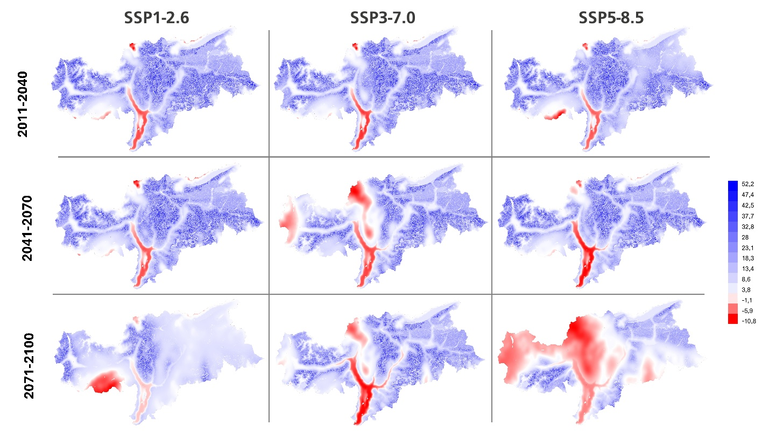
Figure S9. Maps showing the Multivariate Environmental Surface Similarity (MESS) values for combination of climate scenarios and future periods. MESS values below zero (pink to red color) indicate that predictions are slightly out of the range of the training variables.

Table S6. Multivariate Environmental Similarity Surface analysis for future climate projections. The table reports the percentage of pixels characterized by negative MESS values and by MESS values below -5 for each period and climate scenario. Values below -5 were used to identify areas of stronger climatic extrapolation.
Period | Scenario | MESS < 0 (%) | MESS < -5 (%) | Mean MESS
2011–2040  2011–2040  2011–2040  2041–2070  2041–2070  2041–2070  2071–2100  2071–2100  2071–2100 | SSP1-2.6  SSP3-7.0  SSP5-8.5  SSP1-2.6  SSP3-7.0  SSP5-8.5  SSP1-2.6  SSP3-7.0  SSP5-8.5 | 4.28  3.56  4.17  4.54  13.91  5.8  8.29  11.14  43.13 | 1.75  1.45  1.6  2.15  7.3  3.52  5.55  6.37  34.19 | 13.28  13.28  12.59  13.02  9.31  11.98  6.25  9.09  -1.47

References
Elith, J., Kearney, M., and Phillips, S. (2010). The art of modelling range-shifting species: The art of modelling range-shifting species. Methods Ecol. Evol. 1, 330–342. doi: 10.1111/j.2041-210X.2010.00036.x
Marsoner, T., Simion, H., Giombini, V., Egarter Vigl, L., and Candiago, S. (2023). A detailed land use/land cover map for the European Alps macro region. Sci. Data 10, 468. doi: 10.1038/s41597-023-02344-3
Phillips, S. J., Anderson, R. P., and Schapire, R. E. (2006). Maximum entropy modeling of species geographic distributions. Ecol. Model. 190, 231–259.

