Supplementary Materials for "Collaborative Governance for Cybersecurity under Information Asymmetry: A Tripartite Evolutionary Game with Whistleblowing Incentives"
This document provides additional numerical simulations to support the robustness checks and sensitivity analyses discussed in Section 6.4 of the main manuscript. While the main text focuses on the impact of verification precision (q) and false-report penalties (f), these supplementary figures verify the stability of the proposed model under varying initial conditions and exogenous economic parameters (Government Penalty P and Non-compliance Benefit ΔC).

S1. Robustness Check: Independence of Initial Strategies
To verify that the identified equilibrium (specifically the "Silence Trap" or "Collaborative Equilibrium") is a global attractor rather than a local one, we simulated the system's evolution under different initial strategy distributions (x₀, y₀, z₀).
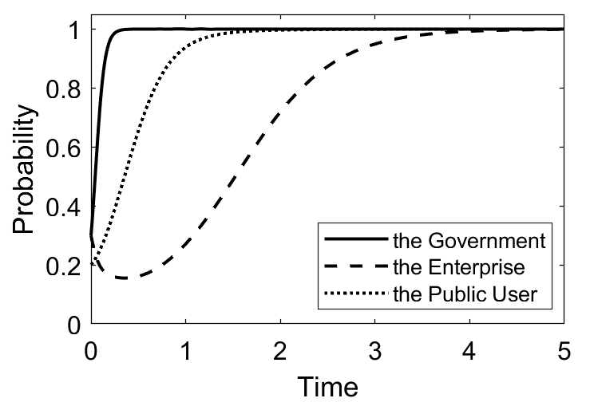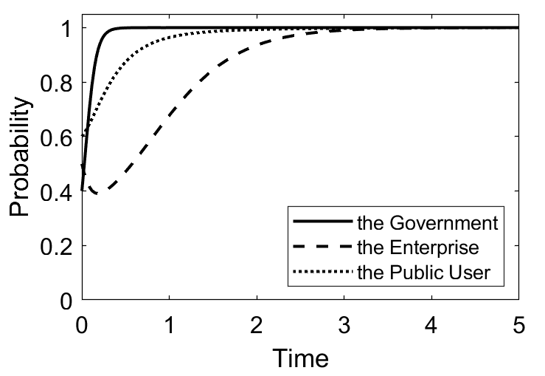（a）Low initial willingness（0.3, 0.3, 0.2 （b）Medium initial willingness（0.4, 0.5, 0.6）
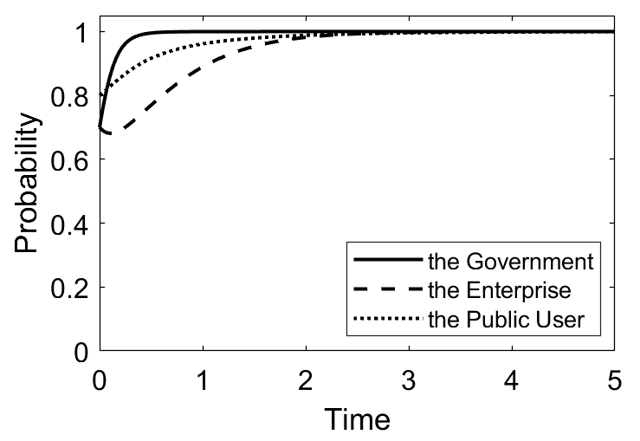
（c）High initial willingness （0.7, 0.7, 0.8）
Figure S1. Evolutionary trajectories of the system under different initial probabilities. (a) Low initial willingness (0.3, 0.3, 0.2); (b) Medium initial willingness (0.4, 0.5, 0.6); (c) High initial willingness (0.7, 0.7, 0.8).
As shown in Figure S1, regardless of whether the initial participation levels of the government, enterprise, or users are low (Panel a) or high (Panel c), the system eventually converges to the same stable equilibrium point E(1,1,1) under the baseline feasible parameters. This confirms the path independence of the model: the final evolutionary outcome is determined by the structural parameters (incentives and constraints) rather than historical starting points. Although higher initial willingness accelerates the convergence speed (shortening the time to stability), it does not alter the direction of evolution.

S2. Sensitivity Analysis: Impact of Government Penalty (P)
We examined how the intensity of the government's penalty on the enterprise (P) affects the evolutionary speed of corporate compliance (y).
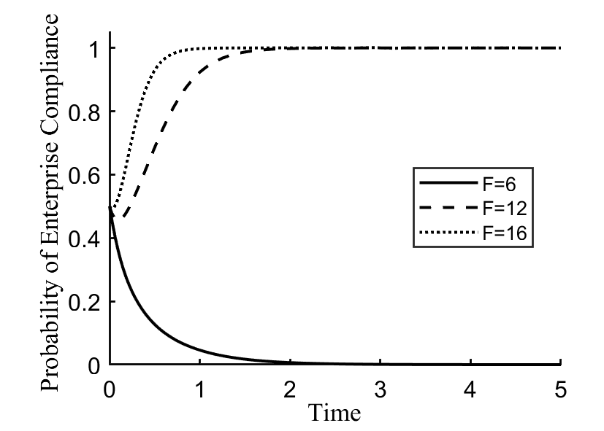
Figure S2. Sensitivity of Enterprise Compliance (y) to Government Penalty Intensity (P). The curves represent the evolutionary path of corporate compliance under Low (P=6), Medium (P=12), and High (P=16) penalty levels.
Figure S2 demonstrates the sensitivity of the enterprise's strategy to punitive measures.
Low Penalty (P=6): When P < ΔC (Penalty is less than the profit from non-compliance), the compliance probability y rapidly drops to 0. The penalty fails to serve as a deterrent.
High Penalty (P=16): When P > ΔC, the enterprise swiftly converges to full compliance (y=1).
Mechanism Validation: This simulation validates the assumption in our model that effective deterrence requires the sum of government penalties and user compensation mechanisms to exceed the violation benefit. It also highlights that while increasing P accelerates compliance, it must be paired with effective detection capabilities (as discussed in the main text's "Signal Quality" section) to be enforceable.

S3. Sensitivity Analysis: Impact of Non-compliance Gains (ΔC)
We further analyzed how the magnitude of potential cost savings from non-compliance (ΔC) influences the resilience of the governance system.
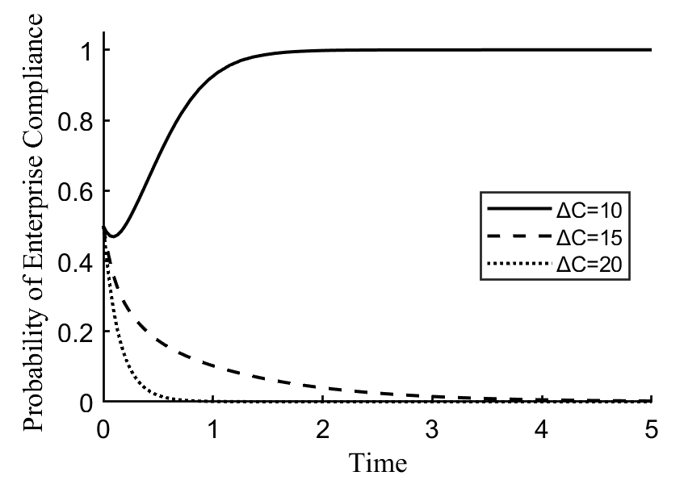
Figure S3. Sensitivity of Enterprise Compliance (y) to Non-compliance Cost Savings (ΔC). Trajectories showing the impact of increasing the economic motivation for violation (ΔC = 10, 15, 20).
Figure S3 illustrates the economic pressure on the governance system:
Low Benefit (ΔC = 10): When the gain from violation is minimal, the enterprise quickly adopts a compliance strategy (y→1) due to the relative high cost of penalties.
High Benefit (ΔC = 20): When ΔC is significantly high (exceeding the combined threat of penalties P and compensation M), the enterprise persists in non-compliance (y→0) despite regulatory efforts.
Implication: This result underscores the limitation of purely punitive approaches. If the economic incentive for cyber-violation is too high (e.g., in high-stakes data theft), standard penalties may be insufficient, necessitating the "high-precision" verification mechanism proposed in the main text to increase the certainty of punishment rather than just the severity.

