Metagenomic Insights into Lignocellulose-Degrading Microbiota in High-Temperature (75°C) Chicken Manure and Straw Compost via Nanopore Sequencing

Tigran Soghomonyan¹, Lev Khoyetsyan¹, Artur Hambardzumyan∗¹, Oleg Reva², Marina Paronyan¹, Karine Dyukova¹, Marieta Izmailyan¹, Anichka Hovsepyan¹, Anna Mkhitaryan¹

¹SPC “Armbiotechnology” NAS RA, Yerevan 0056, Gyurjyan 14, Republic of Armenia
²University of Pretoria, BGM, Centre for Bioinformatics and Computational Biology, Lynnwood Road, Hillcrest, Pretoria 0002, South Africa

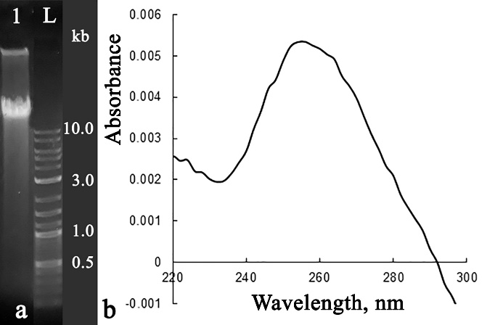
Fig. S1. Molecular and spectral characteristics of DNA prepared from thermophilic compost biomass. (a) – 0.8% agarose gel electrophoresis in TAE buffer (1 – metagenomic DNA sample; L – TriDye™ 1 kb Plus DNA Ladder, NEB); (b) – UV spectrum of a 301-fold diluted metagenomic DNA sample.

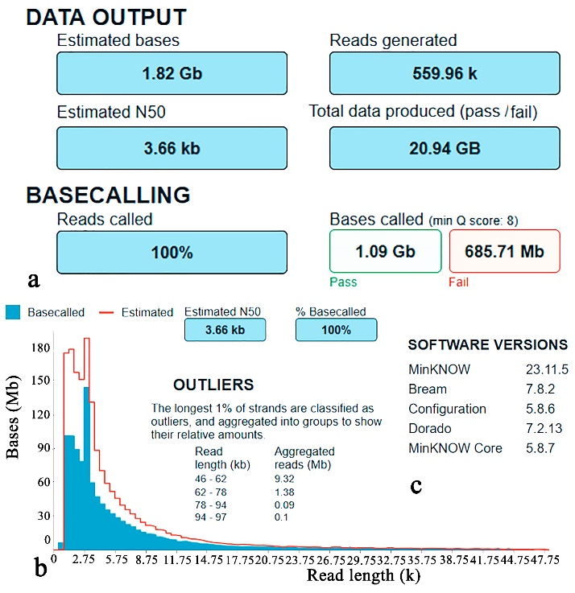
Fig. S2. Main parameters of the MinKNOW Run Report: (a) – Data output and basecalling parameters; (b) – Read length histogram with outliers; (c) – Software versions.

Table S1.
Distribution of quality reads of the obtained metagenome at the phylum level
fastq_pass_M2 | total | superkingdom | kingdom | phylum
169861 | 169861 | Bacteria | Thermotogati | Deinococcota
83893 | 83893 | Unclassified | Unknown | Unknown
44502 | 44502 | Bacteria | Pseudomonadati | Pseudomonadota
11414 | 11414 | Bacteria | Bacillati | Bacillota
2705 | 2705 | Bacteria | Pseudomonadati | Rhodothermota
2388 | 2388 | Bacteria | Bacillati | Actinomycetota
1264 | 1264 | Eukaryota | Metazoa | Chordata
622 | 622 | Bacteria | Thermotogati | Thermotogota
357 | 357 | Bacteria | Pseudomonadati | Bacteroidota
203 | 203 | Bacteria | Pseudomonadati | Thermomicrobiota
117 | 117 | Viruses | Heunggongvirae | Uroviricota
49 | 49 | Bacteria | Pseudomonadati | Thermodesulfobacteriota
18 | 18 | Bacteria | Pseudomonadati | Myxococcota

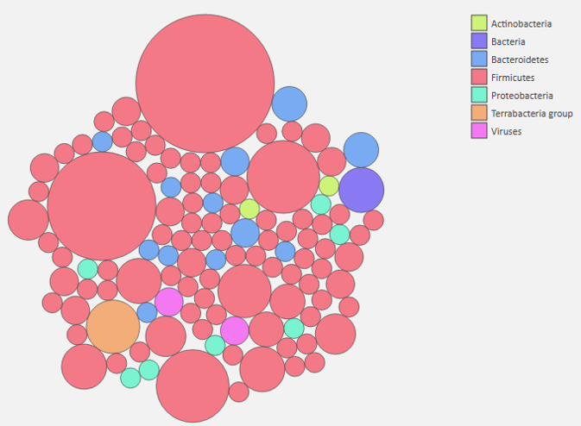
Fig. S3. Taxonomic abundance of bin.001 derived from the Kaiju web server.

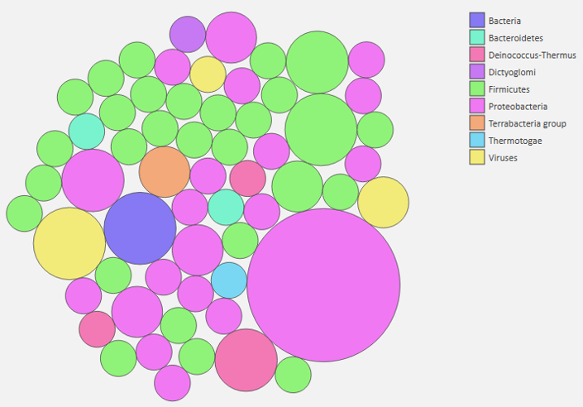
Fig. S4. Taxonomic abundance of bin.002 derived from the Kaiju web server.
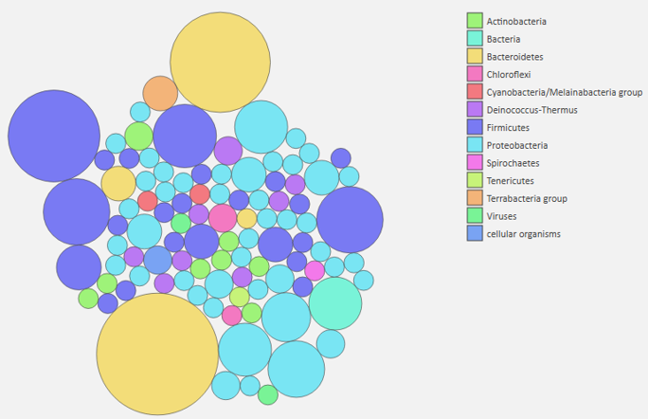
Fig. S5. Taxonomic abundance of bin.003 derived from the Kaiju web server.

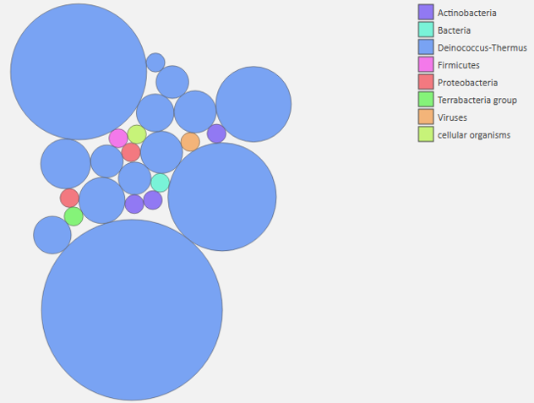
Fig. S6. Taxonomic abundance of bin.004 derived from the Kaiju web server.

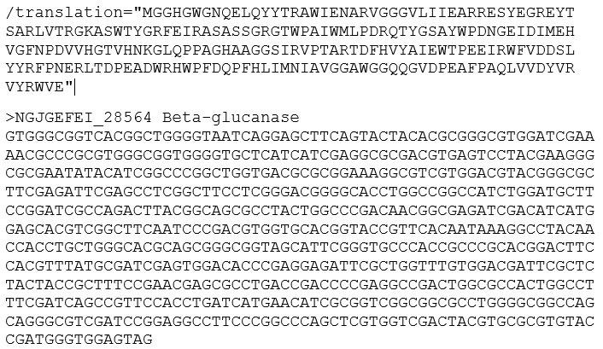
Fig. S7. Amino acid and nucleotide sequences of β-glucanase_28564.

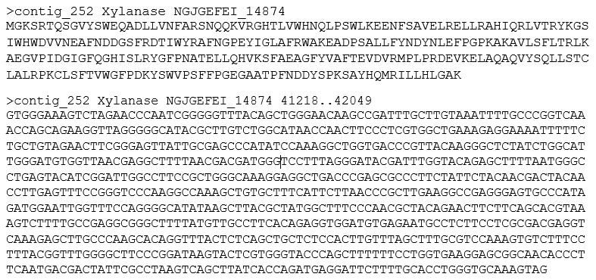
Fig. S8. Amino acid and nucleotide sequences of xylanase_14874.

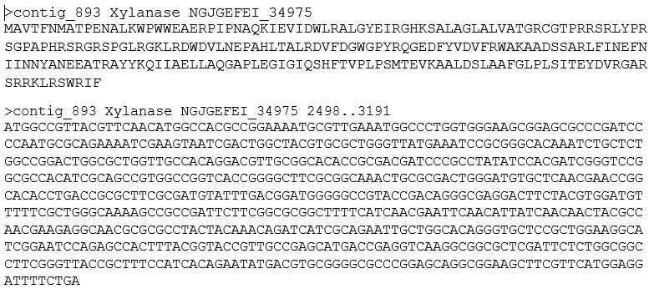
Fig. S9. Amino acid and nucleotide sequences of xylanase_34975.

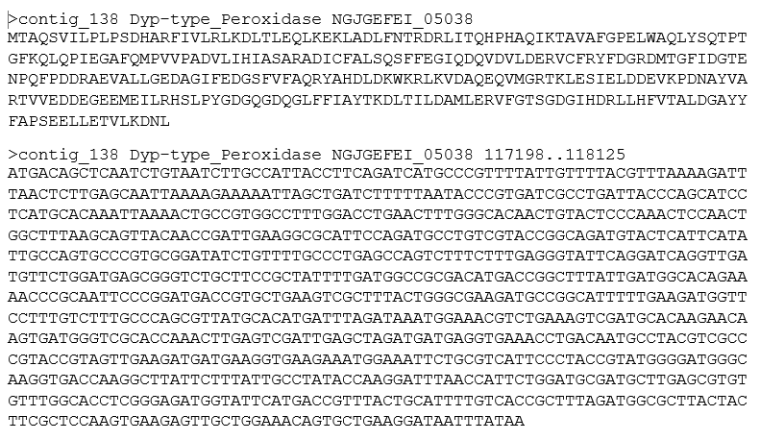
Fig. S10. Amino acid and nucleotide sequences of peroxidase_05038.

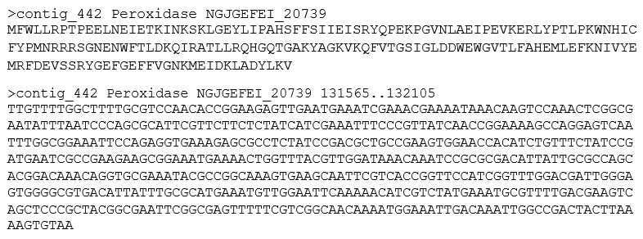
Fig. S11. Amino acid and nucleotide sequences of peroxidase_20739.

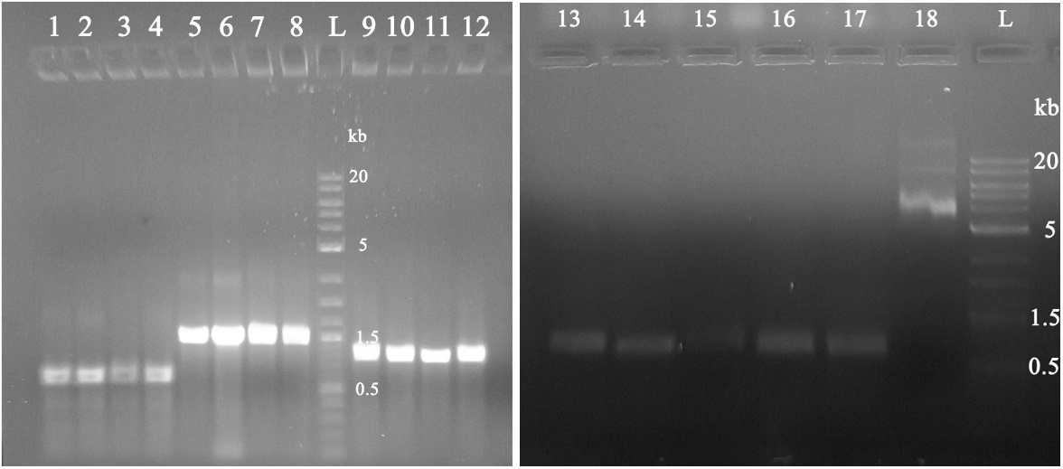
Fig. S12. Colony PCR results for B. subtilis RIK1285 strains harboring xylanase and peroxidase genes on the pBE-S vector. L — NEB TriDye™ 1 kb Plus DNA ladder. Lane identities: 1–4, Xyl_M2_34975; 5–8, Pox_M2_05038; 9–12, Xyl_M2_14874; 13–17, Pox_M2_20739; 18, pBE-S vector.

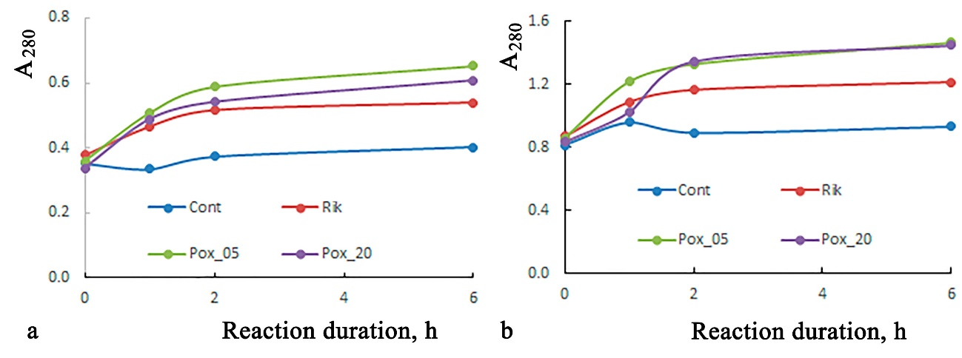
Fig. S13. Estimation of lignin-degrading activity of metagenome-derived peroxidases NGJGEFEI_05038 (05) and NGJGEFEI_20739 (20). Reaction conditions as described in Materials and Methods. (a) Reaction at pH 4.5; samples diluted 6-fold prior to measuring absorbance at 280 nm (A₂₈₀). (b) Reaction at pH 7.2; samples diluted 60-fold prior to measuring absorbance at 280 nm (A₂₈₀).

∗ Corresponding author

