Appendix 1: Digital Story Created with AI Support
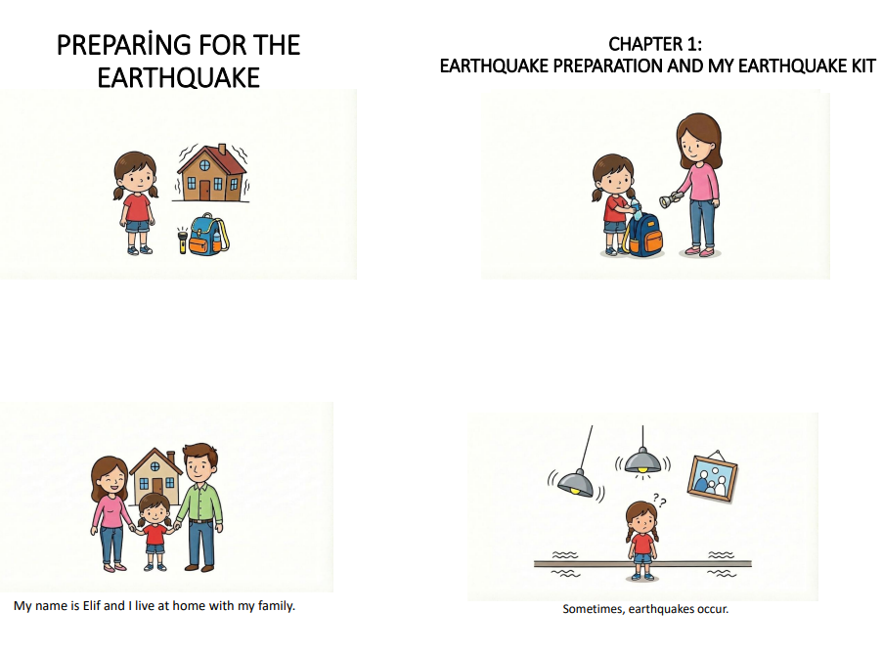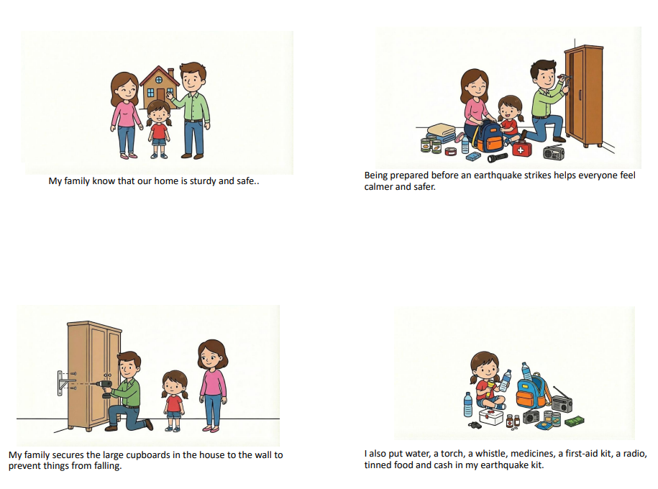
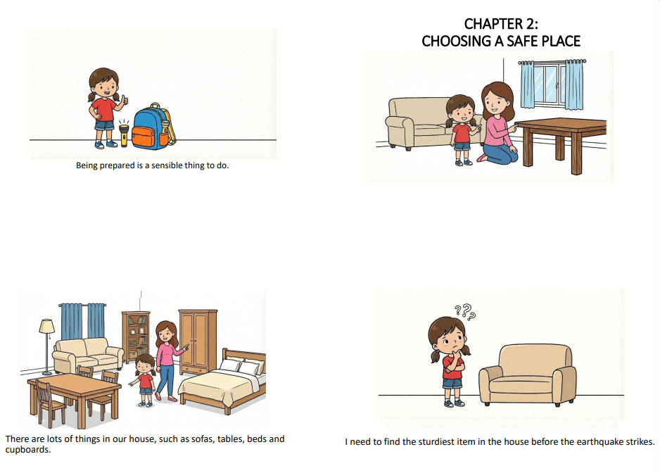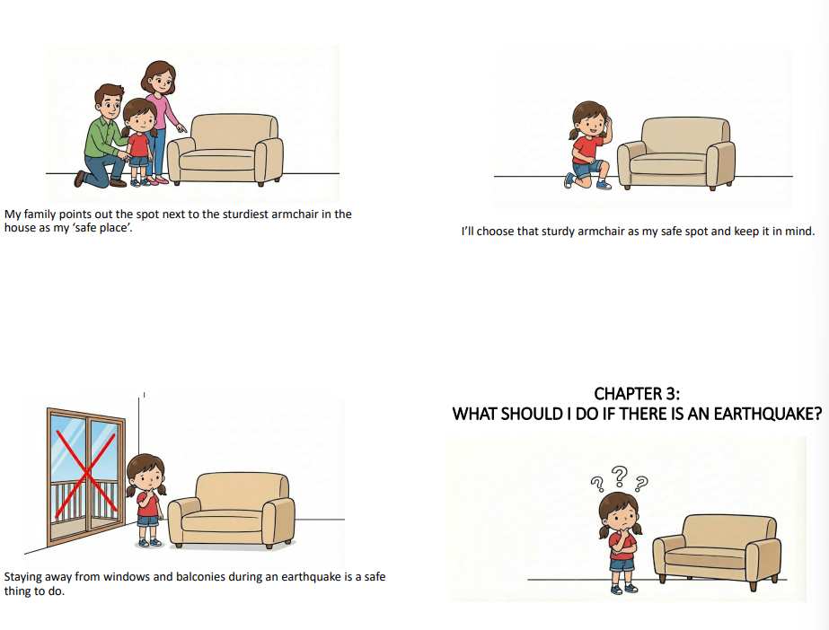

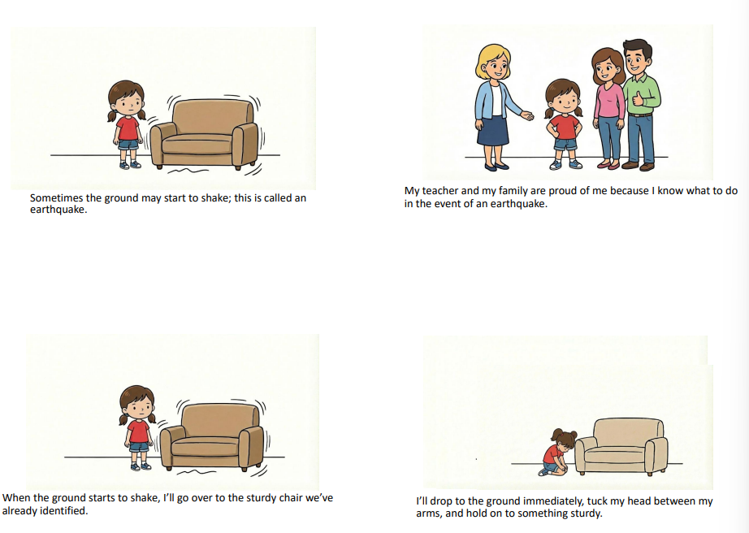
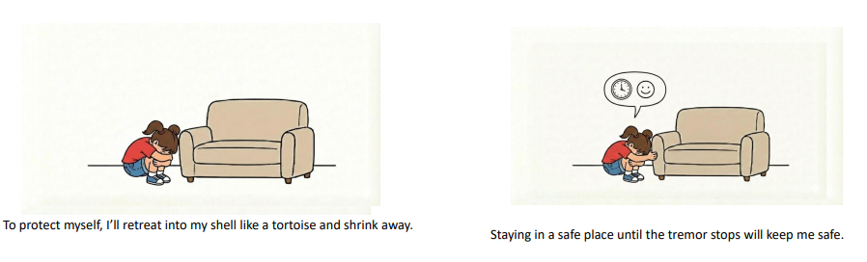

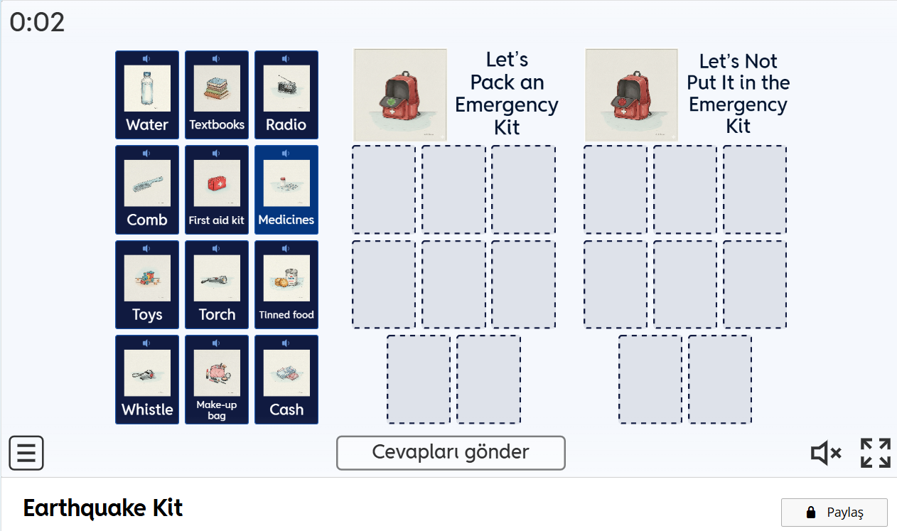
Appendix 2: Earthquake-Related Events
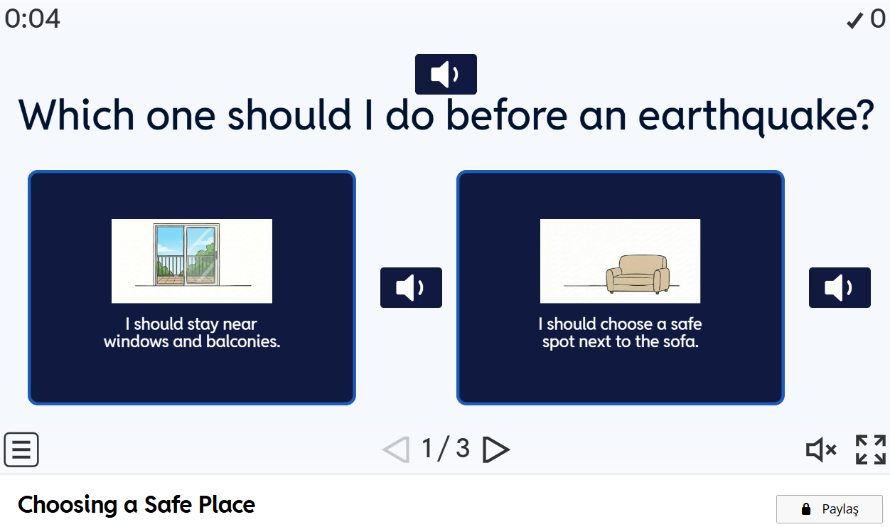

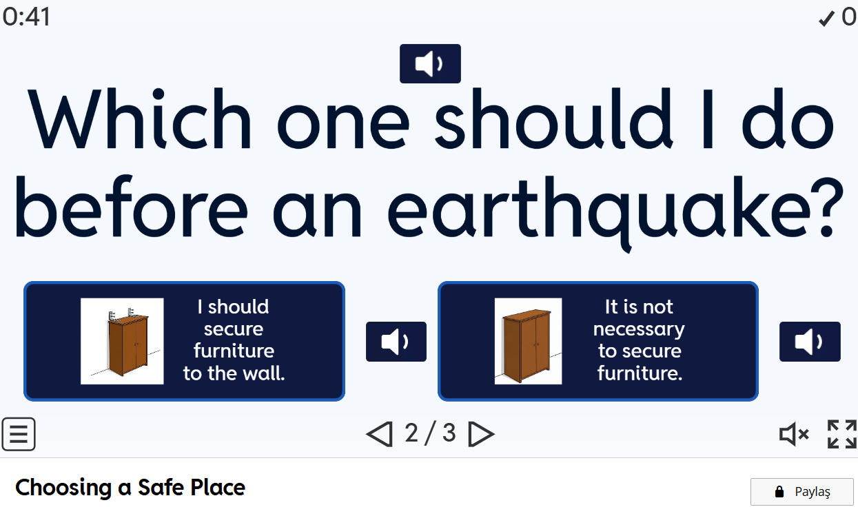
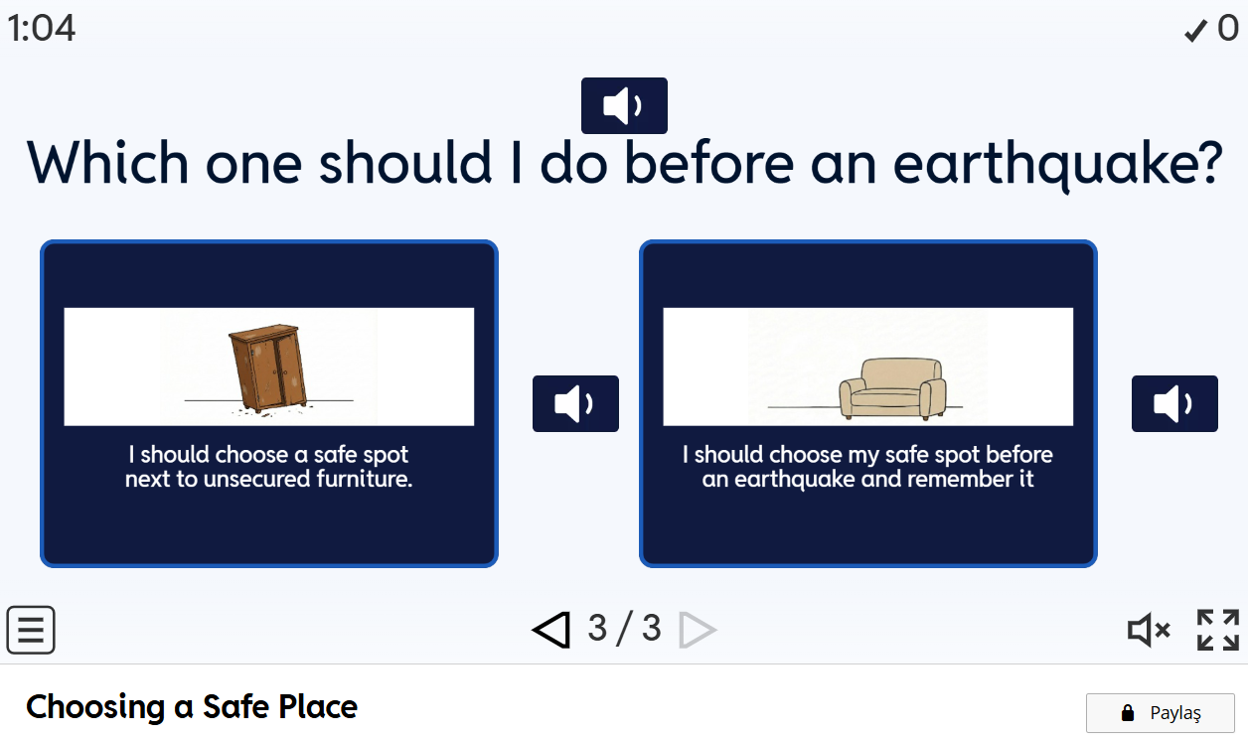
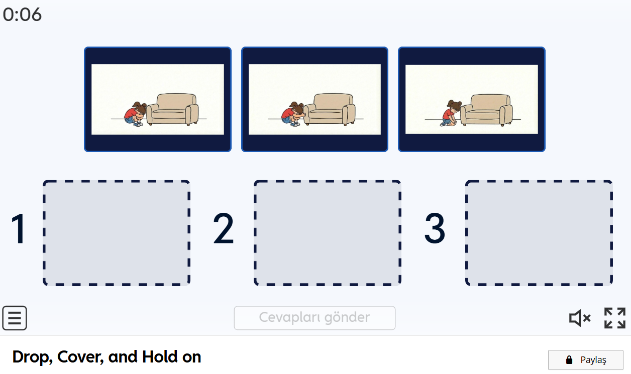

Appendix 3: Target Behavior Achievement Form
Skill | Number | Target Behaviour | Status
Packing an Earthquake Kit | 1 | He doesn’t take the comb out and put it in the earthquake kit.
Packing an Earthquake Kit | 2 | He takes the torch and puts it in the earthquake kit.
Packing an Earthquake Kit | 3 | She sorts out the medicines and puts them in the earthquake kit.
Packing an Earthquake Kit | 4 | She sets the water bottle aside and puts it in her earthquake kit.
Packing an Earthquake Kit | 5 | She doesn’t take her makeup bag out and put it in her earthquake kit.
Packing an Earthquake Kit | 6 | He doesn’t sort out their toys and put them  in the earthquake kit.
Packing an Earthquake Kit | 7 | He takes the first-aid kit out and puts it in the earthquake kit.
Packing an Earthquake Kit | 8 | He takes the whistle and puts it in his earthquake kit.
Packing an Earthquake Kit | 9 | He sets the radio aside and puts it in the earthquake kit.
Packing an Earthquake Kit | 10 | He sorts out the packaged food and puts it in the earthquake kit.
Packing an Earthquake Kit | 11 | He doesn’t set aside his textbooks and put them in his earthquake kit.
Packing an Earthquake Kit | 12 | He sets aside some cash and puts it in her earthquake kit.
Identifying a Safe Location | 13 | He doesn't pick the window edge.
Identifying a Safe Location | 14 | He doesn’t choose which side the items will fall on.
Identifying a Safe Location | 15 | He selects the safe space next to the sturdy object.
Crouch- Cover- Hold On | 16 | Selects the “crouch” action correctly from the images.
Crouch- Cover- Hold On | 17 | Selects the “cover” action correctly from the images
Crouch- Cover- Hold On | 18 | Selects the “hold on” action correctly from the images

Appendix 4: Social Validity Form
Dear Teachers,
A study was conducted at your school to determine the effectiveness of digital stories in teaching students diagnosed with Autism Spectrum Disorder (ASD) about earthquakes. This form has been prepared to gather your feedback on the study. Thank you for your feedback and contributions.
1.) Do you think that teaching the topic of earthquakes using digital stories is effective for students with special educational needs?
( ) YES ( ) NO

2.) Do you think students will be able to apply this behavior during an earthquake after receiving this instruction?
( ) YES ( ) NO

3.) Do you consider teaching earthquake safety—a vital topic for students diagnosed with ASD—to be important for their independent living skills?
( ) YES ( ) NO

4.) Do you find the implementation of this type of technology-enhanced teaching material in your classroom practical and useful?
( ) YES ( ) NO

5.) Do you think it would be beneficial to use these digital teaching materials in other subjects or classes at your school in the future?
( ) YES ( ) NO

