SUPPLEMENTARY INFORMATION
Evaluating the host potential of 9,9’-bifluorenyl-9,9’-diol for anisole and the three methylanisole isomers, and its behaviour in mixed guest solutions
Benita Barton,* Jaime-lee Groenewaldt,* and Eric C. Hosten
Department of Chemistry, Nelson Mandela University, PO Box 77000, Port Elizabeth, 6031, South Africa. Email: benita.barton@mandela.ac.za; s224525069@mandela.ac.za
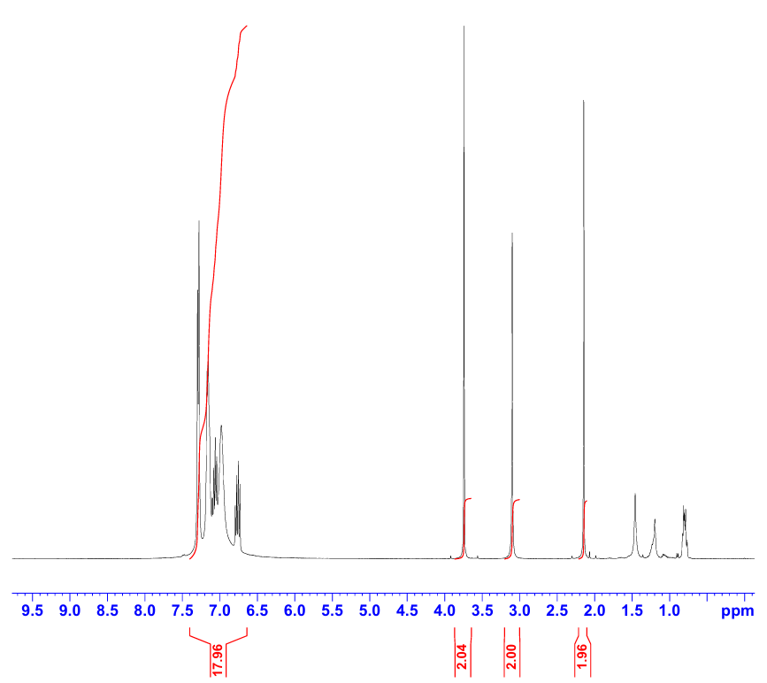
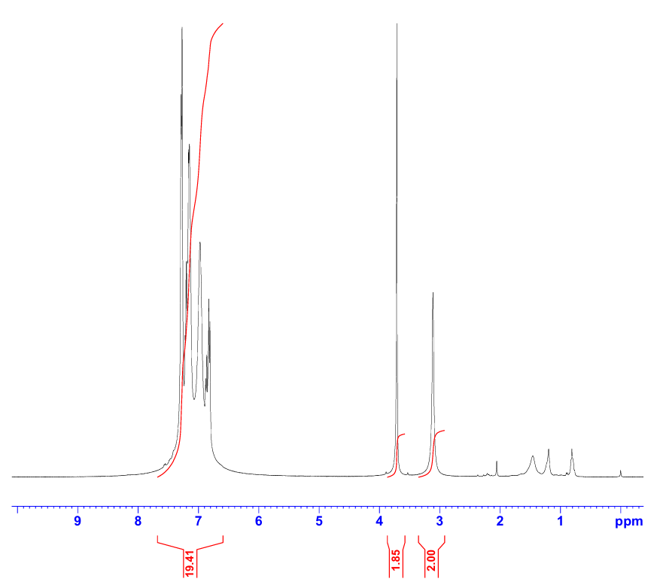
(a) (b)

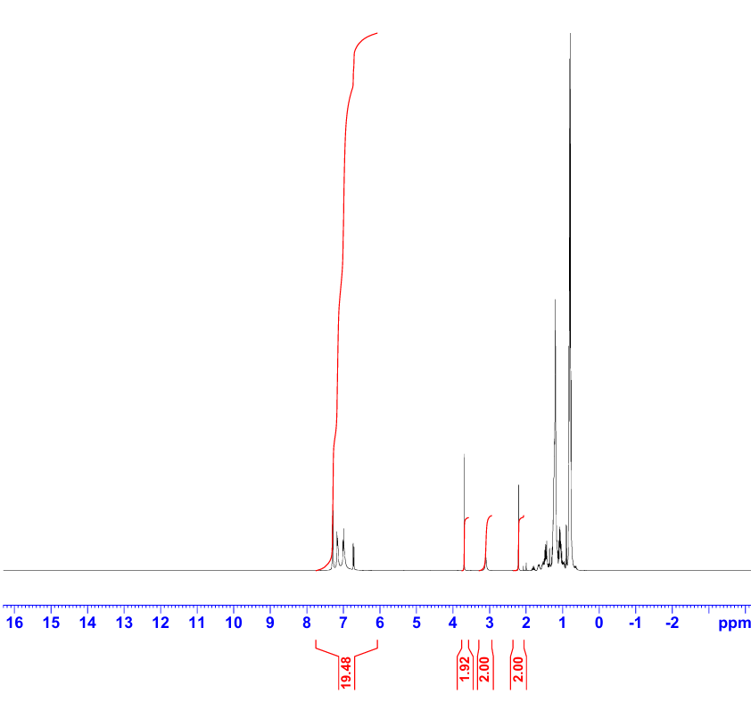
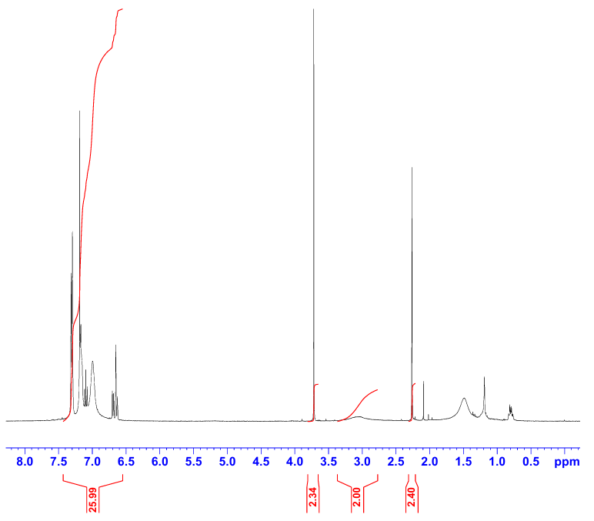
(c) (d)

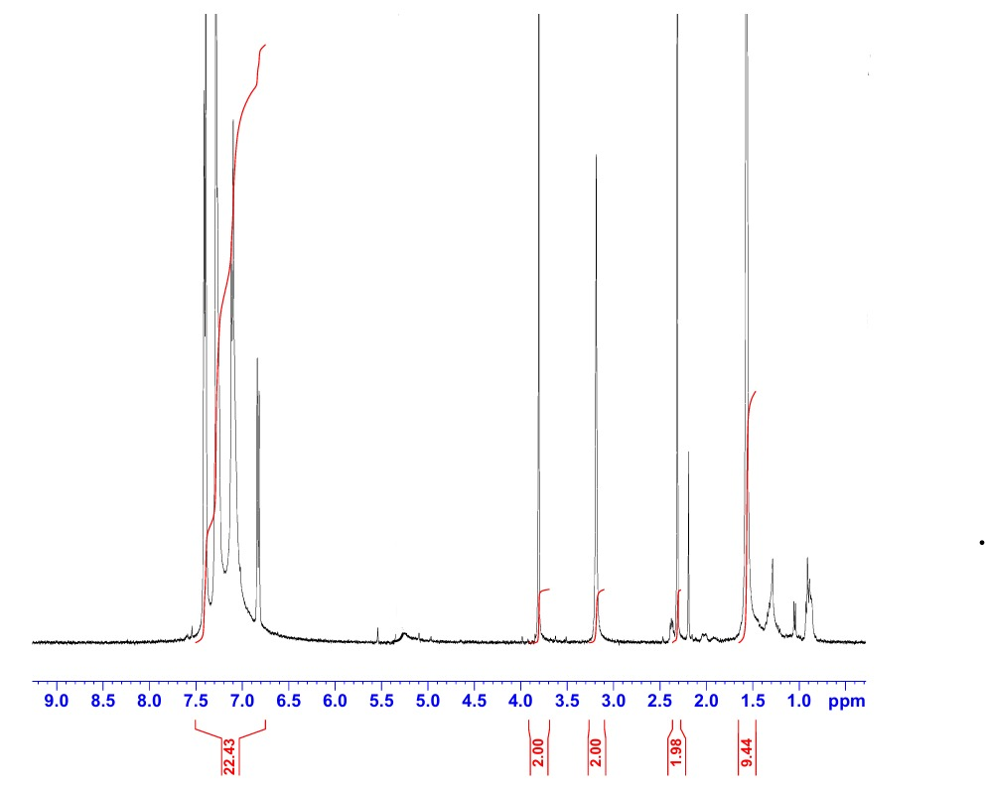
(e)

Figure S1 ¹H-NMR spectra of (a) 2(H)·ANI, (b) H·2MA, (c) H·3MA, (d) 3(H)·2(4MA₁), and (e) H·4MA₂ from single-solvent host crystallization experiments.

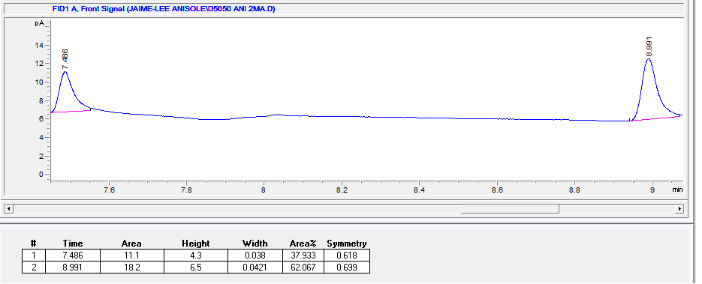
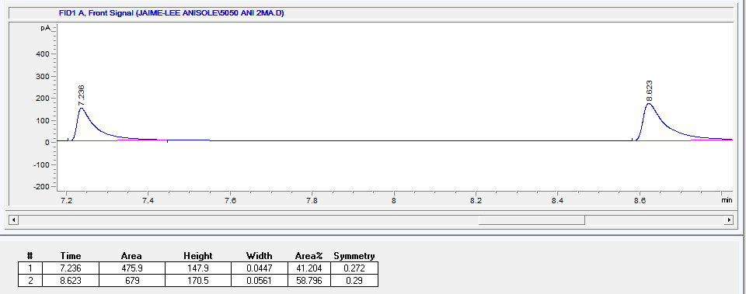
(a) (b)

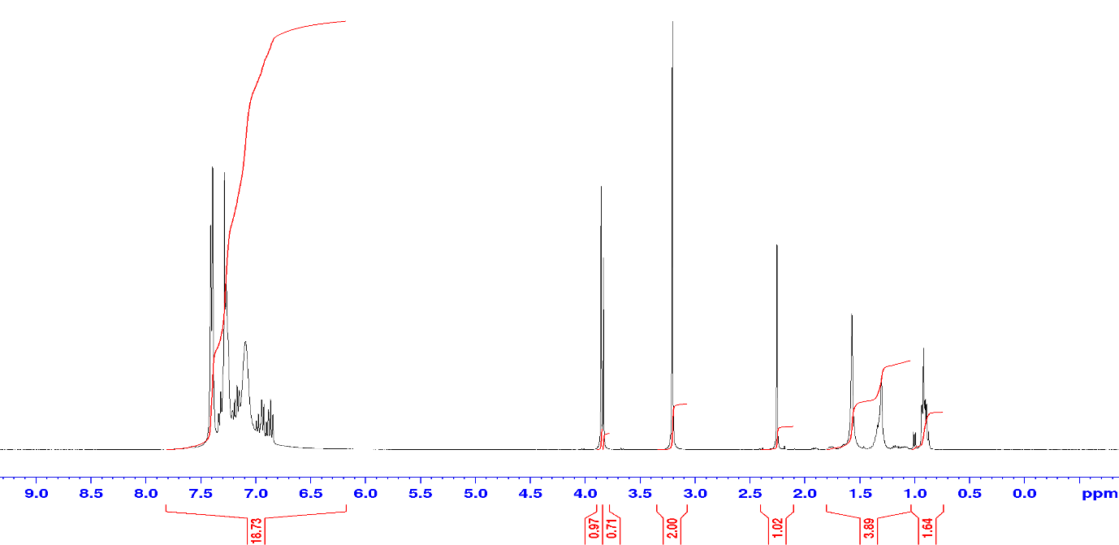
(c)

Figure S2 Relevant data for H equimolar guest competition of ANI:2MA (a) GC trace, (b) GC trace of its duplicate, and (c) ¹H-NMR spectra.
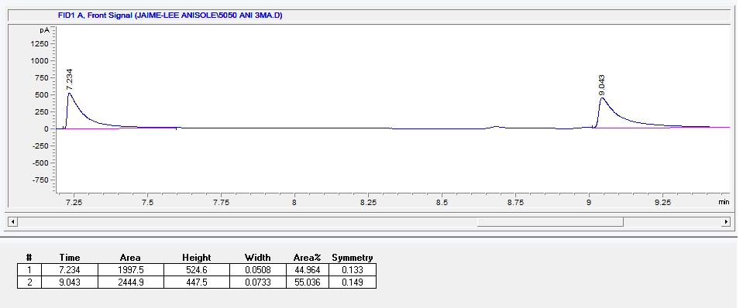
(a) (b)

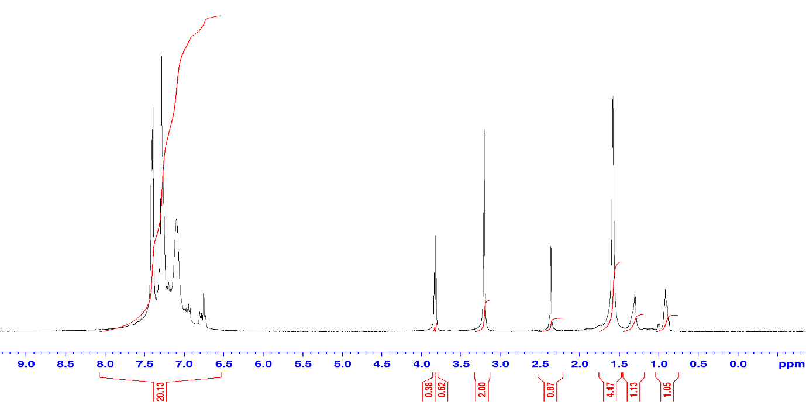
(c)

Figure S3 Relevant data for H equimolar guest competition of ANI:3MA (a) GC trace, (b) GC trace of its duplicate, and (c) ¹H-NMR spectra.
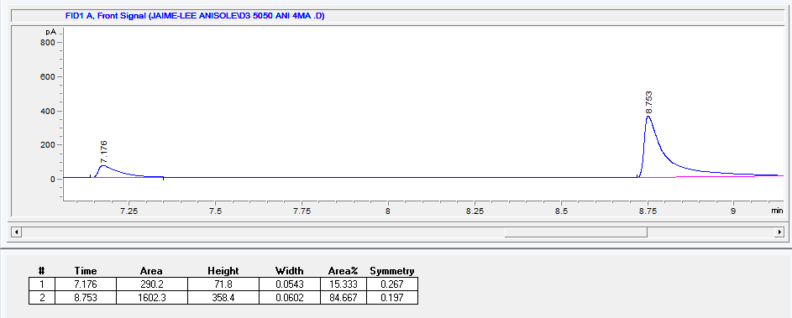
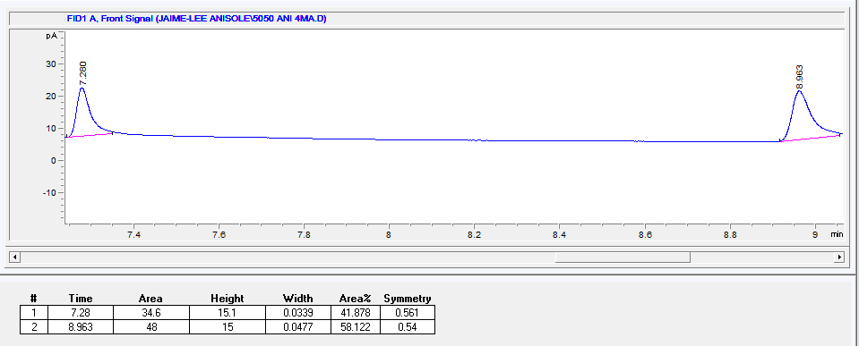
(a) (b)

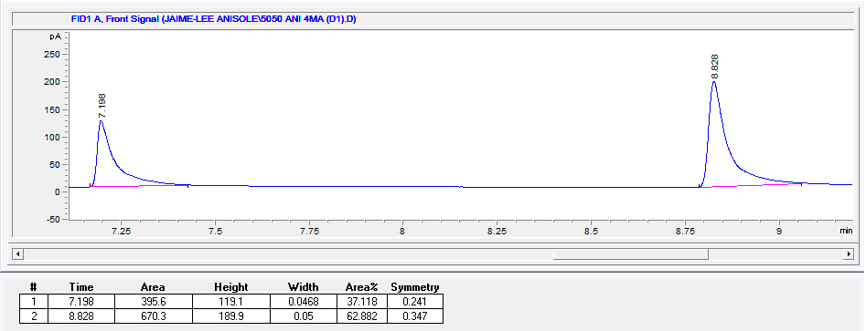
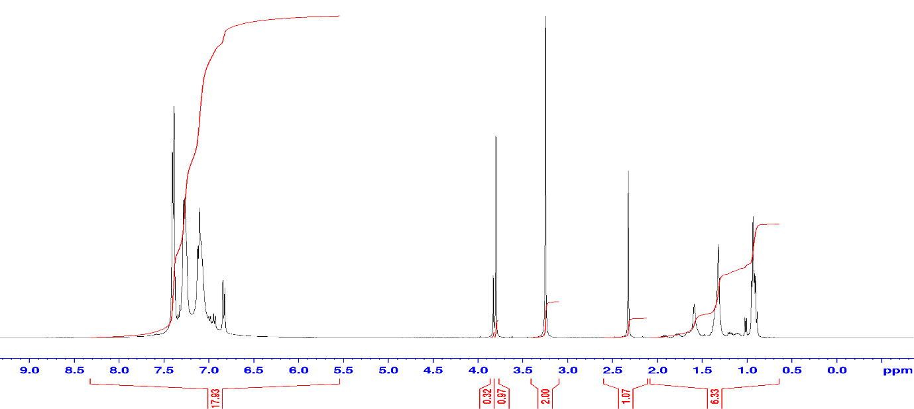
(c) (d)

Figure S4 Relevant data for H equimolar guest competition of ANI:4MA (a) GC trace, (b) GC trace of its duplicate, (c) GC trace of its triplicate, and (d) ¹H-NMR spectra.

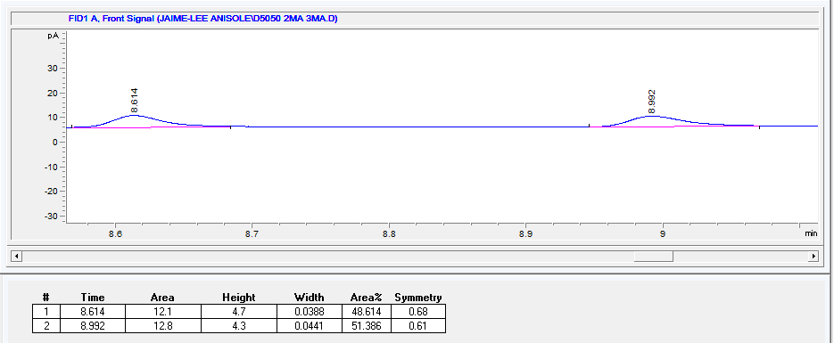
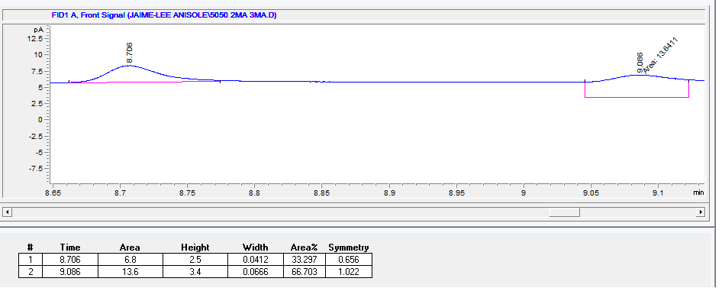
(a) (b)

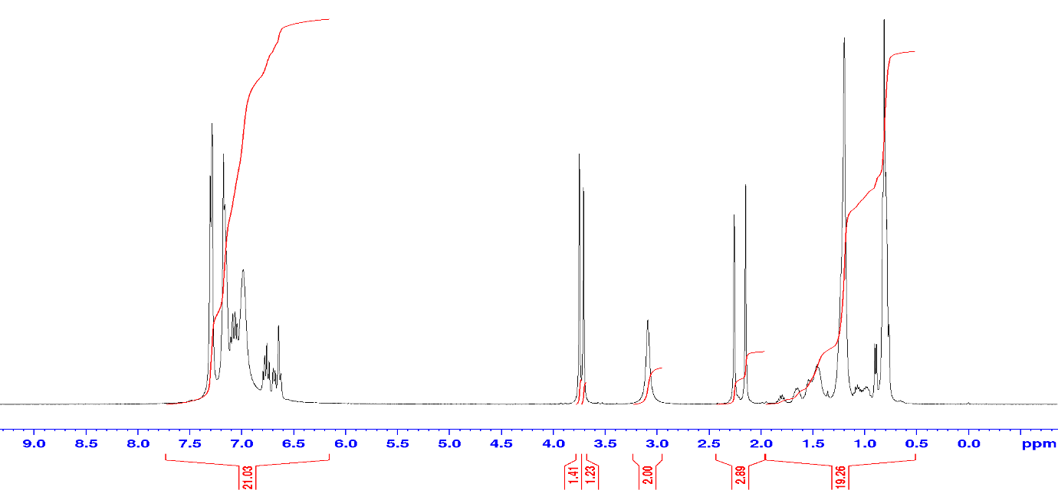
(c)

Figure S5 Relevant data for H equimolar guest competition of 2MA:3MA (a) GC trace, (b) GC trace of its duplicate, and (c) ¹H-NMR spectra.
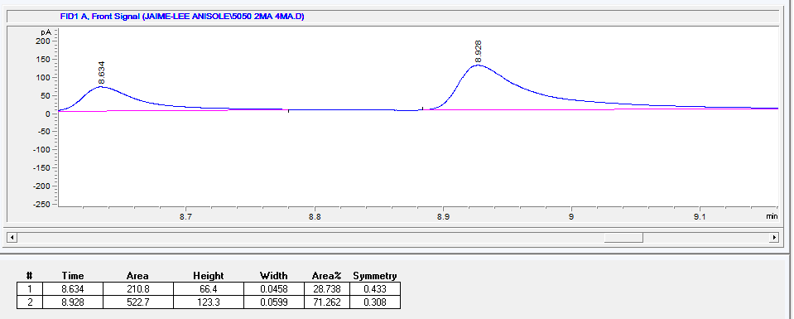
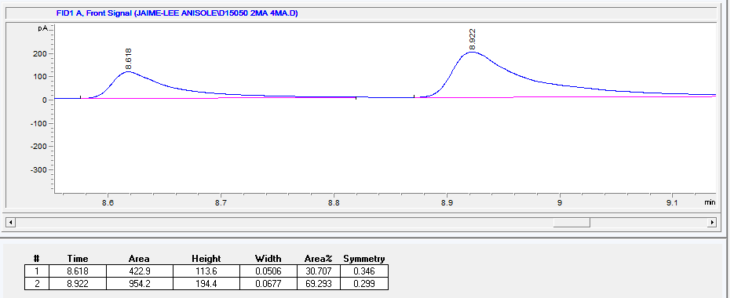
(a) (b)

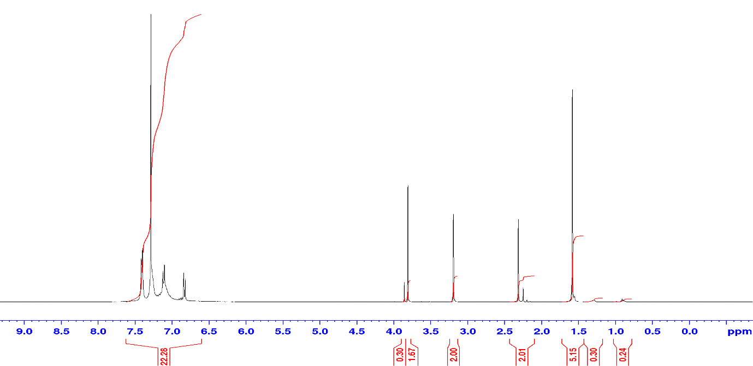
(c)

Figure S6 Relevant data for H equimolar guest competition of 2MA:4MA (a) GC trace, (b) GC trace of its duplicate, and (c) ¹H-NMR spectra.
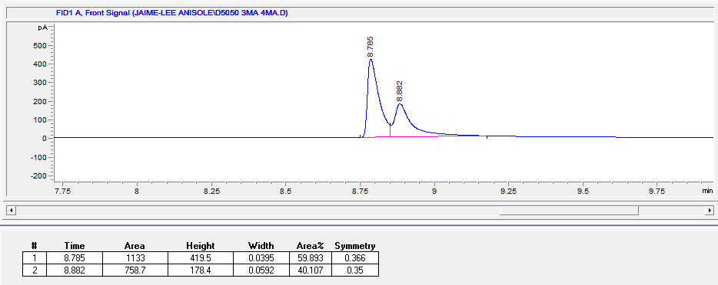
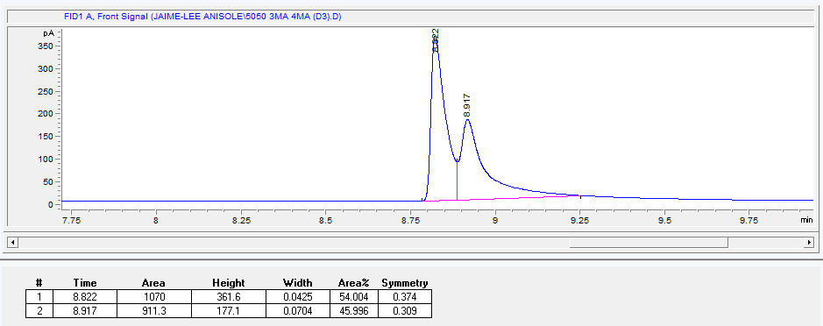
- (b)

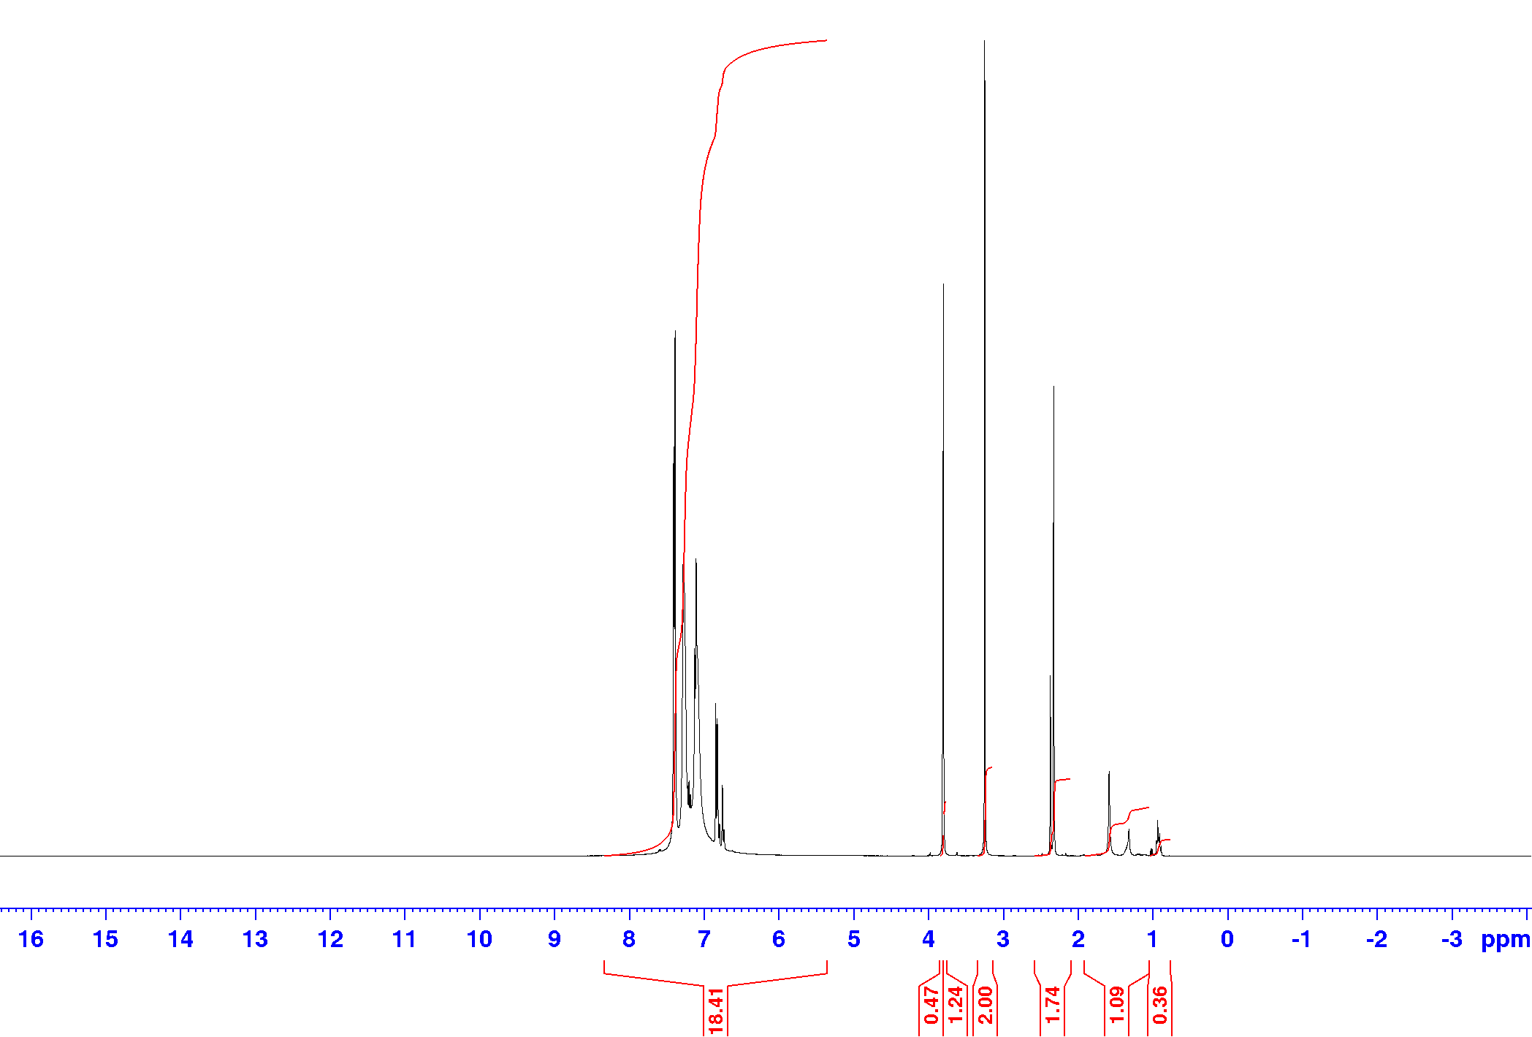
(c)

Figure S7 Relevant data for H equimolar guest competition of 3MA:4MA (a) GC trace, (b) GC trace of its duplicate, and (c) ¹H-NMR spectra.
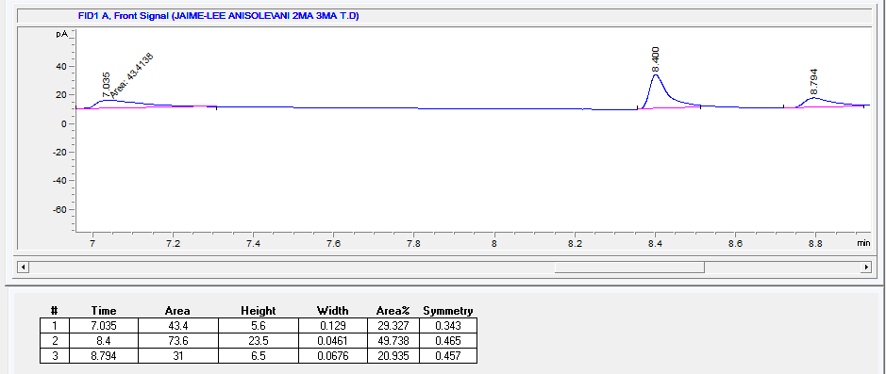
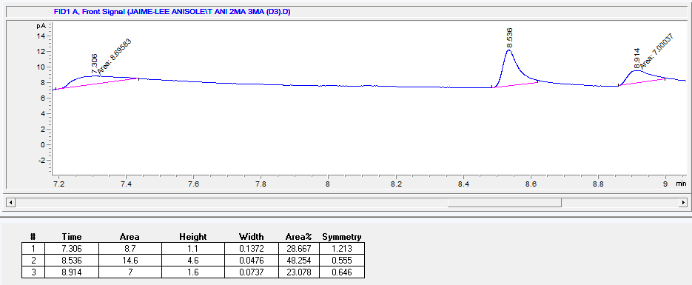
- (b)

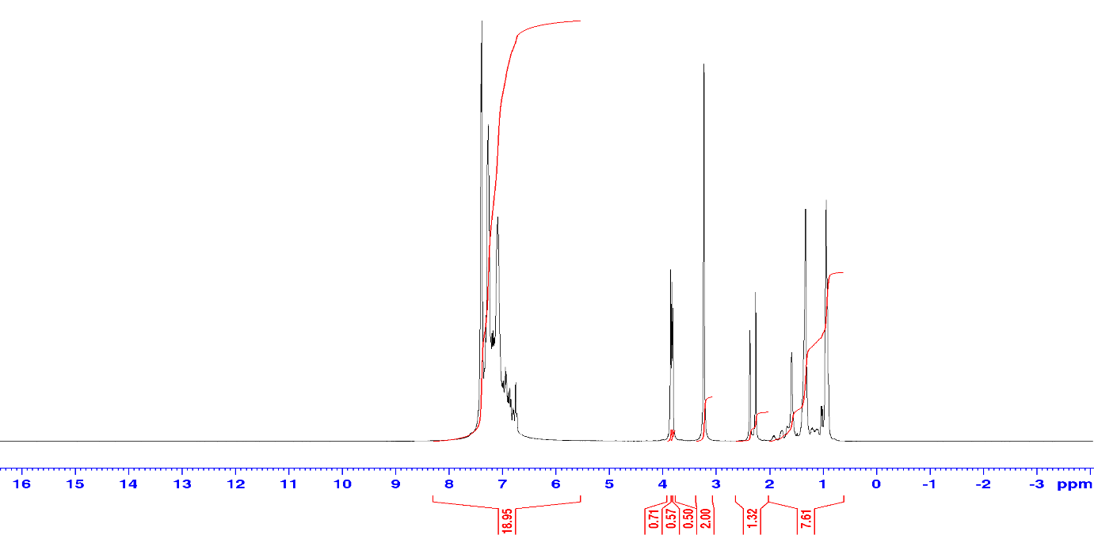
(c)

Figure S8 Relevant data for H equimolar guest competition of ANI:2MA:3MA (a) GC trace, (b) GC trace of its duplicate, and (c) ¹H-NMR spectra.
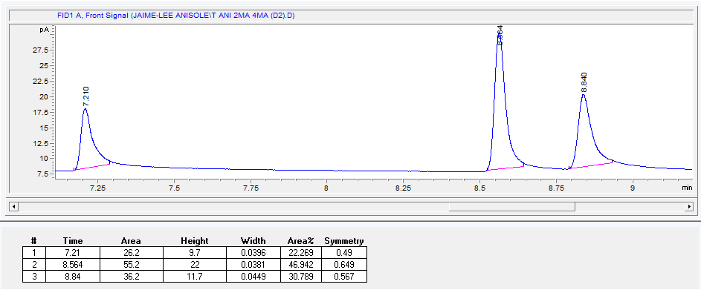
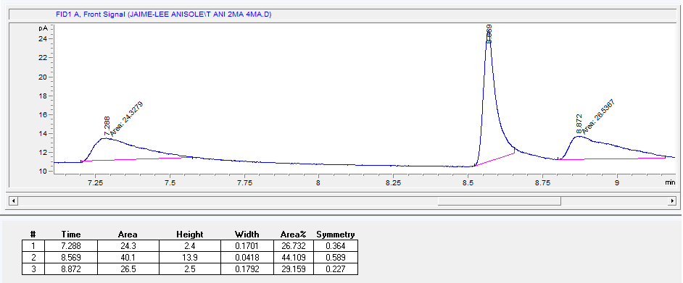
- (b)

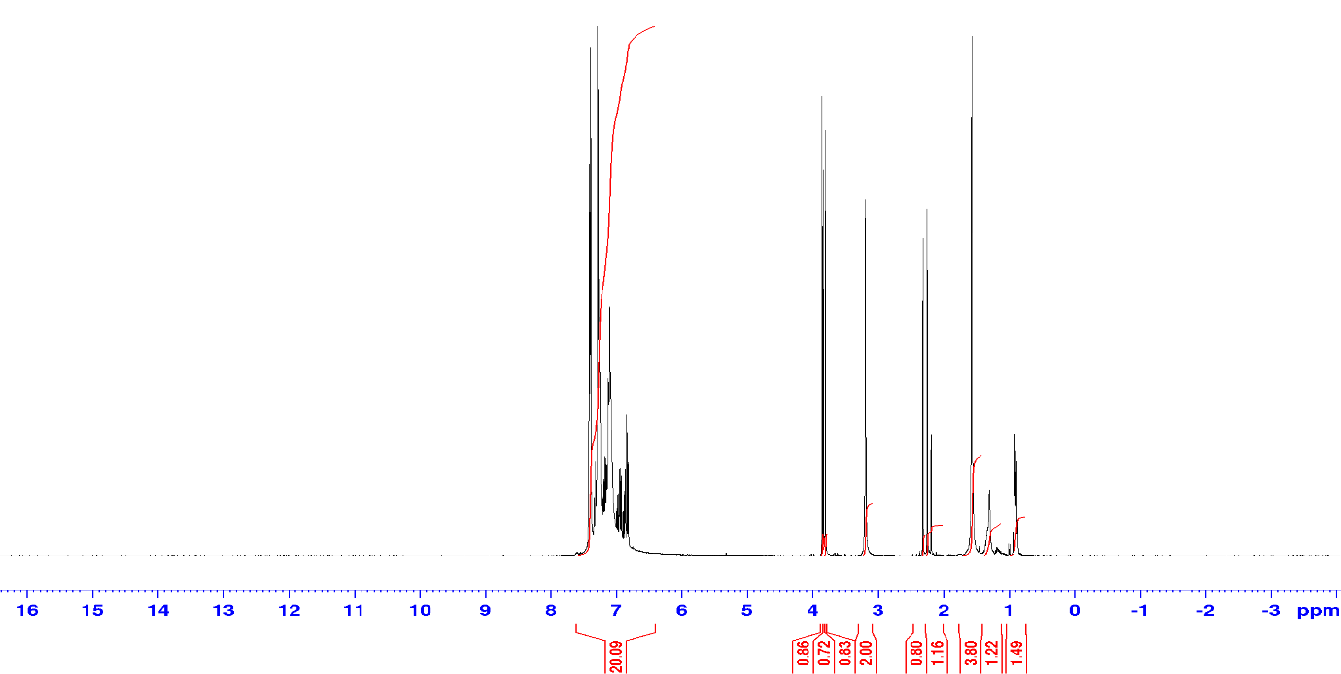
(c)

Figure S9 Relevant data for H equimolar guest competition of ANI:2MA:4MA (a) GC trace, (b) GC trace of its duplicate, and (c) ¹H-NMR spectra.
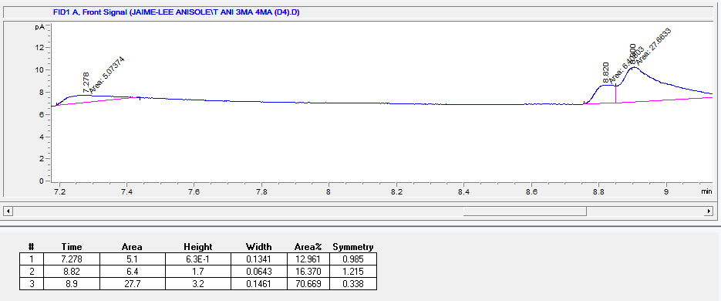
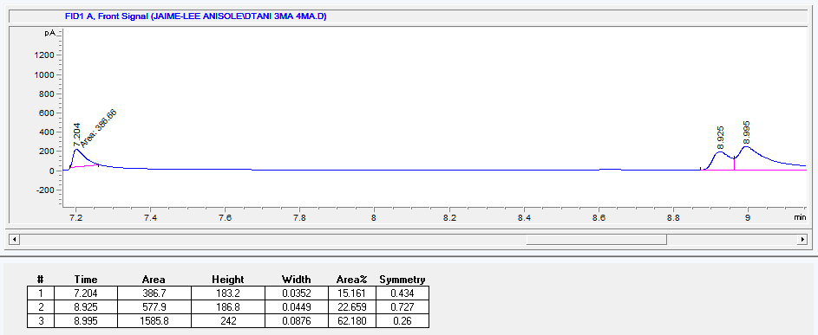
(a) (b)

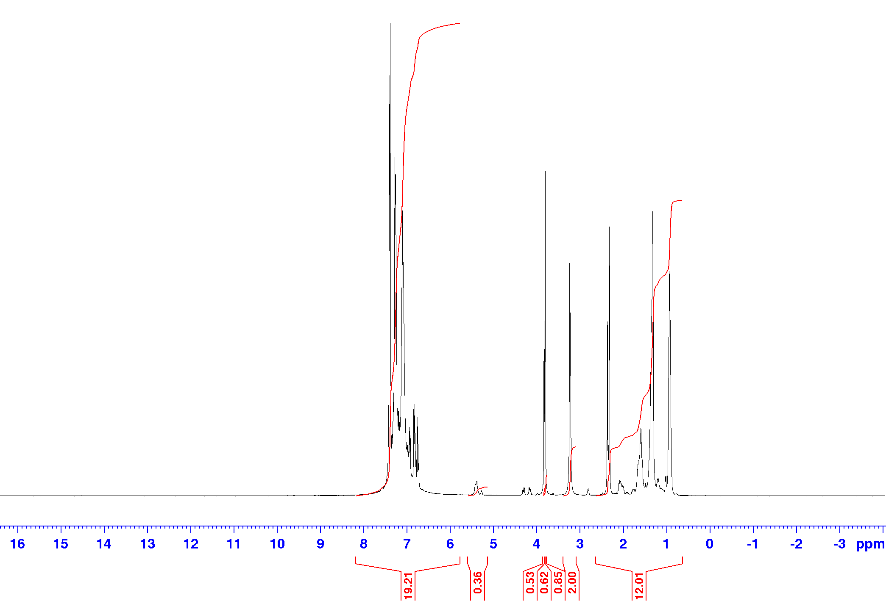
(c)

Figure S10 Relevant data for H equimolar guest competition of ANI:3MA:4MA (a) GC trace, (b) GC trace of its duplicate, and (c) ¹H-NMR spectra.

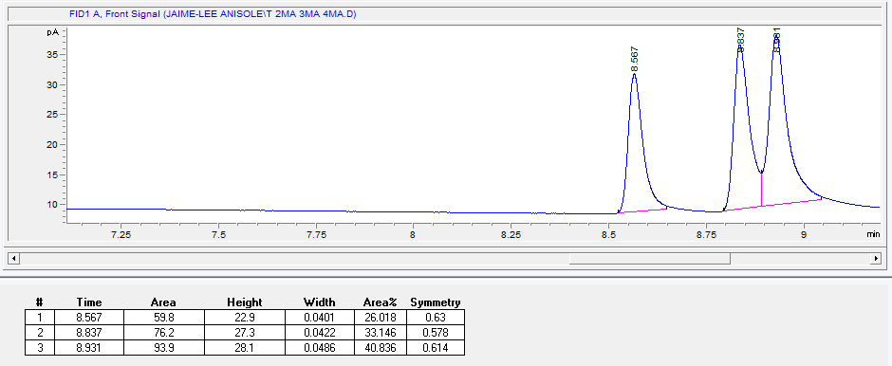
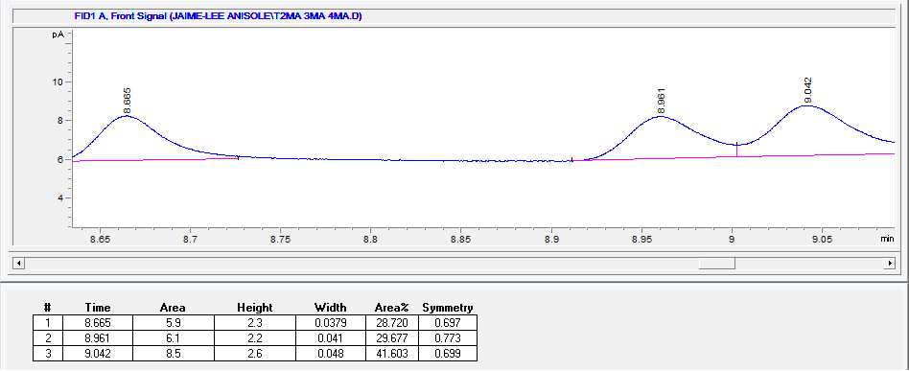
(a) (b)

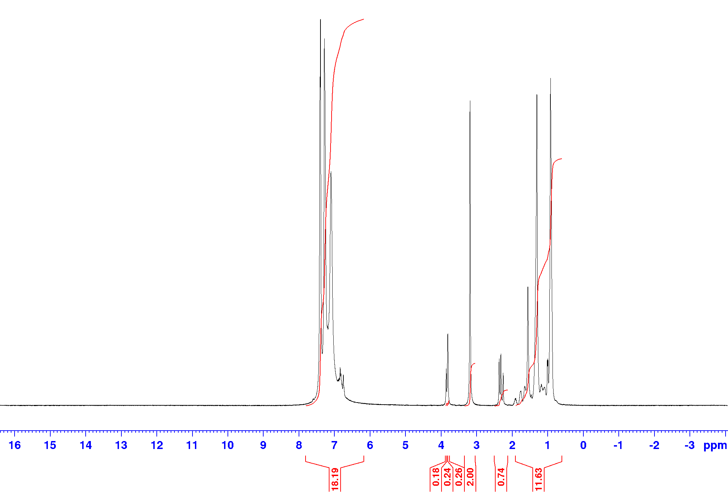
(c)

Figure S11 Relevant data for H equimolar guest competition of 2MA:3MA:4MA (a) GC trace, (b) GC trace of its duplicate, and (c) ¹H-NMR spectra.

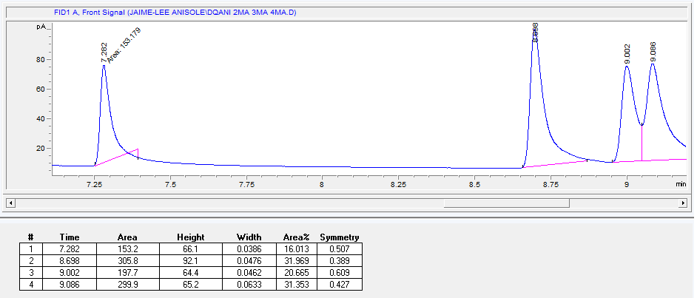
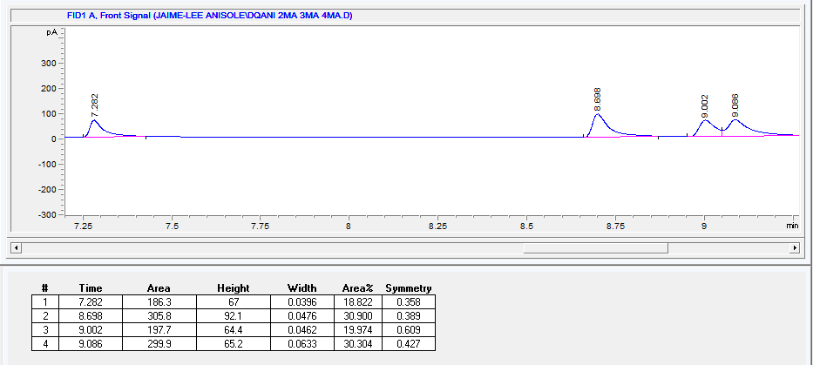
(a) (b)

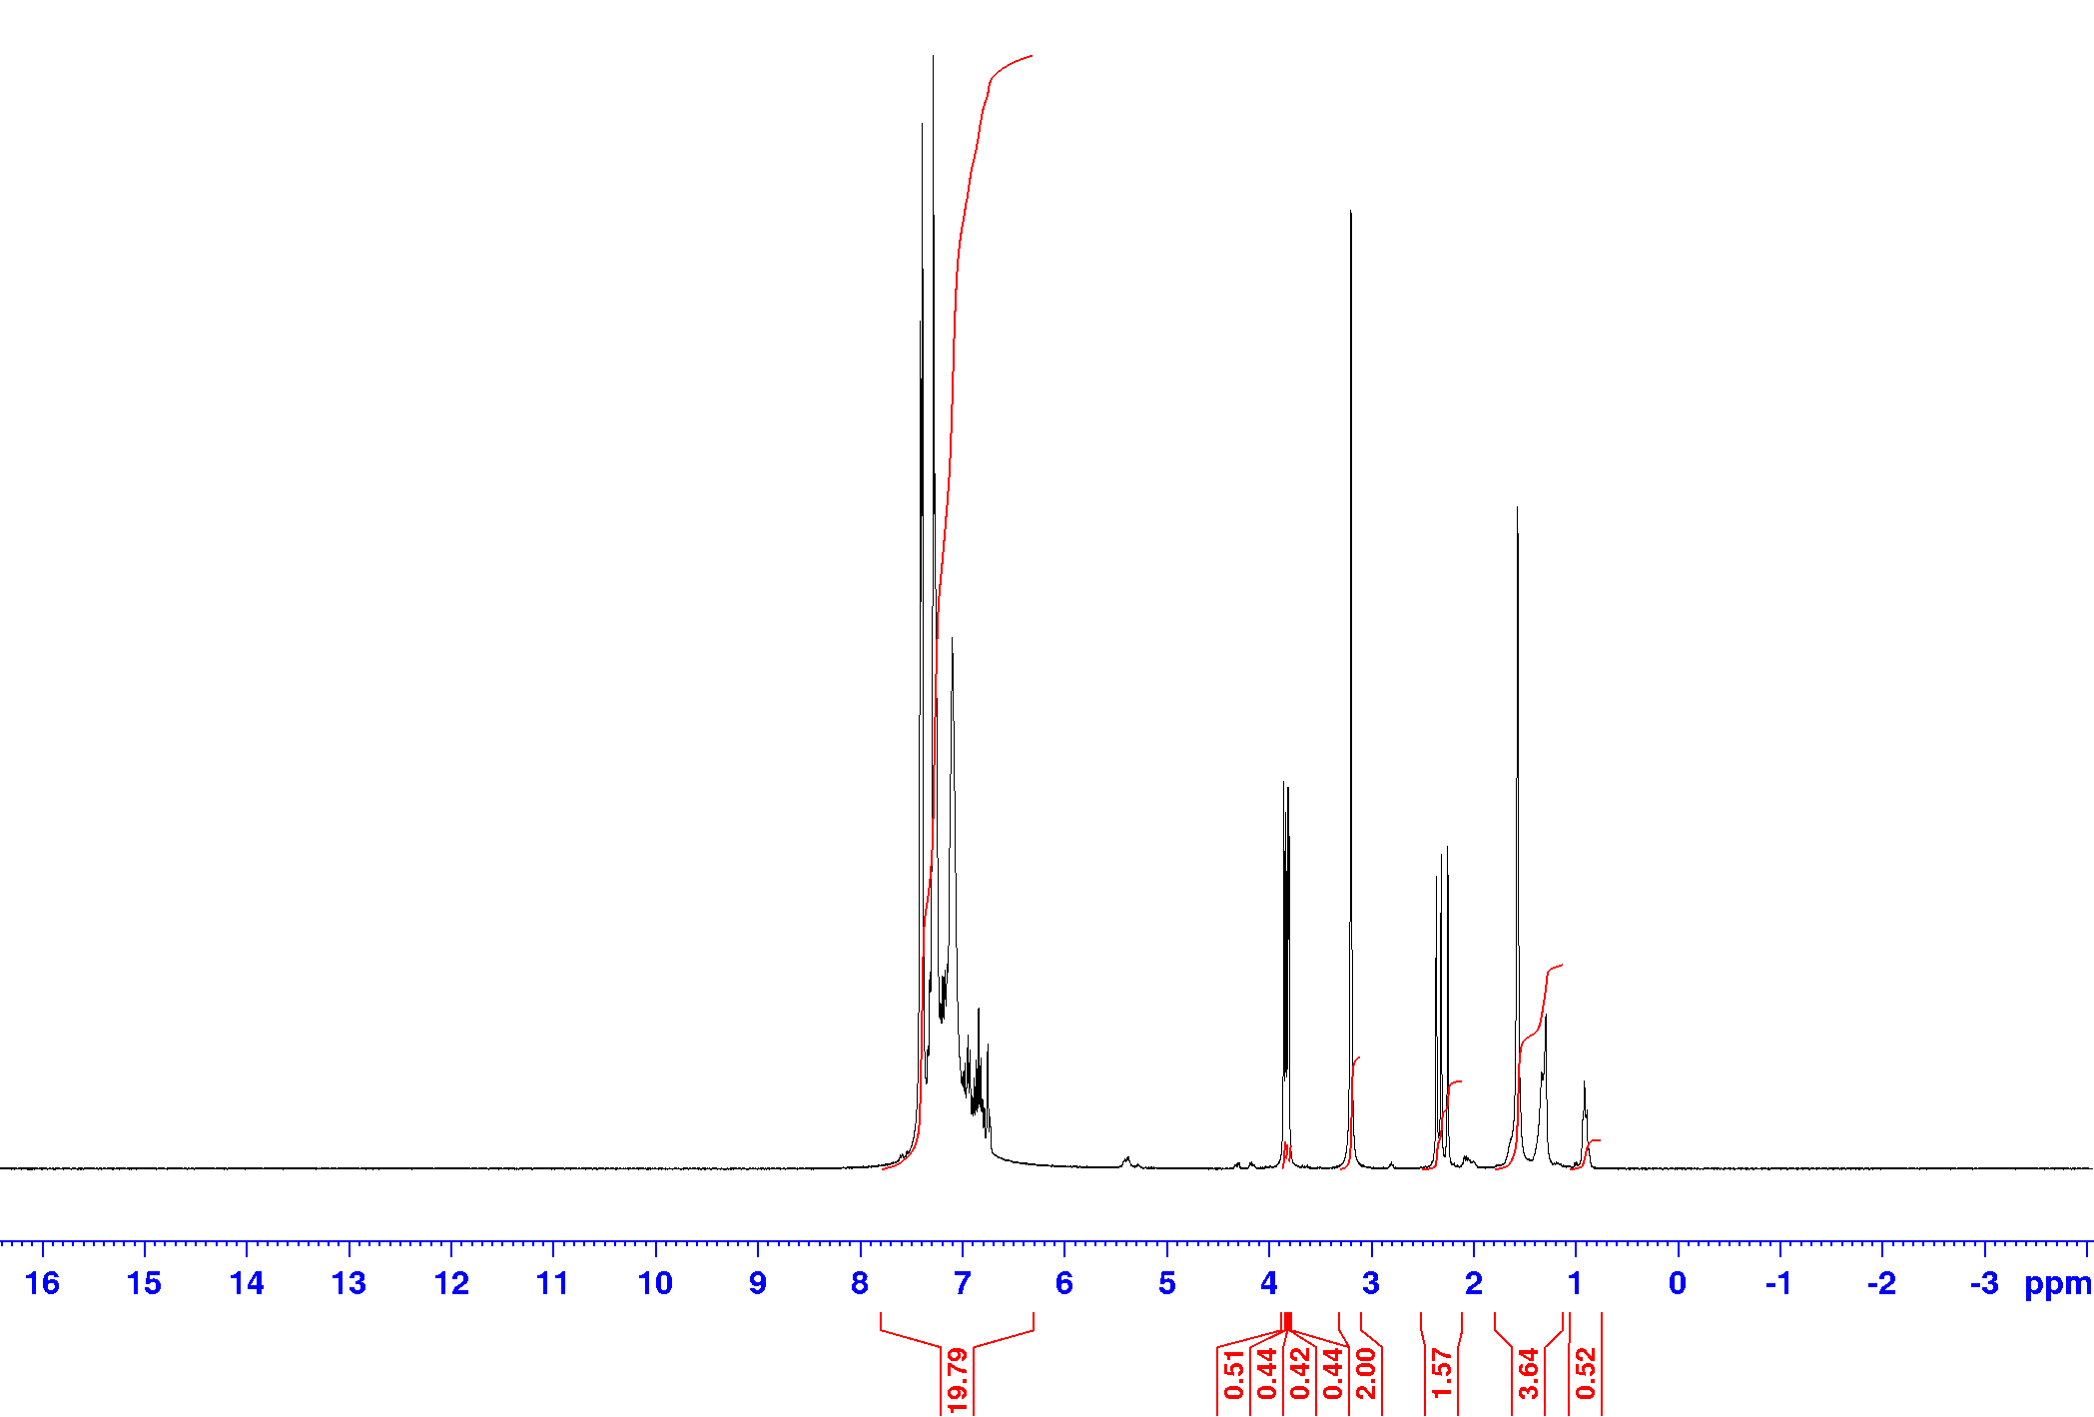
(c)

Figure S12 Relevant data for H equimolar guest competition of ANI:2MA:3MA:4MA (a) GC trace, (b) GC trace of its duplicate, and (c) ¹H-NMR spectra.
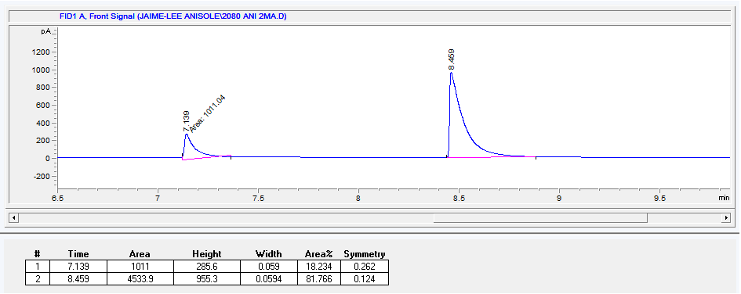
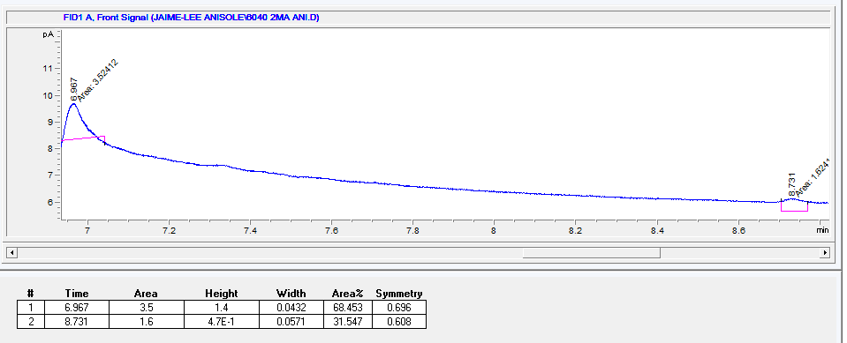
(a) (b)

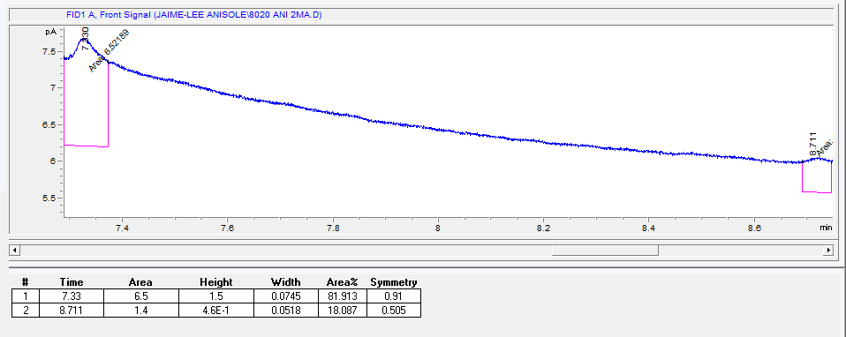
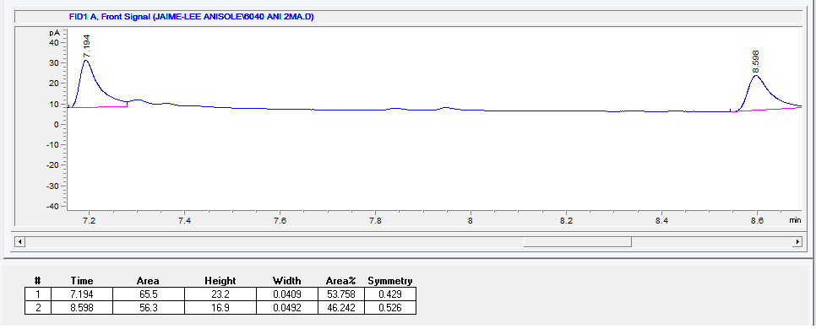
(c) (d)

Figure S13 GC traces for H binary mixtures of ANI and 2MA (a) 20:80, (b) 40:60, (c) 60:40, and (d) 80:20.

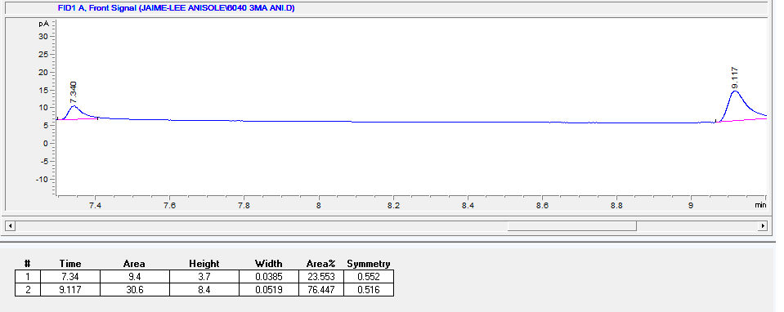
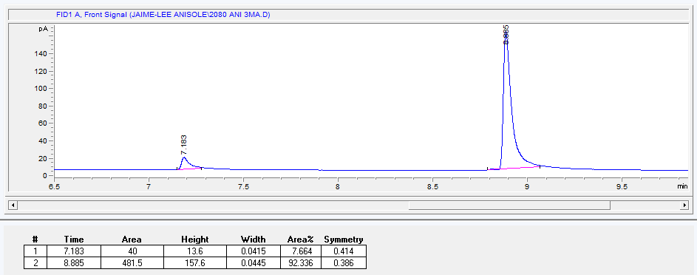
(a) (b)

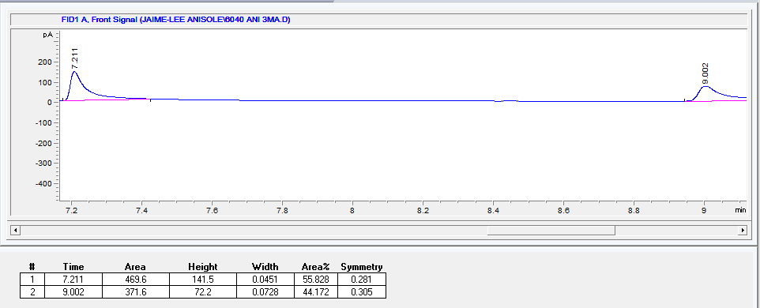
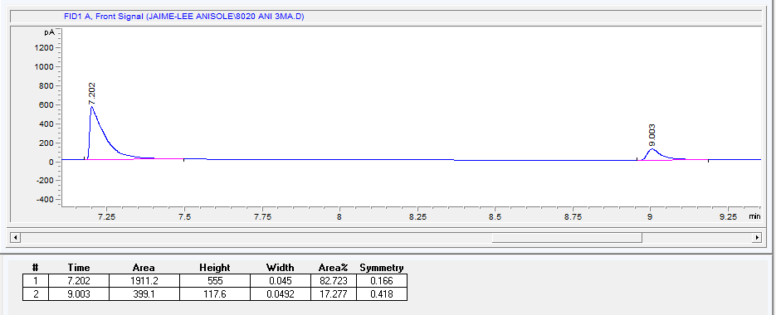
(c) (d)

Figure S14 GC traces for H binary mixtures of ANI and 3MA (a) 20:80, (b) 40:60, (c) 60:40, and (d) 80:20.

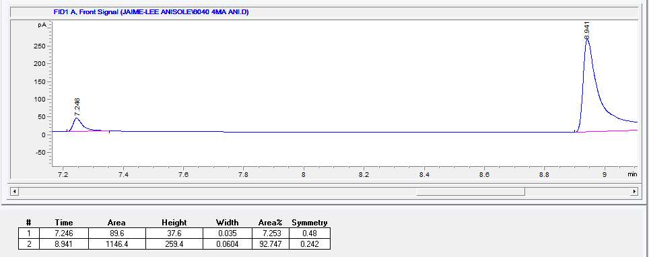
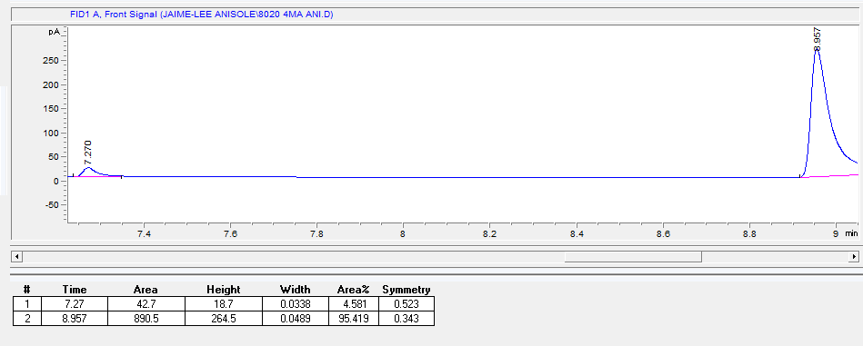
(a) (b)

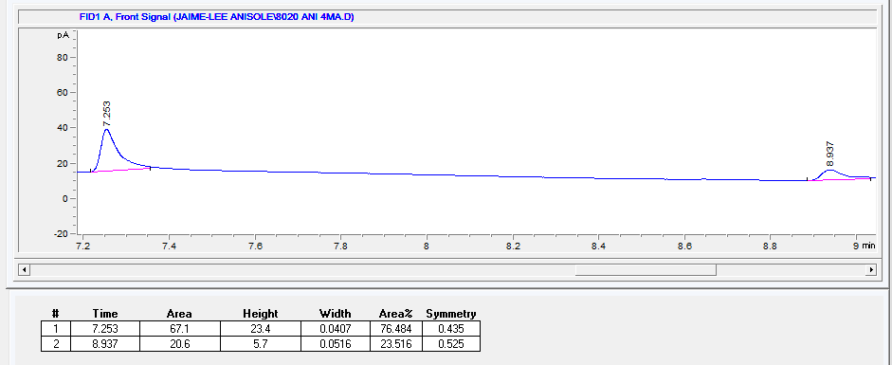
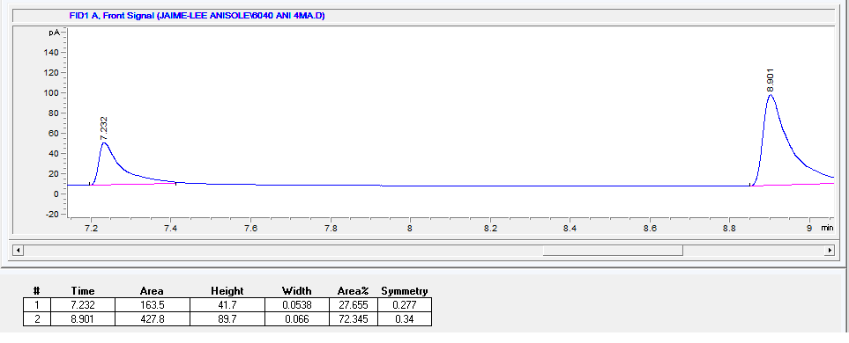
(c) (d)

Figure S15 GC traces for H binary mixtures of ANI and 4MA (a) 20:80, (b) 40:60, (c) 60:40, and (d) 80:20.

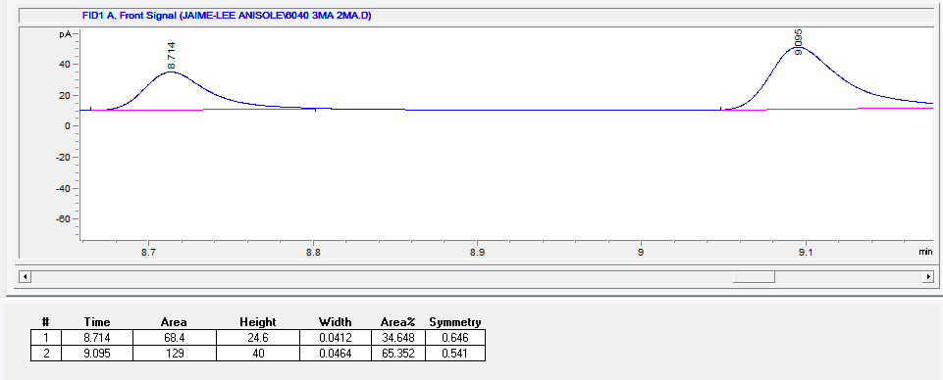
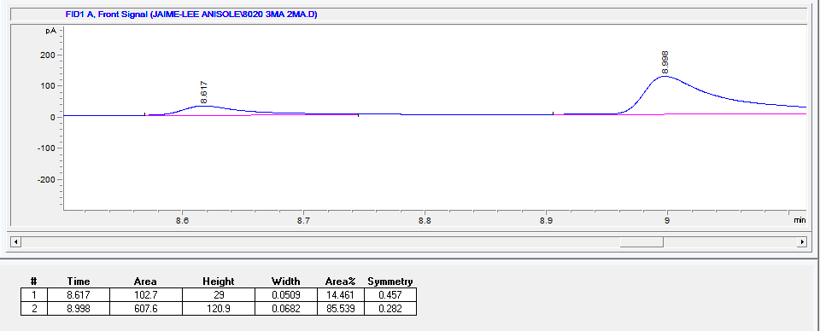
(a) (b)

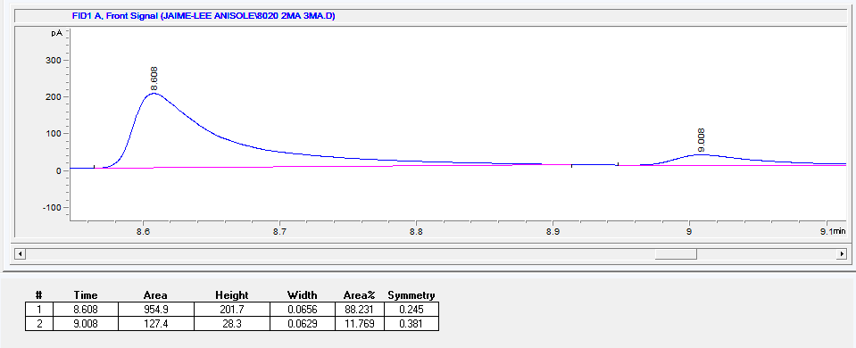
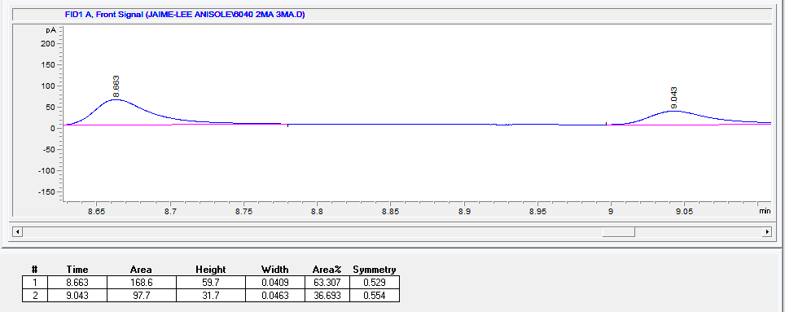
(c) (d)

Figure S16 GC traces for H binary mixtures of 2MA and 3MA (a) 20:80, (b) 40:60, (c) 60:40, and (d) 80:20.

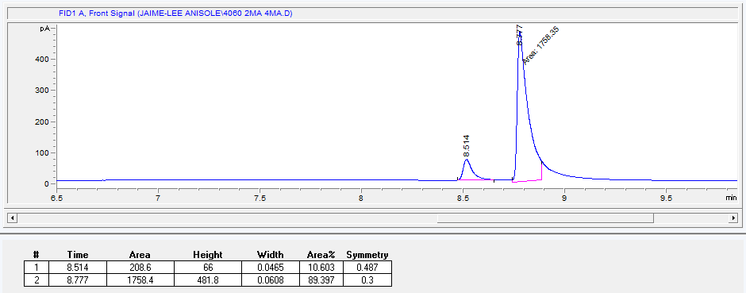
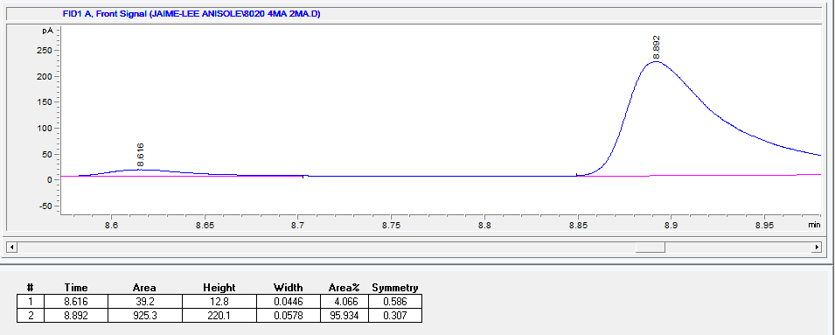
(a) (b)

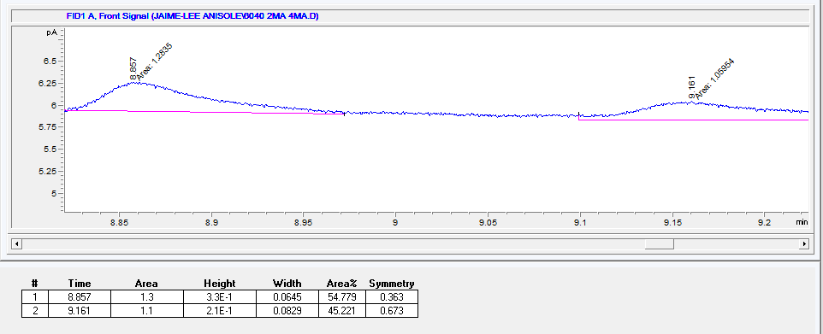
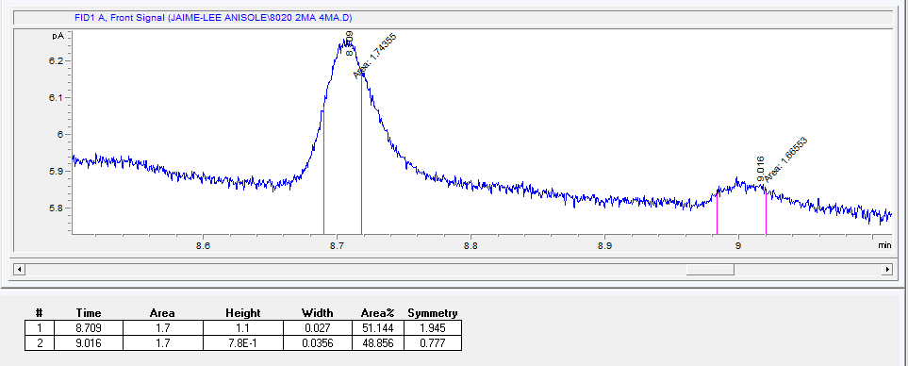
(c) (d)

Figure S17 GC traces for H binary mixtures of 2MA and 4MA (a) 20:80, (b) 40:60, (c) 60:40, and (d) 80:20.

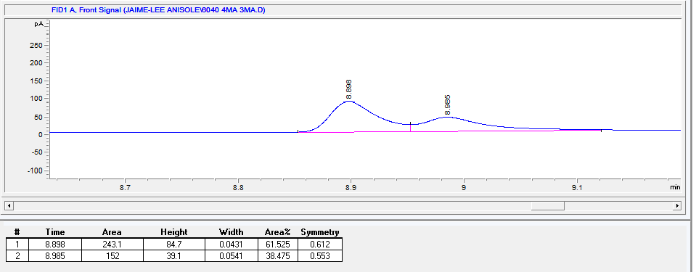
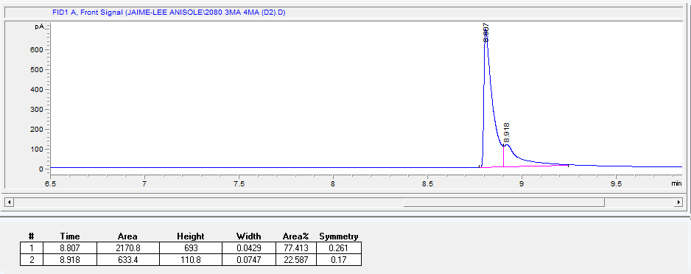
(a) (b)

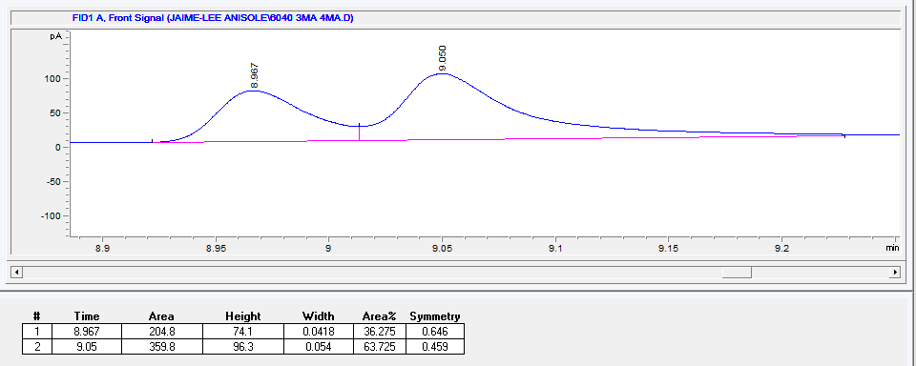
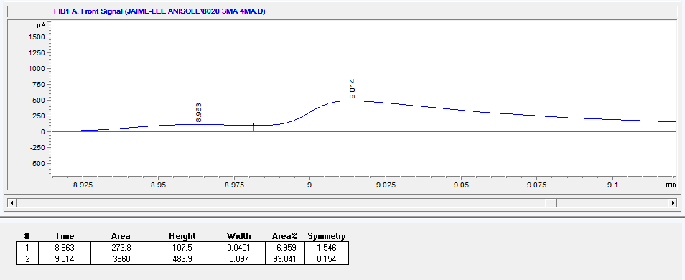
(c) (d)

Figure S18 GC traces for H binary mixtures of 3MA and 4MA (a) 20:80, (b) 40:60, (c) 60:40, and (d) 80:20.

(a) (b)

(c) (d)

(e) (f)

Figure S19 Selectivity profiles for H when crystallized from the (a) 2MA/ANI, (b) 3MA/ANI, (c) 4MA/ANI, (d) 3MA/2MA, (e) 4MA/2MA and (f) 4MA/3MA binary guest solutions. The straight diagonal lines have been inserted to denote a host compound that exhibits no selectivity whatsoever.

Table S1 Calculated K values for H in binary mixtures of ANI and the MAs.
Guest (the first listed in each pair) percentage in the original solution | K values (in favour of)
 | 2MA/ANI | 3MA/ANI | 4MA/ANI | 3MA/2MA | 4MA/2MA | 4MA/3MA
20 | 1.1 (ANI) | 1.2 (ANI) | 1.2 (4MA) | 1.9 (2MA) | 2.6 (2MA) | 3.3 (3MA)
40 | 1.3 (2MA) | 1.2 (3MA) | 3.9 (4MA) | 1.2 (2MA) | 1.2 (4MA) | 1.2 (3MA)
50 | 1.5 (2MA) | 1.2 (3MA) | 2.2 (4MA) | 1.4 (3MA) | 2.4 (4MA) | 1.3 (4MA)
60 | 1.4 (2MA) | 2.2 (3MA) | 8.5 (4MA) | 1.3 (3MA) | 5.6 (4MA) | 1.1 (4MA)
80 | 1.1 (2MA) | 3.0 (3MA) | 5.2 (4MA) | 1.5 (3MA) | 5.9 (4MA) | 0.9 (4MA)

(a)

(b)

(c)

(d)

(e)

Figure S20 ORTEP diagrams for the complexes formed (a) H·0.778(ANI), (b) H·0.778(2MA), (c) H·0.667(3MA), (d) H·0.667(4MA₁) and (e) H·0.75(4MA₂).
Table S2 Crystallographic data before and after the SQUEEZE routine for the complexes of H with ANI, 2MA, 3MA and 4MA.
Guest | ANI | ANI SQ | 2MA | 2MA SQ | 3MA₁ | 3MA₂ | 3MA SQ | 4MA₁ | 4MA₁ SQ | 4MA₂ | 4MA₂ SQ
Comment |  |  |  |  | (Initially) | (Refined)
Space group | R-3 | R-3 | R-3 | R-3 | P-1 | P-1 | P-1 | P-1 | P-1 | P-1 | P-1
a | 31.8624 | 31.8624 | 32.0983 | 32.0983 | 18.6966 | 12.1377 | 12.138 | 12.215 | 12.215 | 10.227 | 10.2266
b | 31.8624 | 31.8624 | 32.0983 | 32.0983 | 18.9785 | 18.4488 | 18.449 | 18.389 | 18.3885 | 12.692 | 12.6915
c | 12.1461 | 12.1461 | 12.1248 | 12.1248 | 24.1663 | 18.7002 | 18.7 | 18.552 | 18.5519 | 19.322 | 19.3221
α | 90 | 90 | 90 | 90 | 101.404 | 115.101 | 115.1 | 115.85 | 115.854 | 84.939 | 84.9386
β | 90 | 90 | 90 | 90 | 103.102 | 101.188 | 101.19 | 101.14 | 101.141 | 83.883 | 83.8825
γ | 120 | 120 | 120 | 120 | 116.657 | 102.425 | 102.43 | 100.54 | 100.542 | 77.579 | 77.5793
Platon ratio H | 1 | 1 | 2 | 1 | 12 | 1 | 1 | 3 | 1 | 4 | 1
Platon ratio G | 0.727 | 0 | 0.667 | 0 | 7 | 0.522 | 0 | 2 | 0 | 3 | 0
ratio H:G | 1.38 | #N/A | 3 | #N/A | 1.71 | 1.92 | #N/A | 1.5 | #N/A | 1.33 | #N/A
z | 18 | 18 | 9 | 18 | 1 | 6 | 6 | 2 | 6 | 1 | 4
e- (H) | 190 | 190 | 190 | 190 | 190 | 190 | 190 | 190 | 190 | 190 | 190
e- (G) | 58 | 58 | 66 | 66 | 66 | 66 | 66 | 66 | 66 | 66 | 66
F(OOO) | 4179 | 3420 | 3816 | 3420 | 2742 | 1347 | 1140 | 1404 | 1140 | 958 | 760
Calc tot e- | 4178.99 | 3420 | 3816.2 | 3420 | 2742 | 1346.712 | 1140 | 1404 | 1140 | 958 | 760
R_{int} | 0.046 | 0.046 | 0.151 | 0.151 | 0.065 | 0.053 | 0.053 | 0.094 | 0.094 | 0.063 | 0.063
R | 0.0997 | 0.0619 | 0.1447 | 0.0768 | 0.0903 | 0.0879 | 0.0708 | 0.1501 | 0.1339 | 0.0485 | 0.0547
wR2 | 0.305 | 0.149 | 0.3999 | 0.1731 | 0.238 | 0.23 | 0.1856 | 0.3659 | 0.3313 | 0.1075 | 0.1364
S | 1.11 | 1.08 | 1.67 | 1.05 | 1.09 | 1.13 | 1.13 | 1.24 | 1.17 | 1.13 | 1.1
e- void/cell | #N/A | 811 | #N/A | 892 | #N/A | #N/A | 250 | #N/A | 291 | #N/A | 201
Num G | #N/A | 13.983 | #N/A | 13.515 | #N/A | #N/A | 3.788 | #N/A | 4.409 | #N/A | 3.045
round (Num G) | #N/A | 14 | #N/A | 14 | #N/A | #N/A | 4 | #N/A | 4 | #N/A | 3
ratio H:G | #N/A | 1.29 | #N/A | 1.29 | #N/A | #N/A | 1.5 | #N/A | 1.5 | #N/A | 1.33
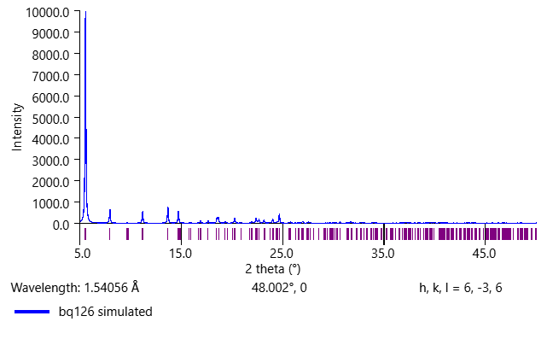
(a)

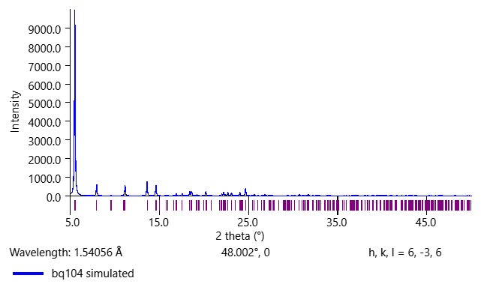
(b)

Figure S21 Calculated powder X-ray diffraction (PXRD) patterns for the complexes of H with (a) ANI and (b) 2MA, illustrating the close similarity between the two.
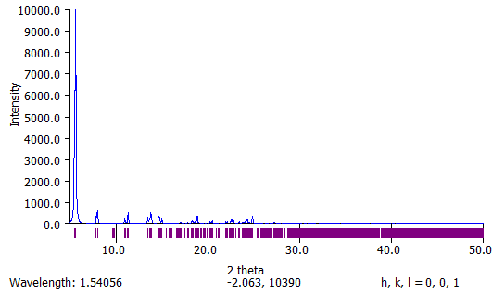
(a)

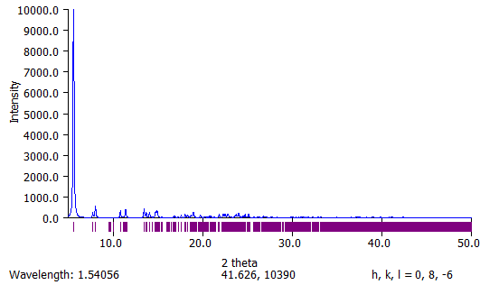
(b)

Figure S22 Calculated powder X-ray diffraction (PXRD) patterns for the complexes of H with (a) 3MA and (b) 4MA₁, illustrating their isostructurality.

