S1: Observational data split for analysis
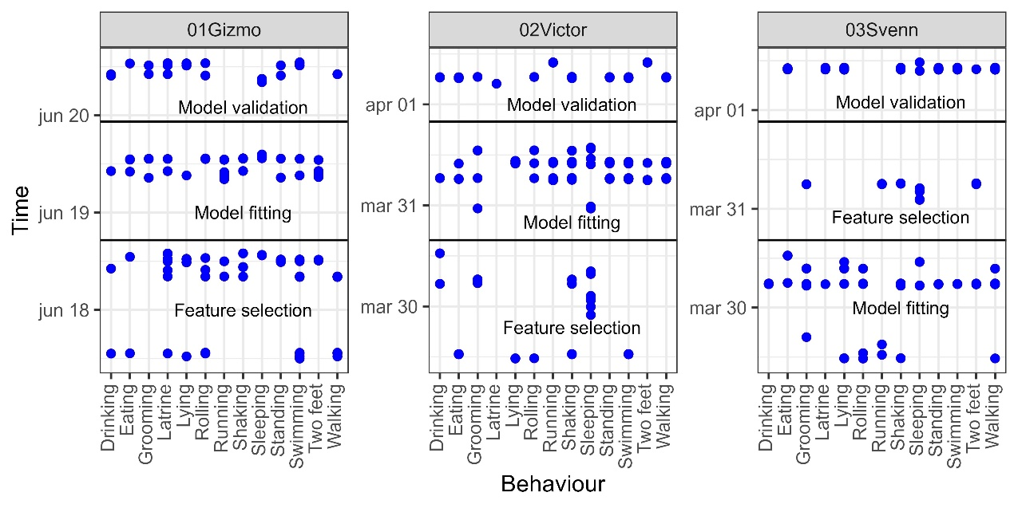
Figure S1. Overview of observed behavioural events for the analysis across the observational period for each individual Eurasian otter. Horizontal lines indicate how the behavioural events where split into data groups for 1) feature selection, 2) hyper parameter tuning and model fitting, and 3) model validation (i.e. time-based splitting or leave-out-some-events, LOSE).

S2: Acceleration features
Table S2. List of 55 statistical features from Eurasian otters calculated from the raw acceleration data, as well as derived static and dynamic acceleration. Each of the 55 statistical features were calculated over a time window of 0.5 s, 1 s, and 3 s (total 165 features).
Acceleration data | Statistical feature | Window length
Static acceleration (X/Y/Z) | Mean  Standard deviation  Minimum  Maximum  Range | 0.5 seconds (12.5 data points)  1 second (25 data points)  3 seconds (75 data points)
Dynamic acceleration (X/Y/Z) | Mean  Standard deviation  Minimum  Maximum  Range  Peak counts  Entropy | 0.5 seconds (12.5 data points)  1 second (25 data points)  3 seconds (75 data points)
Vector of dynamic body acceleration (VeDBA) | Mean  Standard deviation  Minimum  Maximum  Sum  Range  Peak counts  Entropy  Dominant frequency | 0.5 seconds (12.5 data points)  1 second (25 data points)  3 seconds (75 data points)
Roll and pitch angle (radians) | Mean  Standard deviation  Minimum  Maximum  Range | 0.5 seconds (12.5 data points)  1 second (25 data points)  3 seconds (75 data points)

S3: Feature selection
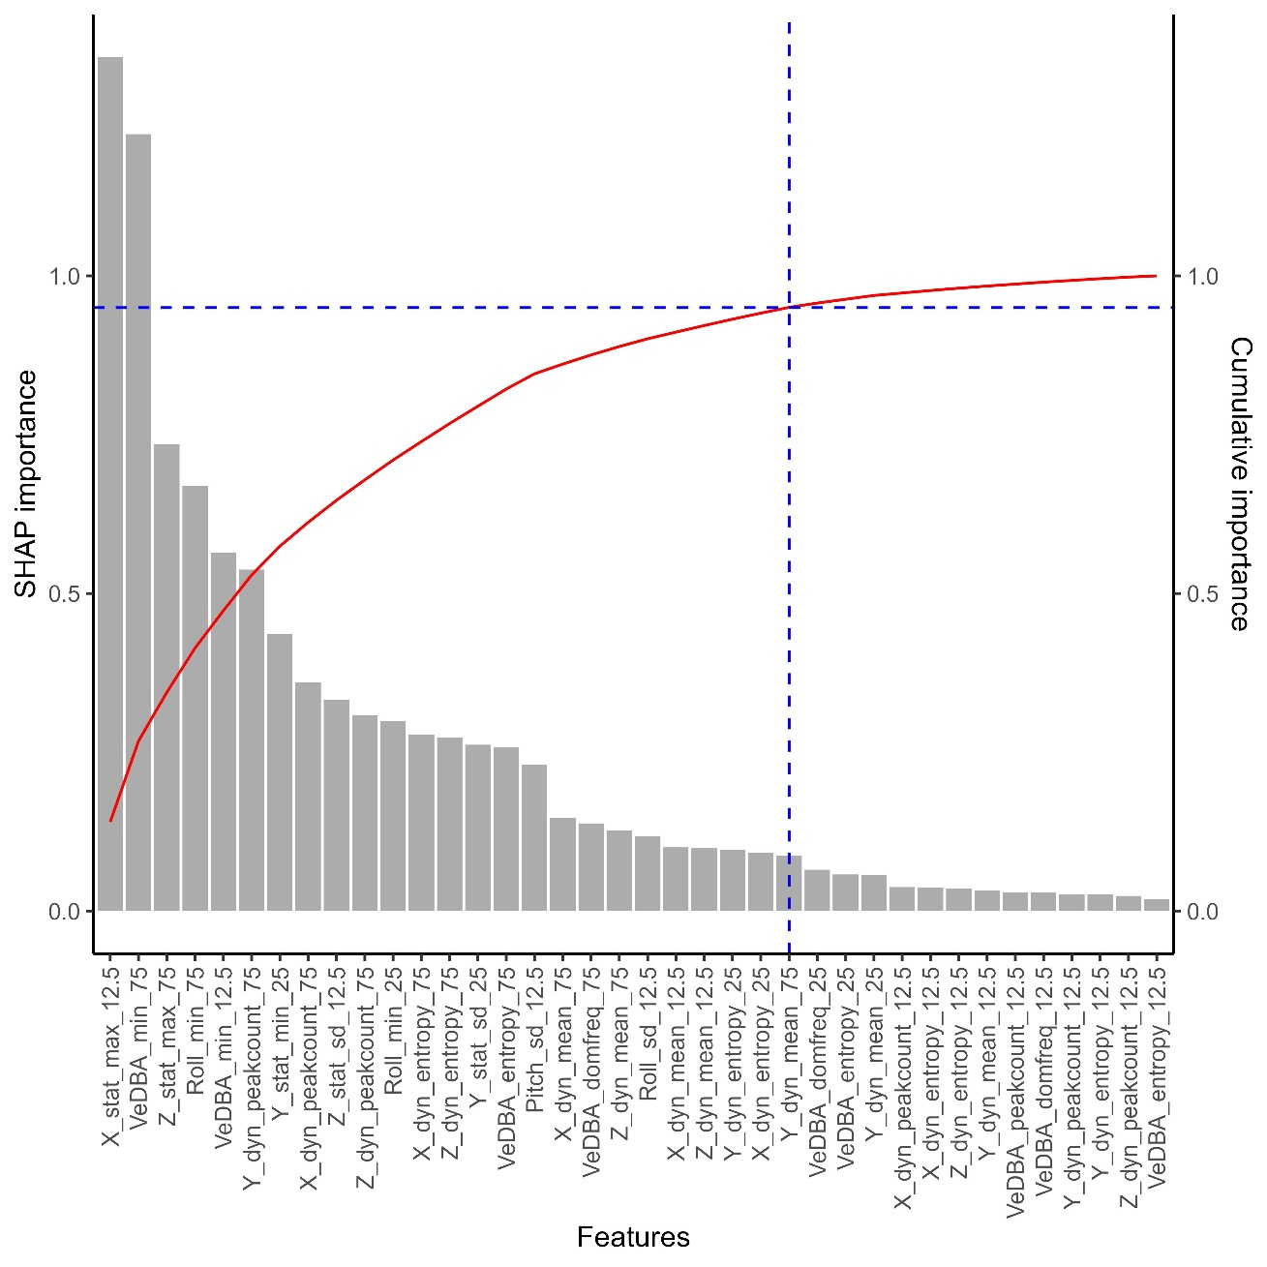
Figure S3. The grey bars represent the SHAP importance values of the 37 uncorrelated features of Eurasian otters arranged from high to low importance. The red line indicates the cumulative importance of including another feature. The blue dashed lines indicate the 95 % importance threshold.

S4: Hyperparameters
Table S4. List of hyperparameters which were tuned for the behavioural classification model of Eurasian otters by fitting XGBoost models with randomly selected hyperparameter values. The best hyperparameter values were evaluated using the lowest average log loss across repeats.
Hyperparameter | Search range | Selected value
max_depth | 3-5 | 4
eta | 0.03-0.08 | 0.07815121
gamma | 0.5-2 | 0.57687468
min_child_weight | 3-8 | 7
subsample | 0.6-0.8 | 0.7023011
colsample_bytree | 0.6-0.8 | 0.6809021
lambda | 1-5 | 2.757726
alpha | 0-1 | 0.2179907

S5: XGBoost model
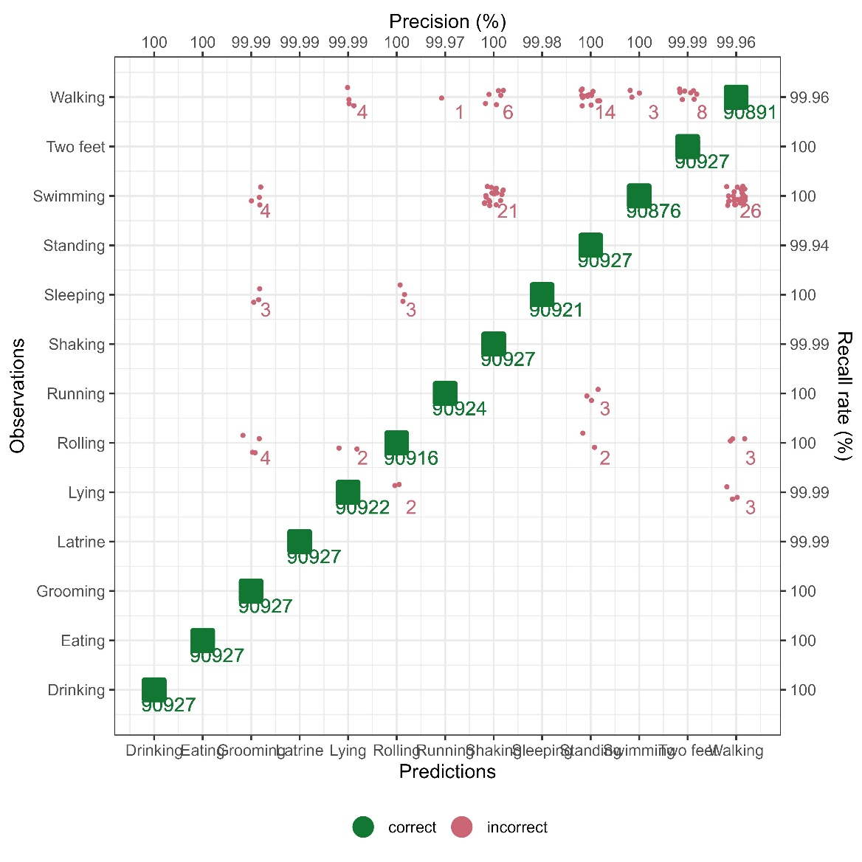
Figure S5. Confusion matrix of observed and predicted behaviours of Eurasian otters based on the five-fold cross-validation with three repetitions of the extreme gradient boosting model. Green points represent correct predictions, red points represent incorrect predictions. Precision and recall rate are indicated on the top and to the right, respectively.

