SOLA
Supplementary Information for
Potential-Vorticity Bridge and Inner-Core Structural Change during Mature to Weakening Phases of Typhoon Neoguri (2025) Captured by Aircraft and Satellite Observations
Satoki Tsujino¹*, Kazuhisa Tsuboki², Sachie Kanada², Soichiro Hirano³, Takuya Takahashi¹, Munehiko Yamaguchi¹, Masaya Kato², Udai Shimada¹, Akiyoshi Wada⁴
1 Meteorological Research Institute, Japan Meteorological Agency, 1-1 Nagamine, Tsukuba, 305-0052, Japan
2 Institute for Space-Earth Environmental Research, Nagoya University, Furo-cho, Chikusa-ku, Nagoya, 464-8601, Japan
3 Disaster Prevention Research Institute, Kyoto University, Gokasho, Uji, 611-0011, Japan
4 Meteorological College, Japan Meteorological Agency, 7-4-81, Asahi-cho, Kashiwa, 277-0852, Japan

Contents of this file

Texts S1 to S2
Table S1
Figures S1 to S5
Caption for Movie S1

Additional Supporting Information (Files uploaded separately)

Movie S1

Introduction
This supplementary information includes the assignment of cloud-top heights used in parallax correction and derivation of atmospheric motion vectors (Text S1), the formulation of the parallax correction in the present study (Text S2), the configuration of the derivation of atmospheric motion vectors (Table S1), additional figures (Figs. S1 to S4), and a movie (Movie S1) supporting the results and discussion in the main manuscript.

Text S1: Assignment of cloud-top heights on geostationary satellite images
In this section, a method to assign cloud-top heights on geostationary satellite images is described. If the infrared brightness temperature (Band-13, 10.8 $μ$m) of each pixel on a Himawari-9 satellite image is assumed to be the cloud-top temperature (e.g., Tsujino et al. 2021; Tsukada et al. 2024), the geopotential height corresponding to that temperature can be obtained from the ERA5 data and assigned to the cloud-top height of each pixel. Based on the cloud-top height and latitude/longitude of each pixel, the latitude/longitude of that pixel was parallax-corrected using the methodology of Tsujino et al. (2021). Because Tsujino et al. (2021) did not provide specific formulations for the parallax correction, we have included the formulations in Text S2. The parallax correction was applied to the infrared and visible images, and the amount of the correction for each pixel was the same in both images.

Text S2: Formulation of parallax correction without any mathematical approximation
In this section, the mathematical formulation of parallax correction caused by meteorological satellite observations is described. According to EUMETSAT (2013), each pixel of brightness temperature observed from a geostationary meteorological satellite is projected onto the geographical latitude and longitude of Earth, assuming that Earth is a spheroid (Normalized Geostationary Projection).
First, consider a Cartesian coordinate system ($x, y, z$) having the center of Earth as an origin (Fig. TS1). When a cloud top (point H) at an altitude $h$ located at a point A ($x_{a},y_{a},z_{a}$) on Earth is observed from a point S ($x_{s},y_{s},z_{s}$), which is the position of a satellite, a pixel having the brightness temperature value is projected onto a point B ($x_{b},y_{b},z_{b}$) on Earth. The parallax correction is an operation for correcting the position ($x_{b},y_{b},z_{b}$) projected on this pixel to the actual cloud position ($x_{a},y_{a},z_{a}$). The formulation derived below finds the corrected amount without any approximation.
Next, when the spheroid imitating Earth has an equatorial radius $r_{e}$ and a polar radius $r_{p}$, an arbitrary point ($x, y, z$) on Earth can be expressed by the equation of a spheroid:
$$\begin{aligned}\frac{x^{2}}{r_{e}^{2}}+\frac{y^{2}}{r_{e}^{2}}+\frac{z^{2}}{r_{p}^{2}}=1\#\left(TS1\right)\end{aligned}$$
and a unit normal vector $n_{ellip}$ on Earth can be expressed as follows:
$$\begin{aligned}n_{ellip}=\left[\begin{matrix}\left(x/r_{e}^{2}\right) \\ \left(y/r_{e}^{2}\right) \\ \left(z/r_{p}^{2}\right)\end{matrix}\right]{\left[\frac{x^{2}}{r_{e}^{4}}+\frac{y^{2}}{r_{e}^{4}}+\frac{z^{2}}{r_{p}^{4}}\right]}^{-1/2}.\#\left(TS2\right)\end{aligned}$$
Since the point H is an internal division point of the line segment OS, the vector OH can be expressed as follows:
$$\begin{aligned}\vec{\text{OH}}=\vec{\text{OB}}+t\vec{\text{BS}}, (0<t<1).\#\left(TS3\right)\end{aligned}$$
Since the point H is on the normal line from the point A on the spheroid, the following equation can be obtained:
$$\begin{aligned}\vec{\text{OH}}=\vec{\text{OA}}+\vec{\text{AH}}=\vec{\text{OA}}+hn_{ellip}.\#\left(TS4\right)\end{aligned}$$
Therefore, the following equation can be obtained from Eqs. (TS2), (TS3), and (TS4):
$$\left(1-t\right)x_{b}+tx_{s}=x_{a}+\left[h\left(r_{p}/r_{e}\right)x_{a}\right]{\left[r_{p}^{2}-\left(1-r_{e}^{2}/r_{p}^{2}\right)z_{a}^{2}\right]}^{-1/2},$$
$$\begin{aligned}\left(1-t\right)y_{b}+ty_{s}=y_{a}+\left[h\left(r_{p}/r_{e}\right)y_{a}\right]{\left[r_{p}^{2}-\left(1-r_{e}^{2}/r_{p}^{2}\right)z_{a}^{2}\right]}^{-1/2},\#\left(TS5\right)\end{aligned}$$
$$\left(1-t\right)z_{b}+tz_{s}=z_{a}+\left[h\left(r_{e}/r_{p}\right)z_{a}\right]{\left[r_{p}^{2}-\left(1-r_{e}^{2}/r_{p}^{2}\right)z_{a}^{2}\right]}^{-1/2}.$$
which are simultaneous equations for unknown variables $t,x_{a},y_{a},$ and $z_{a}$. Since point A is a point on Earth, from Eq. (TS1) we obtain
$$\begin{aligned}\frac{x_{a}^{2}}{r_{e}^{2}}+\frac{y_{a}^{2}}{r_{e}^{2}}+\frac{z_{a}^{2}}{r_{p}^{2}}=1.\#\left(TS6\right)\end{aligned}$$
From Eqs. (TS5) and (TS6), we obtain a single equation for $z_{a}$:
$$\begin{aligned}{\left[x_{b}+\frac{-z_{b}+z_{a}+h\left(r_{e}/r_{p}\right)z_{a}γ\left(z_{a}\right)}{z_{s}-z_{b}}\left(x_{s}-x_{b}\right)\right]}^{2} \\ +{\left[y_{b}+\frac{-z_{b}+z_{a}+h\left(r_{e}/r_{p}\right)z_{a}γ\left(z_{a}\right)}{z_{s}-z_{b}}\left(y_{s}-y_{b}\right)\right]}^{2}=\left(1-\frac{z_{a}^{2}}{r_{p}^{2}}\right){\left[r_{e}+hr_{p}γ\left(z_{a}\right)\right]}^{2},\#\left(TS7\right)\end{aligned}$$
where $γ\left(z_{a}\right)={\left[r_{p}^{2}-\left(1-r_{e}^{2}/r_{p}^{2}\right)z_{a}^{2}\right]}^{-1/2}$. Since Equation (TS7) is an eighth-order nonlinear equation for $z_{a}$, it is solved numerically. When $z_{a}$ does not have multiple roots, there are eight different types of roots, but among the roots, we want to find the root that is a real number, $\left|z_{b}\right|>\left|z_{a}\right|$, and $0 <t <1$. While there are multiple choices for the numerical solution, Tsujino (2026) implemented a dichotomous search using $z_{b}$ and $0.9z_{b}$ as first estimates. After finding $z_{a}$ numerically, we find $t$ from the third equation of Eq. (TS5). The values of $x_{a}$ and $y_{a}$ are obtained from the first and second equations of Eq. (TS5), respectively.
Finally, we show the procedures of the parallax correction. Given the geographic latitude of $ϕ_{b}$ and longitude of $λ_{b}$ at a certain pixel (at the point B of Fig. TS1), the position on the Cartesian coordinate ($x_{b},y_{b},z_{b}$) can be obtained as follows:
$$\begin{aligned}x_{b}=r_{e}\sin{θ_{b}}\cos{λ_{b}}, y_{b}=r_{e}\sin{θ_{b}}\sin{λ_{b}}, z_{b}=r_{p}\cos{θ_{b}},\#\left(TS8\right)\end{aligned}$$
$$θ_{b}=\frac{π}{2}-ψ_{b}, ψ_{b}=\arctan\left[{\left(\frac{r_{p}}{r_{e}}\right)}^{2}\tan{ϕ_{b}}\right].$$
where $θ$ and $ψ$ are the co-geocentric latitude and geocentric latitude, respectively. Substituting ($x_{b},y_{b},z_{b}$) from Eq. (TS8) into Eq. (TS7), we can obtain $z_{a}$. Then, from Eqs. (TS5), $t,x_{a}$, and $y_{a}$ can be obtained. From the inversion of Eq. (TS8),
$$\begin{aligned}θ_{a}=\arccos\left(\frac{z_{a}}{r_{p}}\right), λ_{a}=\arctan\left(\frac{y_{a}}{x_{a}}\right),\#\left(TS9\right)\end{aligned}$$
$$ψ_{a}=\frac{π}{2}-θ_{a}, ϕ_{a}=\arctan\left[{\left(\frac{r_{e}}{r_{p}}\right)}^{2}\tan{ψ_{a}}\right].$$
The obtained geographic latitude of $ϕ_{a}$ and longitude of $λ_{a}$ are the parallax-corrected location for the pixel.

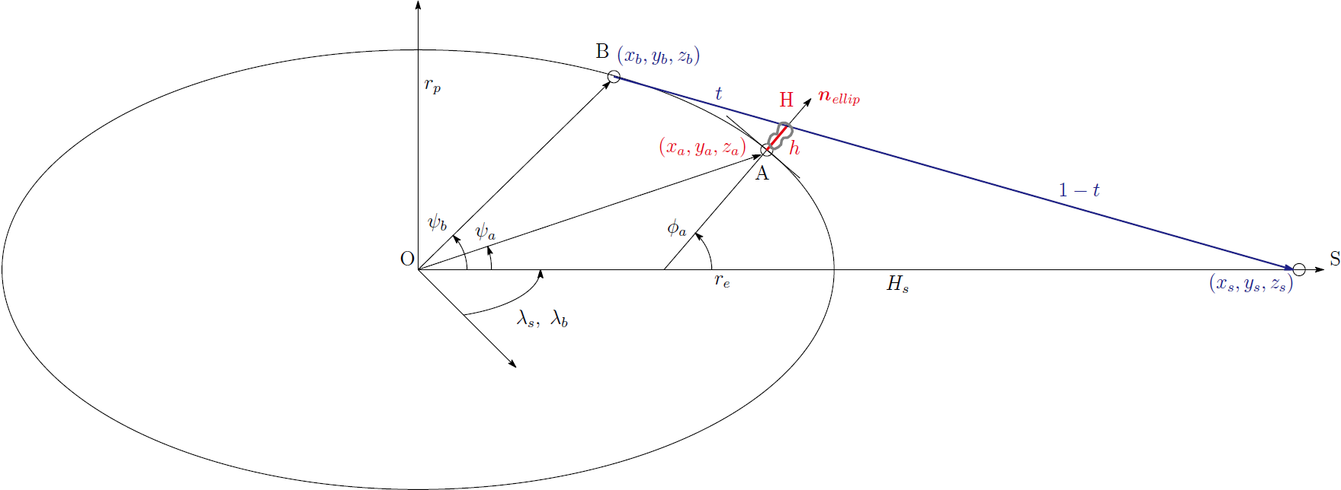
Fig. TS1 Geometry of parallax correction for a pixel from the geostationary satellite. The points O, B, A, H, and S are the origin of the Cartesian coordinate system ($x,y,z$), the location of a pixel before the parallax correction, the location of the pixel after the parallax correction, the top of the cloud with a depth of $h$ on the point A, and the satellite location, respectively. Other symbols are indicated in Text S1.

Table S1. Configuration of the derivation of atmospheric motion vectors
Parameter | Value
Time interval between consecutive images used in deriving AMVs | 30 s
Horizontal resolution of images | 500 m
Time interval of AMV data | 2.5 min
Horizontal grid spacing of AMV derivation | 2 km
Size of template subimage | 11 × 11 pixels
Threshold to limit the lowest value of the peak cross-correlation coefficient | 0.8
Tracking time steps for both forward and backward | 2 steps
Threshold to limit the maximum velocity change between consecutive images | 20 m s^{–1}

Fig. S1 Vertical distributions of the fall speed (colored stars) of dropsondes on 21 September 2025 (Day 1). Red, blue, and green colors indicate dropsondes launched in the eyewall, eye, and outside of the inner core. Large stars by red indicate the dropsonde with relatively slow fall speed in the eyewall updrafts. The fall speed was calculated by approximating the time derivative of the altitude of the dropsonde using a central difference scheme.

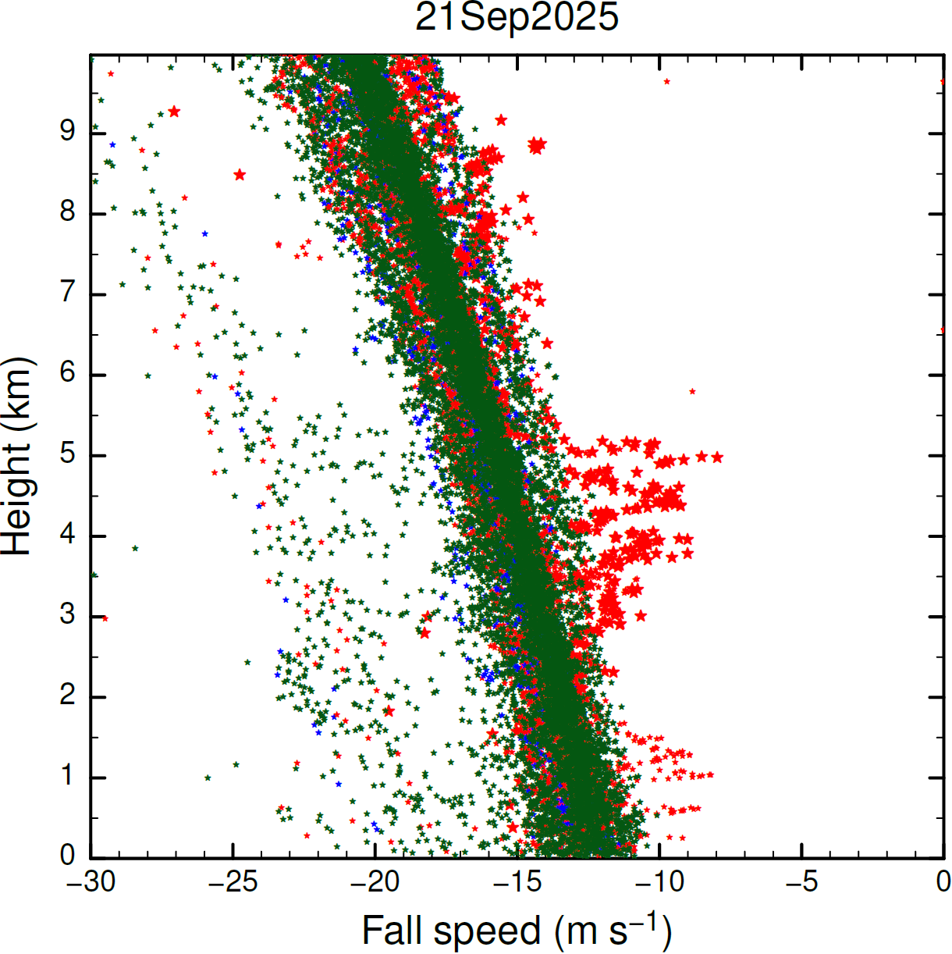

Fig. S2 Intercomparison of horizontal (i.e., zonal and meridional) wind components between the AMVs and dropsondes in the eye on 21 September 2025. On that day, two sondes were dropped in the eye. The abscissa and ordinate indicate horizontal winds for dropsondes and AMVs, respectively. The diagram was drawn as follows. For each dropsonde, we found the horizontal position, altitude, and time at which the difference between the altitude of the falling sonde and the altitude corresponding to the infrared brightness temperature of the satellite observed at the time and horizontal position was minimized. This horizontal position, altitude, and time are named the nearest neighbor location/altitude/time of the dropsonde. The mean value of the wind components over a layer between the top and bottom 750 m, which approximately corresponds to the vertical distance traversed by each dropsonde during a 2.5-minute fall, for the nearest neighbor altitude of the dropsonde was calculated centering on the altitude. We calculated the mean value of AMVs at the eight data points surrounding the nearest neighbor location and time of the dropsonde. These mean values were projected as black dots on the abscissa and ordinate. The standard deviations of the data used to calculate the mean values of the dropsonde wind and the AMV wind are represented by black and red whisker plots, respectively.

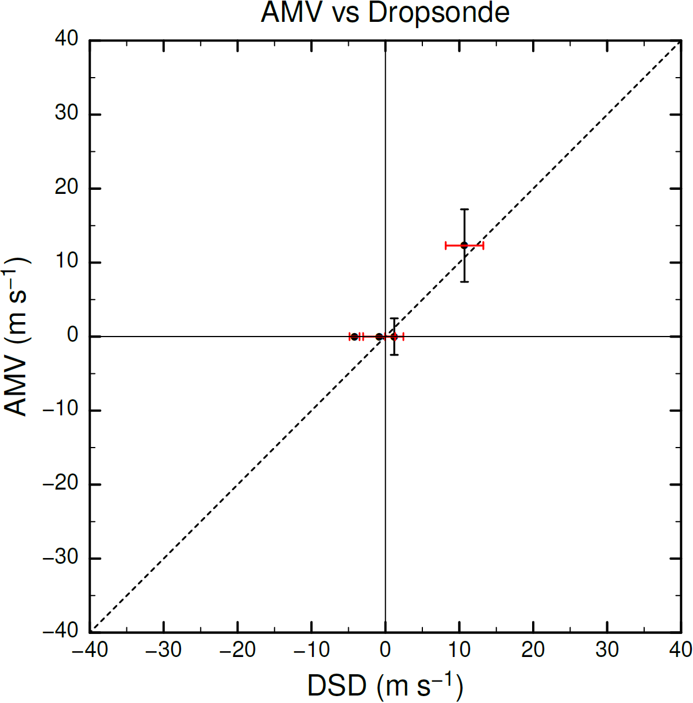

Fig. S3 Radial profiles of the net tendency of radially integrated absolute angular momentum $M\left(r\right)$ (blue line) and radial advection (RADV) of $M\left(r\right)$ (red line), which is defined in Eq. (1) of Horinouchi et al. (2023), in Typhoon Neoguri (2025) during the period from 0000 UTC to 0600 UTC 21 September 2025. The radially integrated angular momentum and the RADV term are defined as follows:
$$\begin{aligned}M\left(r\right)≡\int_{0}^{r}{r^{'}\overline{m}dr^{'}},m≡rυ+\frac{fr^{2}}{2},\#\left(SF1.1\right)\end{aligned}$$
$$\begin{aligned}\text{R}\text{ADV}≡-r\overline{mu}.\#\left(SF1.2\right)\end{aligned}$$
The symbols $r, u, υ,$ and $f$ indicate the radius, radial flow, tangential flow, and the Coriolis parameter, respectively. The overbar indicates an azimuthal average.

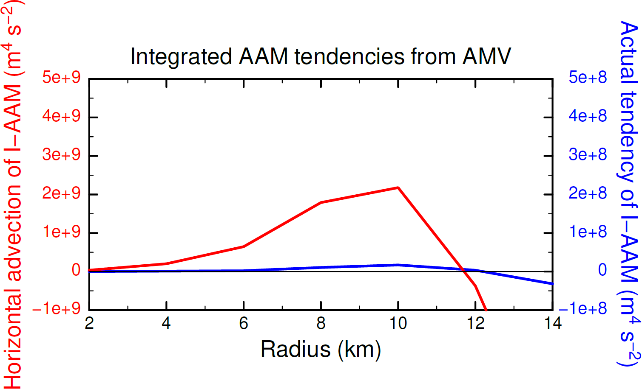

Fig. S4 Horizontal distributions of brightness temperature (color; K) at the infrared band of 10.8 μm captured by the Himawari-9 satellite. The black circles in (a) and (b) denote radii of 25 km, 50 km, and 75 km.

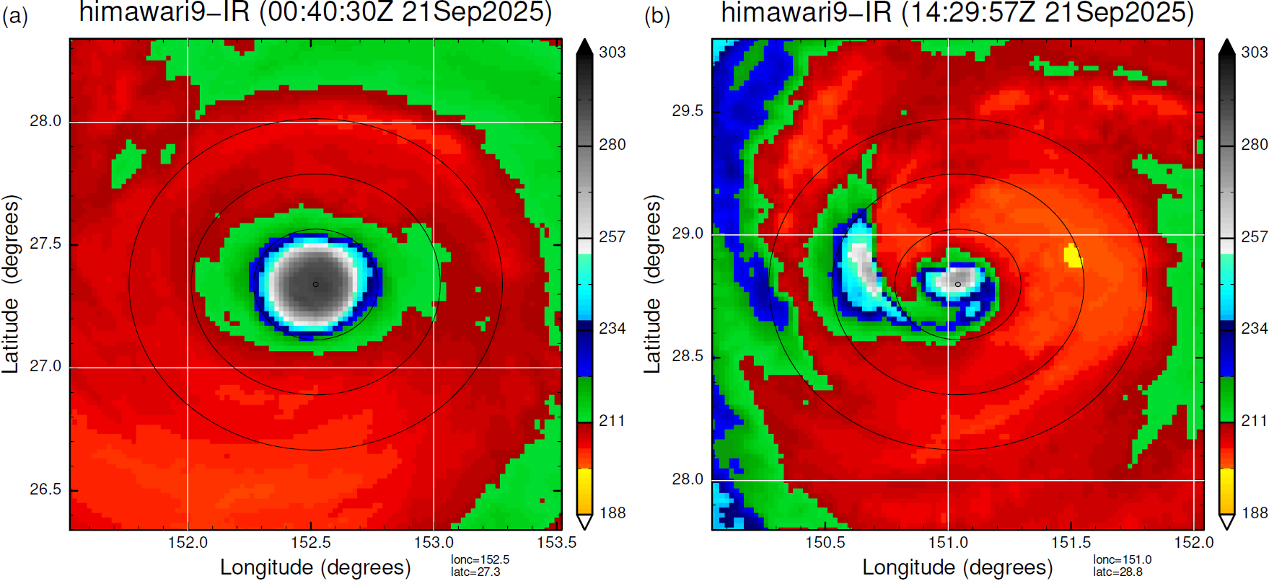

Fig. S5 Sea surface temperature (SST) indicated by shading (unit: K), which was retrieved from microwave and infrared sensors by satellites on (a) 18 September (before the mature stage of Neoguri) and (b) 25 September (after the weakening stage of Neoguri). The green contour indicates the SST value of 26.5 °C. The pink line and stars indicate the track of Neoguri and the locations of the typhoon on the two days when observations were made, respectively. The SST data were obtained from the Remote Sensing Systems website (https://www.remss.com/measurements/sea-surface-temperature/).

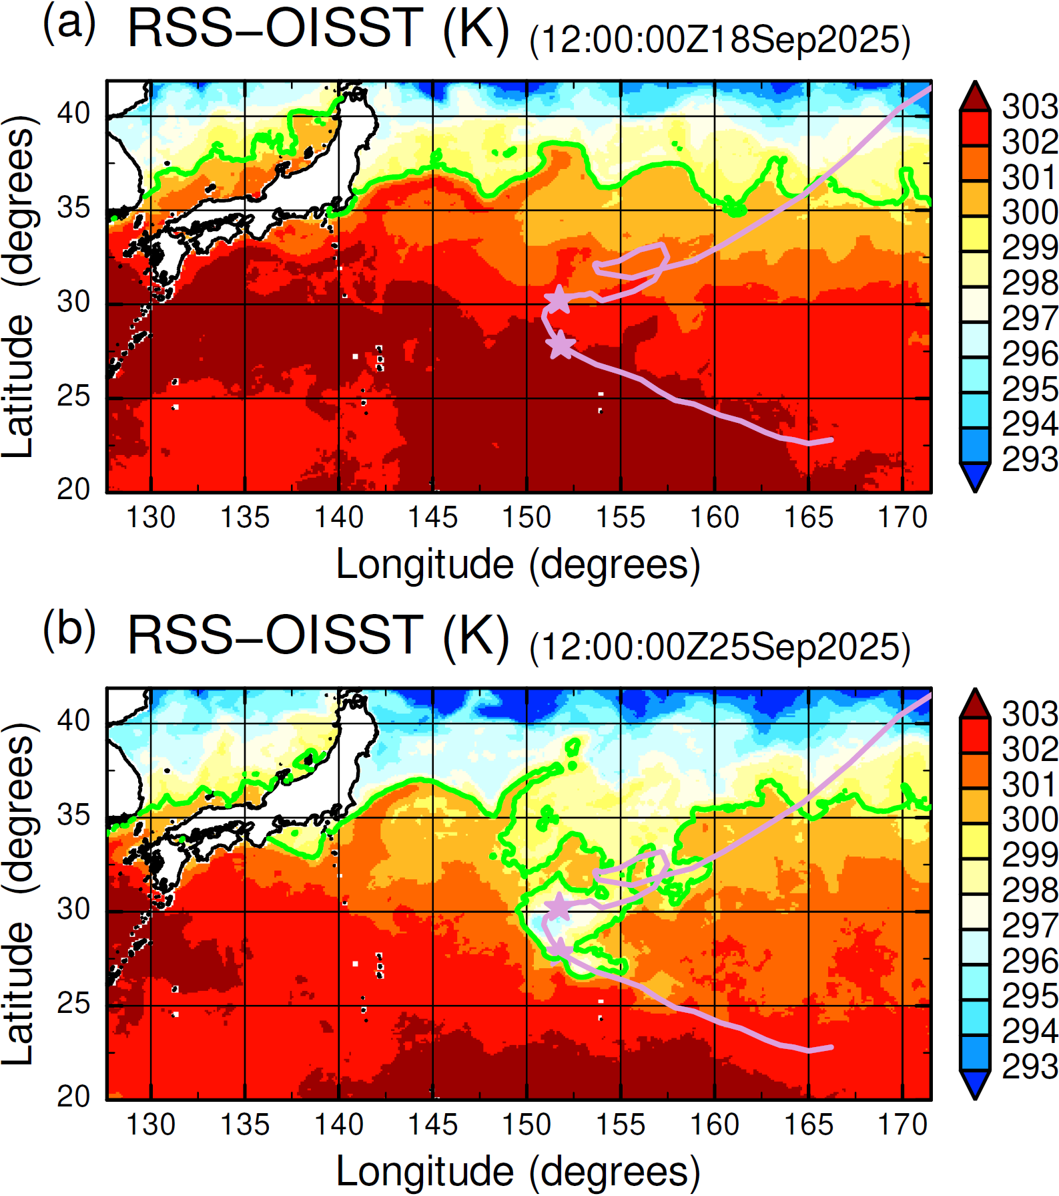

Movie S1. A (storm-relative) animation of the area near the typhoon center created from visible images of the Himawari-9 satellite during the period when the AMV was derived. Note that the movie is rotated in the direction opposite to the representative tangential flow with respect to the typhoon center at an average rotating angular velocity of 2.0 × 10^{–3} rad s^{–1} derived from the lower-layer AMVs in the eye. This type of visualization, as proposed in Tsukada et al. (2024), facilitates the identification of differences between the angular velocities of local cloud patterns and the (axisymmetric) primary rotation. If clouds around the typhoon rotate at the same speed as the rotational angular velocity, the clouds appear to azimuthally stop in this movie. If there are clouds rotating counterclockwise in this movie, this means that is the clouds are moving faster than the angular velocity of 2.0 × 10^{–3} rad s^{–1}. The closed circles indicate radii of 1 km, 15 km, 25 km, and 50 km from the innermost to outermost circles, respectively. Some small-scale clouds can be seen to rotate counterclockwise at around 15 km to 25 km.

References
EUMETSAT (2013) Coordination Group for Meteorological Satellites LRIT/HRIT Global Specification. The Coordination Group for Meteorological Satellites. https://www.cgms-info.org/wp-content/uploads/2021/10/cgms-lrit-hrit-global-specification-(v2-8-of-30-oct-2013).pdf [Accessed 01 March 2026]
Horinouchi T, Tsujino S, Hayashi M, Shimada U, Yanase W, Wada A, Yamada H (2023) Stationary and transient asymmetric features in tropical cyclone eye with wavenumber-one instability: Case study for Typhoon Haishen (2020) with atmospheric motion vectors from 30-second imaging. Mon Wea Rev 151:253-273. doi:10.1175/MWR-D-22-0179.1
Tsujino S, Horinouchi T, Tsukada T, Kuo H-C, Yamada H, Tsuboki K (2021) Inner-core wind field in a concentric eyewall replacement of Typhoon Trami (2018): A quantitative analysis based on the Himawari-8 satellite. J Geophys Res: Atmos 126:e2020JD034434. doi:10.1029/2020JD034434
Tsujino S (2026) JParallaxCorrect: version-0.2.0 (v0.2.0). Zenodo, doi:10.5281/zenodo.18870145.
Tsukada T, Horinouchi T, Tsujino S (2024) Wind distribution in the eye of tropical cyclone revealed by a novel atmospheric motion vector derivation. J Geophys Res: Atmos 129:e2023JD040585. doi:10.1029/2023JD040585

The parallax correction based on this formulation has already been derived by Tsujino et al. (2021), but they did not describe the details of the formulation and procedure. This Supplementary Information introduces the details. Tsujino (2026) provided the Fortran library and JuliaLang scripts to perform the parallax correction on GitHub.

