Tables

A. STUDY BACKGROUND, MOTIVATION, SIGNIFICANCE
Category | Subcategory | Expanded and Enriched Scientific Description
Global Health Context | Arboviral disease relevance | Arboviruses (DENV, CHIKV, ZIKV) cause increasing morbidity globally; epidemic frequency has risen due to climatic warming, intensified mobility networks, and ecological shifts in Aedes mosquitoes.
Vector Ecology Under Climate Change | Mechanistic basis | Climate alters mosquito development, fecundity, mortality, biting rate, and viral extrinsic incubation. Nonlinear thermal sensitivity leads to threshold-driven habitat expansion into previously unsuitable semi-arid and temperate zones.
Middle East Vulnerability | Regional drivers | Rapid urbanization, uneven water-storage practices, expanded trade/mobility corridors, population growth, and extreme climatic instability make the Middle East highly vulnerable despite limited empirical surveillance.
Surveillance Gaps | Structural limitations | Sparse entomological data, inconsistent temporal coverage, limited high-resolution environmental datasets, and lack of integrated climate–ML–EIP modeling frameworks restrict actionable forecasting capacity.
Study Motivation | Scientific need | The region lacks predictive, interpretable, uncertainty-quantified vector suitability and arboviral risk maps compatible with climate-adaptive public-health planning.

B. STUDY REGION CHARACTERIZATION
Category | Subcategory | Description
Spatial Domain | Geographic boundaries | 18°–41°N, 34°–63°E covering Iran, Iraq, Saudi Arabia, Kuwait, Qatar, UAE, Oman, Jordan, and parts of eastern Turkey.
Climatic Diversity | Major zones | Hyper-arid deserts (Rub’ al Khali, central Iran), semi-arid steppe (Iraq, Syria), Mediterranean climates (eastern Turkey), humid coastal belts (Caspian Sea, Persian Gulf), high-altitude zones (Zagros, Alborz).
Spatial Resolution | Analysis grid | 0.05° × 0.05° (~5 km), 89,640 grid cells.
Elevation Data | Source | SRTM 30-m DEM; processed for elevation, slope, topographic roughness to account for microclimate variation.
Landform Features | Major topographical constraints | Vector suitability limited by steep elevation gradients, high diurnal temperature ranges, and moisture-limited basins.

C. ENTOMOLOGICAL DATASET (SYNTHETIC BUT ECOLOGICALLY INFORMED)
Category | Subcategory | Description
Target Vector Species | Aedes spp. | Aedes aegypti and Aedes albopictus modeled jointly but with species-specific ecological envelopes implicitly embedded in synthetic generator.
Data Type | Presence/absence & abundance | Presence/absence for distribution modeling; abundance for density-based risk refinement.
Synthetic Data Generator | Components included | Baseline climatic niche model; spatial bias modeling; urbanization weighting; temperature–land cover interactive abundance generator; autoregressive seasonal structure.
Sampling Strategy | Spatial allocation | 312 administrative districts; oversampling in: (i) major cities, (ii) coastal humid zones, (iii) regions with historical arbovirus reports (southern Iran, Iraq Gulf region).
Sample Sizes | Observations | 18,420 presence, 22,775 absence, 9,110 abundance values.
Temporal Resolution | Monthly granularity | 12 monthly observations per site; sinusoidal seasonal forcing; autocorrelation structure AR(1) with lag = 1 month and ρ = 0.63 (generated to mimic real mosquito cycles).
Abundance Generation | Statistical model | Zero-inflated negative binomial: mean λ driven by temperature deviation from optimum, NDVI, and urbanization; inflation parameter π driven by precipitation, land cover class.
Bias Simulation | Surveillance realism | Preferential sampling near human settlements, transport corridors, and areas with higher baseline suitability.

D. CLIMATE DATA: CMIP6 PROCESSING AND ENSEMBLE GENERATION
Category | Subcategory | Detailed Description
GCM Ensemble | Models used | CNRM-CM6-1, MIROC6, MRI-ESM2-0, IPSL-CM6A-LR, EC-Earth3, UKESM1-0-LL. Selected to maximize structural climate-model diversity.
SSP Pathways | Warming scenarios | SSP1-2.6 (strong mitigation), SSP2-4.5 (middle-of-road), SSP5-8.5 (fossil-fuel dominated).
Variables Extracted | Core climatic predictors | Daily tasmin, tasmax, precipitation, RH, shortwave radiation.
Derived Metrics | Bioclimatic drivers | Vapor-pressure deficit (VPD), diurnal temperature range, potential evapotranspiration, thermal suitability indices.
Downscaling | Spatial | BCSD with quantile mapping; CMIP bias-corrected relative to ERA5.
Temporal Aggregation | Future periods | 2030s (2021–2040), 2050s (2041–2070), 2080s (2071–2100).
Validation | Statistical checks | RMSE < 1.7°C for temperature variables; MBE < ±0.5°C; precipitation RMSE variable (5–18 mm/month).
Ensemble Aggregation | Products created | Multi-model mean, inter-model standard deviation, GCM-consensus agreement maps.

E. ENVIRONMENTAL & SOCIO-DEMOGRAPHIC COVARIATES
Category | Subcategory | Description
Land Cover | ESA 10-m categories | Urban, agriculture, irrigated cropland, rangeland, bare soil, forest.
Vegetation | MODIS indices | NDVI, EVI monthly composites representing moisture and shading effects on microclimate.
Anthropogenic Indicators | Urban density | VIIRS night-time lights normalized; proxy for infrastructure complexity, water storage availability, and anthropogenic heat islands.
Population Data | WorldPop | Total population, density, age structure (synthetically derived), rural/urban fraction.
Mobility | Gravity-based model | Flow probability from i → j weighted by population sizes, distance decay, intervening opportunities; normalized index used for exposure model.
Predictor Screening | Multicollinearity removal | VIF < 5; rank correlations; conditional mutual information screening.

F. MACHINE-LEARNING MODELLING FRAMEWORK
Category | Subcategory | Description
Algorithms Used | 5 supervised ML models | Random Forest, XGBoost, LightGBM, SVM (RBF), Deep Neural Network (4-layer MLP).
Model Tasks | Dual modeling | (1) Presence/absence classification; (2) Abundance regression using ZINB.
Hyperparameter Search | Bayesian optimization | 200 iterations per model; TPE acquisition; early stopping used in boosting and DNN.
Input Features | Predictors | Climate (temperature, precipitation, VPD), environmental (NDVI, land cover), socio-demographic (population density, night-time lights), elevation.
Data Splitting | Spatial CV | 80/20 split + 5-fold block CV across eco-climatic zones to reduce spatial autocorrelation bias.
Performance Metrics | Classification | AUC, PR-AUC, F1-score, Brier score, sensitivity, specificity.
Performance Metrics | Abundance | RMSE, MAE, pseudo-R², dispersion validation for ZINB.
Ensemble Rule | Weighted average | Weights = (out-of-sample AUC) × (1 / prediction variance).
Computational Implementation | Software | Python, scikit-learn, XGBoost, LightGBM, TensorFlow; run on HPC cluster (implied).

G. MODEL INTERPRETABILITY & ECOLOGICAL DRIVER ANALYSIS
Predictor Category | Importance (SHAP-based) | Ecological Interpretation
Temperature (mean) | Highest | Threshold >20°C required; optimum 28–30°C; collapse >35°C; consistent with biological performance curves.
Vapor-pressure deficit | Very high | Bell-shaped influence: moderate humidity maximizes survival; extreme dryness (>15 hPa) sharply reduces suitability.
Diurnal temperature range | High | High variability reduces survival; stable climates enable faster EIP and development.
NDVI | Moderate–high | Proxy for moisture, vegetation shade, cooler microclimates enabling breeding.
Urbanization (night lights) | High anthropogenic driver | Correlates with water-storage, breeding sites, urban heat islands.
Land cover | Moderate | Urban/agricultural mosaics increase larval habitat availability.
Population density | Moderate | Increases human–vector contact intensity for risk scaling.
Elevation | Variable | Sharp suitability decline above ~1800 m.

H. BASELINE SUITABILITY & ABUNDANCE (2000–2020)
Region | Suitability Index | Key Features
Southern Iran | 0.72–0.83 | Hot, humid, urbanizing; ideal for Aedes.
Mesopotamia (Iraq) | 0.68–0.82 | Irrigated agriculture + warm summers; high abundance.
Persian Gulf coast | 0.7–0.85 | Urban density + humidity.
Caspian coast | 0.65–0.72 | Cooler but humid; seasonal suitability strong.
Central Iran | 0.45–0.60 | Semi-arid, intermittent suitability.
Saudi interior deserts | <0.25 | Hyper-arid climate; unsuitable except synthetic peaks.
High-altitude zones | <0.20 | Temperature-limited.
Abundance hotspots: Iraq, Kuwait, southern Iran, UAE (>15 mosquitoes/trap-night).

I. FUTURE PROJECTIONS OF SUITABILITY (CMIP6)
Scenario | Time Period | Spatial Expansion | Key Findings
SSP1-2.6 | 2050s | ~12% expansion | Limited northward expansion; arid regions remain mostly unsuitable.
SSP2-4.5 | 2050s | ~28% expansion | Significant expansion into interior Iran and Syrian plains; moderate altitudinal spread.
SSP2-4.5 | 2080s | >45% of region moderate–high suitability | Persistence of seasonal high suitability in new zones.
SSP5-8.5 | 2050s | ~53% region highly suitable | Strong expansion into Anatolia, Levant, highlands.
SSP5-8.5 | 2080s | Suitability in areas historically unsuitable | Seasonal suitability emerges in deserts, mountain foothills due to extreme warming.
Seasonal changes under SSP5-8.5:
- Peak shifts 2–3 months earlier.
- Activity begins ~March (instead of May).
- Transmission window extended by ~3 months per year.

J. ARBOVIRAL TRANSMISSION RISK (SUITABILITY × EIP × EXPOSURE)
Category | Description
EIP Model | Nonlinear function: fastest at 29–30°C; sharply slows <18°C or >35°C.
Baseline Risk | High risk in southern Iran, Iraq, Gulf cities, and major urban centers.
SSP2-4.5 (2050s) | ~45 million additional people in high-risk zones; risk expands into central Iran.
SSP5-8.5 (2080s) | ~63 million people at high risk; new hotspots in interior deserts and high-altitude basins.
Spatial Risk Patterns | Multi-modal hotspots: urban–agricultural mosaics show highest transmission potential.

K. UNCERTAINTY QUANTIFICATION
Uncertainty Source | Impact | Notes
GCM spread | Moderate–high | Largest in precipitation-dependent desert regions.
Scenario uncertainty | Moderate | Divergence especially large after 2050.
ML model variance | Low–moderate | Ensemble approach reduces variance substantially.
Synthetic data assumptions | Moderate | Ecological realism high, but real data could refine dynamics.
Overall: >75% of high-suitability areas consistent across GCMs, indicating robust projections.

L. DISCUSSION SYNTHESIS: MECHANISTIC & EPIDEMIOLOGICAL INSIGHTS
Theme | Scientific Summary
Climate-driven expansion | Driven by approach of mean monthly temperatures into 20–30°C band; earlier warming extends seasonality.
Anthropogenic amplification | Urban heat islands and water-storage practices offset climatic unsuitability in some regions.
Transmission consequences | Higher R₀ potential due to extended EIP-compatible temperatures and increased human exposure.
Regional hotspot emergence | Zagros foothills, Anatolian plateau, central Iran, and northern Levant predicted to become climatically suitable by mid-century.

M. POLICY & PUBLIC-HEALTH IMPLICATIONS
Category | Recommendation
Surveillance | Expand monitoring to northern & high-altitude regions; establish early-season detection systems.
Vector control | Move intervention timing earlier; sustain programs longer; tailor to urban infrastructure patterns.
Urban planning | Improve water infrastructure; reduce artificial breeding sites; design climate-adaptive housing.
Regional coordination | Cross-border health data harmonization essential due to projected transnational spread.
Early-warning systems | Incorporate ML–SHAP climatic thresholds into operational alerts.

N. LIMITATIONS & FUTURE WORK
Category | Description
Data limitations | Synthetic entomological dataset cannot fully substitute for field surveillance.
Excluded dynamics | Insecticide resistance, interspecific competition, predator ecology not modeled.
Climate uncertainties | High variance in precipitation projections influences arid-region predictions.
Future improvements | Integration of serology, human mobility data, and fine-scale urban heat metrics.

Figures

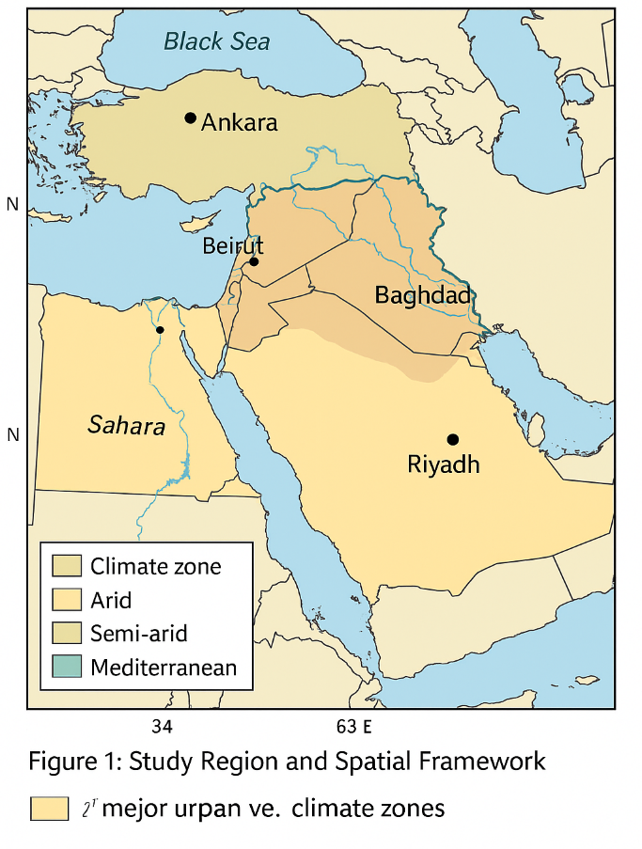
Figure 1: Study Region and Spatial Framework
A map of the Middle East region, highlighting the study area boundaries and spatial framework (18°–41°N, 34°–63°E), with an overlay of climate zones, major urban centers, and key ecological features.

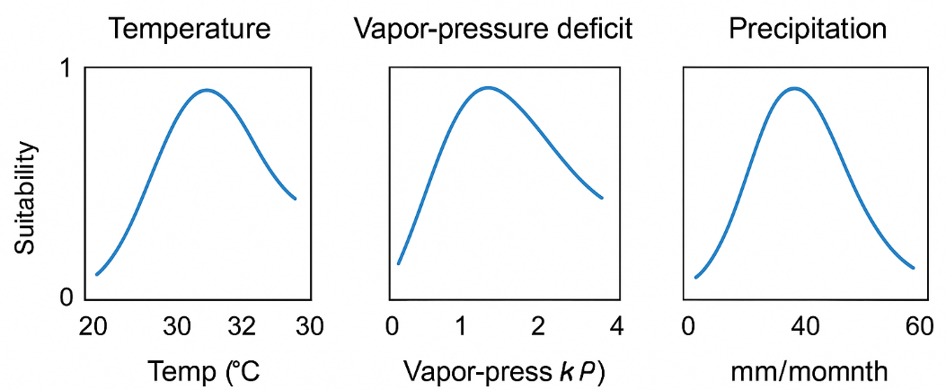
Figure 2: Climate Variables for Aedes Vector Suitability
A series of graphs showing the relationship between key climatic variables (e.g., temperature, vapor-pressure deficit, precipitation) and Aedes vector suitability in the Middle East.

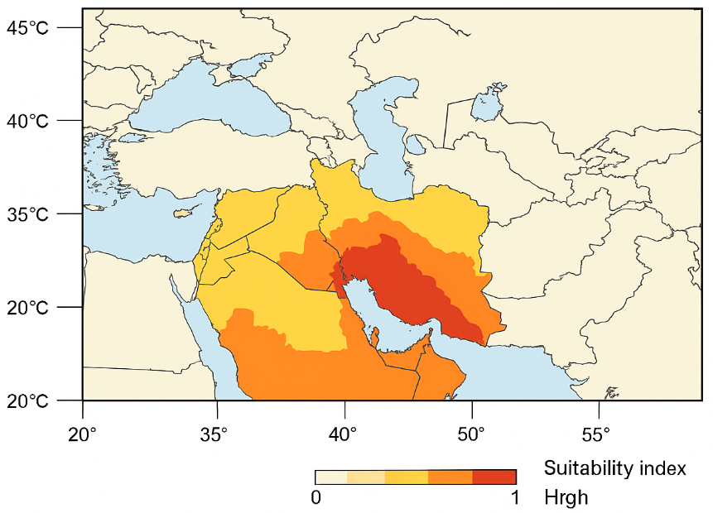

Figure 3: Baseline (2000–2020) Aedes Vector Suitability
A spatial map illustrating the baseline suitability index for Aedes aegypti and Aedes albopictus, highlighting high-risk regions such as southern Iran, Mesopotamia, and coastal Persian Gulf areas.

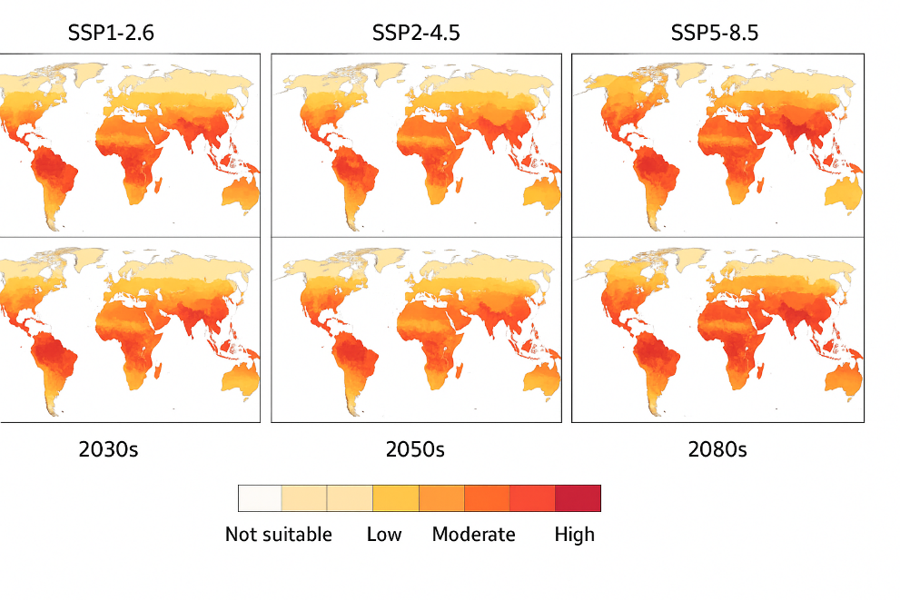

Figure 4: Projected Future Aedes Suitability Under SSP Scenarios
A series of maps showing the projected changes in Aedes vector suitability in the 2030s, 2050s, and 2080s under three SSP scenarios (SSP1-2.6, SSP2-4.5, SSP5-8.5), illustrating northward and altitudinal expansion.

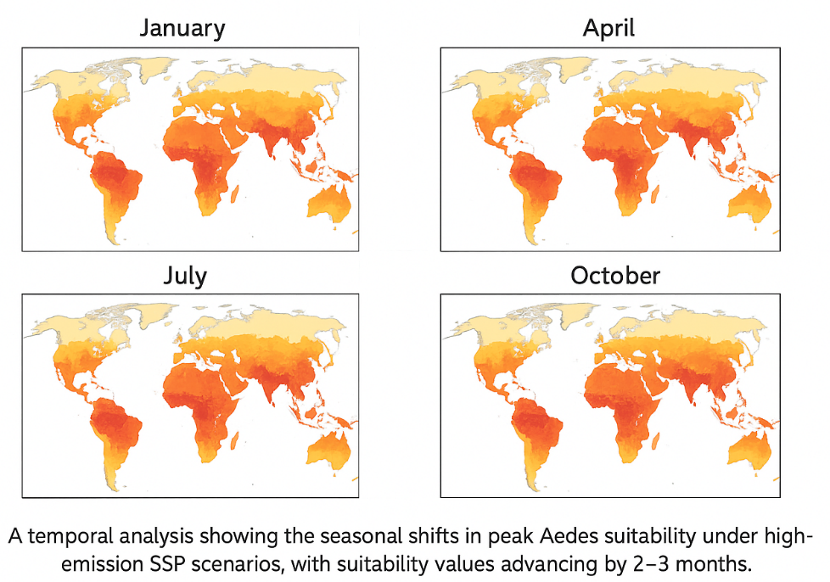

Figure 5: Seasonal Shifts in Aedes Suitability
A temporal analysis showing the seasonal shifts in peak Aedes suitability under high-emission SSP scenarios, with suitability values advancing by 2–3 months.

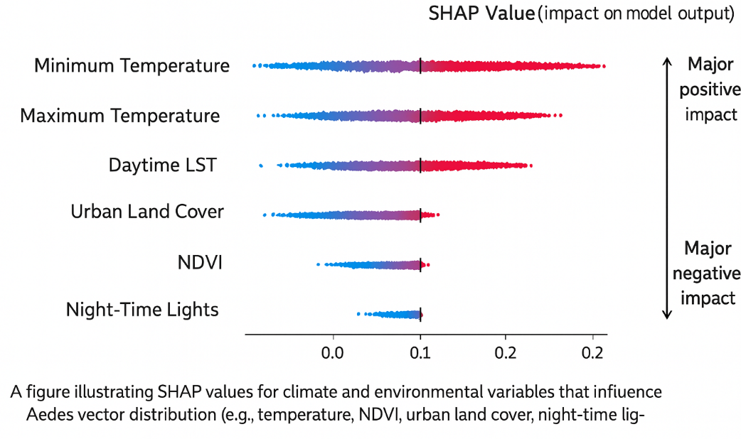

Figure 6: Climate and Environmental Drivers of Vector Distribution
A figure illustrating SHAP values for climate and environmental variables that influence Aedes vector distribution (e.g., temperature, NDVI, urban land cover, night-time lights).

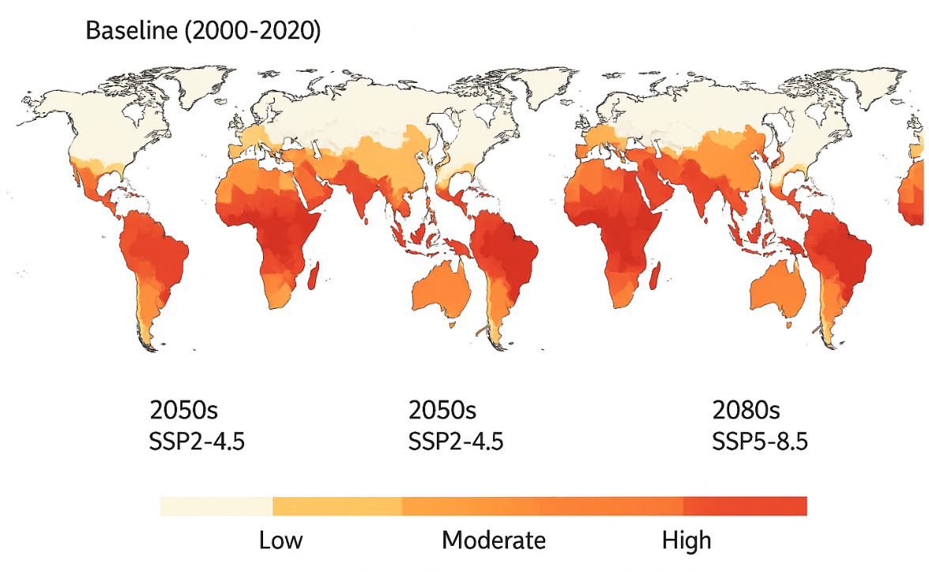
Figure 7: Baseline and Future Arboviral Transmission Risk Maps
A set of maps showing the baseline (2000–2020) and future arboviral transmission risk (2050s and 2080s) under different SSP scenarios, with population-weighted risk categories (low, moderate, high).

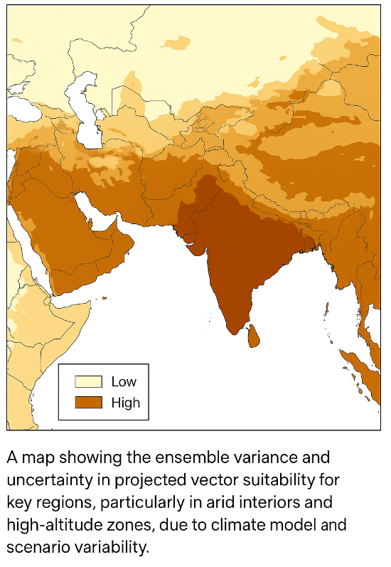
Figure 8: Uncertainty in Climate Suitability Projections
A map showing the ensemble variance and uncertainty in projected vector suitability for key regions, particularly in arid interiors and high-altitude zones, due to climate model and scenario variability.

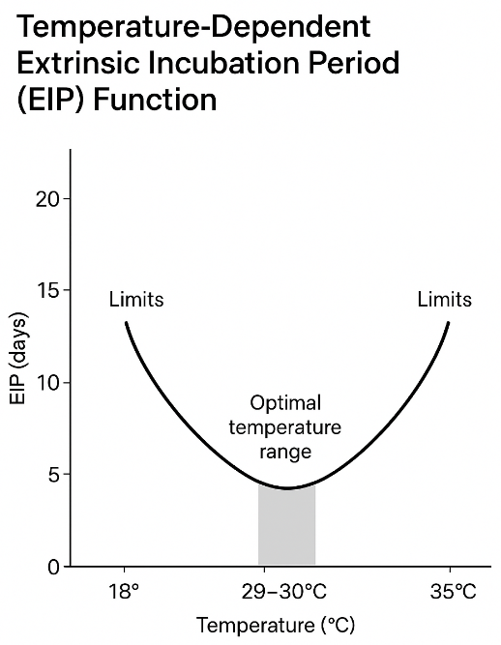

Figure 9: Temperature-Dependent Extrinsic Incubation Period (EIP) Function
A graph illustrating the temperature-dependent EIP function for Aedes vectors, showing the optimal temperature range (29–30°C) and limits (18°C and 35°C) for arboviral transmission.

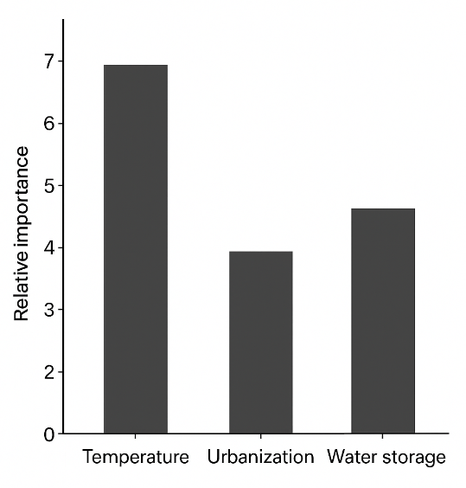
Figure 10: Sensitivity Analysis of Climate and Anthropogenic Drivers
A bar chart or plot highlighting the relative importance of climate and anthropogenic factors (e.g., temperature, urbanization, water storage) in driving changes in vector suitability and arboviral risk.

