Supplementary
Explainable Machine Learning for Predicting Depression in Older Adults Living Alone: From Model Validation to Screening Tool Development
Part S1. Feature Name
This table summarizes the feature variables used in the study, categorized into seven main domains: socioeconomic factors, vital signs, anthropometric measures, physical function, health behaviors, chronic diseases, and sleep quality.
- Depression: the Short Form of the Geriatric Depression Scale (SGDS), which includes 15 items
- Satisfaction – “Are you generally satisfied with your current life?”
- Motivation – “Have you recently experienced a significant decrease in activity or motivation?”
- Emptiness – “Do you feel that your life is empty or meaningless?”
- Boredom – “Do you often feel that your daily life is boring?”
- Cheerfulness – “Would you say your mood is usually cheerful?”
- Anxiety – “Do you feel anxious, as if something bad might happen to you?”
- Happiness – “Would you say you generally feel happy?”
- Hopelessness – “Do you often feel hopeless?”
- Social withdrawal – “Do you prefer staying at home rather than going out?”
- Memory – “Do you feel that your memory is worse than that of most people your age?”
- Joy of life – “Do you find joy in being alive right now?”
- Worthlessness – “Do you feel that you are a worthless person?”
- Energy – “Do you feel physically energetic?”
- Despair – “Do you feel that your current situation is hopeless?”
- Inferiority – “Do you think you are worse off than most other people?”
- Socioeconomic factors: Gender, National Health Insurance (NHI) status, age, years of education, and marital status.
- Vital signs: Resting heart rate and respiratory rate.
- Anthropometric measures: Head circumference, neck circumference, and waist circumference.
- Physical function: Hearing impairment, visual impairment, olfactory dysfunction, gustatory dysfunction, gait function score, and balance function score.
- Health behaviors: Meal frequency, weekly physical activity duration, weekly alcohol consumption, and lifetime smoking exposure.
- Chronic diseases: Total score from the Cumulative Illness Rating Scale (CIRS) and presence of specific conditions including cardiovascular disease, respiratory disease, hypertension, ophthalmologic and ENT disorders, upper and lower gastrointestinal disorders, liver disease, kidney disease, genitourinary disorders, musculoskeletal and dermatological conditions, neurological disorders, and endocrine/metabolic or breast disorders.
- Sleep quality: Overall sleep quality, sleep latency, sleep duration, habitual sleep efficiency, sleep disturbances, use of sleep medications, and daytime dysfunction.
- The Patient Health Questionnaire-9 (PHQ-9), which includes 9 items covering depressed mood, loss of interest, appetite changes, sleep problems, psychomotor changes, fatigue, feelings of worthlessness, poor concentration, and suicidal ideation.
- Depressed mood – “Feeling down, depressed, or hopeless?”
- Loss of interest – “Little interest or pleasure in doing things?”
- Appetite changes – “Poor appetite or overeating?”
- Sleep problems – “Trouble falling or staying asleep, or sleeping too much?”
- Psychomotor changes – “Moving or speaking so slowly that other people could have noticed? Or so fidgety or restless that you have been moving a lot more than usual?”
- Fatigue/low energy – “Feeling tired or having little energy?”
- Feelings of worthlessness – “Feeling bad about yourself — or that you are a failure or have let yourself or your family down?”
- Poor concentration – “Trouble concentrating on things, such as reading the newspaper or watching television?”
- Suicidal ideation – “Thoughts that you would be better off dead, or thoughts of hurting yourself in some way?”

Part S2. Features and its codes of the Study
Variable |  | Category | Code
Dependent variable |  | Depression | 0: No; 1: Yes
Independent variable
Socioeconomic | Gender* |  | 0: Female; 1: Male
Socioeconomic | NHI status* |  | 1: National health insurance; 2: type 1 medical aid; 3: type 2 medical aid
Socioeconomic | Age |  | Number of years (65 ~ 98 year)
Socioeconomic | Educational level |  | Number of years (0 ~ 18 year)
Socioeconomic | Marital statsu* |  | 0: married; 1: widowed; 2: separated/divorced; 3: Never married
Vital signs | Heart rate |  | 0: Normal; 1: Bradycardia; 2: Tachycardia
Vital signs | Respiratory rate |  | 0: Normal; 1: Tachypnea
Anthropometric measures | Head circumference |  | Continuous
Anthropometric measures | Neck circumference |  | 0: Normal; 1: Fraity
Anthropometric measures | Waist circumference |  | Continuous
Physical function | Hearing impairment* |  | Normal: 0; impaired: 1
Physical function | Visual impairment* |  | Normal: 0; impaired: 1
Physical function | Olfactory dysfunction* |  | Normal: 0; impaired: 1
Physical function | Gustatory dysfunction* |  | Normal: 0; impaired: 1
Physical function | Gait assessment |  | Continuous (The higher the better; 0~12 score)
Physical function | Balance assessment |  | Continuous (The higher the better; 0~16 score)
Health behavior | Meal frequency |  | Number of meals per day
Health behavior | Weekly exercise time |  | Minutes per session × Frequency per week
Health behavior | Weekly alcohol consumption |  | Alcohol intake per occasion (standard drink) $×$Drinking frequency per week
Health behavior | Lifetime smoking exposure |  | Average daily smoking amount (packs of cigarettes)$×$Total duration of smoking (years)
Chronic Diseases | Total score of CIRS |  | $\sum_{i=1}^{14}{{type}_{i}}×{severity}_{i} of diseases$*
Chronic Diseases | Heart Disease |  | 0: None; 1: Mild; 2: Moderate; 3: Severe; 4: Extreme
Chronic Diseases | Respiratory Disease |  | 0: None; 1: Mild; 2: Moderate; 3: Severe; 4: Extreme
Chronic Diseases | Hypertension |  | 0: None; 1: Mild; 2: Moderate; 3: Severe; 4: Extreme
Chronic Diseases | Ophthalmologic & ENT disorders |  | 0: None; 1: Mild; 2: Moderate; 3: Severe; 4: Extreme
Chronic Diseases | Upper Gastrointestinal Disorder |  | 0: None; 1: Mild; 2: Moderate; 3: Severe; 4: Extreme
Chronic Diseases | Lower Gastrointestinal Disorder |  | 0: None; 1: Mild; 2: Moderate; 3: Severe; 4: Extreme
Chronic Diseases | Liver Disease |  | 0: None; 1: Mild; 2: Moderate; 3: Severe; 4: Extreme
Chronic Diseases | Kidney Disease |  | 0: None; 1: Mild; 2: Moderate; 3: Severe; 4: Extreme
Chronic Diseases | Genitourinary Disorders |  | 0: None; 1: Mild; 2: Moderate; 3: Severe; 4: Extreme
Chronic Diseases | Musculoskeletal & Dermatological Disorder |  | 0: None; 1: Mild; 2: Moderate; 3: Severe; 4: Extreme
Chronic Diseases | Neurological Disorder |  | 0: None; 1: Mild; 2: Moderate; 3: Severe; 4: Extreme
Chronic Diseases | Endocrine/Metabolic & Breast Disorders |  | 0: None; 1: Mild; 2: Moderate; 3: Severe; 4: Extreme
Sleep quality | Sleep quality |  | 0: Very good, 1: Fairly good, 2: Fairly bad, 3: Very bad
Sleep quality | Sleep Latency |  | 0: None, 1: Mild, 2: Moderate, 3: Severe
Sleep quality | Sleep Duration |  | 0: >7 hours, 1: >6 hours, 2: >5 hours, 3: ≤5 hours
Sleep quality | Habitual sleep efficiency |  | 0: ≥85%, 1: ≥75%, 2: ≥65%, 3: <65%
Sleep quality | Sleep Disturbance |  | 0: None, 1: Mild, 2: Moderate, 3: Severe
Sleep quality | Use of Sleep medications |  | 0: Not at all, 1: <1 time/week, 2: 1–2 times/week, 3: ≥3 times/week
Sleep quality | Daytime dysfunction |  | 0: None, 1: Mild, 2: Moderate, 3: Severe
PHQ-9 | Depressed mood |  | 0: Not at all, 1: More than 7 days or half the days, 2: Nearly every day
PHQ-9 | Loss of interest |  | 0: Not at all, 1: More than 7 days or half the days, 2: Nearly every day
PHQ-9 | Appetite change |  | 0: Not at all, 1: More than 7 days or half the days, 2: Nearly every day
PHQ-9 | Sleep problems |  | 0: Not at all, 1: More than 7 days or half the days, 2: Nearly every day
PHQ-9 | Psychomotor changes |  | 0: Not at all, 1: More than 7 days or half the days, 2: Nearly every day
PHQ-9 | Fatigue / low energy |  | 0: Not at all, 1: More than 7 days or half the days, 2: Nearly every day
PHQ-9 | Feelings of worthlessness |  | 0: Not at all, 1: More than 7 days or half the days, 2: Nearly every day
PHQ-9 | Poor concentration |  | 0: Not at all, 1: More than 7 days or half the days, 2: Nearly every day
PHQ-9 | Suicidal thoughts |  | 0: Not at all, 1: More than 7 days or half the days, 2: Nearly every day
Note: *Dummy encoding

Part S3: Machine Learning Model Parameters: Grid Search Outcome
This table presents the hyperparameter configurations for each machine learning model used in the study. Extensive tuning was performed for all models using systematic grid search procedures with 5-fold cross-validation. The number and range of parameters were determined through iterative refinement, and in many instances, alternative configurations with more or fewer hyperparameters led to reduced predictive performance. The configurations reported here represent the optimal and most stable settings identified across multiple experimental runs.
- Support Vector Machine (SVM): The SVM model was implemented using an RBF kernel with probability=True, without hyperparameter tuning. Default values for C, gamma, and kernel were applied, as alternative configurations yielded inferior classification performance during preliminary testing.
- Random Forest: Hyperparameter tuning was conducted using grid search. The search space included max_depth = [20], max_features = ['sqrt'], and n_estimators = [200].
- Gradient Boosting: Grid search optimization was applied with parameter ranges including n_estimators = [100, 200], learning_rate = [0.05, 0.1], and max_depth = [3, 5].
- XGBoost: Grid search was used to tune n_estimators = [100, 200], learning_rate = [0.05, 0.1], and max_depth = [3, 5]. Other parameters such as gamma, colsample_bytree, or subsample were held constant.
- k-Nearest Neighbors (k-NN): Grid search tuning was applied across n_neighbors = [3, 5, 7, 9, 11], weights = ['uniform', 'distance'], p = [1, 2], leaf_size = [10, 30, 50], and algorithm = ['auto', 'ball_tree', 'kd_tree'].
- SHAP Analysis: SHAP values were computed using the XGBoost model trained with default parameters. The top 30 features were visualized via beeswarm and bar plots to enhance model explainability.
Table S4. Machine Learning Model Parameters: Grid Search Outcome
Model | Best Parameters
Support Vector Machine | Kernel = ‘rbf’, probability = true (default hyperparameters)
Random Forest | max_depth = 20, max_features = 'sqrt', min_samples_leaf = 10, min_samples_split = 9, n_estimators = 200
Gradient Boosting | max_depth = [3, 5], learning rate = [0.05, 01], n_estimators = [100, 200]
XGBoost | max_depth = [3, 5], learning rate = [0.05, 01], n_estimators = [100, 200]
Naïve Bayse | -  (As Naive Bayes has no tunable hyperparameters in its Gaussian form, the model was used in its default configuration.)
K-Nearest Neighbor | n_neighbors = [3, 5, 7, 9, 11], weights = ['uniform', 'distance'], p = [1, 2], leaf_size = [10, 30, 50], algorithm = ['auto', 'ball_tree', 'kd_tree']

Part S4: Performance Comparison of Six Classifiers for Depression Prediction Using the DPASC Framework
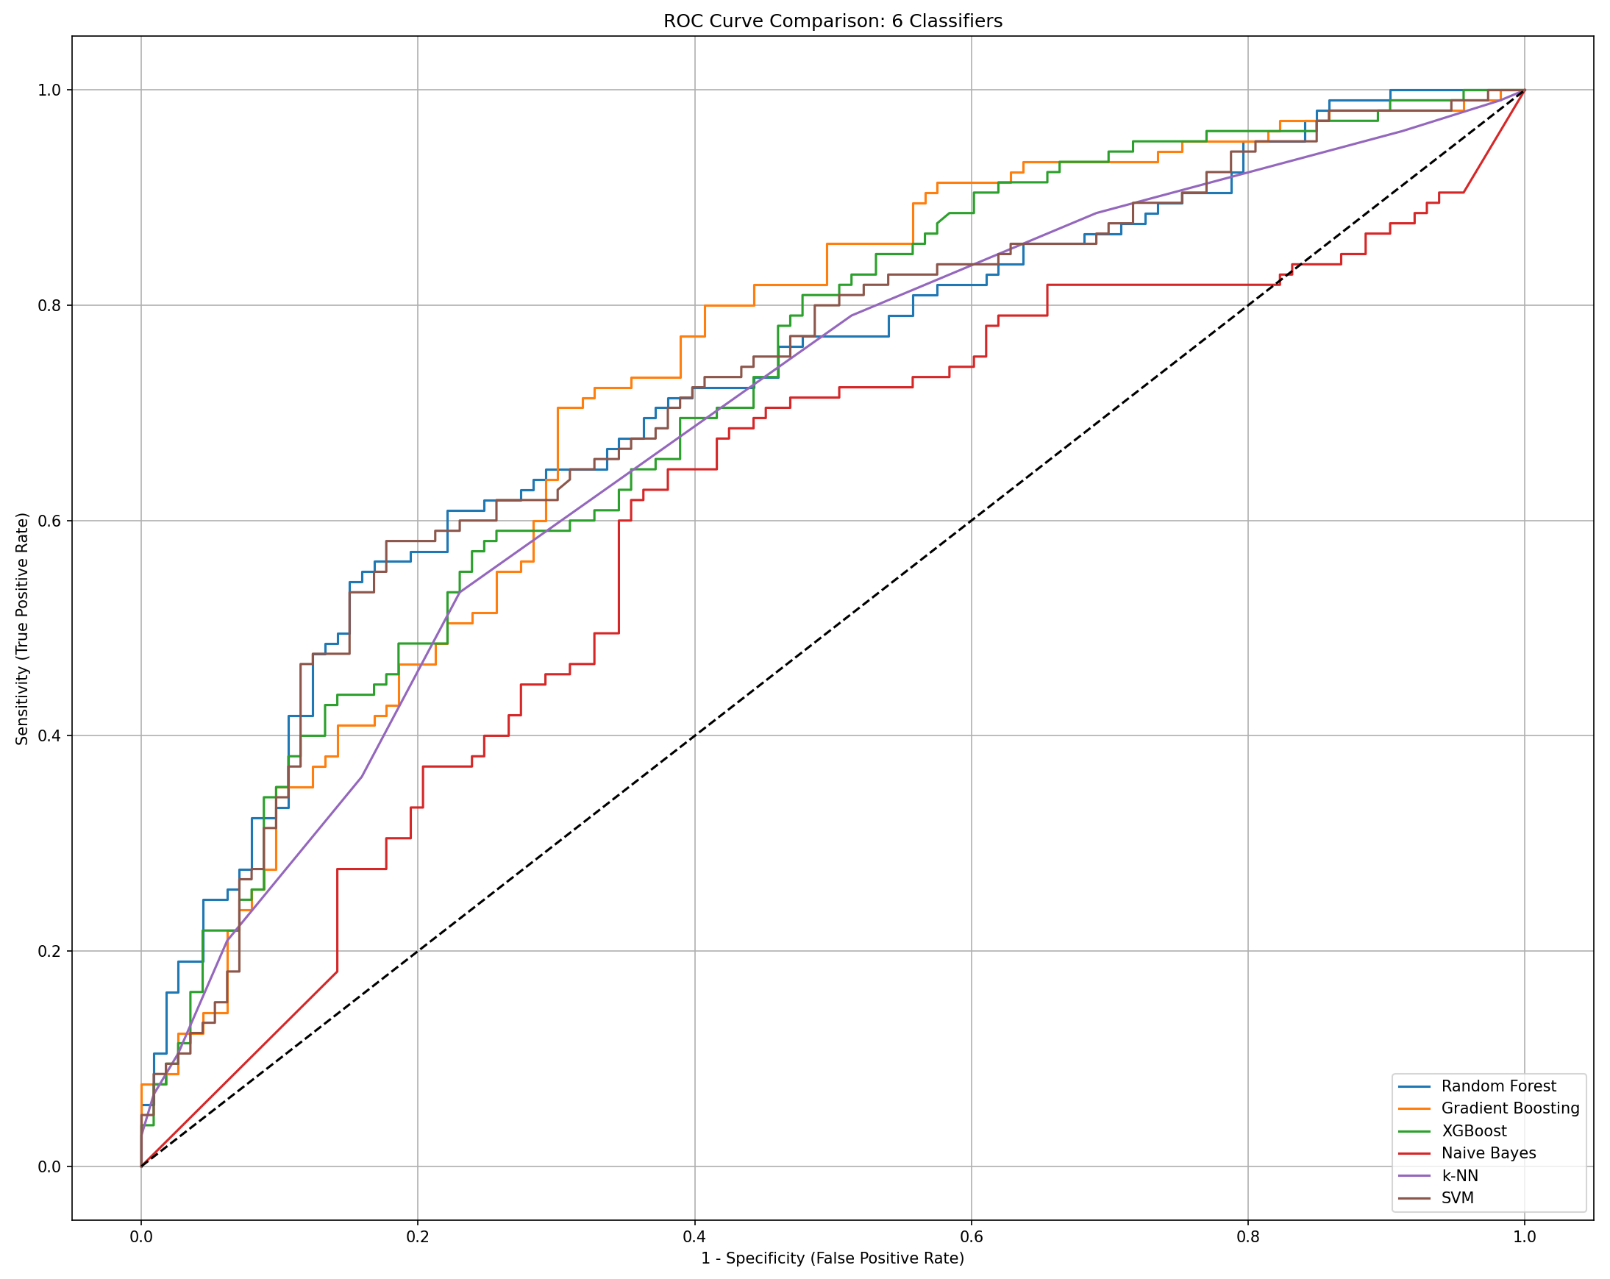
Figure S1. ROC curves of six machine learning classifiers for depression prediction with DPASC screening framework. Each line color represents a different classifier: blue for Random Forest, orange for Gradient Boosting, green for XGBoost, brown for Naive Bayes, purple for k-Nearest Neighbors (k-NN), and red for Support Vector Machine (SVM). The models were trained and evaluated using 5-fold cross-validation. The gray diagonal line indicates the performance of a non-informative classifier with no discriminative ability.

Part S5: Distributional Characteristics of Key Predictors Based on SHAP Values
Figure 5 presents the SHAP value distributions of the top four features derived from the DPASC screening framework, based on machine learning model outputs. Unlike Figure 4, which focused on the relative SHAP importance and impact direction, Figure 5 uses density plots to depict the probability distribution of SHAP values between groups, offering a more nuanced view of feature behavior. This approach enables clearer identification of distributional patterns, particularly in cases where feature effects overlap between depression and non-depression groups. For instance, while Figure 5A shows that sleep quality (PSQIsleepQual) is one of the most important predictors, it does not reveal the full extent of how sharply the groups are separated. In contrast, Figure 5A demonstrates that the depression group (orange) is more heavily concentrated in the higher SHAP value range, highlighting a stronger contribution of poor sleep quality to depression prediction. In Figure 5B, daily meal frequency shows a moderate distributional shift, with the depression group exhibiting a higher density around lower SHAP value peaks. This suggests that reduced meal frequency may be modestly associated with increased depression risk, though the effect appears more uniform than sharply discriminative. Figure 5C reveals that waist circumference is slightly right-shifted in the depression group, suggesting a subtle association with depressive symptoms. Finally, Figure 5D shows a broader and flatter distribution for the depression group in balance function, indicating greater variability and a tendency toward lower SHAP values, which may reflect impaired physical stability as a depression-related feature. Overall, Figure 5 complements Figure 4 by offering distributional transparency, revealing not only which features are important but also how their contributions vary across individuals.
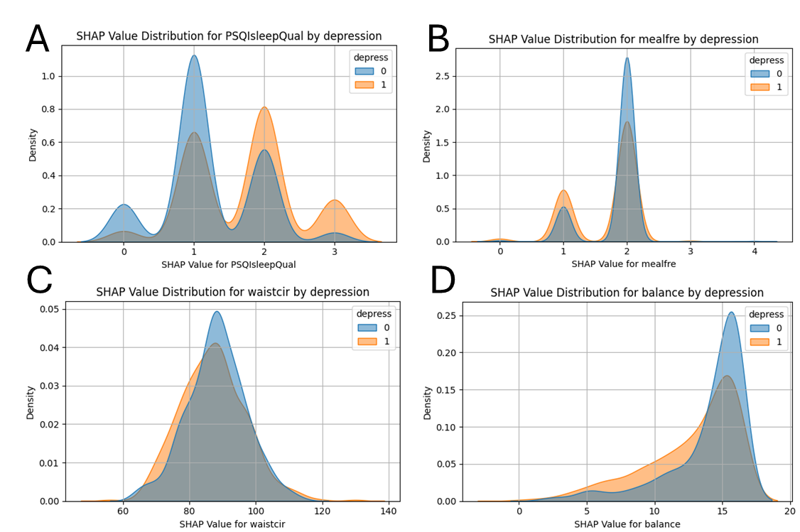
Figure S2. SHAP value distributions of selected predictors by depression status. Note: SHAP value density plots for four representative features from the DPASC screening framework are shown, comparing older adults with and without depression (depress = 1 and 0, respectively). Figure 3A (Sleep quality; PSQIsleepQual): Individuals with depression (orange) show a right-shifted distribution, indicating higher SHAP values and poorer sleep quality. Figure 3B (Daily meal frequency; mealfre): Minor differences are observed between groups, suggesting limited discriminatory power in this feature. Figure 3C (Waist circumference; waistcir): The distribution for depressed individuals is slightly shifted to the right, implying a subtle association between larger waist circumference and depression. Figure 3D (Balance function; balance): The depression group shows a wider and flatter distribution, with generally lower SHAP values, highlighting impaired balance as a potential risk factor. These SHAP-based distributions suggest that both sleep-related and physical function indicators are relevant in distinguishing depression status in older adults living alone.

