Sequential Exposure to Cold Waves and PM_{2.5} Pollution and the Risk of Emergency Ambulance Calls for Circulatory Diseases: A Time series Study in Shijiazhuang, China
Siyuan Chen^{1,2}, Mengna Li^{1,3}, Yishan Ding^{1,2}, Ning Xu^{1,3}, Mingyang Guan^{1,4,5*}, Fengge Chen^{1,4,5}, Junwang Tong², Mengfei Kou¹
1. Department of Public Health Monitoring and Evaluation, Shijiazhuang Center for Disease Control and Prevention, Shijiazhuang,Hebei, China
2. School of Public Health, North China University of Science and Technology, Tangshan, Hebei, China
3. School of Public Health, Hebei Medical University, Shijiazhuang, Hebei, China
4. Research Base for Environment and Health in Shijiazhuang, Chinese Center for Disease Control and Prevention, Shijiazhuang, Hebei, China.
5. Hebei Key Laboratory of Intractable Pathogens, Shijiazhuang, China
Corresponding author: Mingyang Guan, Department of Public Health Monitoring and Evaluation, Shijiazhuang Center for Disease Control and Prevention, Shijiazhuang,Hebei, China; Research Base for Environment and Health in Shijiazhuang, Chinese Center for Disease Control and Prevention, Shijiazhuang, Hebei, China; Hebei Key Laboratory of Intractable Pathogens, Shijiazhuang, China. Email: gmyguan@126.com
Funding Program: 2024 Shijiazhuang Municipal Science and Technology Plan (Project No. 2414605403)
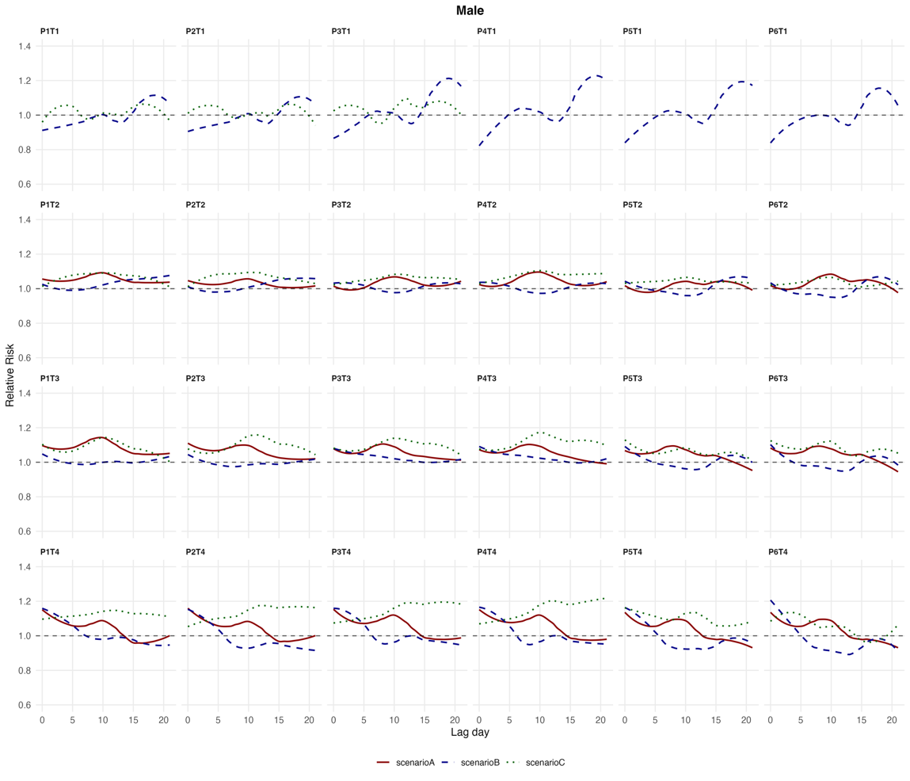
Figure S1 Relative risk of joint exposure (Male).

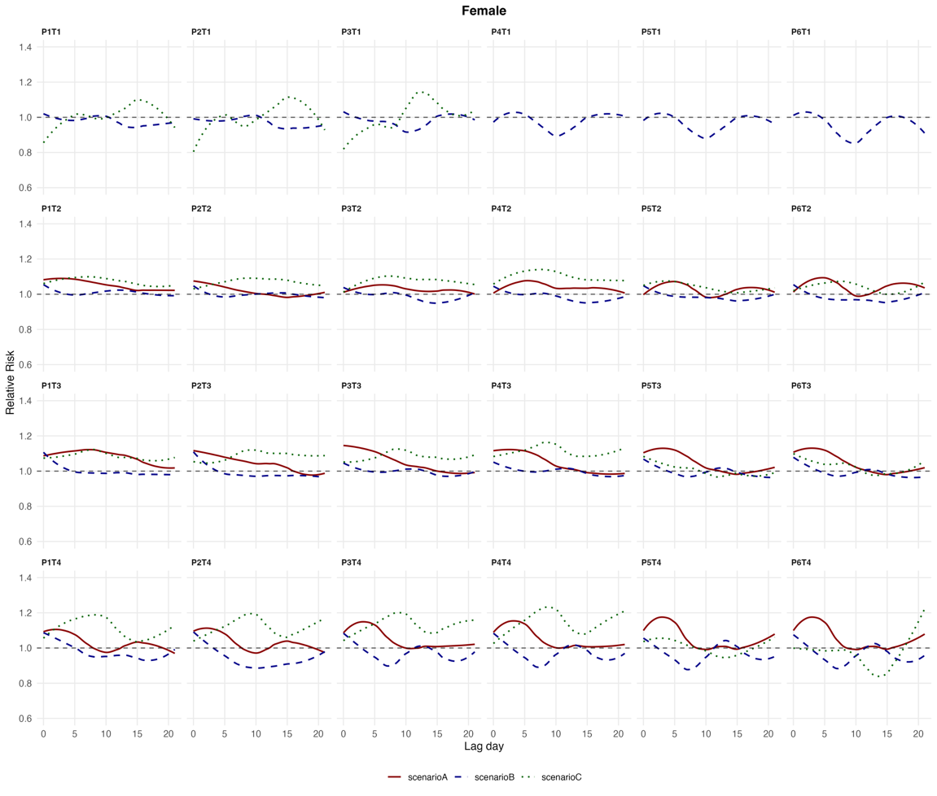
Figure S2 Relative risk of joint exposure (Female)
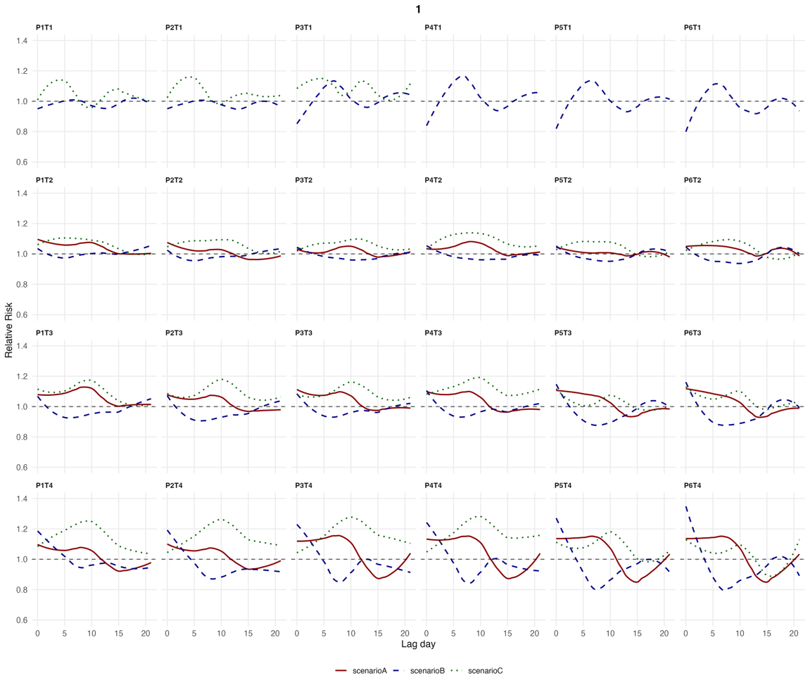
Figure S3 Relative risk of joint exposure (<65 years).

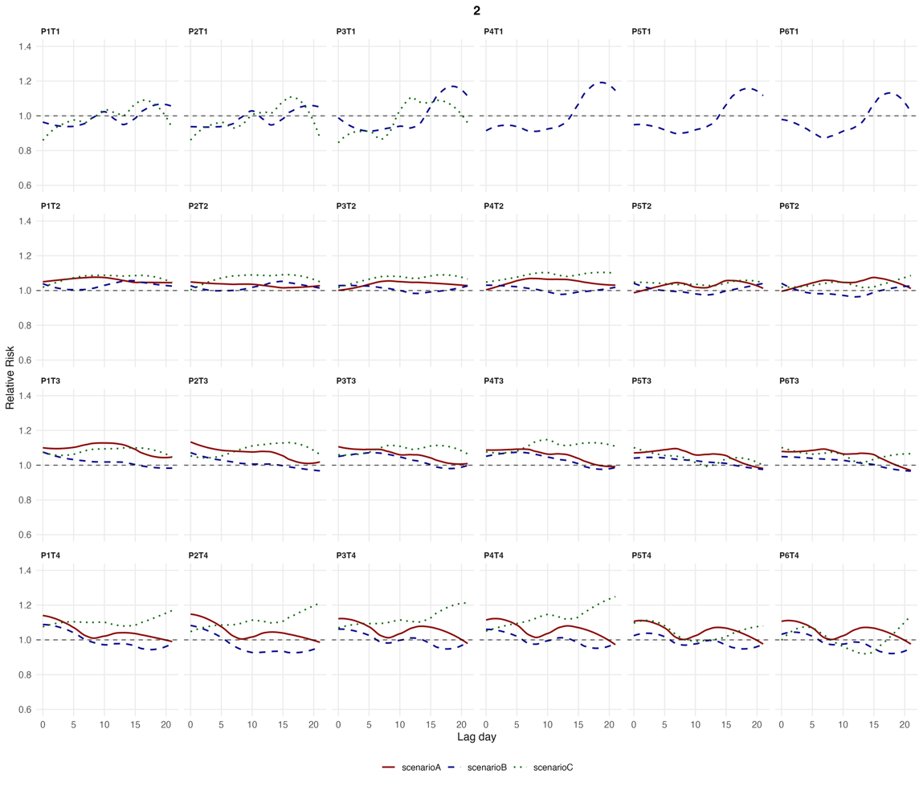
Figure S4 Relative risk of joint exposure (≥65 years).

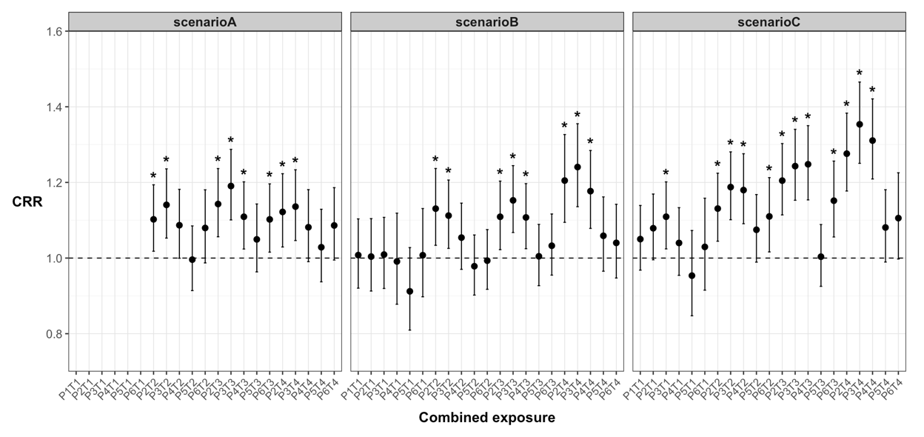
Figure S5 Cumulative relative risk of the joint event for Males over lag days 0–21

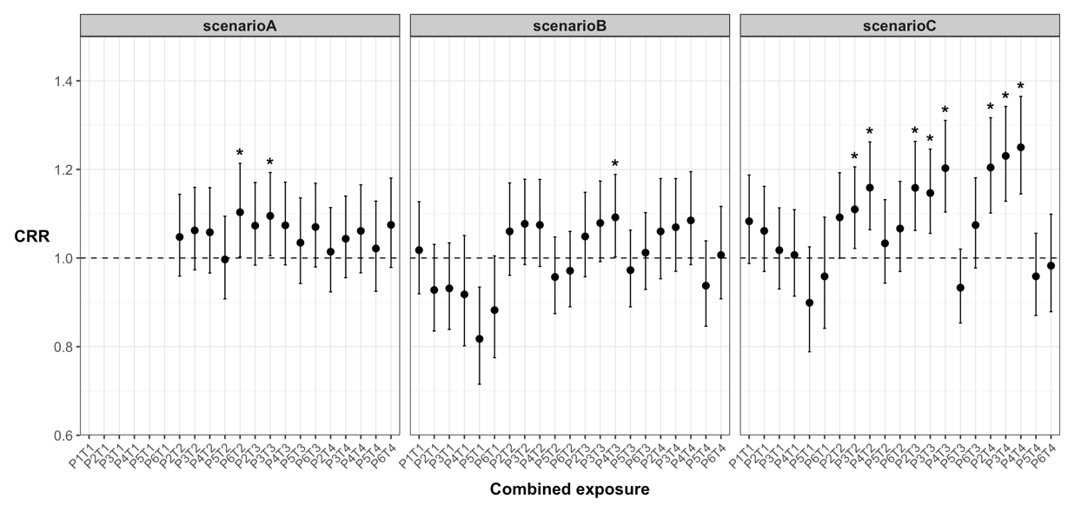Figure S6 Cumulative relative risk of the joint event for Females over lag days 0–21
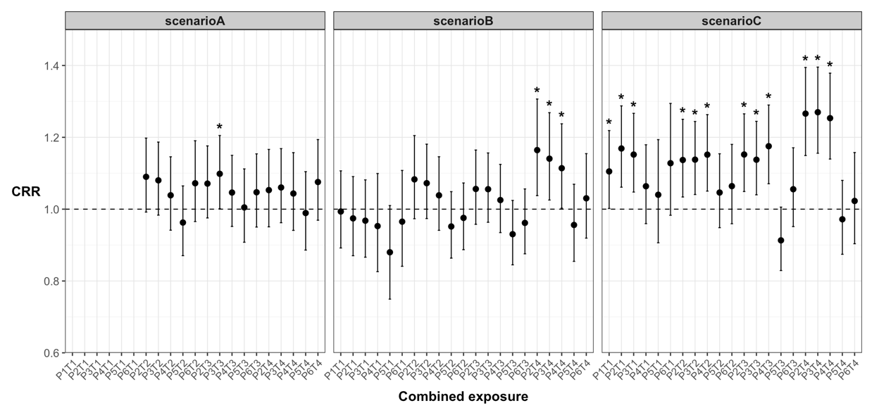Figure S7 Cumulative relative risk of the joint event for < 65 years over lag days 0–21
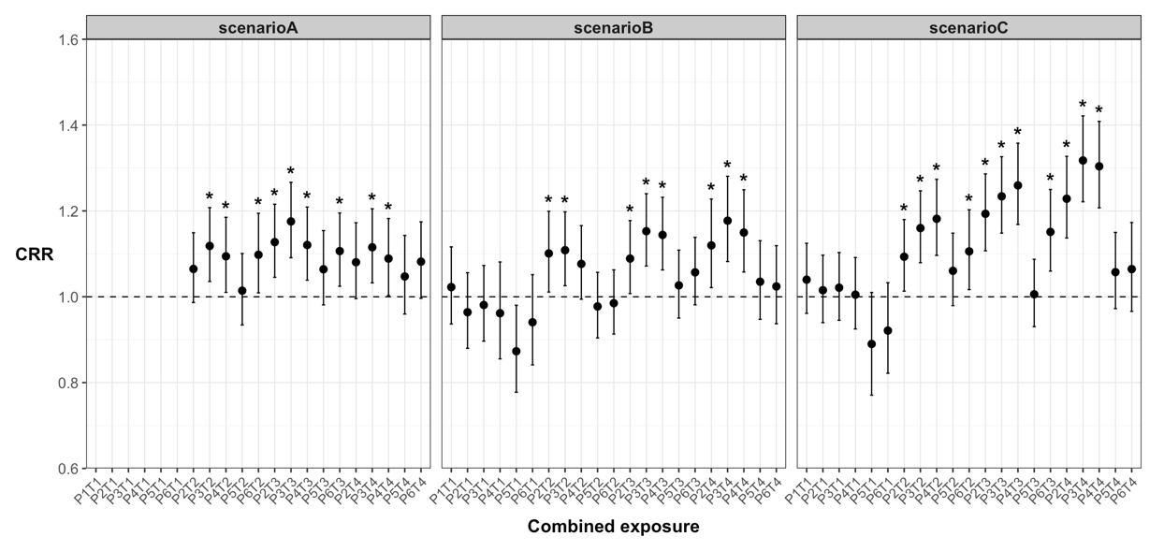Figure S8 Cumulative relative risk of the joint event for ≥ 65 years over lag days 0–21

Scenario A
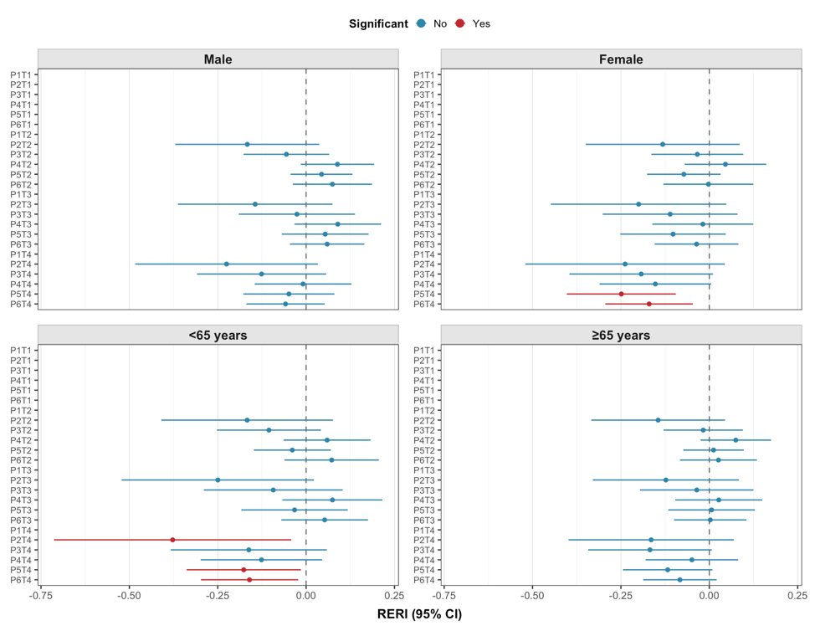
Scenario B
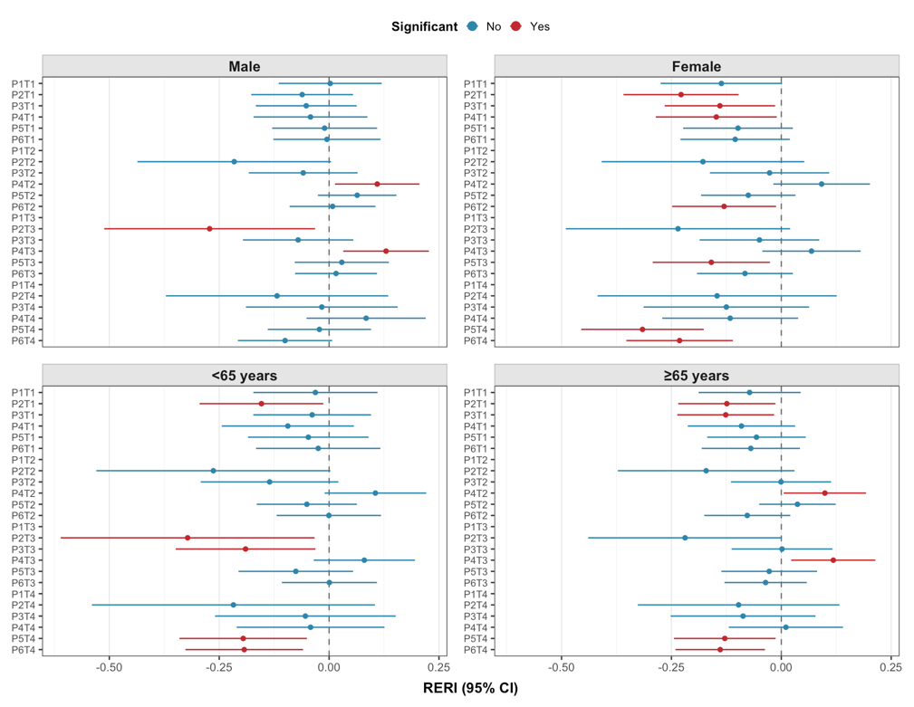
Scenario C
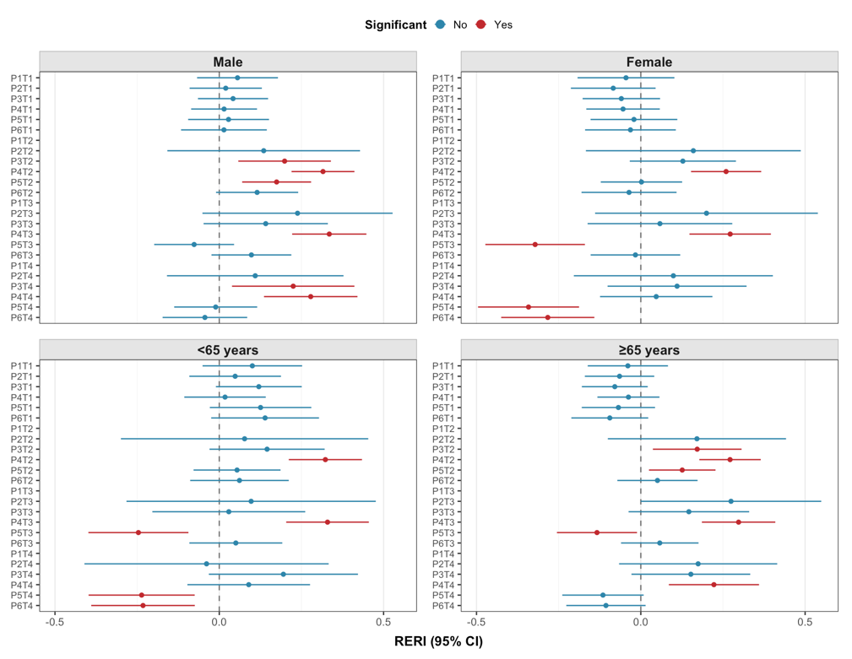
Figure S9 Stratified interaction analysis of joint exposure across sex and age groups

TableS2 AIC values for different joint exposure definitions under Scenario C after excluding combinations without valid estimates in Scenario A
Joint exposure | Circulatory diseases | Cerebrovascular disease | Heart diseases | Hypertension
P2T2 | 22937.1 | 18542.5 | 17303.8 | 15281.5
P2T3 | 22890.6 | 18531.0 | 17282.7 | 15281.7
P2T4 | 22875.6 | 18513.4 | 17290.8 | 15259.2
P3T1 | 22953.0 | 18543.8 | 17312.9 | 15292.8
P3T2 | 22913.0 | 18538.4 | 17294.0 | 15278.5
P3T3 | 22889.6 | 18524.6 | 17292.9 | 15278.9
P3T4 | 22851.8 | 18511.8 | 17289.7 | 15252.3
P4T1 | 22955.2 | 18544.2 | 17312.2 | 15294.6
P4T2 | 22868.7 | 18526.2 | 17290.5 | 15264.9
P4T3 | 22862.2 | 18518.4 | 17289.1 | 15263.3
P4T4 | 22861.9 | 18519.2 | 17292.6 | 15251.5
P5T1 | 22955.5 | 18544.0 | 17312.9 | 15294.4
P5T2 | 22940.3 | 18541.2 | 17305.3 | 15293.0
P5T3 | 22955.2 | 18544.3 | 17310.2 | 15289.4
P5T4 | 22948.4 | 18541.0 | 17309.2 | 15294.1
P6T1 | 22955.5 | 18544.0 | 17312.9 | 15294.4
P6T2 | 22944.0 | 18542.9 | 17306.6 | 15291.9
P6T3 | 22932.1 | 18536.5 | 17302.1 | 15293.5
P6T4 | 22954.2 | 18542.2 | 17312.5 | 15294.9

