Supplements
To obtain vertical cross-sections of radar parameters along the snow-streak in Fig. 4, we first defined a blue line as horizontal axis of the cross-sections, representing the mean orientation of the snow-streak identified in Fig. 1. The line was set to span from the approximately 20 km offshore to 50 km inland (Fig. S1). Because the snow-streak was not always located exactly on the blue line, points of maximum reflectivity were identified in directions orthogonal to the blue line (indicated by cross marks in Fig. S1). These points were then projected onto the blue line. This procedure was repeated at altitudes from 0 to 6 km at 0.5 km intervals, yielding the vertical cross-sections shown in Fig. 4.
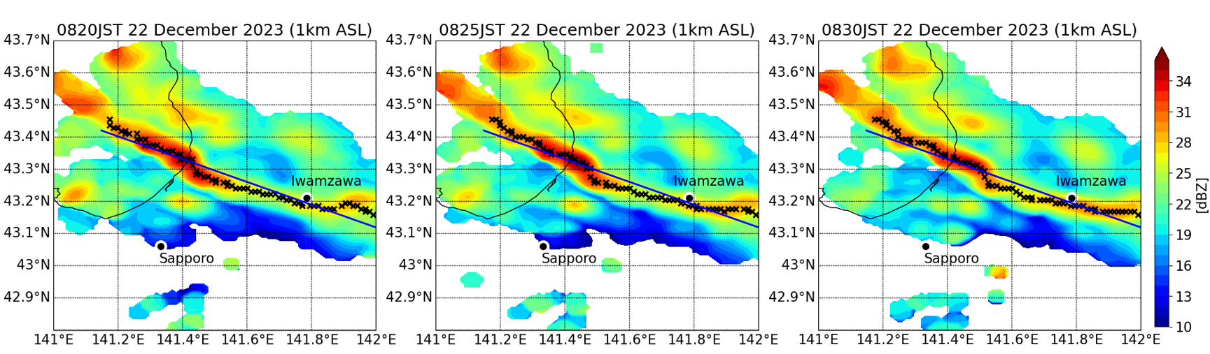
Fig. S1 Horizontal distributions of radar reflectivity ($Z_{H}$; color shading) at an altitude of 1 km from 0820 to 0830 JST on 22 December 2023. This figure shows the location of the vertical cross-section in Fig. 4. Cross marks denote the points of maximum reflectivity used for the vertical cross-section, and the blue line indicates the horizontal axis of the cross-section in Fig. 4.

