Appendix A. Demographic and clinical characteristics of study cohorts after matching.

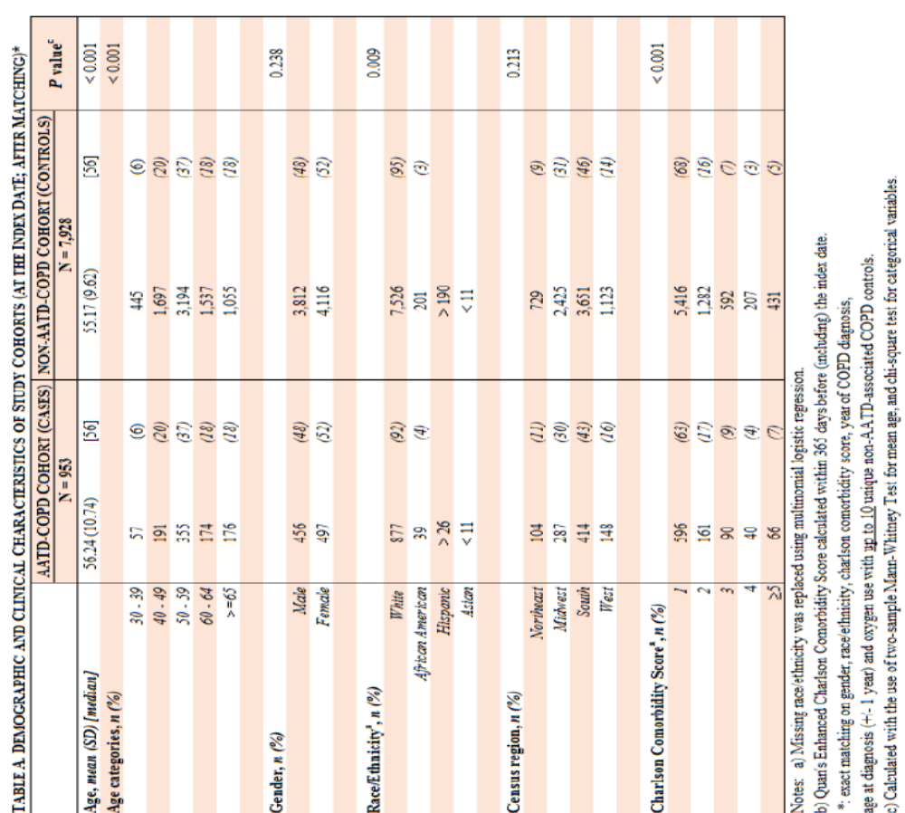

Appendix B. Demographic and clinical characteristics of study cohorts with prescription drug coverage after matching.

