Supplementary Information

Supplementary Note S1. Evaluation of daily substrate utilization and conversion pathways

This section details the estimation of soluble COD (S-COD) partitioning between biohythane production and intermediate product formation. The estimation assumes that production efficiency represents the ratio of actual yield to maximum potential yield. Consequently, the fraction of S-COD not converted into hydrogen (in R1) or methane (in R2) is attributed to the formation of intermediates, such as volatile fatty acids (VFAs) and alcohols.

Hydrogen Reactor (R1). As illustrated in Fig. S1a, the developed model (TS) effectively tracked the biological shifts in substrate utilization. During the start-up (Phase I), the model estimated that only 57.62% of the consumed S-COD was converted to hydrogen, implying that a substantial portion (~42%) was diverted to intermediates. This model-based prediction is strongly corroborated by the experimental data, which showed a high accumulation of VFAs (15.52 g/L) during this period. Conversely, in the steady-state Phase II, the model estimated an increase in hydrogen conversion efficiency to 85%. This aligns with the observed reduction in VFA concentration to an average of 7.75 g/L. Furthermore, the model accurately captured the response to the shock load in Phase III, where the estimated hydrogen conversion dropped to 64.09%, coinciding with a VFA spiking to 15.00 g/L. These correlations validate the model’s capability to diagnose biological performance shifts based on mass balance principles.

Methane Reactor (R2). In the methane reactor, CO₂ was analyzed as the primary intermediate product (Fig. S1b). During Phase II, the model estimated that 78.67% of S-COD was utilized for methane formation. This estimation is consistent with the biogas composition analysis, which showed a high CO₂ content (>60%) in the early stages of this phase. However, the correlation between the estimated intermediate fraction and actual CO2 levels in R2 was less consistent compared to R1, suggesting that the methanogenic stage involves more complex metabolic pathways or inhibitory mechanisms that are not fully captured by the simplified mass balance estimation.

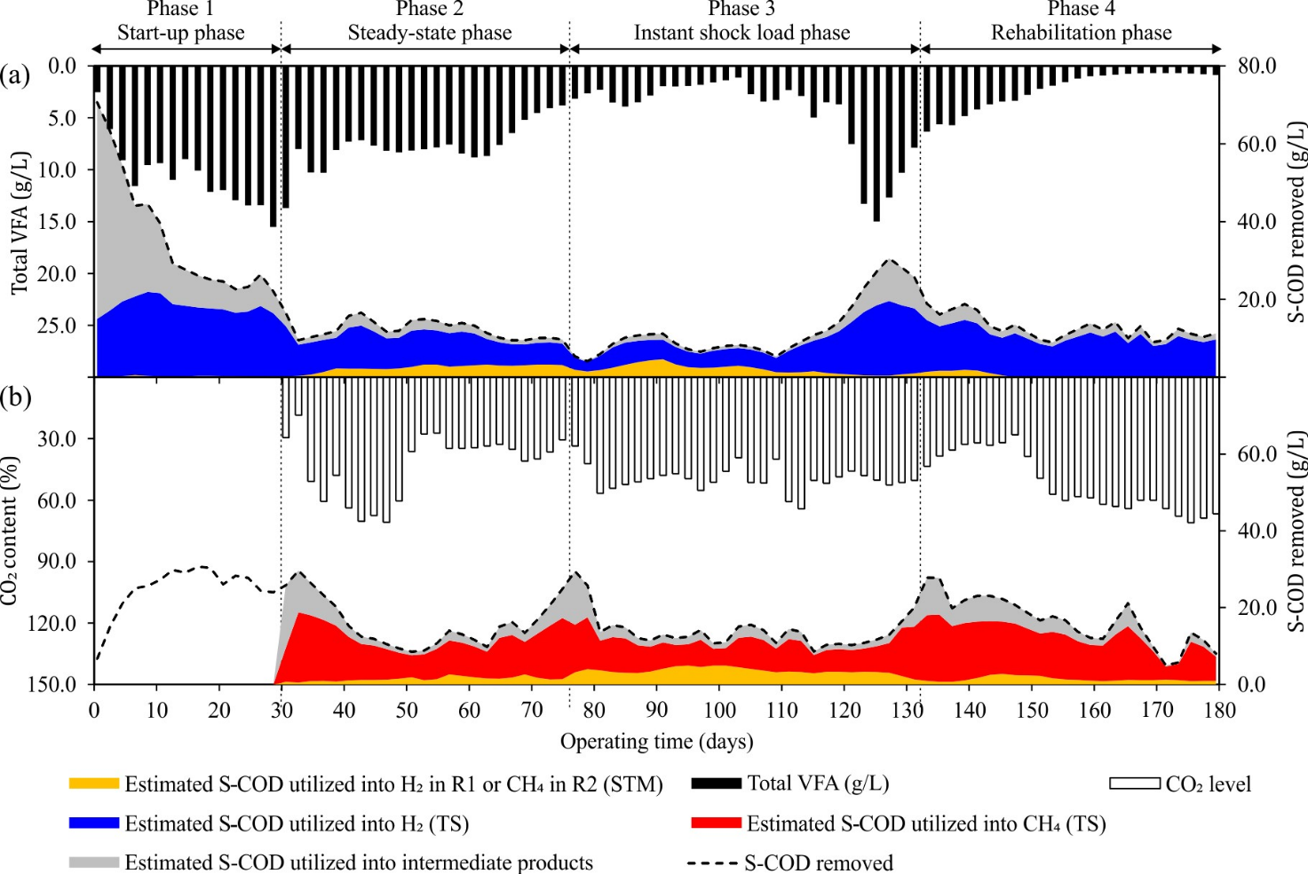
Fig. S1. Estimation of S-COD utilization across experimental phases: Comparison between the developed model (TS) and the stoichiometric model (STM). (a) S-COD conversion to H₂ and VFA intermediates in R1, and (b) S-COD conversion to CH₄ and CO₂ intermediates in R2.

