Table S1. Pairwise comparison summaries for eight diversity metrics and three ecological communities (i.e. plants, birds and fish) between sites (i.e. Unrestored, Restored and Reference) and sampling events (Winter 2022 or Summer 2023).
Community | Event | Site Pairs | Species Richness | Shannon Diversity | Simpson Diversity | Geometric Mean Abundance | Sørensen - Similarity | Sørensen - Dispersion | Bray-Curtis - Similarity | Bray-Curtis - Dispersion
Plants | 2022 Winter | Unrestored Site vs Restored Site | 0.688 | 0.141 | 0.788 | 0.583 | <0.001 | <0.001 | <0.001 | 0.002
Plants | 2022 Winter | Unrestored Site vs Reference Site | 0.138 | 0.011 | 0.344 | 0.002 | <0.001 | <0.001 | <0.001 | <0.001
Plants | 2022 Winter | Restored Site vs Reference Site | 0.525 | 0.579 | 0.740 | 0.047 | 0.128 | 0.848 | <0.001 | 0.526
Plants | 2023 Summer | Unrestored Site vs Restored Site | 0.506 | 0.094 | 0.835 | 0.757 | <0.001 | <0.001 | <0.001 | 0.003
Plants | 2023 Summer | Unrestored Site vs Reference Site | 0.073 | 0.010 | 0.402 | 0.006 | <0.001 | <0.001 | <0.001 | <0.001
Plants | 2023 Summer | Restored Site vs Reference Site | 0.525 | 0.674 | 0.753 | 0.048 | 0.128 | 0.849 | <0.001 | 0.500
Birds | 2022 Winter | Unrestored Site vs Restored Site | 0.908 | 0.952 | 0.887 | 0.209 | 0.510 | 0.957 | 0.512 | 0.992
Birds | 2022 Winter | Unrestored Site vs Reference Site | 0.698 | 0.943 | 0.766 | 0.890 | <0.001 | <0.001 | <0.001 | <0.001
Birds | 2022 Winter | Restored Site vs Reference Site | 0.919 | 1.000 | 0.971 | 0.083 | 0.006 | <0.001 | 0.002 | <0.001
Birds | 2023 Summer | Unrestored Site vs Restored Site | 0.310 | 0.065 | 0.781 | 0.355 | 0.255 | 0.353 | 0.228 | 0.518
Birds | 2023 Summer | Unrestored Site vs Reference Site | <0.001 | <0.001 | 0.875 | <0.001 | <0.001 | <0.001 | <0.001 | <0.001
Birds | 2023 Summer | Restored Site vs Reference Site | 0.007 | 0.039 | 0.477 | 0.003 | <0.001 | <0.001 | <0.001 | <0.001
Fish | 2022 Winter | Unrestored Site vs Restored Site | <0.001 | 0.018 | <0.001 | <0.001 | <0.001 | 0.341 | <0.001 | 0.848
Fish | 2022 Winter | Unrestored Site vs Reference Site | <0.001 | 0.052 | <0.001 | <0.001 | <0.001 | 0.144 | <0.001 | 0.030
Fish | 2022 Winter | Restored Site vs Reference Site | 0.830 | 0.919 | 0.993 | 0.545 | 0.953 | 0.874 | 0.017 | 0.107
Fish | 2023 Summer | Unrestored Site vs Restored Site | <0.001 | <0.001 | <0.001 | <0.001 | <0.001 | 0.804 | <0.001 | 0.685
Fish | 2023 Summer | Unrestored Site vs Reference Site | <0.001 | 0.001 | <0.001 | <0.001 | <0.001 | 1.000 | <0.001 | 0.383
Fish | 2023 Summer | Restored Site vs Reference Site | 0.015 | 0.925 | 0.952 | 0.986 | 0.427 | 0.816 | 0.052 | 0.873

Table S2. Summary of rescaled performance test results for the range of diversity metrics used in this study.
Metric | Indicator | Eligibility 2022 | Effectiveness 2022 | Sensitivity 2022 | Variability 2022 | Eligibility 2023 | Effectiveness 2023 | Sensitivity 2023 | Variability 2023 | Average
Species richness | Plants | 0 | 0 | 1 | 0.276414 | 0 | 0 | 1 | 0.285419 | 0.32
Shannon Diversity | Plants | 1 | 0 | 1 | 0 | 1 | 0 | 1 | 0 | 0.50
Simpson Diversity | Plants | 0 | 0 | 1 | 0.117627 | 0 | 0 | 1 | 0.119876 | 0.28
Geometric Mean Abundance | Plants | 1 | 0 | 0 | 0.486111 | 1 | 0 | 0 | 0.479955 | 0.37
Sørensen - Similarity | Plants | 1 | 1 | 1 | 0.586909 | 1 | 1 | 1 | 0.591637 | 0.90
Sørensen - Dispersion | Plants | 1 | 1 | 1 | 1 | 1 | 1 | 1 | 1 | 1.00
Bray-Curtis - Similarity | Plants | 1 | 1 | 0 | 0.728248 | 1 | 1 | 0 | 0.731544 | 0.68
Bray-Curtis - Dispersion | Plants | 1 | 1 | 1 | 0.953024 | 1 | 1 | 1 | 0.953428 | 0.99
Species richness | Birds | 0 | 0 | 1 | 0.038472 | 1 | 0 | 0 | 0.303137 | 0.29
Shannon Diversity | Birds | 0 | 0 | 1 | 0 | 1 | 0 | 0 | 0.206674 | 0.28
Simpson Diversity | Birds | 0 | 0 | 1 | 0.24775 | 0 | 0 | 1 | 0 | 0.28
Geometric Mean Abundance | Birds | 0 | 0 | 1 | 0.086206 | 1 | 0 | 0 | 0.325339 | 0.30
Sørensen - Similarity | Birds | 1 | 0 | 0 | 0.089697 | 1 | 0 | 0 | 0.419537 | 0.31
Sørensen - Dispersion | Birds | 1 | 0 | 0 | 0.977412 | 1 | 0 | 0 | 0.988247 | 0.50
Bray-Curtis - Similarity | Birds | 1 | 0 | 0 | 0.152498 | 1 | 0 | 0 | 0.471093 | 0.33
Bray-Curtis - Dispersion | Birds | 1 | 0 | 0 | 1 | 1 | 0 | 0 | 1 | 0.50
Species richness | Fish | 1 | 1 | 1 | 0.496051 | 1 | 1 | 1 | 0.911455 | 0.93
Shannon Diversity | Fish | 0 | 1 | 1 | 0.170762 | 1 | 1 | 1 | 0.036724 | 0.65
Simpson Diversity | Fish | 1 | 1 | 1 | 0.325704 | 1 | 1 | 1 | 0 | 0.79
Geometric Mean Abundance | Fish | 1 | 1 | 1 | 0.359562 | 1 | 1 | 1 | 0.433317 | 0.85
Sørensen - Similarity | Fish | 1 | 1 | 1 | 1 | 1 | 1 | 1 | 1 | 1.00
Sørensen - Dispersion | Fish | 0 | 0 | 1 | 0.136108 | 0 | 0 | 1 | 0.295774 | 0.30
Bray-Curtis - Similarity | Fish | 1 | 1 | 0 | 0.673431 | 1 | 1 | 1 | 0.644328 | 0.79
Bray-Curtis - Dispersion | Fish | 1 | 0 | 1 | 0 | 0 | 0 | 1 | 0.040914 | 0.38

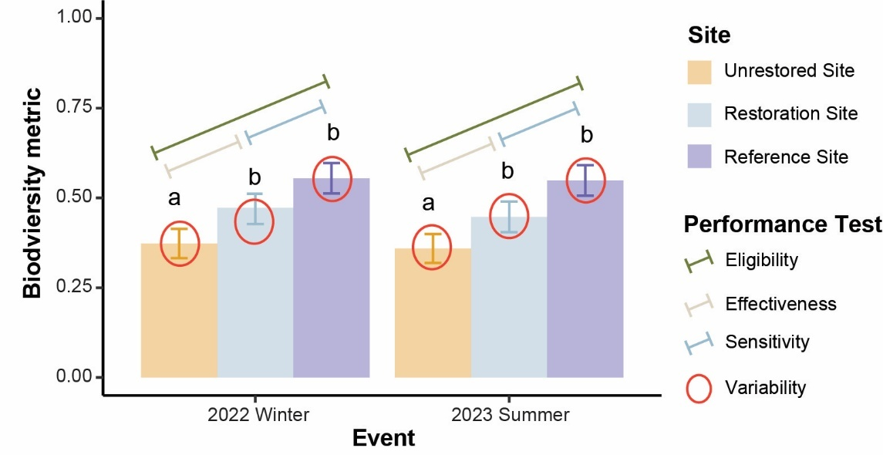
Figure S1. Summary that visualised the performance tests used to evaluate each biodiversity metric using generalised linear mode

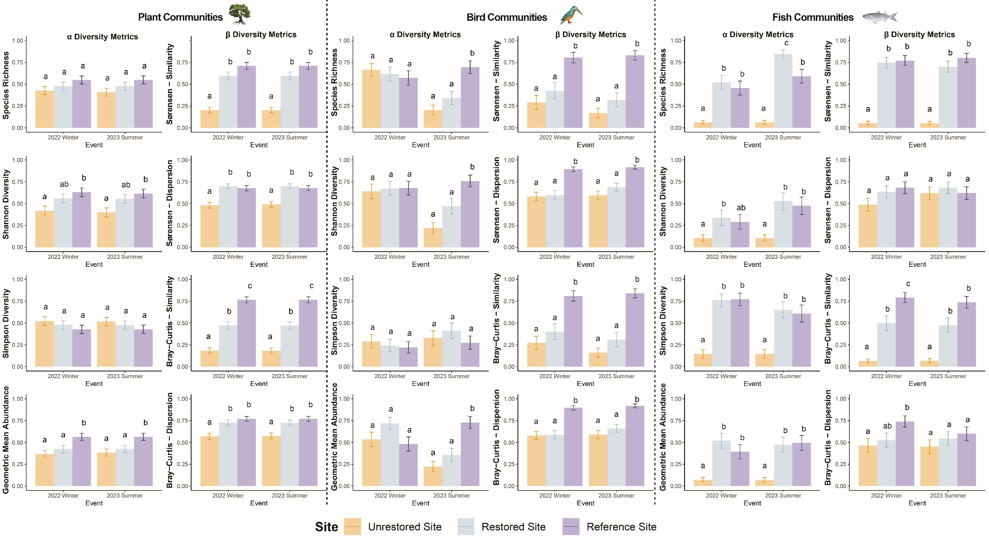
Figure S2. Summary of all biodiversity indicators and biodiversity metrics used in this study and analysed using Generalised Linear Models (GLMs). Matching letters indicate significant similarities. Error bars represent standard error around the mean of each value

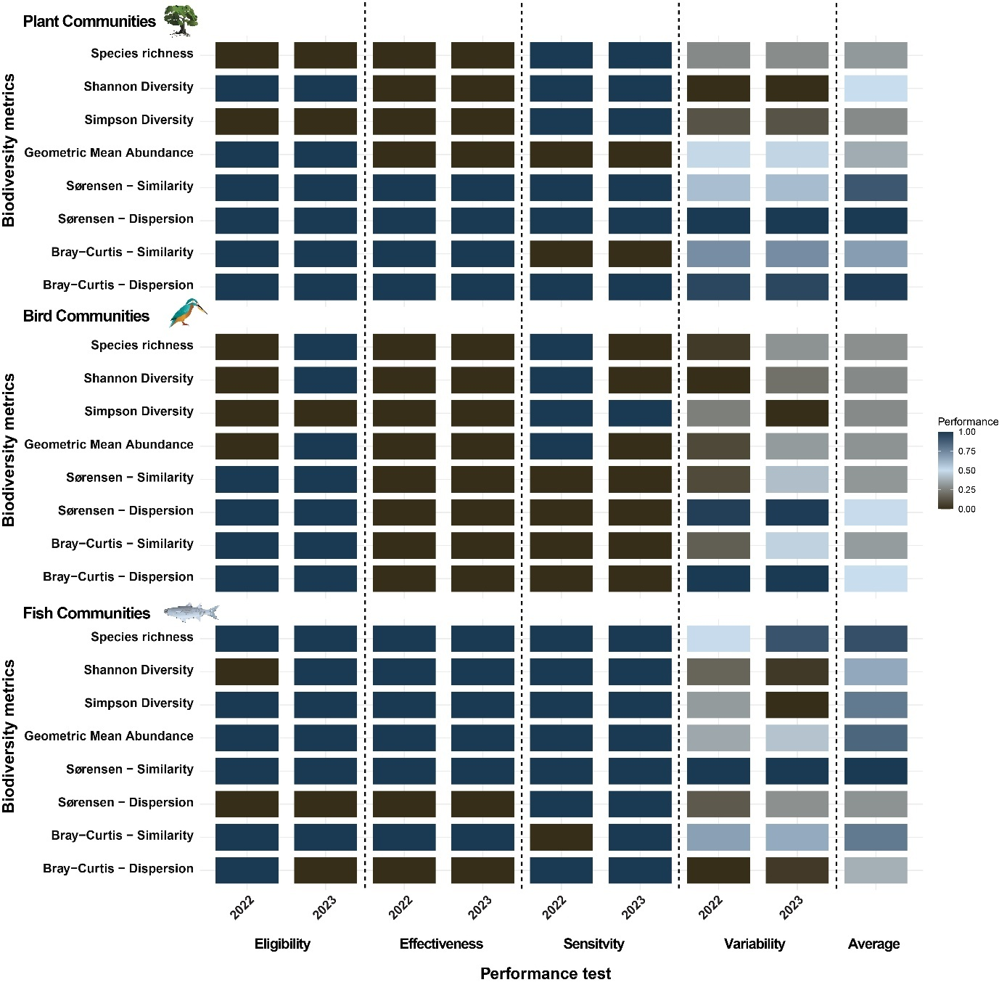
Figure S3. Heatmap demonstrating results of four performances tests for each biodiversity metric across each sampling events and indicator. Darker blue indicates better performance, while darker brown indicates poor performance

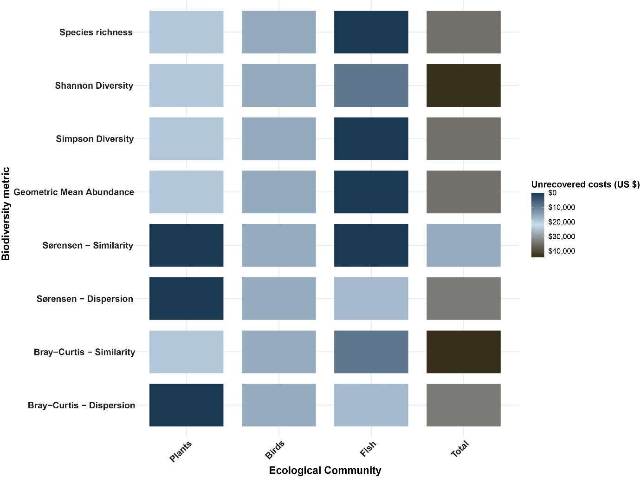
Figure S4. Heatmap demonstrating results of combined unrecovered costs across each ecological community. Darker blue indicates better performance, darker brown indicates poor performance

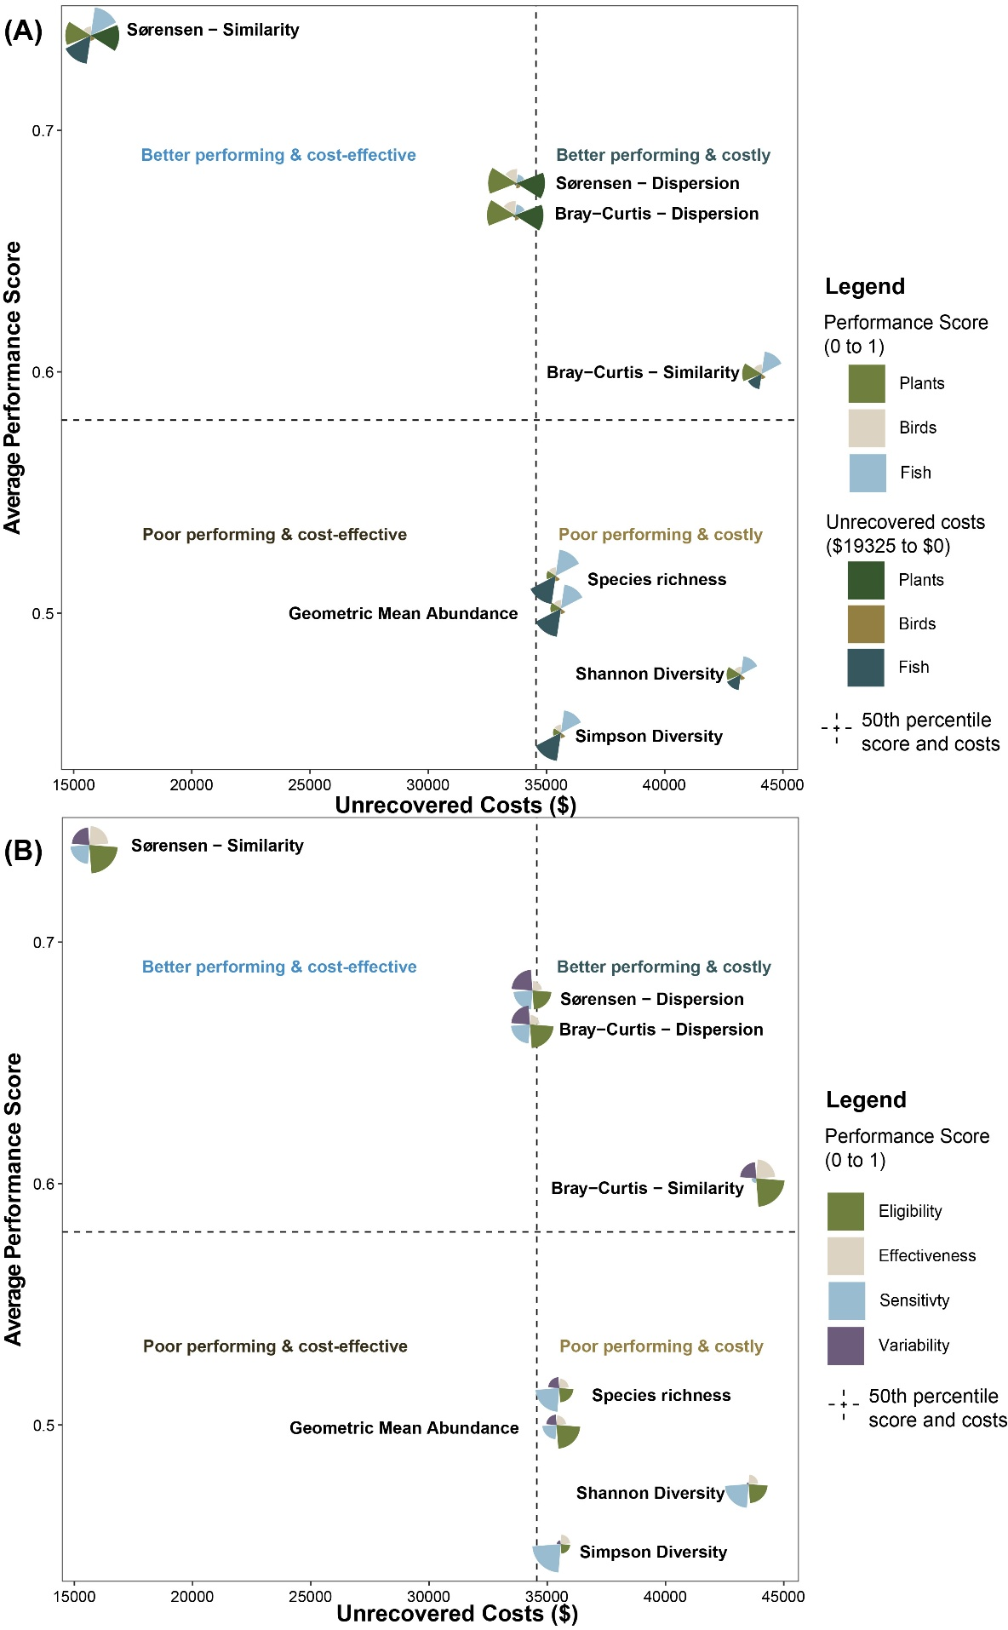
Figure S5. Segmented bi-plot plot visualising the average performance score and total unrecovered costs for each biodiversity metric; (A) segments represent; 1) relative performance tests and unrecovered cost results for each ecological community where larger segments represent better performance scores and lower unrecovered costs; and (B) segments represent performance test results for each biodiversity metrics, where larger segments represent better performance scores.

