Supplementary Material
For:
Religiosity is associated with lower acceptance of organ donation: A survey of European students (N = 2193) and its public health ethical implications

Authors: Silke Schicktanz¹; Gonzalo Díaz Cobacho³, Anja MB Jensen 6; Alberto Molina Pérez³; Maria Victoria Martínez-López⁴; Janet Delgado⁵, , Sabine Wöhlke²
Table 1: Reluctance to donate an organ and religiosity
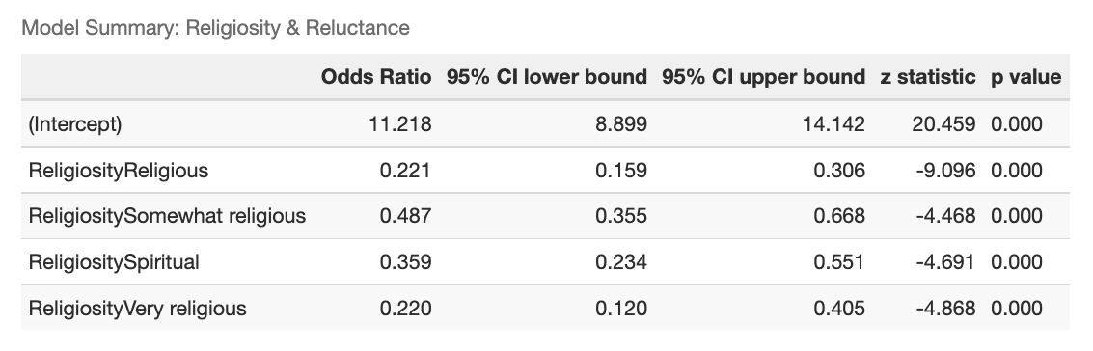
Table 2 Willingness to donate an organ and religion
contrast | odds.ratio | SE | df | null | z.ratio | p.value
Muslim / None | 13.896 | 5.0100 | Inf | 1 | 7.302 | <.0001
Muslim / Orthodox | 3.662 | 1.3600 | Inf | 1 | 3.506 | 0.0061
Muslim / Other | 5.037 | 2.0400 | Inf | 1 | 3.998 | 0.0009
Muslim / Protestant | 6.508 | 2.4800 | Inf | 1 | 4.913 | <.0001
Muslim / Roman Catholic | 6.891 | 2.4800 | Inf | 1 | 5.369 | <.0001
None / Orthodox | 0.264 | 0.0483 | Inf | 1 | -7.279 | <.0001
None / Other | 0.362 | 0.0888 | Inf | 1 | -4.141 | 0.0005
None / Protestant | 0.468 | 0.0959 | Inf | 1 | -3.706 | 0.0029
None / Roman Catholic | 0.496 | 0.0796 | Inf | 1 | -4.369 | 0.0002
Orthodox / Other | 1.376 | 0.3570 | Inf | 1 | 1.230 | 0.8222
Orthodox / Protestant | 1.777 | 0.3940 | Inf | 1 | 2.597 | 0.0980
Orthodox / Roman Catholic | 1.882 | 0.3410 | Inf | 1 | 3.485 | 0.0065
Other / Protestant | 1.292 | 0.3550 | Inf | 1 | 0.932 | 0.9383
Other / Roman Catholic | 1.368 | 0.3330 | Inf | 1 | 1.286 | 0.7929
Protestant / Roman Catholic | 1.059 | 0.2150 | Inf | 1 | 0.282 | 0.9998

Table 3: Brain death acceptance by religiosity
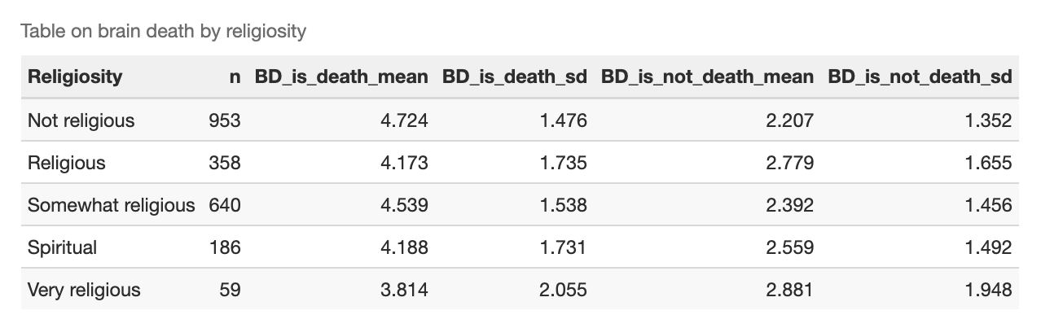
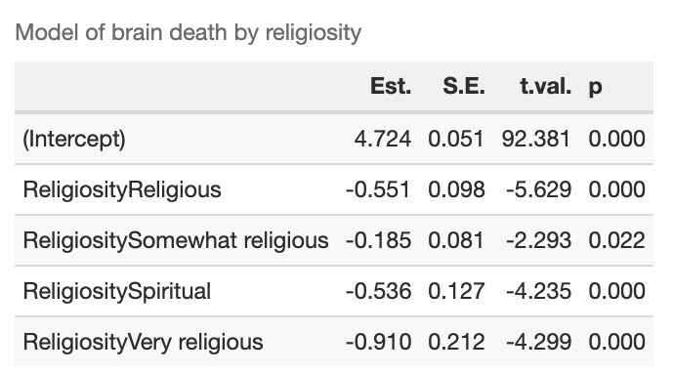
Table 4 Model of Brain Death by Religiosity
Table 5: Model of Not Brain Death by Religiosity
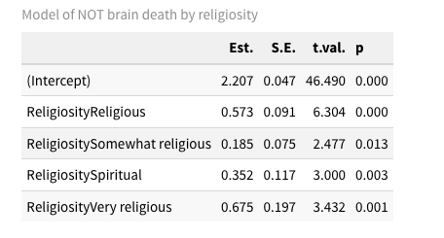
Table 6. Brain Death is Alive by religion
Religion | n | Mean | Standard Deviation | Total BD is Alive | Mean | Standard Deviation
Muslim | 35 | 3.40 | 1.91 | 35 | 3.11 | 1.60
None | 948 | 4.66 | 1.50 | 948 | 2.24 | 1.36
Orthodox | 251 | 4.12 | 1.81 | 251 | 2.87 | 1.73
Other | 129 | 4.34 | 1.66 | 129 | 2.53 | 1.50
Protestant | 247 | 4.80 | 1.40 | 247 | 2.11 | 1.30
Roman Catholic | 586 | 4.41 | 1.62 | 586 | 2.51 | 1.54

Table 7 Willingness to receive an organ from brain death person
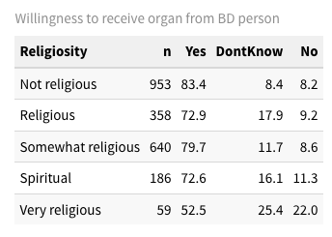

Table 8. Willingness to receive an organ from a non-heart beating donor
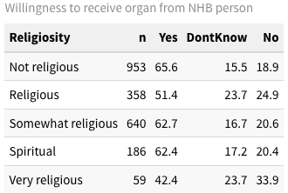
Table 9. Reluctance to receive an organ from an Heart-Beating Donor
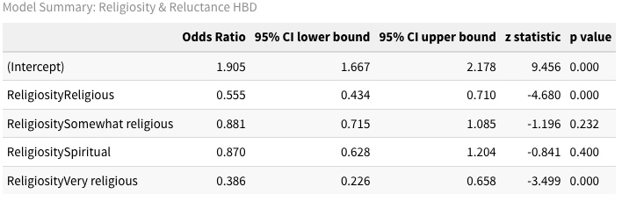
Table 10. Willingness to receive an organ an animal (xenotransplant)
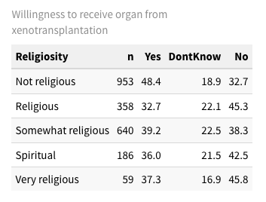
Table 11.
