Supplemental Figures
Supplemental Figure 1. Recurrence-free survival by AI Risk groups. Kaplan-Meier survival curves showing the probability of recurrence-free survival for low- and high-risk groups in the multi-institution discovery test dataset, as predicted by the AI Risk model.

Supplemental Figure 2. Feature Importance assessed by SHAP Values. Ranking of SHAP feature importance in the MRI-RS.
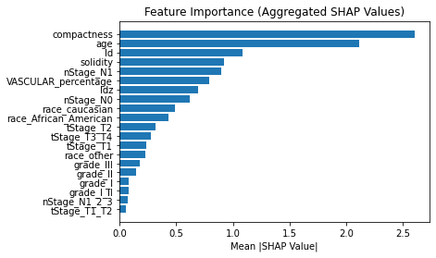

Supplemental Figure 3 Propensity Score Matching. (left) Matching results in MRI-RS low-risk patients. (right) Matching results in MRI-RS high-risk patients.

