Cross-species oncolytic virotherapy in vitro: BoHV4EGFPΔTK as a novel candidate against canine osteosarcoma and histiocytic sarcoma
Di Pentima Melania^{1,#}, Minesso Sergio^{2, #}, Franceschi Valentina², Di Lecce Rosanna¹, Corradi Attilio¹, Borghetti Paolo¹, Donofrio Gaetano², Razzuoli Elisabetta³ , Fruscione Floriana³, Baumgärtner Wolfgang⁴, Vescovini Rosanna⁵, Andrani Melania⁶, Basini Giuseppina⁶, Bussolati Simona⁶ ,Passeri Benedetta^{1, #}, Armando Federico^{1,#}

Supplementary material
This file contains:
-Supplementary tables:1
-Supplementary figures: 4

Supplementary Table 1: Primer sequences used for gene expression analysis in the OSA2 osteosarcoma cell line.
Gene | Sequence | Bp | Accession number
TP53 | FW 5’-CGTTTGGGGTTCCTGCATTC-3’  Rev 5’-CACTACTGTCAGAGCAGCGT-3 | 231 | NM_001389218.1
PTEN | FW 5’-GTGAAGCTGTACTTCACAA-3’  Rev 5’-CTGGGTCAGAGTCAGTGGTG-3’ | 135 | NM_001003192.1
ERBB2 | FW 5'-CTGAGGGCCGATATACCTTC-3'  Rev 5'-TCACCTCTTGGTTGTTCAGG-3' | 113 | NM_001003217.3
STAT5A | FW 5'- TTGACTCTCCTGACCGCAAC-3'  Rev 5'- TCCGTCTACTGCTTTAGCGA-3' | 181 | XM_038547290.1
TGFB | FW 5'-AAGTAGACATTAACGGGTTCAGTTC-3'  Rev 5'- GGTCGGTTCATGCCATGAAT-3' | 70 | L34956.1
GAPDH | FW 5'-TTCCACGGCACAGTCAAG-3'  Rev 5'-ACTCAGCACCAGCATCAC-3 | 114 | NM_001003142.2
B2M | FW 5'-ACGGAAAGGAGATGAAAGCA -3'  Rev 5'-CCTGCTCATTGGGAGTGAA -3' | 98 | NM_001284479.1

Supplementary Figure 1: Gene expression profile of the OSA2 osteosarcoma primary cell line.
Heatmap illustrating the relative mRNA expression of selected genes involved in tumor suppression and oncogenic signaling in the OSA2 osteosarcoma cell line, assessed by quantitative real-time PCR (qPCR). Gene expression was normalized to the reference genes GAPDH and B2M and calculated using the ΔΔCq method. Data represent the mean of three independent biological replicates. PTEN expression was not detectable (n/a), indicating loss of tumor suppressor gene expression. TP53 showed relatively high expression levels, whereas ERBB2, STAT5, and TGFB1 were expressed at moderate levels. Color coding represents relative expression levels, with black indicating no detectable expression, red indicating high expression, and green indicating moderate expression. This expression pattern reflects deregulation of key molecular pathways relevant to osteosarcoma cell biology. Gene expression analysis confirmed that OSA2 cells are osteosarcoma, as evidenced by high TP53 mRNA levels, undetectable PTEN expression, and moderate expression of ERBB2, STAT5, and TGFB1, suggesting partial activation of oncogenic and pro-tumorigenic signaling pathways.
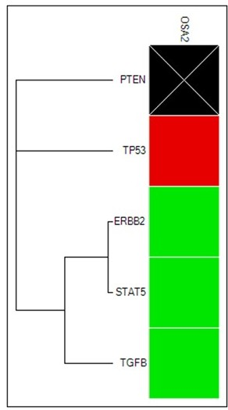

Supplementary Figure 2: Cell culture autofluorescence. Representative fluorescence images of not infected (A) DH82, (B) D17, (C) OSA2, and (D) FDOG cells showing a minimal GFP autofluorescence.

Supplementary Figure 3: BoHV1 and BoHV4EGFPΔTK recovery assay. Crystal violet staining of BEK monolayers exposed to culture supernatants collected daily from FDOG, D17, DH82, and OSA2 cell lines infected with BoHV1 or BoHV4EGFPΔTK. Supernatants were applied to permissive BEK cells to detect newly produced infectious virus. The presence of cytopathic effect on BEK monolayers confirmed recovery of infectious particles and thus productive infection in the corresponding donor cell lines. No CPE was observed for supernatants derived from non-permissive cell lines (D17 and DH82 for BoHV1 and FDOG for BoHV4EGFP ΔTK) indicating the absence of recoverable virus at all time points.
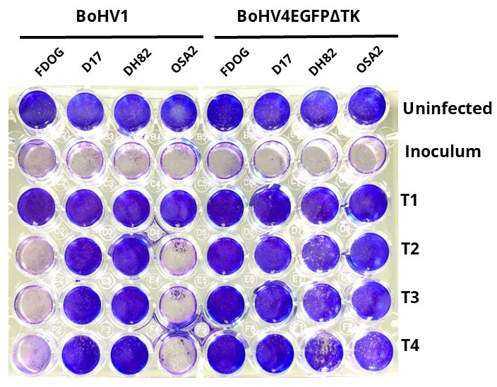

Supplementary Figure 4: BoHV1 and BoHV4EGFPΔTK detail at 96 hpi of recovery assay. Representative bright-field and fluorescence images of BEK cells exposed to culture supernatants collected 96 hours post infection from FDOG, D17, DH82, and OSA2 cells infected with BoHV1 or BoHV4EGFPΔTK. Supernatants were applied to permissive BEK monolayers to assess cytopathic effect and EGFP expression as indicators of infectious virus recovery. BoHV4 was successfully recovered from DH82, OSA2, and D17 supernatants, whereas BoHV1 was recovered only from OSA2 and FDOG supernatants.

