Exogenous organic acid–induced reconfiguration of extracellular polymeric substances enhances biological nitrogen removal
Chuchu Wang^{1,2,†}, Ao Xu^{1,2,†}, Shangbin Ma^{1,2}, Dawen Gao^{1,2, *}, Xiaofei Gong^{1,2}, Tiantian Li^{1,2}, Zheng Huang^{1,2}, Yanyu An^{1,2}
- Centre for Urban Environmental Remediation, Beijing University of Civil Engineering and Architecture, Beijing 100044, China
- Collaborative Innovation Center of Energy Conservation & Emission Reduction and Sustainable Urban-Rural Development in Beijing, Beijing University of Civil Engineering and Architecture, Beijing 100044, China
†Ao Xu and Chuchu Wang contributed equally to this work.
* Corresponding authors. E-mail addresses: gaodawen@bucea.edu.cn

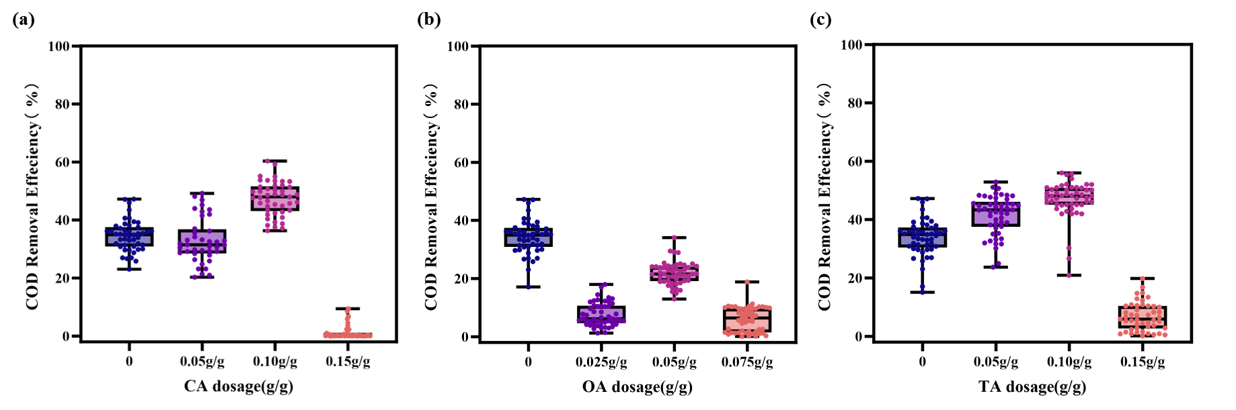
Fig S1 COD removal performance of denitrifying sludge during the 50-day operation period：（a）DNCA，（b）DNOA，（c）DNTA.

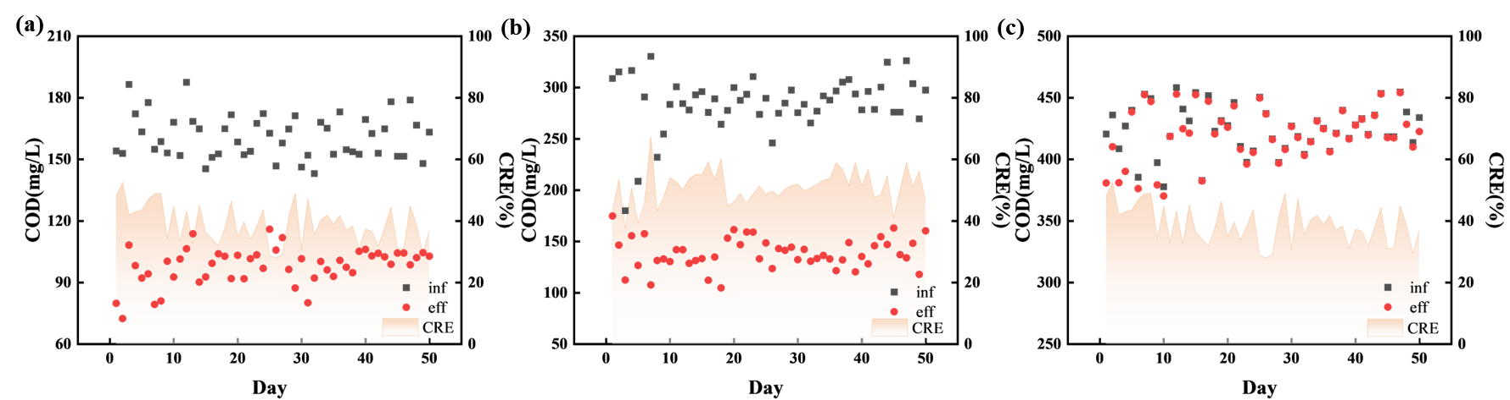
Fig S2 COD removal performance of denitrifying sludge in different groups under citric acid treatment over 50 days：(a)DNCA0.05， (b)DNCA0.10， (c)DNCA0.15.

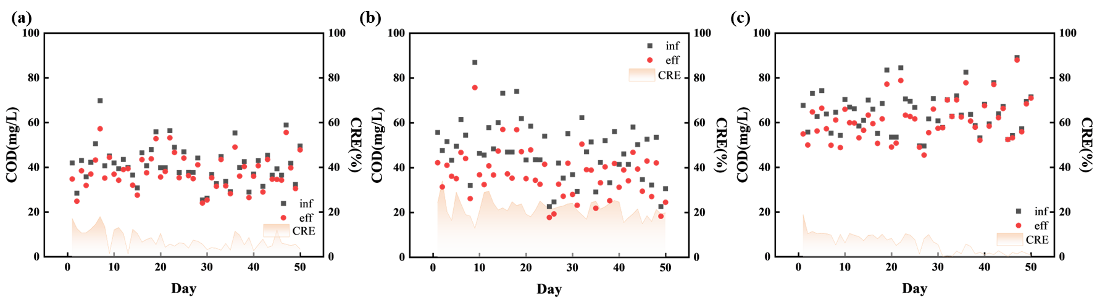
Fig S3 COD removal performance of denitrifying sludge in different groups under oxalic acid treatment over 50 days：(a)DNOA0.025， (b)DNOA0.05， (c)DNOA0.075.

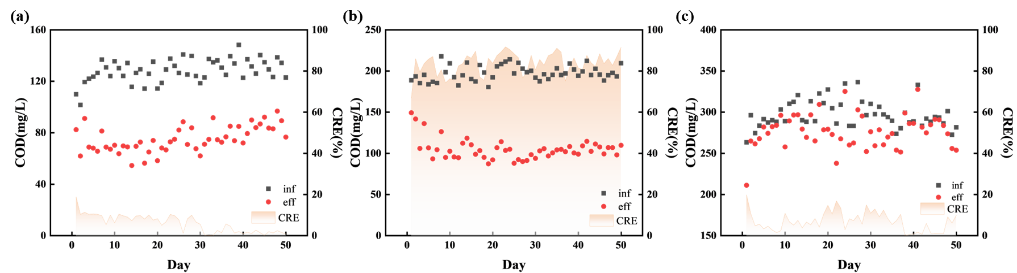
Fig S4 COD removal performance of denitrifying sludge in different groups under tartaric acid treatment over 50 days：(a)DNTA0.05， (b)DNTA0.10， (c)DNTA0.15.
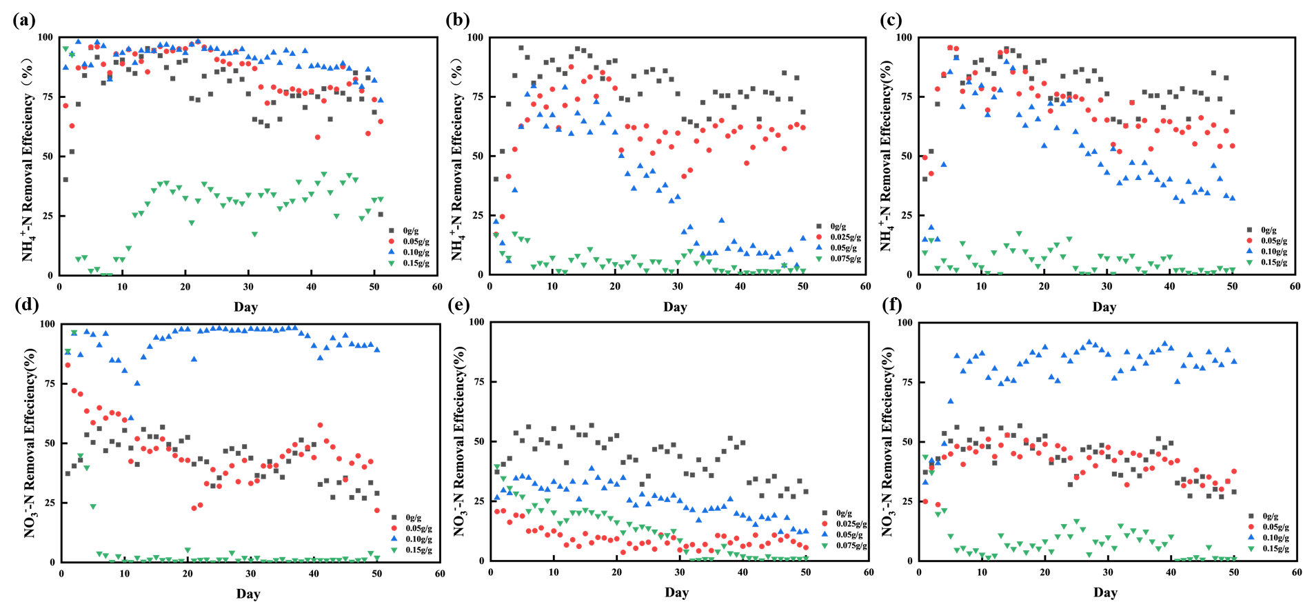
Fig S5 Nitrogen removal efficiency over 50 days. Nitrification: (a) NCA, (b) NOA, (c) NTA; Denitrification: (d) DNCA, (e) DNOA, (f) DNTA.
Table S1 Initial pH of nitrifying sludge in different organic acid treatment groups.
Nitrifying sludge | pH | Denitrifying sludge | pH
NCK | 7.32±0.24 | DNCK | 7.84±0.20
NOA0.025 | 7.06±0.15 | DNOA0.025 | 7.10±0.07
NOA0.05 | 6.19±0.46 | DNOA0.050 | 6.67±0.10
NOA0.075 | 5.11±0.38 | DNOA0.075 | 5.32±0.21
NCA0.05 | 6.96±0.18 | DNCA0.05 | 7.11±0.11
NCA0.10 | 6.37±0.19 | DNCA0.10 | 6.57±0.10
NCA0.15 | 5.69±0.35 | DNCA0.15 | 6.05±0.26
NTA0.05 | 6.92±0.35 | DNTA0.05 | 7.09±0.40
NTA0.10 | 6.14±0.21 | DNTA0.10 | 6.53±0.20
NTA0.15 | 5.52±0.43 | DNTA0.15 | 5.62±0.39

Table S2 Initial COD concentrations of denitrifying sludge in different organic acid treatment groups.
Denitrifying sludge | COD(mg/L) | Denitrifying sludge | COD(mg/L) | Denitrifying sludge | COD(mg/L)
DNCK | 163.1±11.1 | DNCK | 163.1±11.1 | DNCK | 163.1±11.1
DNOA0.025 | 40.9±8.7 | DNCA0.05 | 161.1±10.8 | DNTA0.05 | 128.6±9.0
DNOA0.05 | 47.8±13.1 | DNCA0.10 | 284.7±27.1 | DNTA0.10 | 197.4±8.9
DNOA0.075 | 64.7.±9.2 | DNCA0.15 | 424.6±19.7 | DNTA0.15 | 297.4±16.4

