SUPPLEMENTARY MATERIAL
Supplementary Table S1. Description of Rhizoctonia -like isolates used for phylogenetic analysis based on the ITS rDNA region, including collection details and GenBank accession numbers.
GenBank | Taxonomic assignation | Location | Host | Isolation source
AB122145 | Ceratobasidium sp. AG-k | Japan | Allium cepa | mycelium
AB196647 | Ceratobasidium sp. | Japan | Arachis hypogaea | mycelium
AB196650 | Ceratobasidium sp. AG-I | Japan | Artemisia sp. | mycelia
AJ427407 | Ceratobasidium sp. AGR | USA | Cucumis sp. | mycelia
AF354095 | Ceratobasidium sp. AGQ | Japan | Cynodon_Soil | mycelia
KY075643 | Ceratobasidium theobromae | China | Lonicera japonica | --
KP119764 | Ceratobasidium theobromae | China | Lonicera japonica | --
KP119766 | Ceratobasidium theobromae | China | Lonicera japonica | --
KP119765 | Ceratobasidium theobromae | China | Lonicera japonica | --
OR145521 | Ceratobasidium theobromae | Cambodia | Manihot esculenta | petiole
OR145522 | Ceratobasidium theobromae | Vietnam | Manihot esculenta | petiole
OR145523 | Ceratobasidium theobromae | Lao PDR | Manihot esculenta | petiole
AB286940 | Ceratobasidium sp. AG-P | Japan | -- | --
AB290017 | Ceratobasidium sp. AG-E | Japan | -- | --
AB000019 | Rhizoctonia solani | Japan | -- | --
AY154313 | Thanatephorus cucumeris | Brazil | -- | --
AF354108 | Thanatephorus cucumeris | Veracruz | Solanum tuberosum | mycelia
AF153804 | Rhizoctonia solani | Australia | Pterostylis acuminata | --
AB286930 | Ceratobasidium sp. AG-Ba | Japan | Rice | --
AB196659 | Ceratobasidium sp. AG-T | Japan | Rosa odorata | --
AB196653 | Ceratobasidium sp. AG-L | Japan | Soil | mycelium
AB000003 | Rhizoctonia solani | Japan | Soil | --
AF153800 | Rhizoctonia solani | Australia | Soil | --
AB196649 | Ceratobasidium sp. AG-H | Japan | Soil | mycelia
AB290021 | Ceratobasidium sp. AG-C | Japan | Sugar beet | mycelia
KU255726 | Ceratobasidium theobromae | Indonesia | Theobroma cacao | leaf
KU319572 | Ceratobasidium theobromae | Indonesia | Theobroma cacao | leaf
KU255724 | Ceratobasidium theobromae | Indonesia | Theobroma cacao | petiole
KM523668 | Ceratobasidium theobromae | Indonesia | Theobroma cacao | mycelium
KU319573 | Ceratobasidium theobromae | Indonesia | Theobroma cacao | leaf
KU310940 | Ceratobasidium theobromae | India | Theobroma cacao | petiole
KU310941 | Ceratobasidium theobromae | India | Theobroma cacao | petiole
AB000004 | Rhizoctonia solani | U.S.A. | Tobacco | --
AB198702 | Ceratobasidium sp. AG-D | Japan | Zoysia japonica | mycelia
MZ159527 | Scotomyces subviolaceus | Scotland | -- | --
MT340869 | Heteroacanthella acanthophysa | -- | -- | --
PQ192611 | Ceratobasidium theobromae | Brazil | Manihot esculenta | petiole
PQ192612 | Ceratobasidium theobromae | Brazil | Manihot esculenta | stem
Adapted from Oliveira et al. (2025).
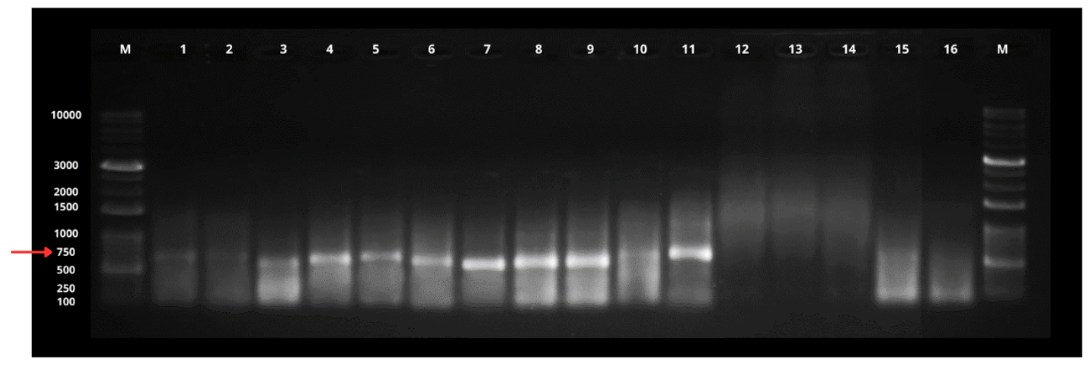
Figure S1. PCR products amplified using the CWBD-CIAT-F2/R2 primer set from 16 cassava samples analyzed on agarose 1% gel electrophoresis stained with GelRed and visualized under ultraviolet light. M: molecular weight marker (1 kb DNA Plus Ladder, Invitrogen); lanes 1–11: leaf and stem samples positive for R. theobromae; lanes 12–15: leaf and stem samples positive for R. theobromae only by qPCR; lane 16: negative control (healthy cassava leaf sample).

E
Supplemental Figure S2. Evaluation of the efficiency and specificity of the qPCR system using the β-tubulin endogenous control. (A) Regression curve for leaf samples; (B) Regression curve for stem samples; (C) and (D) Boxplots representing the number of copies detected in leaves and stems, respectively; (E) Heat map representing the average number of copies obtained from ΔCt values.

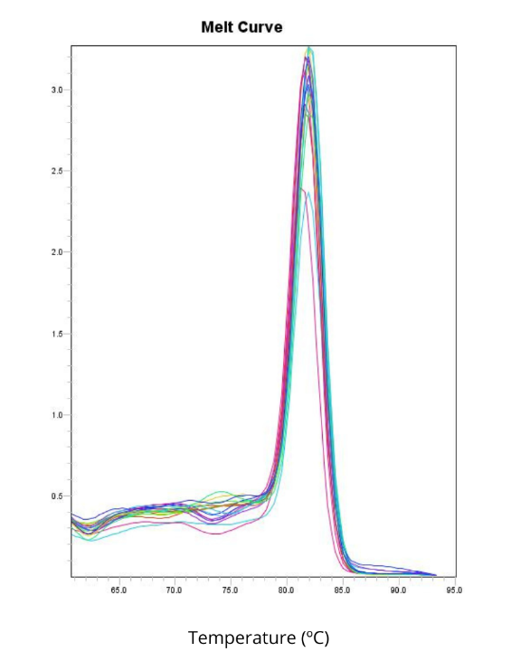
Figure S3. Dissociation curve (melt curve) analysis of the qPCR system. The presence of a single, sharp peak indicates high specificity of the amplification and the absence of non-specific products or primer-dimers, confirming the reliability of the CaMK/CaMKL probe-based assay.

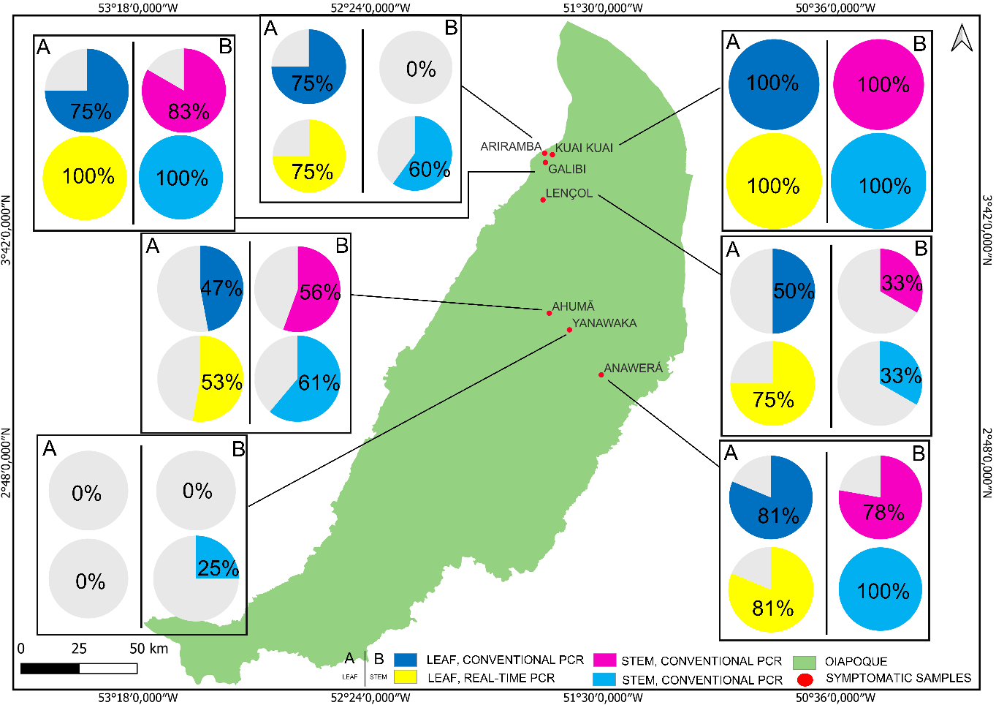
Figure S4. Map of Rhizoctonia theobromae incidence in cassava sample’s locations collected at villages in the Oiapoque region (Kuai-Kuai, Ariramba, Galibí, Lençol, Ahumã, Anawerá, and Yanawaka). The red dots indicate the collection sites. The pie charts represent the results of molecular detection by both methods: dark blue (leaf, conventional PCR); pink (stem, conventional PCR); yellow (leaf, qPCR); and light blue (stem, qPCR). Column A corresponds to the leaf samples, and column B corresponds to the stem samples. The green area represents the Oiapoque municipality.

