Appendix
Figure 1 presents the comparison between Methods 1, 2, and 3 with the SPIV data for Case 10 (Reynolds number = 44,500).
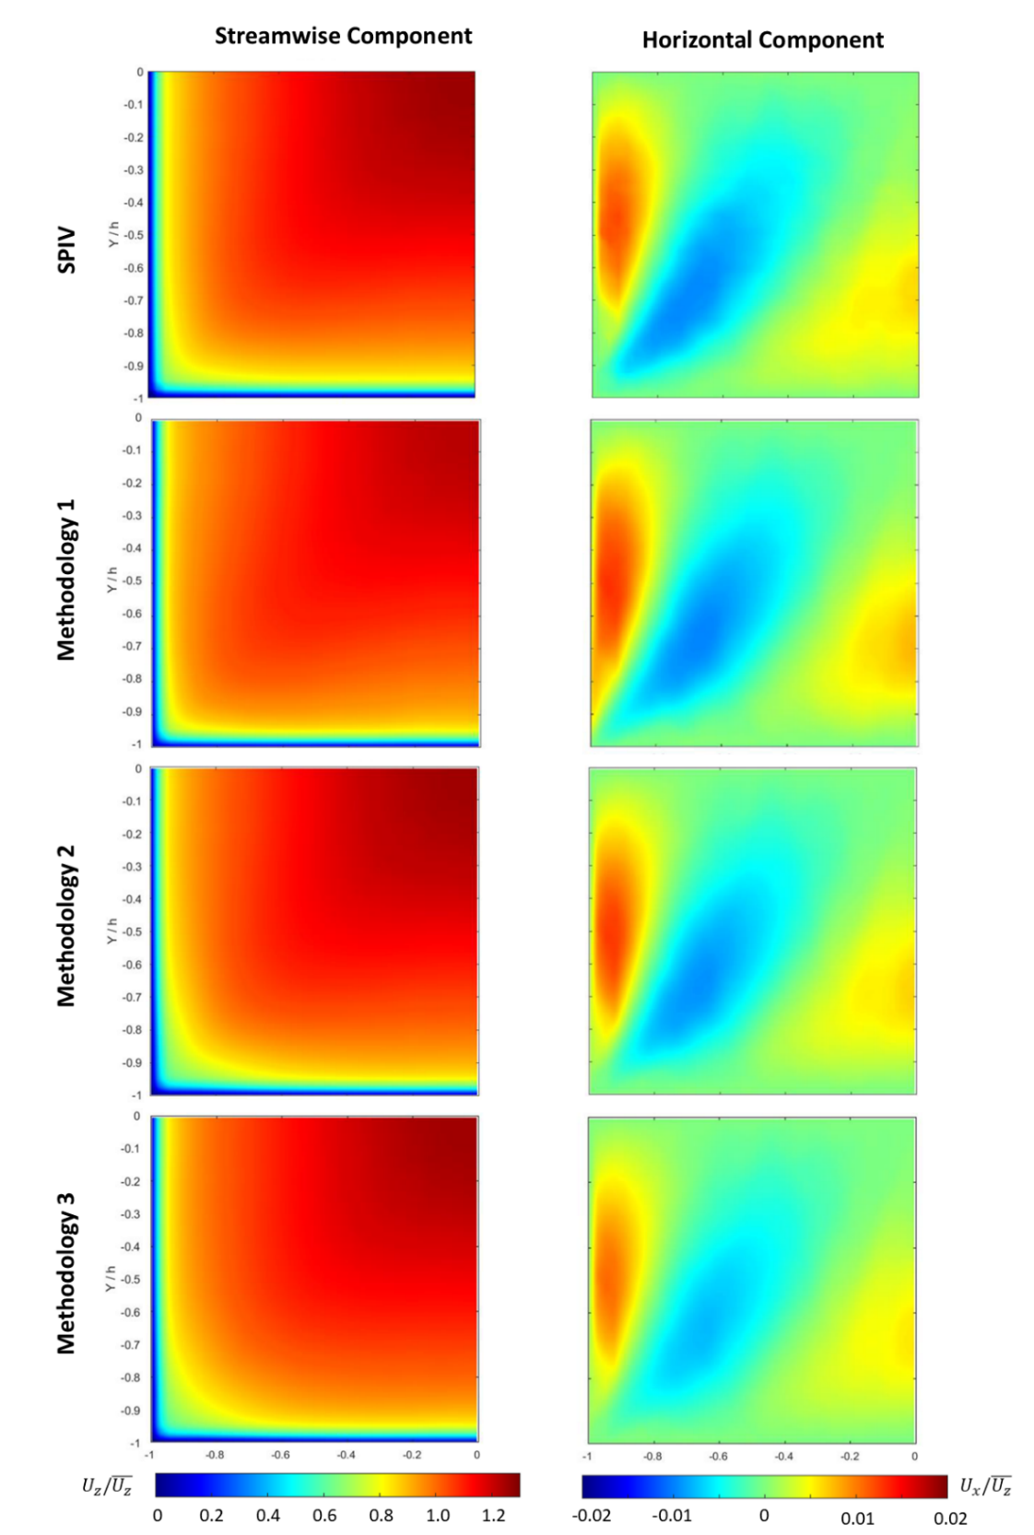
Figure 1 – Comparison of the different data-driven Methods with the SPIV data for Case 10 (Reynolds number = 44,500) for the normalized streamwise (U_{z}) and horizontal (U_{x}) components of the velocity vector

