Ultrasound Assisted Extraction and Response Surface Methodology and Artificial Neural Network of Optimization Pectin from Orange Peel

Corresponding author; Ketema Beyecha Hundie

School of Chemical Engineering, Jimma institute of Technology, Jimma
University, Jimma, Ethiopia

Corresponding author email: ktmbych2001@gmail.com ; ambobara2012@gmail.com

Tel: +25191355744; 0942637868

Abstract and Graphical abstract
The objective of study was ultrasound-assisted extraction of pectin from orange peel using response surface method and artificial neural network technique. The following findings are absorbed from the effects of extraction parameters and technique used. The pH solution was highly significant compared to ultrasound power. As well as interaction between ultrasound and pH were found to be strongly influenced the extraction yield of pectin. The optimal parameters for extraction were irradiation time of 22.5min, pH of 1.5, and ultrasound power of 155W and liquid-solid ratio 22.5:1 mL/ g.
Under these conditions, yield of pectin was 26.87% experimentally, while 26.74 and 26.93% of yield were predicted by response surface and artificial neural network model respectively.
The extracted pectin was categorized as high methoxyl pectin, since it has 63.13% degree of esterification, which is above 50% affirmed by Fourier transform infrared spectroscopy detection.
Both response surface methodology and artificial neural network model prediction was in good agreement with experimental data; however, the prediction of artificial neural network prediction was better than artificial neural network.
Therefore, artificial neural network model is much more accurate in estimating the values of pectin yield and mean square error when compared with the response surface methodology.

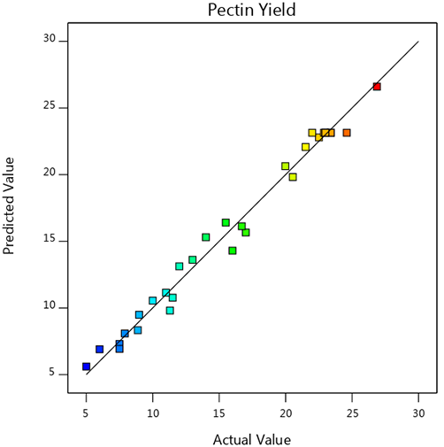
Fig. Experimental value versus RSM expected of pectin yield (%).

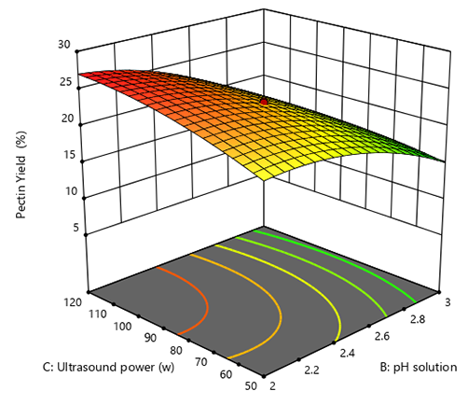
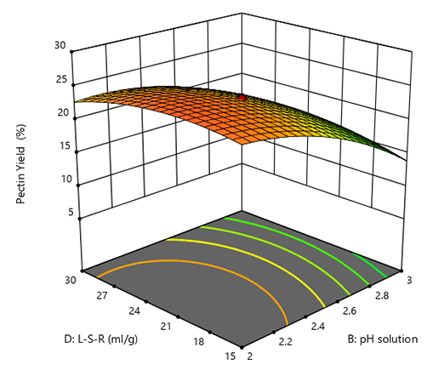
a)
b)
Fig. Ultrasound versus pH (a) and Liquid-solid ratio versus pH on the yield of pectin (b)

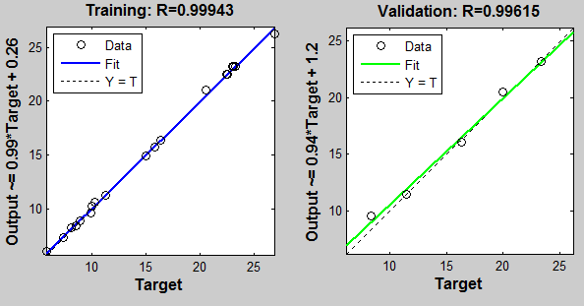
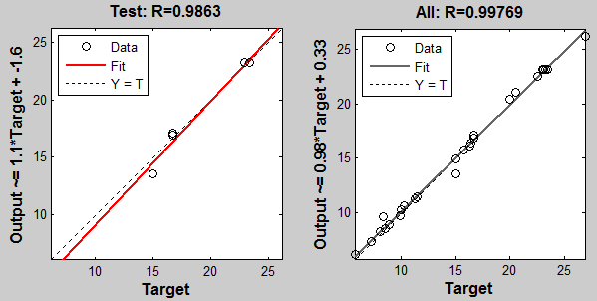

Fig. Correlation coefficients for mean pectin yield (ANN).

