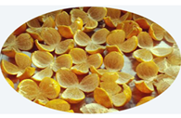
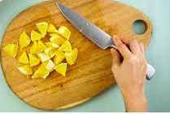
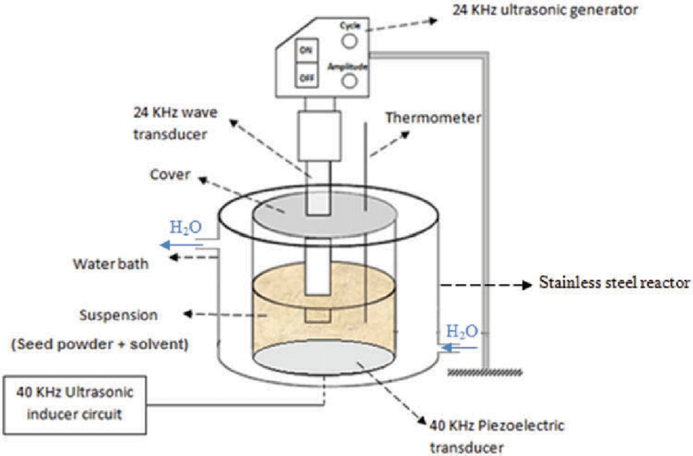
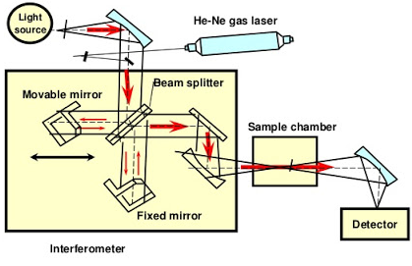
Raw material collection
Raw material analysis
- Drying
- Size reduction
- Sieve analysis

Pectin extraction
Pectin drying
Pectin Characterization

Fig. Pectin extraction process flow diagram.

