Supplementary material

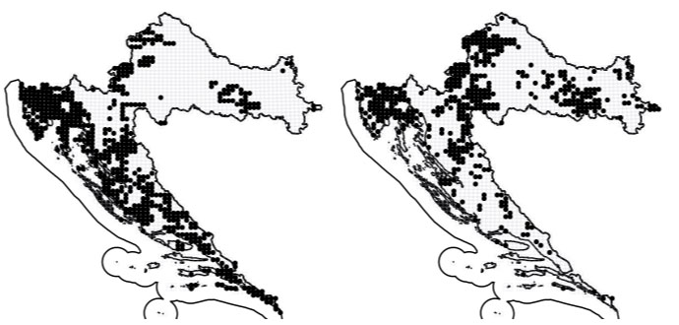
Supplement Fig. 1 Area of natural occurrence of (left) Q. pubescens and (right) Q. cerris in Croatia, depicted as black dots. Source: Nikolić, 2015

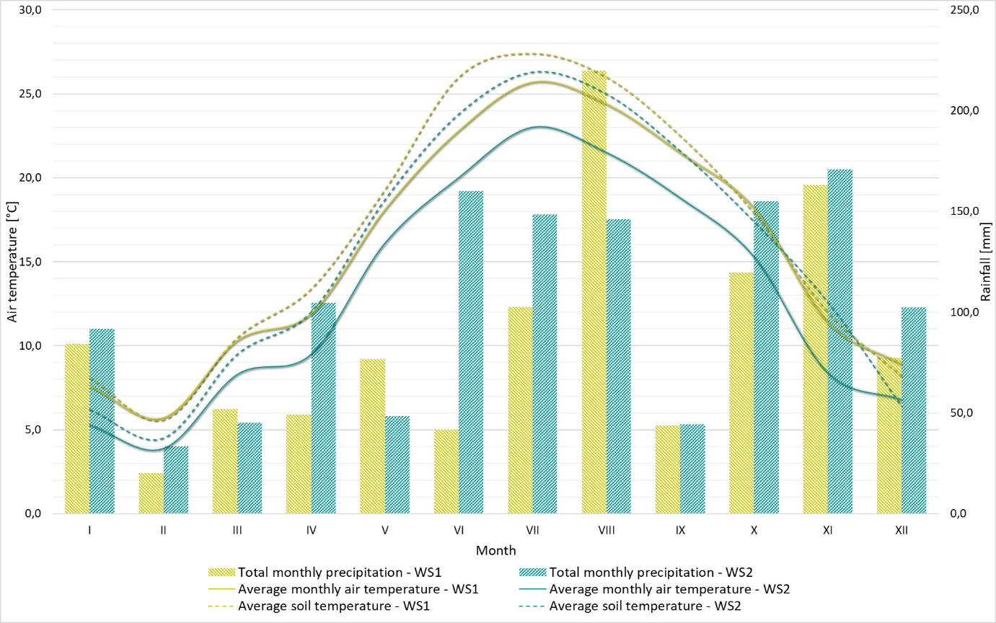
Supplement Fig. 2 Total monthly precipitation, average monthly air temperature and average monthly soil temperature at a 10 cm depth recorded during the year 2023 on two weather stations (WS1 - Poreč, WS2 - Pazin) of the research area
Supplement Table 1 Sampling plots properties of identified Tuber aestivum productive locations within research area
Quercus pubescens (total number of sample pairs: 28)
sampling zone | IN |  |  |  | OUT
 | min | med | mean | max | min | med | mean | max
altitude [m] | 7 | 282.5 | 225.7 | 421 | 7 | 282.5 | 225.7 | 421
pH | 6.69 | 7.15 | 7.10 | 7.46 | 6.00 | 7.10 | 7.01 | 7.56
sand [%] | 4.36 | 13.61 | 14.65 | 30.32 | 3.25 | 11.18 | 16.16 | 51.54
silt [%] | 47.58 | 63.73 | 64.19 | 86.42 | 35.06 | 62.04 | 62.63 | 86.79
clay [%] | 6.30 | 21.50 | 21.16 | 39.00 | 0.10 | 20.10 | 21.18 | 37.00
C [g kg⁻¹] | 23.94 | 60.09 | 57.35 | 82.92 | 12.86 | 52.81 | 55.77 | 107.73
Ca [g kg⁻¹] | 0.008 | 0.014 | 0.030 | 0.119 | 0.005 | 0.012 | 0.037 | 0.154
K [g kg⁻¹] | 8.43 | 11.91 | 12.18 | 16.44 | 4.46 | 11.40 | 11.71 | 16.48
N [g kg⁻¹] | 2.56 | 4.78 | 4.82 | 6.80 | 1.25 | 4.60 | 4.52 | 8.16
P [g kg⁻¹] | 0.087 | 0.142 | 0.166 | 0.901 | 0.076 | 0.123 | 0.165 | 1.357
Quercus cerris (total number of sample pairs: 37)
sampling zone | IN |  |  |  | OUT
 | min | med | mean | max | min | med | mean | max
altitude [m] | 284 | 376.0 | 373.7 | 443 | 284 | 376.0 | 373.7 | 443
pH | 6.57 | 7.20 | 7.17 | 7.83 | 5.99 | 7.20 | 7.13 | 8.05
sand [%] | 8.42 | 13.77 | 14.76 | 34.19 | 7.90 | 13.51 | 15.55 | 44.05
silt [%] | 45.51 | 63.70 | 64.08 | 85.55 | 45.18 | 64.70 | 64.13 | 83.66
clay [%] | 3.60 | 23.50 | 21.16 | 38.30 | 0.60 | 17.90 | 20.31 | 40.50
C [g kg⁻¹] | 26.69 | 57.04 | 60.31 | 131.50 | 14.11 | 55.43 | 57.94 | 122.48
Ca [g kg⁻¹] | 0.008 | 0.035 | 0.057 | 0.148 | 0.006 | 0.033 | 0.055 | 0.147
K [g kg⁻¹] | 9.87 | 13.88 | 13.80 | 17.80 | 9.40 | 13.87 | 13.73 | 18.08
N [g kg⁻¹] | 2.92 | 4.42 | 4.78 | 8.46 | 1.43 | 4.35 | 4.46 | 8.15
P [g kg⁻¹] | 0.070 | 0.124 | 0.397 | 2.977 | 0.057 | 0.137 | 0.403 | 3.144

Supplement Table 2 Average monthly air temperature of dry thermometer (Croatian Meteorological and Hydrological Service, 2025), average monthly soil temperature on 10 cm depth and total monthly precipitation (Croatian Meteorological and Hydrological Service, 2024a and 2024b) recorded during the sampling year (2023) from two weather stations (WS1 - Poreč and WS2 - Pazin) of the research area (Figure 1)
 | Month
Station | I | II | III | IV | V | VI | VII | VIII | IX | X | XI | XII
Average monthly air temperature [°C] of the dry thermometer
Pazin | 5,3 | 3,9 | 8,3 | 9,5 | 16,1 | 20,0 | 23,0 | 21,5 | 18,8 | 15,3 | 8,4 | 6,8
Poreč | 7,6 | 5,7 | 10,3 | 11,9 | 18,1 | 22,8 | 25,7 | 24,4 | 21,5 | 18,2 | 11,4 | 8,9
Average monthly soil temperature [°C] at 10 cm depth
Pazin | 6,2 | 4,5 | 9,5 | 12,0 | 18,7 | 23,8 | 26,3 | 25,0 | 21,6 | 17,4 | 12,6 | 6,4
Poreč | 8,1 | 5,6 | 10,5 | 13,4 | 19,3 | 26,0 | 27,4 | 26,0 | 22,5 | 17,9 | 12,0 | 8,2
Total monthly precipitation [mm]
Pazin | 91,7 | 33,4 | 45,0 | 104,5 | 48,5 | 160,0 | 148,4 | 146,2 | 44,3 | 155,1 | 170,8 | 102,4
Poreč | 84,1 | 20,2 | 52,0 | 49,1 | 76,7 | 41,8 | 102,5 | 219,8 | 43,8 | 119,8 | 163,0 | 77,4

