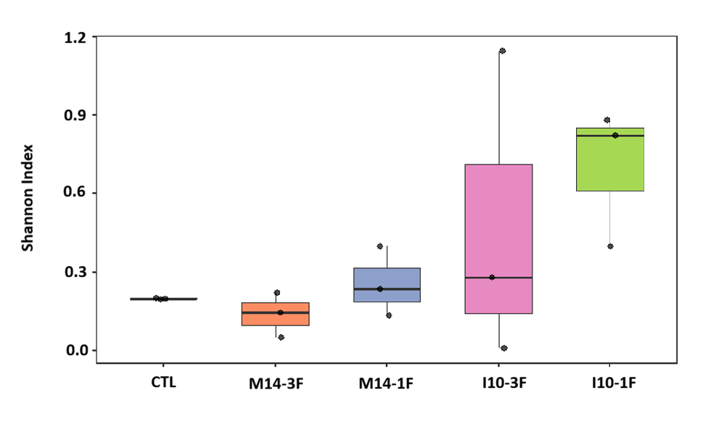
Figure S1. Shannon diversity index at the species level for gut microbiota of juvenile Colossoma macropomum supplemented with Weissella cibaria strains for 90 days. CTL: control; M14-3F: feed supplemented with strain M14, provided 3 times a day; M14-1F: feed supplemented with strain M14, provided once a day; I10-3F: feed supplemented with strain I10, provided 3 times a day and I10-1F: feed supplemented with strain I10, provided once a day. Boxes represent the interquartile range (25–75%), the center line indicates the median, and points represent individual replicates. There was no significant difference between treatments (ANOVA, F₄,₁₀ = 1.80, p = 0.205).

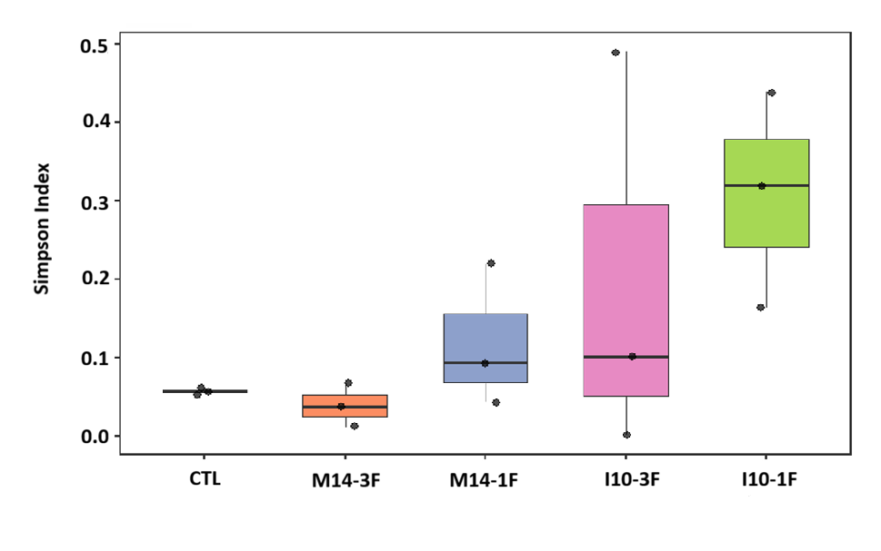
Figure S2. Simpson diversity index at the species level for gut microbiota of juvenile Colossoma macropomum supplemented with Weissella cibaria strains for 90 days. CTL: control; M14-3F: feed supplemented with strain M14, provided 3 times a day; M14-1F: feed supplemented with strain M14, provided once a day; I10-3F: feed supplemented with strain I10, provided 3 times a day and I10-1F: feed supplemented with strain I10, provided once a day. Boxes represent the interquartile range (25–75%), the center line indicates the median, and points represent individual replicates. There was no significant difference between treatments (ANOVA, F₄,₁₀ = 1.93, p = 0.183).

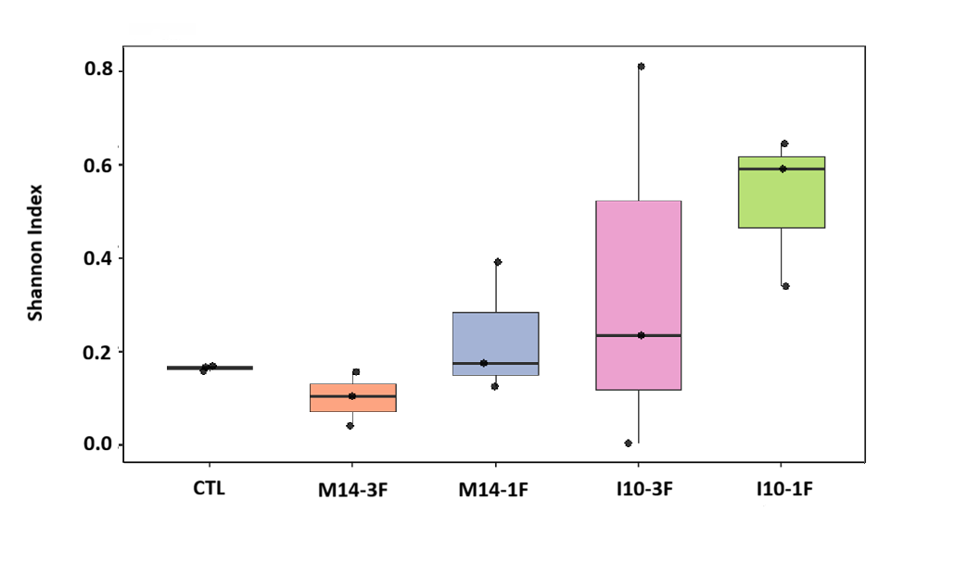
Figure S3. Shannon diversity index at the phylum level for gut microbiota of juvenile Colossoma macropomum supplemented with Weissella cibaria strains for 90 days. CTL: control; M14-3F: feed supplemented with strain M14, provided 3 times a day; M14-1F: feed supplemented with strain M14, provided once a day; I10-3F: feed supplemented with strain I10, provided 3 times a day and I10-1F: feed supplemented with strain I10, provided once a day. Boxes represent the interquartile range (25–75%), the center line indicates the median, and points represent individual replicates. There was no significant difference between treatments (ANOVA, F₄,₁₀ = 1.905, p = 0.186).

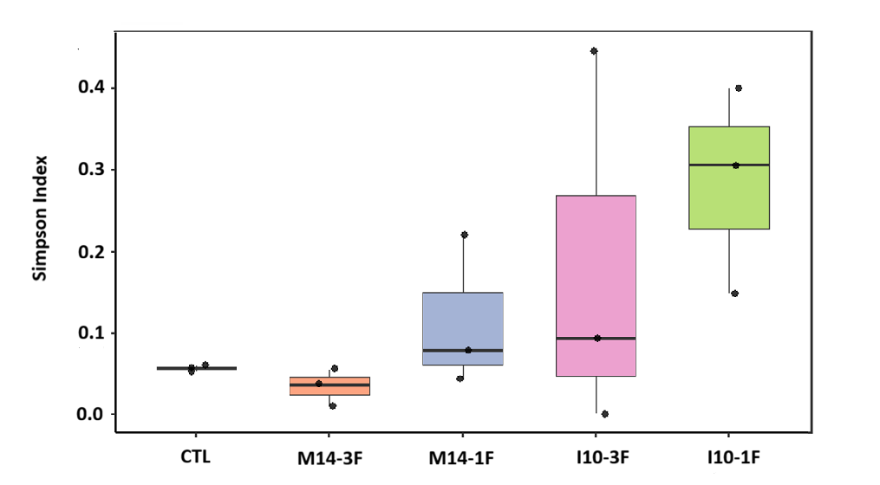
Figure S4. Simpson diversity index at the phylum level for gut microbiota of juvenile Colossoma macropomum supplemented with Weissella cibaria strains for 90 days. CTL: control; M14-3F: feed supplemented with strain M14, provided 3 times a day; M14-1F: feed supplemented with strain M14, provided once a day; I10-3F: feed supplemented with strain I10, provided 3 times a day and I10-1F: feed supplemented with strain I10, provided once a day. Boxes represent the interquartile range (25–75%), the center line indicates the median, and points represent individual replicates. There was no significant difference between treatments (ANOVA, F₄,₁₀ = 1.921, p = 0.183).

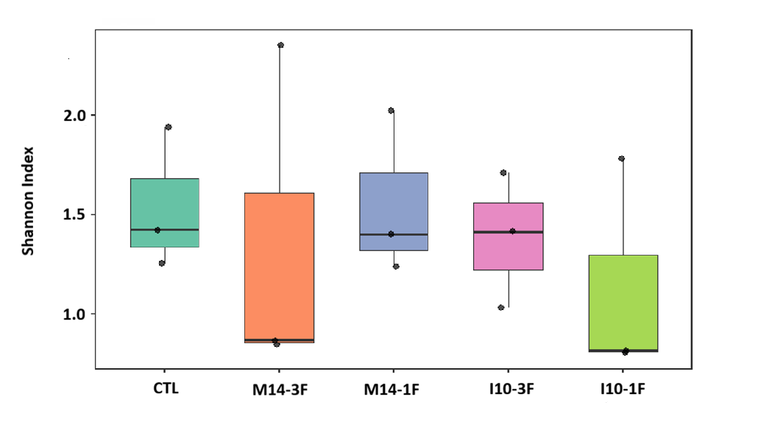
Figure S5. Shannon diversity index at the species level for gut microbiota of juvenile Colossoma macropomum supplemented with Weissella cibaria strains for 90 days and challenged with Aeromonas hydrophila. CTL: control; M14-3F: feed supplemented with strain M14, provided 3 times a day; M14-1F: feed supplemented with strain M14, provided once a day; I10-3F: feed supplemented with strain I10, provided 3 times a day and I10-1F: feed supplemented with strain I10, provided once a day. Boxes represent the interquartile range (25–75%), the center line indicates the median, and the points represent the individual replicates. There was no significant difference between the treatments (ANOVA, F₄,₁₀ = 0.29, p = 0.875).

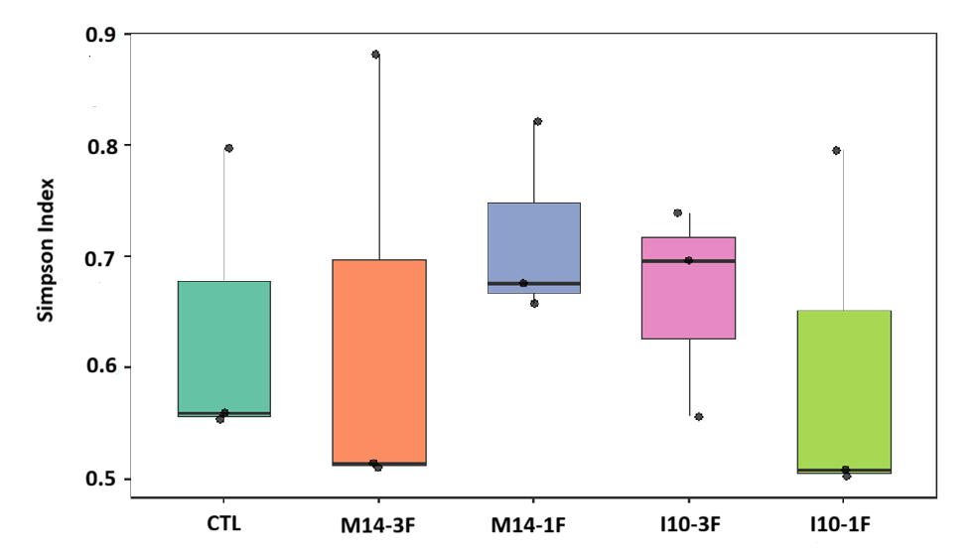
Figure S6. Simpson diversity index at the species level for gut microbiota of juvenile Colossoma macropomum supplemented with Weissella cibaria strains for 90 days and challenged with Aeromonas hydrophila. CTL: control; M14-3F: feed supplemented with strain M14, provided 3 times a day; M14-1F: feed supplemented with strain M14, provided once a day; I10-3F: feed supplemented with strain I10, provided 3 times a day and I10-1F: feed supplemented with strain I10, provided once a day. Boxes represent the interquartile range (25–75%), the center line indicates the median, and points represent individual replicates. No significant differences were observed between treatments (Kruskal–Wallis, χ² = 2.40, df = 4, p = 0.663).

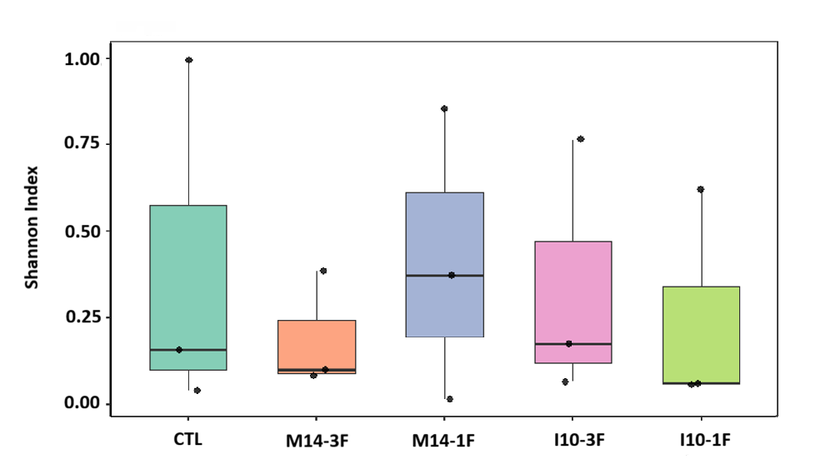
Figure S7. Shannon diversity index at the phylum level for gut microbiota of juvenile Colossoma macropomum supplemented with Weissella cibaria strains for 90 days and challenged with Aeromonas hydrophila. CTL: control; M14-3F: feed supplemented with strain M14, provided 3 times a day; M14-1F: feed supplemented with strain M14, provided once a day; I10-3F: feed supplemented with strain I10, provided 3 times a day and I10-1F: feed supplemented with strain I10, provided once a day. Boxes represent the interquartile range (25–75%), the center line indicates the median, and points represent individual replicates. There was no significant difference between treatments (ANOVA, F₄,₁₀ = 0.195, p = 0.935).

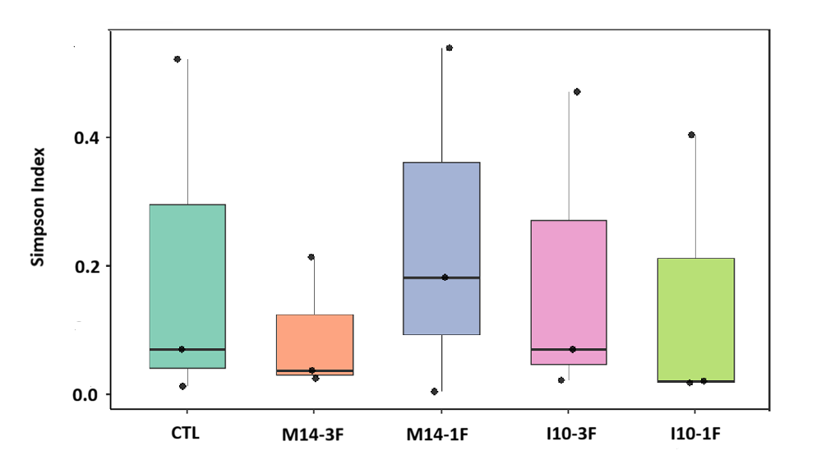
Figure S8. Simpson diversity index at the phylum level for gut microbiota of juvenile Colossoma macropomum supplemented with Weissella cibaria strains for 90 days and challenged with Aeromonas hydrophila. CTL: control; M14-3F: feed supplemented with strain M14, provided 3 times a day; M14-1F: feed supplemented with strain M14, provided once a day; I10-3F: feed supplemented with strain I10, provided 3 times a day and I10-1F: feed supplemented with strain I10, provided once a day. Boxes represent the interquartile range (25–75%), the center line indicates the median, and points represent individual replicates. There was no significant difference between treatments (Kruskal–Wallis, χ² = 0.633, df = 4, p = 0.959).

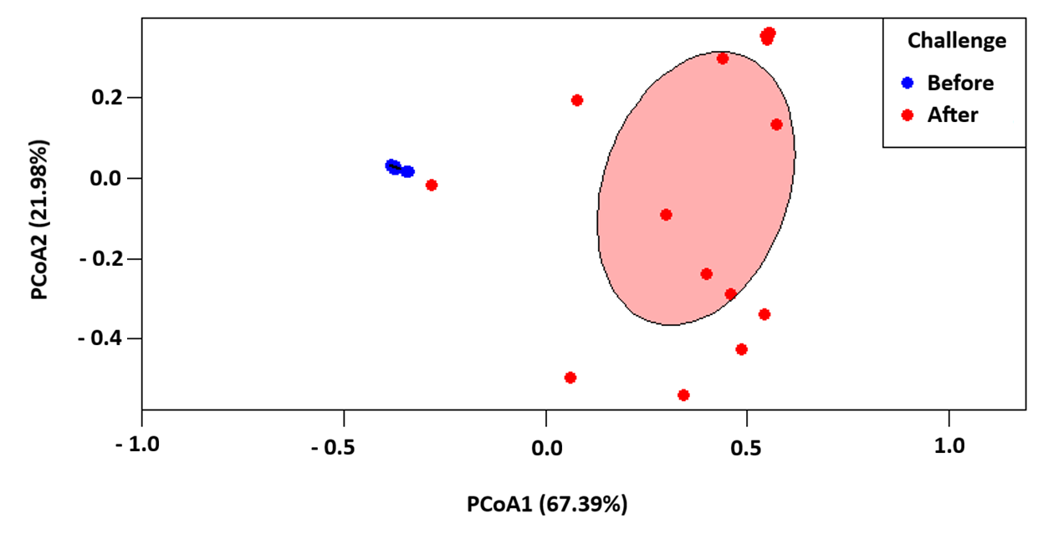
Figure S9. Principal coordinate analysis (PCoA) based on Bray–Curtis distance demonstrating the structure of the microbial community before (blue) and after (red) the experimental challenge. Axis 1 and axis 2 explain 67.39% and 21.98% of the total variation, respectively. Ellipses represent the dispersion of the groups (confidence interval based on standard deviation).

