Identification and Haplotype Diversity Analysis of DVL Family Genes in Rice

figure S1.Expression analysis of OsDLH gene. Color markings indicate changes in gene expression. Red represents high expression, and blue represents low expression.(a) Expression levels of the OsDLH gene in roots and shoots after drought stress.(b) Expression levels of the OsDLH gene in stems and leaves after heat treatment.(c) Expression levels of the OsDLH gene in roots and shoots after ABA hormone treatment.(d) Expression levels of the OsDLH gene in roots and shoots after MeJA treatment.

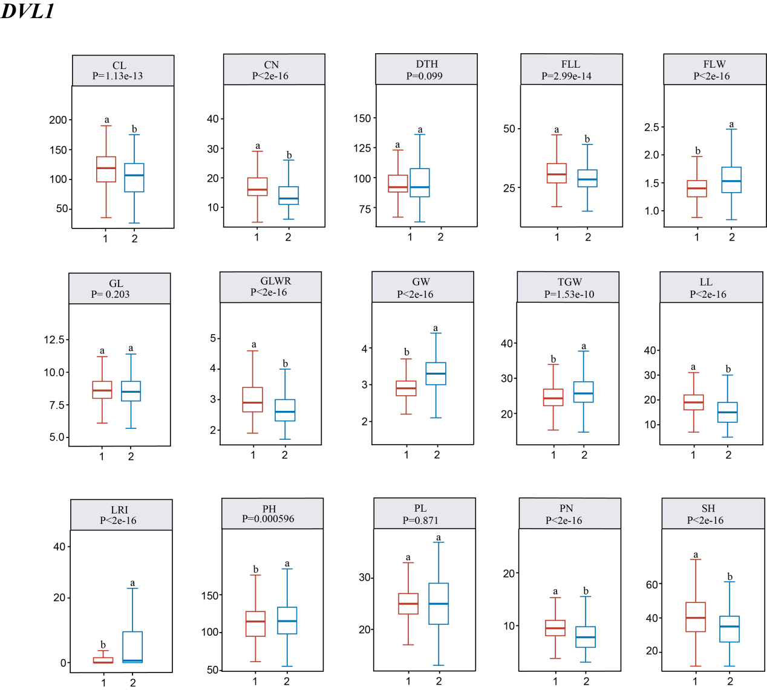
Figure S2. Comparison and analysis of 15 agronomic traits among the predominant gcHap, unfavorable gcHap, and major gcHaps of OsDVL1.

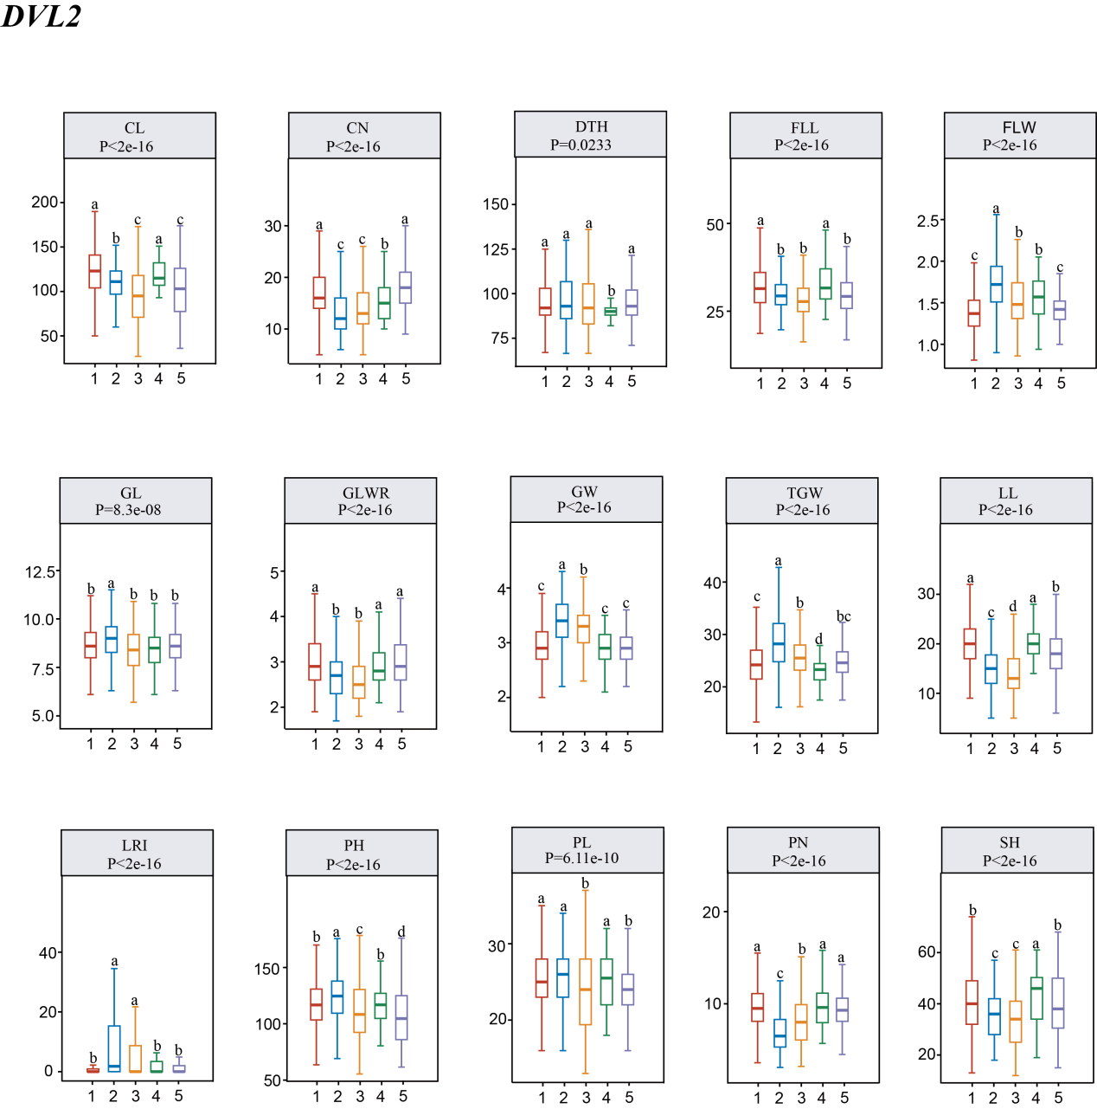
Figure S3. Comparison and analysis of 15 agronomic traits among the predominant gcHap, unfavorable gcHap, and major gcHaps of OsDVL3.
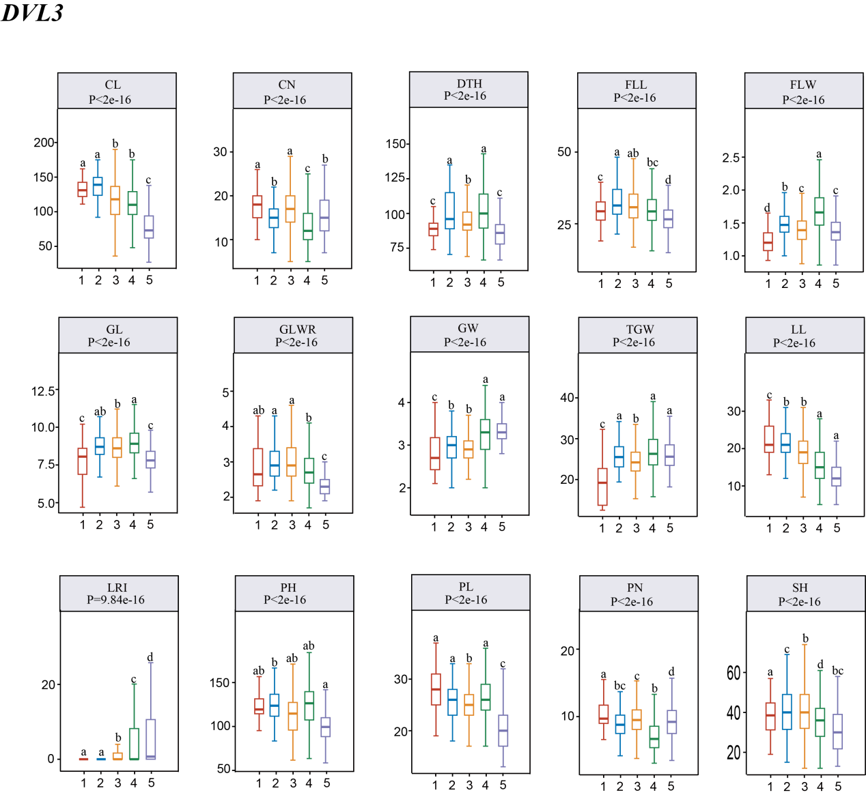
Figure S4. Comparison and analysis of 15 agronomic traits among the predominant gcHap, unfavorable gcHap, and major gcHaps of OsDVL4.
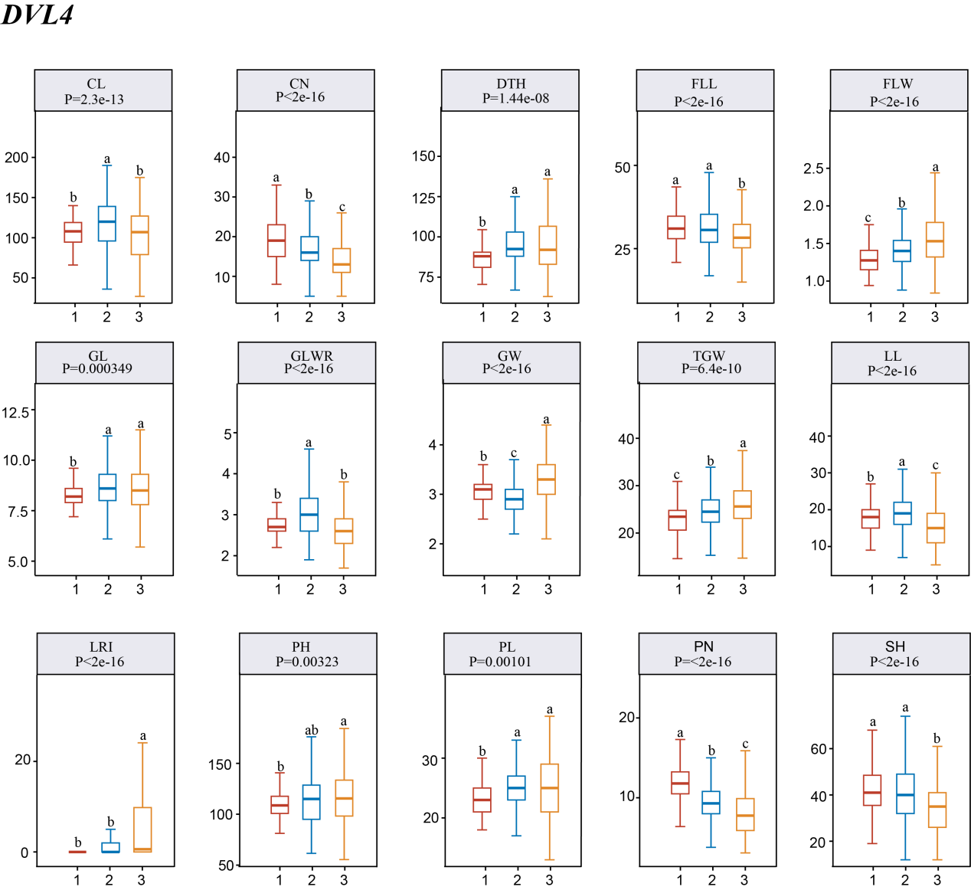
Figure S5. Comparison and analysis of 15 agronomic traits among the predominant gcHap, unfavorable gcHap, and major gcHaps of OsDVL5.

figure S6. Haplotype networks of the OsDLH gene from 4 clones in 3KRG and 4 related agronomic traits. Letters represent the differences among haplotypes evaluated by two-factor analysis of variance. Different letters on the box-and-whisker plots indicate statistically significant differences at p < 0.05 according to the Duncan's multiple-range test. The bar chart on the right shows the frequency differences of the main gcHaps between the landraces (LAN) and modern varieties (MV) of Xian (indica) and Geng (japonica). The chi-square test was used to determine the significant differences in the proportions of gcHaps among different populations at p<0.0001.

