Supplementary Material

Supplemental Fig. 1. The blood side clearance of small molecular weight substances of (a) UN, (b) UA, (c) IP, and (d) Cre at 60 minutes. Mean values are shown as diamonds.

Supplemental Fig. 2. Removal rate of small molecular weight substances of (a) UN, (b) UA, (c) IP, and (d) Cre before and after dialysis session. Mean values are shown as diamonds.

Supplemental Fig. 1
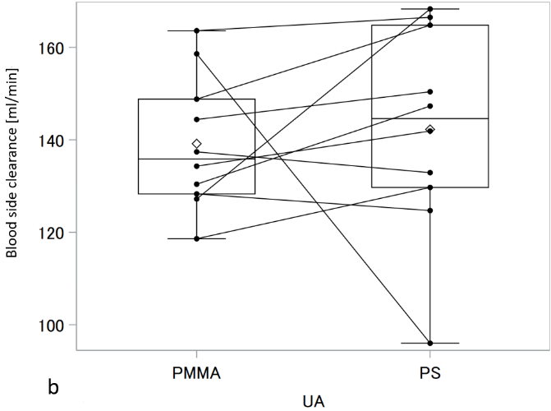
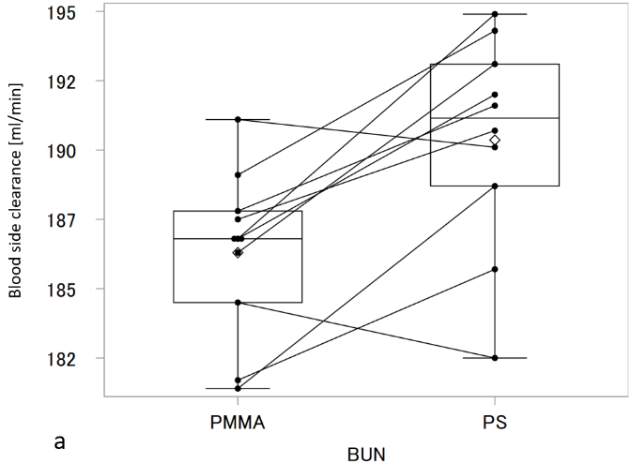
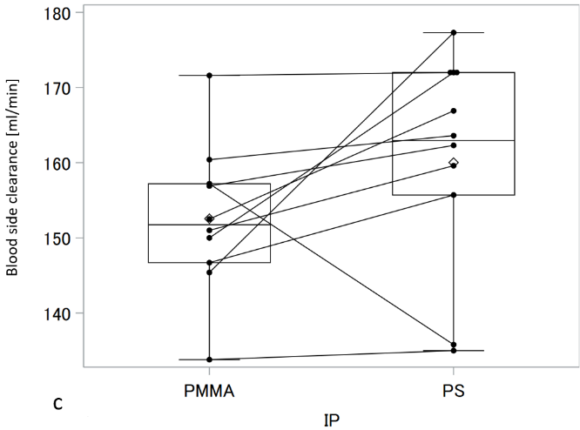
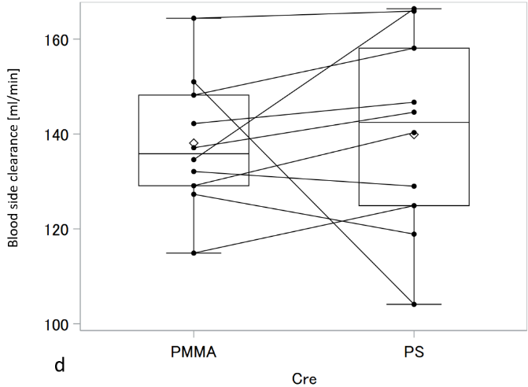

Supplemental Fig. 2

