Delirium screening in the emergency department: a systematic review and meta-analysis

Qian Zhang^{1#}, Meixi Chen^{2#}, Liangying Hou^{2,3}, Ziqi Guo⁴, Qing Zhang⁴, Baoshan Di^{5*}, Long Ge^{1,2,3*}

¹ Evidence-Based Nursing Center, School of Nursing, Lanzhou University, Lanzhou 730000, China
² Evidence-Based Social Science Research Center, School of Public Health, Lanzhou University, Lanzhou 730000, China
³ Department of Social Science and Health Management, School of Public Health, Lanzhou University, Lanzhou 730000, China
⁴ The Second Hospital, Lanzhou University, Lanzhou 730000, China
⁵ Department of Emergency, Gansu Provincial Hospital, Lanzhou 730000, China

#Co-first author: Qian Zhang and Meixi Chen
*Co-corresponding author: Long Ge and Baoshan Di
E-mail: gelong2009@163.com
Telephone number: 13893192463

Table 1 Search Strategy 5
Table 2 List of Excluded Studies and the Reasons 9
Table 3 Risk of Bias 11
Figure 1 Sensitivity and Specificity of the CAM 13
Figure 2 DOR of the CAM 14
Figure 3 Pre-test and Post-test Probability 15
Figure 4 Likelihood Ratio 16
Figure 5 Publication Bias 17
Figure 6 Sensitivity and Specificity of the 4AT 18
Figure 7 DOR of the 4AT 19
Figure 8 Pre-Test and Post-Test Probability 20
Figure 9 Likelihood Ratio 21
Figure 10 Results of the network meta-analysis 22

Table 1 Search Strategy
Databases [Platform] Searches run September 17th 2019 | Results
PubMed | 1685
Cochrane Library | 402
Embase | 2556
psyc INFO | 574
TOTAL | 4904
Duplicate | 298

Database: psyc INFO< September 20th 2019> 574
Search Strategy:
# | Searches | Results
S1 | mainsubject(delirium) | 574
S2 | ti(delirium) OR ti( clouded state*) OR ti("clouding of consciousness") OR ti("exogenous psychosis") OR ti("toxic psychosis") OR ti("toxic confusion") OR ti(obnubilat*) OR ti("mental confusion") OR ti("clouding of consciousness") | 2864
S3 | ab(delirium) OR ab(clouded state*) OR ab("clouding of consciousness") OR ab("exogenous psychosis") OR ab("toxic psychosis") OR ab("toxic confusion") OR ab(obnubilat*) OR ab("mental confusion") OR ab("clouding of consciousness") | 6431
S4 | ab(deliri*) OR ab("acute confusion") OR ab("acute organic psychosyndrome") OR ab(“acute brain syndrome”) OR ab(“acute brain dysfunction”) OR ab(“acute brain failure”) OR ab(“organic psychosyndrome”) OR ab(“metabolic encephalopathy”) OR ab(“psycho-organic syndrome”) | 525
S5 | ti(deliri*) OR ti("acute confusion") OR ti("acute organic psychosyndrome") OR ti("acute brain syndrome") OR ti("acute brain dysfunction") OR ti("acute brain failure") OR ti("organic psychosyndrome") OR ti("metabolic encephalopathy") OR ti("psycho-organic syndrome") | 3175
S6 | S2 OR S3 OR S4 OR S5 | 7684
S7 | mainsubject(Sensitivity and Specificity) | 10218
S8 | ti(Sensitivity ) OR ab(Sensitivity ) OR ti(Specificity) OR ab(Specificity) OR ti(Sensitivity and Specificity) OR ab(Sensitivity and Specificity) | 113564
S9 | S7 OR S8 | 118600
S10 | ti(accuracy) OR ab(accuracy) OR ti(diagnos*) OR ti(screen*) OR ti(detect*) | 143265
S11 | S9 OR S10 | 248757
S12 | S6 AND S11 | 574

Database: PubMed< September 20th 2019> 1685
Search Strategy:
# | Searches | Results
#1 | "Delirium"[Mesh] | 1685
#2 | Search (((((((((((((((((delirium[Title/Abstract]) OR deliri*[Title/Abstract]) OR "acute confusion"[Title/Abstract]) OR “acute organic psychosyndrome”[Title/Abstract]) OR “acute brain syndrome”[Title/Abstract]) OR “acute brain dysfunction”[Title/Abstract]) OR “acute brain failure”[Title/Abstract]) OR “organic psychosyndrome”[Title/Abstract]) OR “metabolic encephalopathy”[Title/Abstract]) OR “psycho-organic syndrome”[Title/Abstract]) OR clouded state*[Title/Abstract]) OR “clouding of consciousness”[Title/Abstract]) OR “exogenous psychosis”[Title/Abstract]) OR “toxic psychosis”[Title/Abstract]) OR “toxic confusion”[Title/Abstract]) OR obnubilat*[Title/Abstract]) OR “mental confusion”[Title/Abstract]) OR “clouding of consciousness”[Title/Abstract] | 16798
#3 | #1 OR #2 | 18356
#4 | "Sensitivity and Specificity"[Mesh] | 561472
#5 | ((Sensitivity[Title/Abstract]) OR Specificity[Title/Abstract]) OR (Sensitivity[Title/Abstract] AND Specificity[Title/Abstract]) | 992279
#6 | #4 OR #5 | 1373987
#7 | (((accuracy[Title/Abstract]) OR diagnos*[Title]) OR screen*[Title]) OR detect*[Title] | 1373945
#8 | #6 OR #7 | 2451744
#9 | #3 AND #8 | 1685

Database: Embase< September 23th 2019> 2556
Search Strategy:
# | Searches | Results
#1 | delirium:ab,ti OR deliri*:ab,ti OR 'acute confusion':ab,ti OR 'acute organic psychosyndrome':ab,ti OR 'acute brain syndrome':ab,ti OR 'acute brain dysfunction':ab,ti OR 'acute brain failure':ab,ti OR 'organic psychosyndrome':ab,ti OR 'metabolic encephalopathy':ab,ti OR 'psycho-organic syndrome':ab,ti OR 'clouded state*':ab,ti OR 'exogenous psychosis':ab,ti OR 'toxic psychosis':ab,ti OR 'toxic confusion':ab,ti OR obnubilat*:ab,ti OR 'mental confusion':ab,ti OR 'clouding of consciousness':ab,ti OR 'delirium'/exp | 36740
#2 | sensitivity:ab,ti | 981506
#3 | specificity:ab,ti | 569097
#4 | #2 OR #3 | 1253883
#5 | #2 AND #3 | 296720
#6 | 'sensitivity'/exp AND 'specificity'/exp | 362
#7 | #4 OR #5 OR #6 | 1253976
#8 | accuracy:ab,ti OR diagnos*:ti OR screen*:ti OR detect*:ti | 1726811
#9 | #7 OR #8 | 2707656
#10 | #1 AND #9 | 2556

Database: Cochrane Library < September 21th 2019> 402
Search Strategy:
# | Searches | Results
#1 | MeSH descriptor: [Delirium] explode all trees | 590
#2 | (delirium):ti,ab,kw OR (deliri*):ti,ab,kw OR (“acute confusion”):ti,ab,kw OR (“acute organic psychosyndrome”):ti,ab,kw OR (“acute brain syndrome”):ti,ab,kw | 3082
#3 | ("acute brain dysfunction"):ti,ab,kw OR ("acute brain failure"):ti,ab,kw OR ("organic psychosyndrome"):ti,ab,kw OR ("metabolic encephalopathy"):ti,ab,kw OR ("psycho-organic syndrome"):ti,ab,kw | 73
#4 | (clouded state*):ti,ab,kw OR ("clouding of consciousness"):ti,ab,kw OR ("exogenous psychosis"):ti,ab,kw OR ("toxic psychosis"):ti,ab,kw OR ("toxic confusion"):ti,ab,kw | 48
#5 | (obnubilat*):ti,ab,kw OR ("mental confusion"):ti,ab,kw OR ("clouding of consciousness"):ti,ab,kw | 56
#6 | #1 OR #2 OR #3 OR #4 OR #5 | 3237
#7 | MeSH descriptor: [Sensitivity and Specificity] explode all trees | 16166
#8 | (Sensitivity and Specificity):ti,ab,kw OR (Sensitivity):ti,ab,kw OR (Specificity):ti,ab,kw | 172827
#9 | #7 OR #8 | 178015
#10 | (accuracy):ti,ab,kw OR (diagnos*):ti OR (screen*):ti OR (detect*):ti | 51341
#11 | #9 OR #10 | 211046
#12 | #6 AND #11 | 402

Table 2 List of Excluded Studies and the Reasons
Study/Year | References | Exclusion Reasons
Catherine/2019 | Bédard C, Boucher V, Voyer P, et al. Validation of the O3DY French Version (O3DY-F) for the Screening of Cognitive Impairment in Community Seniors in the Emergency Department. J Emerg Med. 2019;57(1):59-65. | Wrong reference standard
Choon/2009 | Bong CL, Ng AS. Evaluation of emergence delirium in Asian children using the Pediatric Anesthesia Emergence Delirium Scale. Paediatr Anaesth. 2009;19(6):593-600. | Wrong reference standard
Han/2015 | Carpenter CR. ACP Journal Club: the Richmond Agitation Sedation Scale was accurate for detecting delirium in older patients in the ED. Ann Intern Med. 2015;163(10):JC10. | Duplication
Martin/2003 | Cole MG, Dendukuri N, McCusker J, et al. An empirical study of different diagnostic criteria for delirium among elderly medical inpatients. J Neuropsychiatry Clin Neurosci. 2003;15(2):200-207. | Wrong study design
Daniel/2007 | de Negreiros DP, da Silva Meleiro AM, Furlanetto LM, et al. Portuguese version of the Delirium Rating Scale-Revised-98: reliability and validity. Int J Geriatr Psychiatry. 2008;23(5):472-477. | Wrong reference standard
Ahmed/2016 | Elsayem, Ahmed F, Valentine AD, et al. “Delirium frequency among advanced cancer patients presenting to an emergency department: A prospective, randomized, observational study.” Cancer vol. 122,18 (2016): 2918-24 | Wrong reference standard
Chris/2018 | Utility of the 4at rapid assessment Instrument in assessment of Delirium and cognitive Impairment in acute care | Abstract only
Gagné/2017 | The contrarian effect: how does a Choosing Wisely focused knowledge translation initiative affect emergency physician practice in a high awareness-low investigation environment? | Abstract only
Gagne/2018 | Gagné AJ, Voyer P, Boucher V, et al. Performance of the French version of the 4AT for screening the elderly for delirium in the emergency department. CJEM. 2018;20(6):903-910. | Wrong reference standard
Florian/2014 | Grossmann FF, Hasemann W, Graber A, et al. Screening, detection and management of delirium in the emergency department - a pilot study on the feasibility of a new algorithm for use in older emergency department patients: the modified Confusion Assessment Method for the Emergency Department (mCAM-ED). Scand J Trauma Resusc Emerg Med. 2014;22:19. Published 2014 Mar 13. doi:10.1186/1757-7241-22-19 | Wrong study design
Jin/2014 | The Relationship between a Chief Complaint of “Altered Mental Status” and Delirium in Older Emergency Department Patients | Abstract only
Jin/2018 | Han JH, Wilson A, Schnelle JF, et al. An evaluation of single question delirium screening tools in older emergency department patients. Am J Emerg Med. 2018;36(7):1249-1252. | Wrong index test
Han/2013 | A Quick and Easy Delirium Assessment for Non-Physician Research Personnel | Abstract only
Han/2012 | Validation of the Brief Confusion Assessment Method in Older Emergency Department Patients | Abstract only
Wolfgang/2019 | Hasemann W, Grossmann FF, Bingisser R, et al. Optimizing the month of the year backwards test for delirium screening of older patients in the emergency department. Am J Emerg Med. 2019;37(9):1754-1757. | Wrong study design
Masashi/2010 | Kato M, Kishi Y, Okuyama T, Trzepacz PT, Hosaka T. Japanese version of the Delirium Rating Scale, Revised-98 (DRS-R98-J): reliability and validity. Psychosomatics. 2010;51(5):425-431. | Wrong index test
Maura/2011 | How Accurate Are Emergency Department Physicians and Nurses at Assessing Delirium Among Elderly Emergency Department Patients? | Abstract only
Maura/2012 | Identification of Delirium in Elderly Emergency Department Patients | Abstract only
Sangil/2019 | External Validation of Emergency Department Derived Delirium Prediction Models Using a Hospital-Wide Cohort | Abstract only
Benjamin/1990 | Liptzin B, Levkoff SE, Cleary PD, et al. An empirical study of diagnostic criteria for delirium. Am J Psychiatry. 1991;148(4):454-457. | Wrong reference standard
Jacinta/2018 | Lucke JA, De Gelder J, Blomaard LC, et al. CAM-ICU may not be the optimal screening tool for early delirium screening in older emergency department patients: a prospective cohort study. Eur J Emerg Med. 2019;26(6):428-432. | Wrong reference standard
Annachiara/2015 | Marra A, Jackson JC, Ely EW, et al. Focusing on Inattention: The Diagnostic Accuracy of Brief Measures of Inattention for Detecting Delirium. J Hosp Med. 2018;13(8):551-557. | Wrong study design
Shaunt/1994 | O"Keeffe S T . Rating the severity of delirium: The delirium assessment scale[J]. International Journal of Geriatric Psychiatry, 1994, 9(7):551–556. | Wrong reference standard
O'Regan/2017 | O'Regan NA, Maughan K, Liddy N, et al. Five short screening tests in the detection of prevalent delirium: diagnostic accuracy and performance in different neurocognitive subgroups. Int J Geriatr Psychiatry. 2017;32(12):1440-1449. | Wrong reference standard
Wilber/2008 | Wilber ST, Carpenter CR, Hustey FM. The Six-Item Screener to detect cognitive impairment in older emergency department patients. Acad Emerg Med. 2008;15(7):613-616. | Wrong reference standard
Zeng/2015 | Zeng L, Josephson SA, Fukuda KA, Neuhaus J, Douglas VC. A Prospective Comparison of Informant-based and Performance-based Dementia Screening Tools to Predict In-Hospital Delirium. Alzheimer Dis Assoc Disord. 2015;29(4):312-316. | Wrong reference standard

Table 3 Risk of Bias
Study/Year | PATIENT SELECTION | INDEX TEST | REFERENCE STANDARD | FLOW AND TIMING
Verena/2018 | Low | Low | Low | Unclear
Jayita/2016 | Unclear | Low | Low | Low
Florian/2017 | Low | Low | Low | Unclear
Jin/2015 | Unclear | Low | Low | Low
Jin/2014 | Unclear | Low | Low | Low
Jin/2013 | Unclear | Low | Low | Low
Jin*/2013 | Unclear | Low | Low | Low
Wolfgang/2017 | Low | Low | Low | Unclear
Sanchai/2016 | Unclear | Low | Low | Low
MacLullich/2019 | Unclear | Unclear | Unclear | Low
MacLullich*/2019 | Unclear | Unclear | Unclear | Low
O'Sullivan/2017 | Unclear | High | Low | Low
O'Sullivan*/2017 | Unclear | High | Low | Low
Shenkin/2019 | Unclear | Low | Low | Low
Shenkin*/2019 | Unclear | Low | Low | Low
Van/2016 | Low | Low | Low | Unclear
Renato/2001 | Unclear | Low | Low | Low

Results
Low | 4 | 13 | 15 | 13
High | 0 | 2 | 0 | 0
Unclear | 13 | 2 | 2 | 4

Figure 1 Sensitivity and Specificity of the CAM
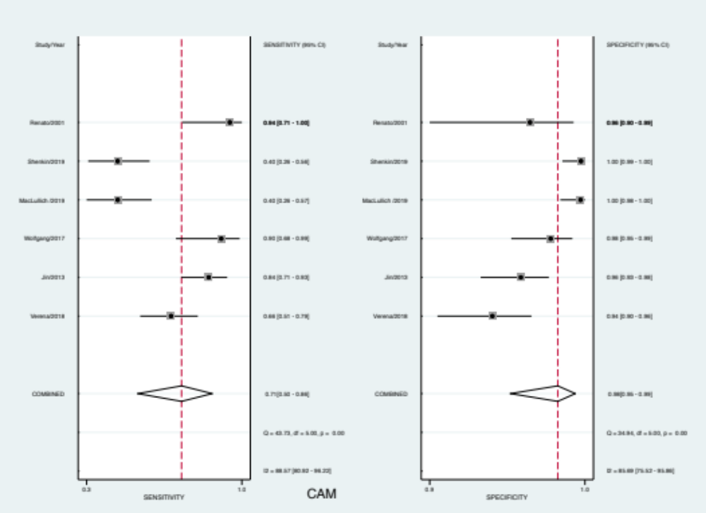

Figure 2 DOR of the CAM
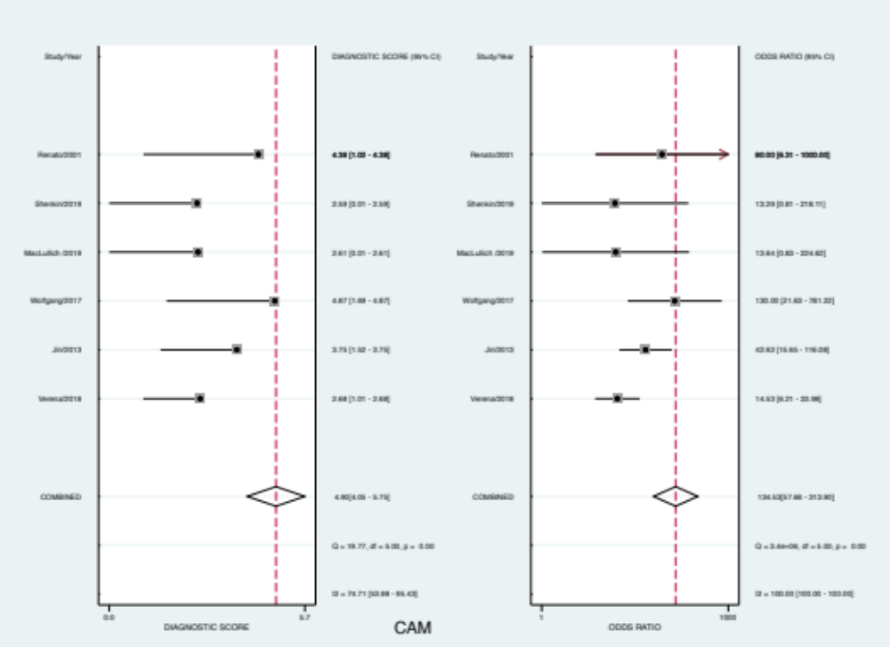

Figure 3 Pre-test and Post-test Probability
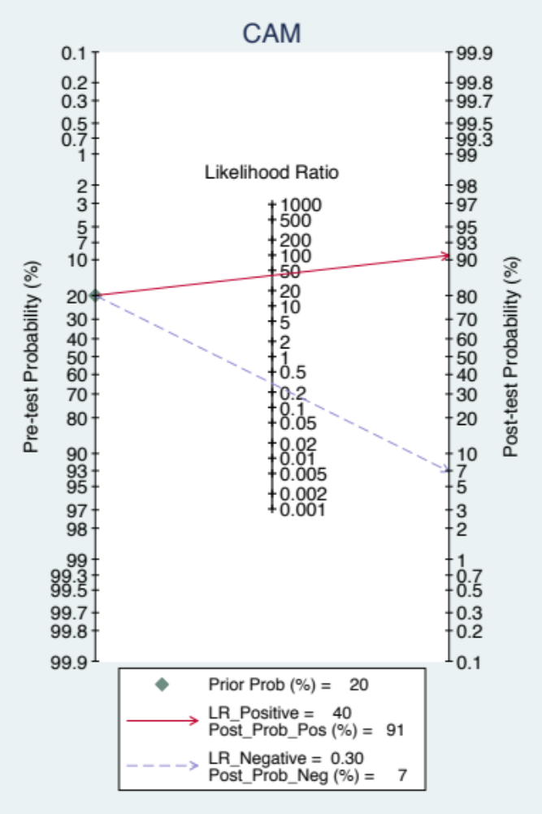

Figure 4 Likelihood Ratio
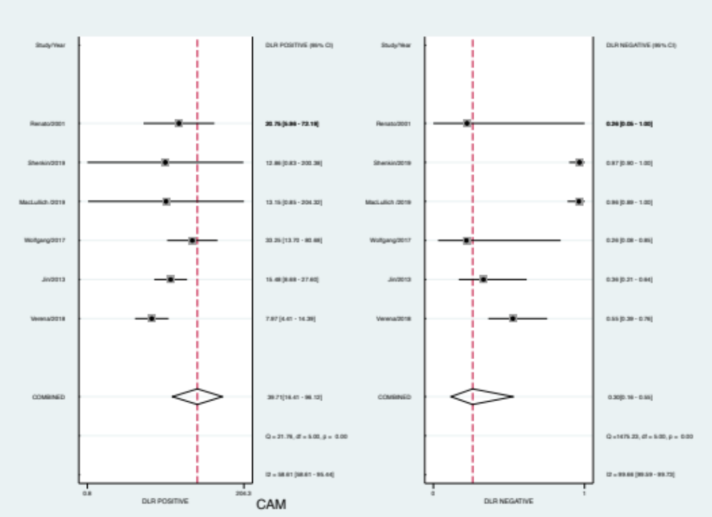

Figure 5 Publication Bias
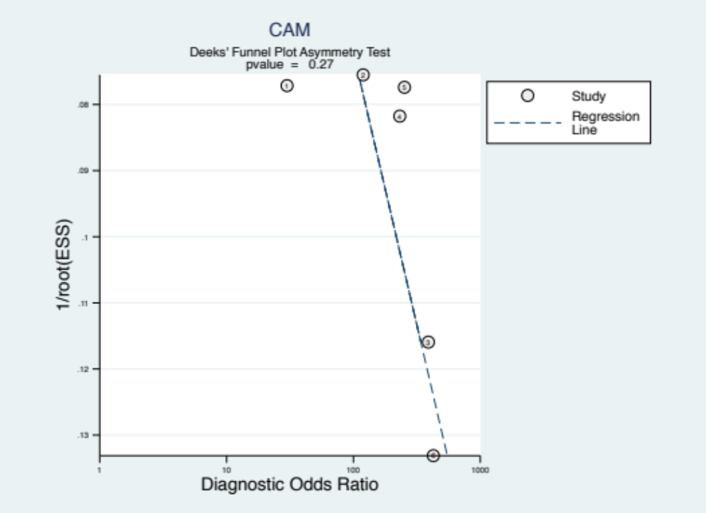

Figure 6 Sensitivity and Specificity of the 4AT
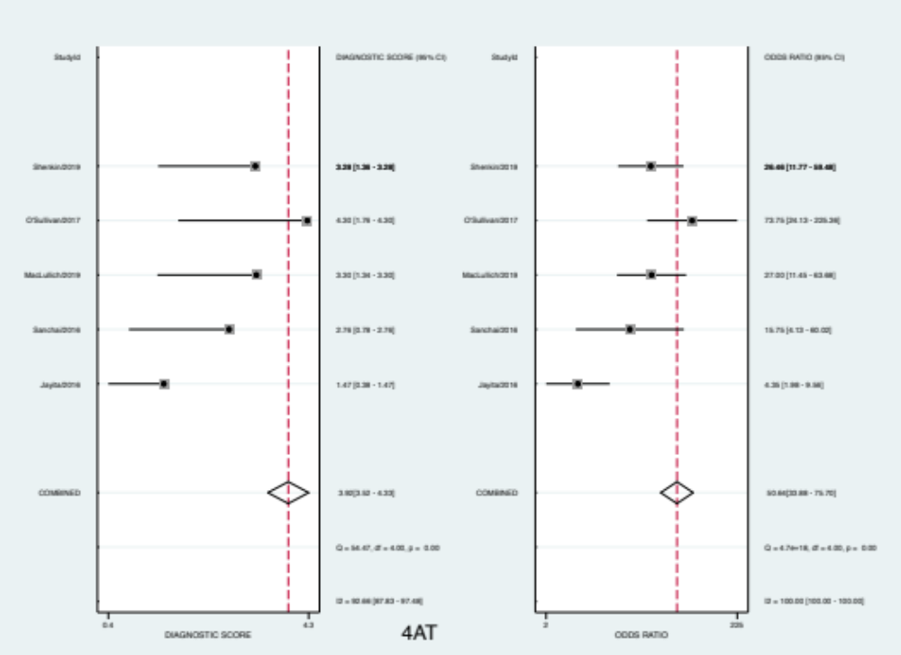

Figure 7 DOR of the 4AT

Figure 8 Pre-Test and Post-Test Probability
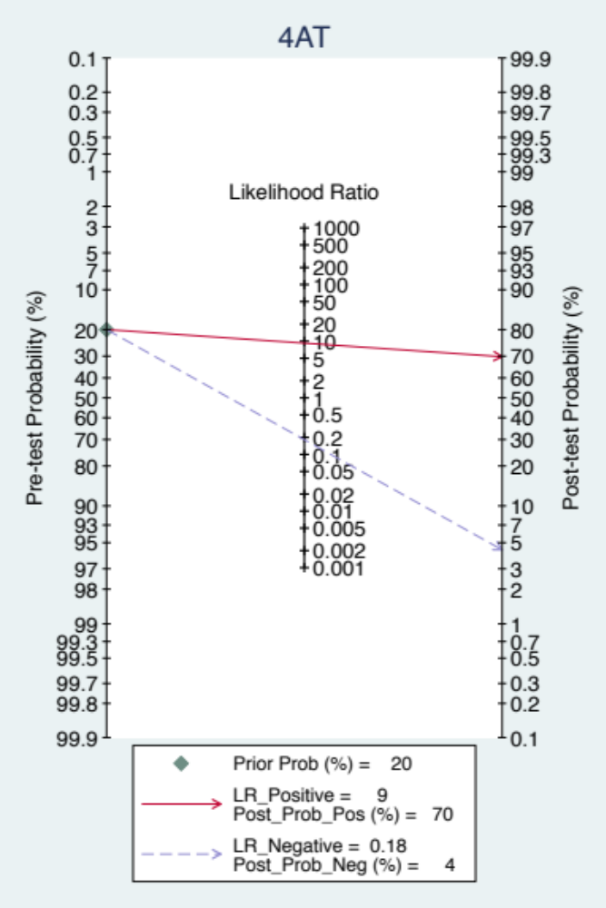

Figure 9 Likelihood Ratio
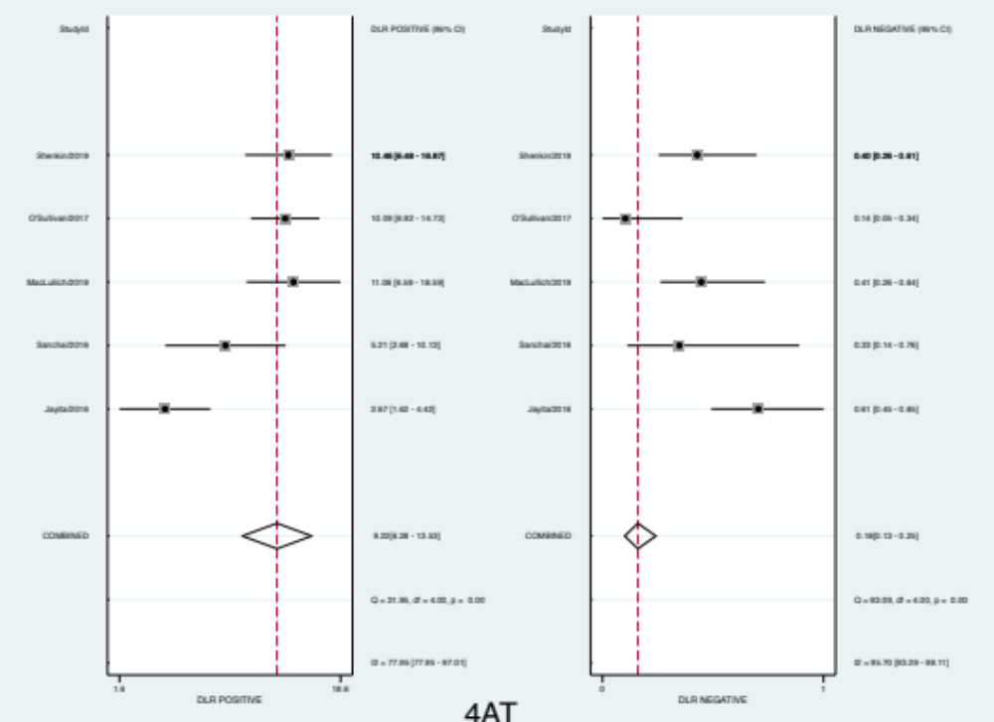

Figure 10 Results of the network meta-analysis

