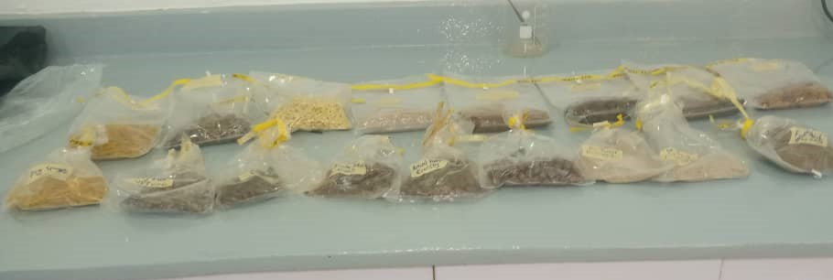
Plate 1- Dog food samples collected
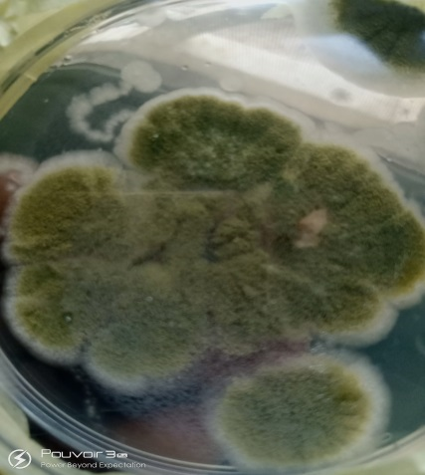
Plate 2- Colonies of Aspergillus parasiticus (presumptive) on PDA (Obverse)
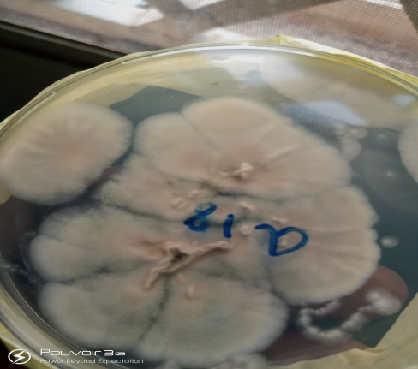
Plate 3 - Colonies of Aspergillus parasiticus (presumptive) on PDA (Reverse)
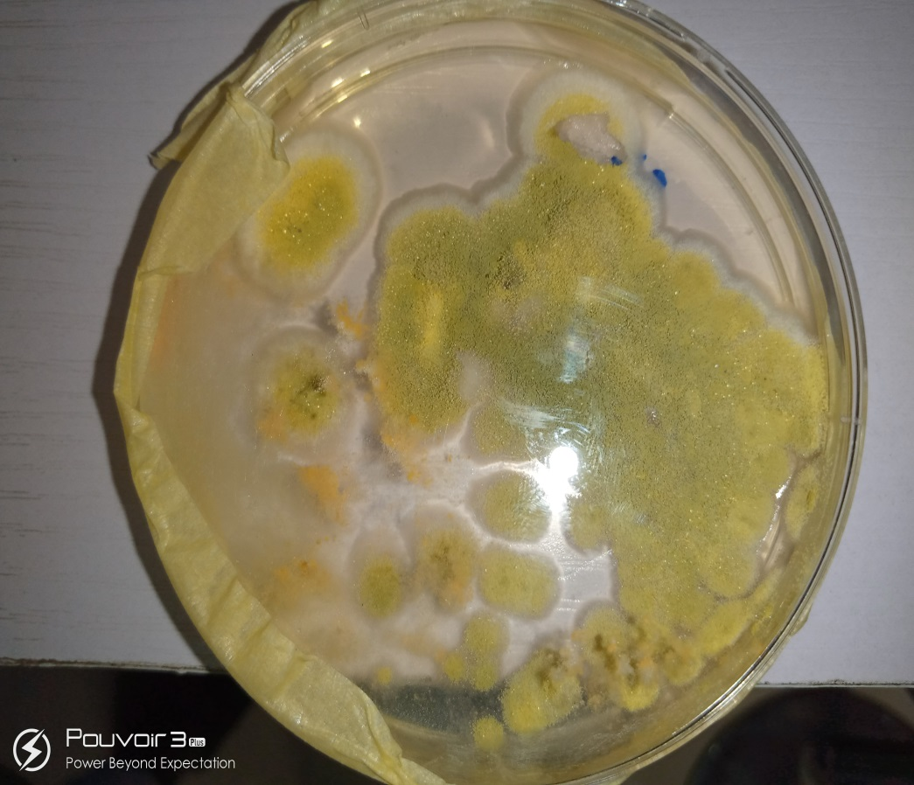
Picture 4- Colonies of Aspergillus flavus (presumptive) on PDA (Obverse)

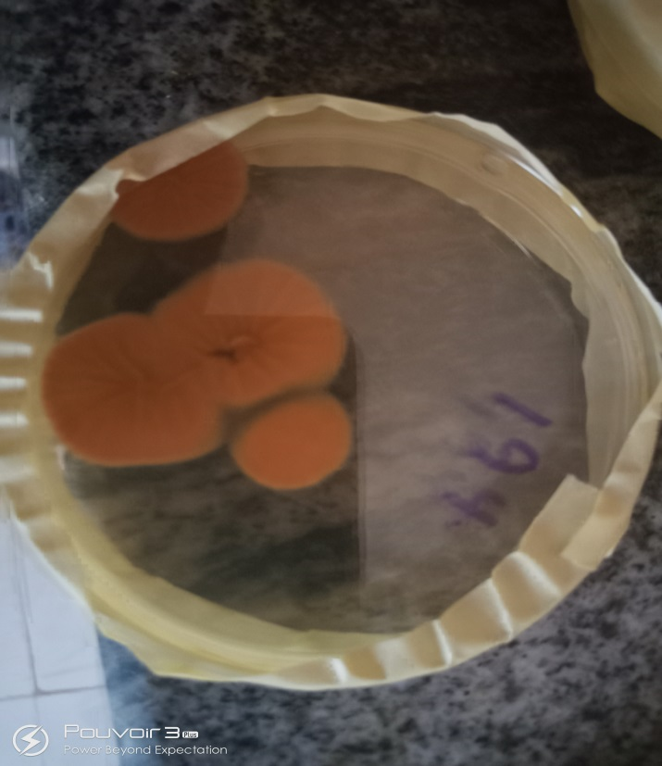

Plate 5 - Positive isolates of AFPA on AFPA Agar
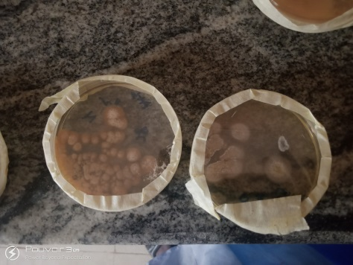
Plate 6 - Negative isolates on AFPA Agar

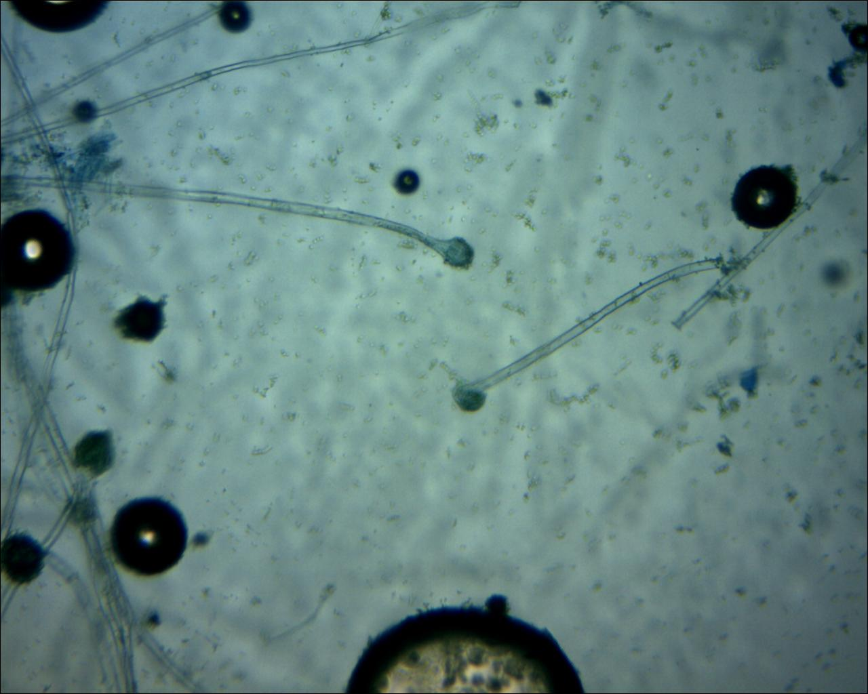
Plate 7 - Microscopic image of A. flavus showing long non-septate hyphae and dome shaped vesicle x100 LCP

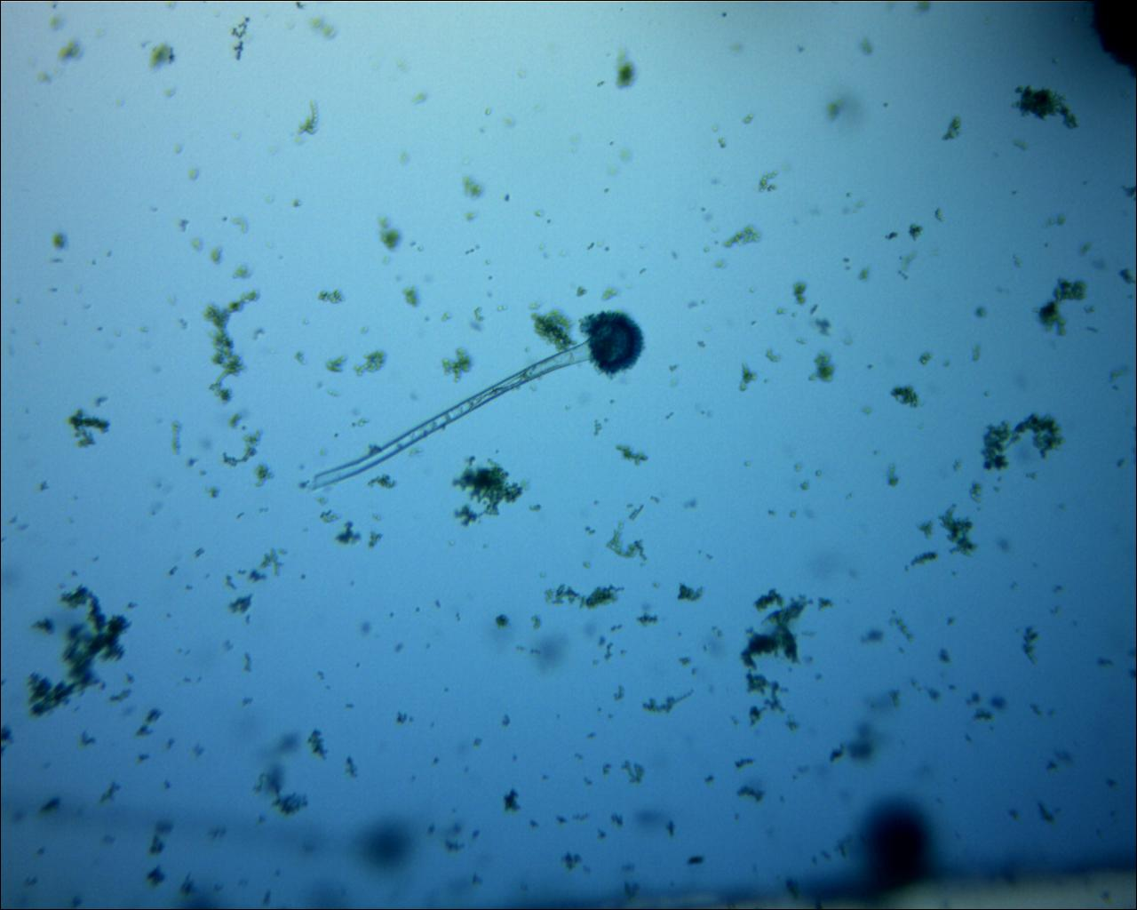
Plate 8 - Microscopic image of A. Parasiticus –long and rough hyphae with globose radiating head x100 LCP

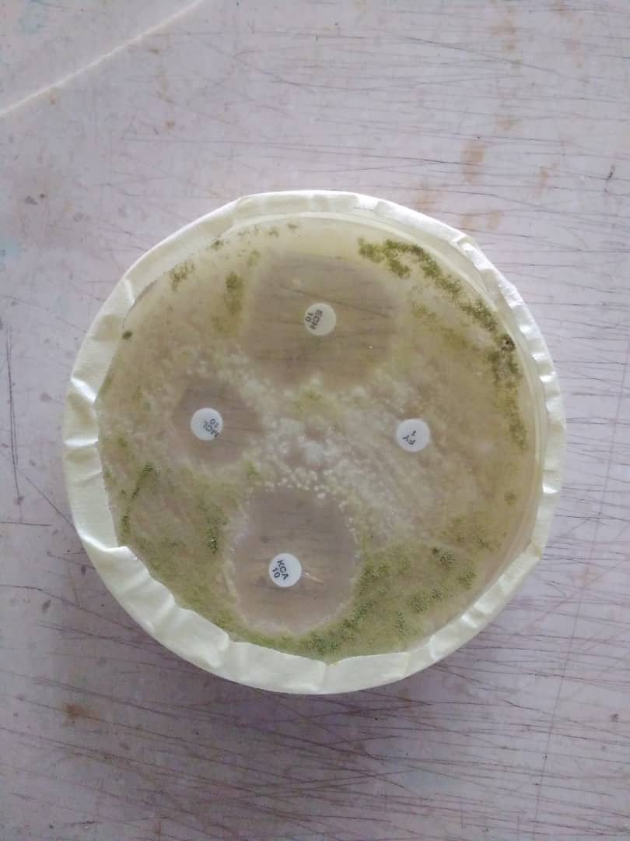
Plate 9 – Zone on inhibition

