Supplementary information

Apoptosis induction in the human hepatocellular carcinoma cell line HepG2 using a large-area wavelength-selective far-infrared light source

Well position dependence of the fluorescence microscope images of Hep G2 cells treated with wavelength-selective far-infrared light irradiation and 4-TBP
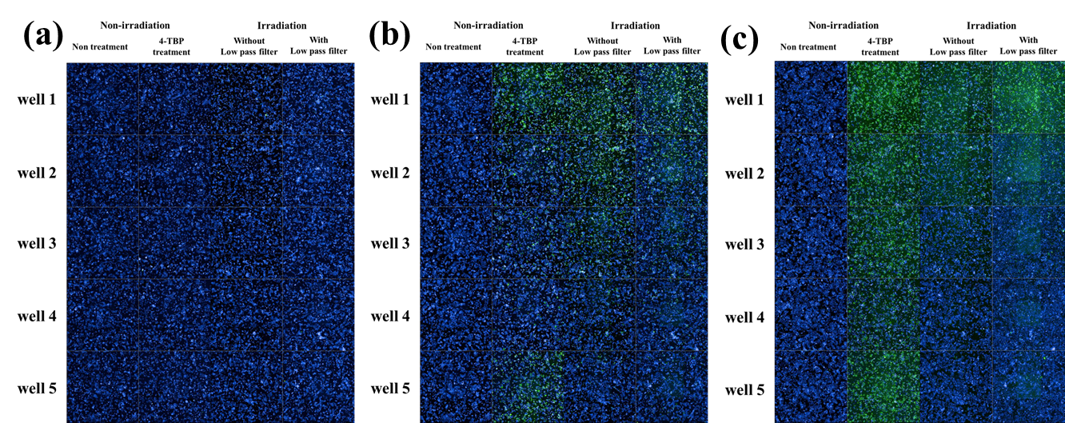
Supplemental Figure S1 shows the position dependence of the wells in the second experiment (distance: 30 mm; time: 2 h; 50,000 cells/well), in which apoptosis was observed. In the 4-TBP-treated group, a change in the fluorescence intensity depending on the well position was also observed, as measured by caspase-3 activity. Fluorescence was slightly weaker in wells 3 and 4. The results of the wavelength-selected far-infrared light (WSFIL) irradiation experiment also showed a change in intensity depending on the well position, with a stronger fluorescence having been detected in wells 1 and 2. This result is the same as that observed in the 4-TBP-treated group. Although the effect of wells 3 and 4 could have become weaker, it is also possible that a change in light intensity might have occurred due to the position of the light source and the well plate given that this experiment used the weak scattered light of far-infrared rays. Regardless, it is clear from our data that apoptosis is being detected in multiple wells.
Fig. S1. Well position dependence of the fluorescence microscope images of Hep G2 cells treated with wavelength-selective far-infrared light irradiation and 4-TBP in the second experiment.
Caspase-3 activity measurement after wavelength-selective far-infrared irradiation of HepG2 cells
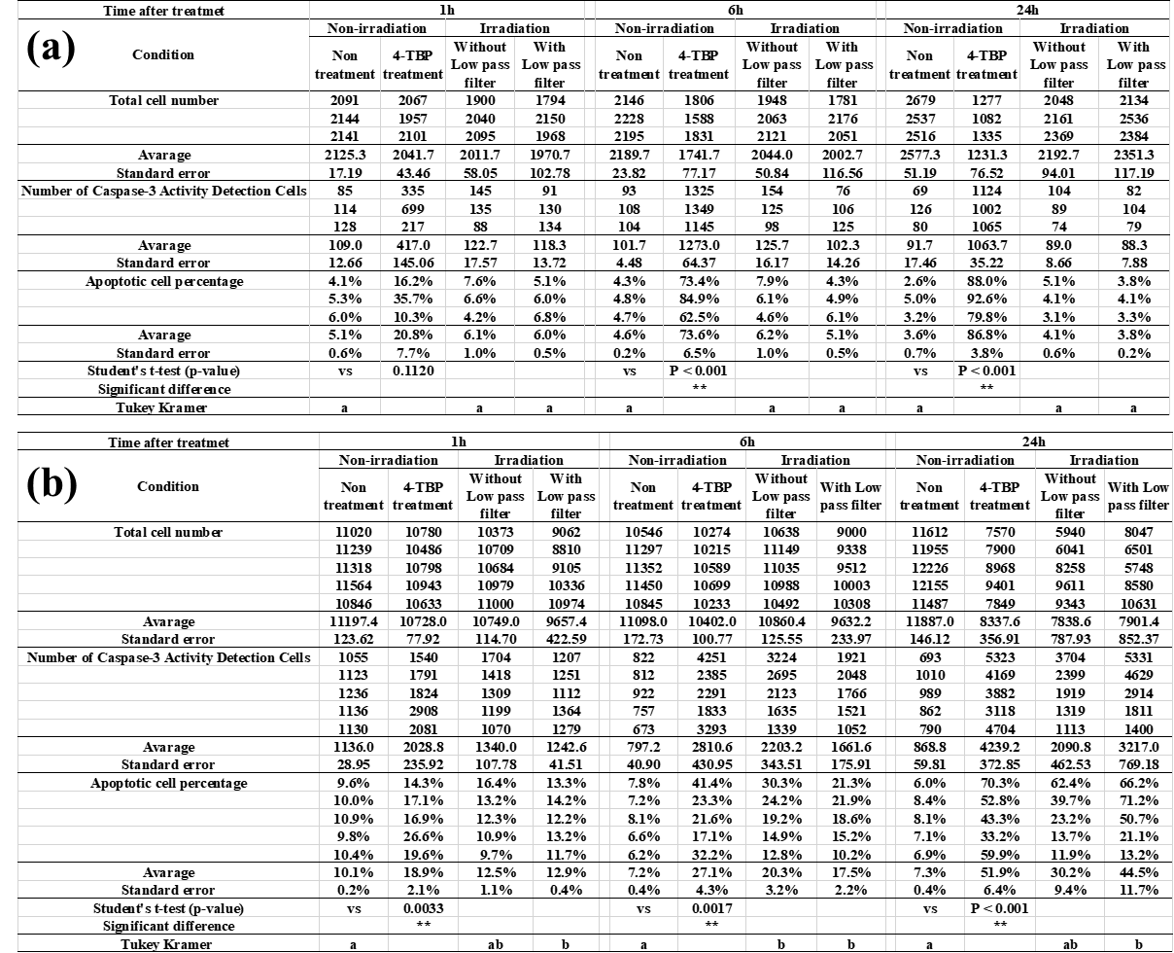
The number and percentage of caspase-3 activity apoptotic cells treated with WSFIL irradiation are shown in Supplemental Table S1. (a) First experiment (distance: 100 mm; time: 1 h; 10,000 cells/well); (b) second experiment (distance: 30 mm; time: 2 h; 50,000 cells/well). For comparison, 4-TBP treatment caused apoptosis in Hep G2 cells.
Table S1 Caspase-3 activity measurement following wavelength-selected far-infrared irradiation of HepG2 cells. (a) First experiment (distance: 100 mm; time: 1 h; 10,000 cells/well); (b) second experiment (distance: 30 mm; time: 2 h; 50,000 cells/well).

