Supplementary Table 1 | Trace element concentrations in tank seawater across the experimental period. Measurements of dissolved inorganic nutrients and ions in the recirculating tank system. Values are expressed as mean ± standard deviation based on triplicate measurements. “<” indicates concentrations below the detection limit of the test kits: NO₂⁻ (<0.1 mg/L), NO₃⁻ (<2 mg/L), and PO₄³⁻ (<0.03 mg/L). Units: NO₂⁻, NO₃⁻, PO₄³⁻ in mg/L; KH in dKH; Mg²⁺ and Ca²⁺ in mg/L.

Time | NO₂⁻ | NO₃⁻ | PO₄³⁻ | KH | Mg²⁺ | Ca²⁺
Week1 | < 0.1 | 5.7 ± 3.3 | < 0.03 | 7.03 ± 009 | 1288.3 ± 31.7 | 316.7 ± 12.5
Week2 | < 0.1 | < 2 | < 0.03 | 6.70 ± 0 | 1286.7 ± 16.5 | 290.0 ± 8.2
Week3 | < 0.1 | < 2 | < 0.03 | 7.20 ± 0.36 | 1250.0 ± 28.3 | 280.0± 0
Week4 | < 0.1 | < 2 | < 0.03 | 6.03 ± 0.61 | 1180.0 ± 28.3 | 273.3 ± 4.7
Week5 | < 0.1 | < 2 | < 0.03 | 6.60 ± 0.28 | 1223.3 ± 26.2 | 366.7 ± 4.7
Week6 | < 0.1 | < 2 | < 0.03 | 6.20 ± 0.14 | 1220 ± 28.3 | 403.3 ± 14.1
Week7 | < 0.1 | < 2 | < 0.03 | 6.23 ± 0.09 | 1220 ± 50.1 | 440.0 ± 9.4
Week8 | < 0.1 | < 2 | < 0.03 | 6.27 ± 0.40 | 1216.7 ± 23.6 | 403.3 ± 14.1
Week9 | < 0.1 | < 2 | < 0.03 | 5.97 ± 0.37 | 1240.0 ± 42.4 | 410.0 ± 14.1
Week10 | < 0.1 | < 2 | < 0.03 | 5.93 ± 0.19 | 1200.0 ± 61.7 | 406.7 ± 14.1
Week11 | < 0.1 | < 2 | < 0.03 | 6.10 ± 0.79 | 1250.0 ± 0 | 416.7 ± 4.71
Week12 | < 0.1 | < 2 | < 0.03 | 5.9 ± 0 | 1200.0 ± 61.6 | 405.0 ± 12.5
Week19 | < 0.1 | < 2 | < 0.03 | 6.12 ± 0.23 | 1230.0 ± 32.4 | 412.3 ± 2.19

Supplementary Table 2 | Abbreviation of metabolite names

Original metabolite name | Abbreviation
4.8.12.15.18. eicosapentaenoic.acid | Eicosapentaenoic.acid
28.6.10Z.13Z.16Z.19Z.22Z.25Z | 28:6 FA
6Z.9Z.12Z.15Z.18Z. tetracosapentaenoic.acid | Tetracosapentaenoic.acid

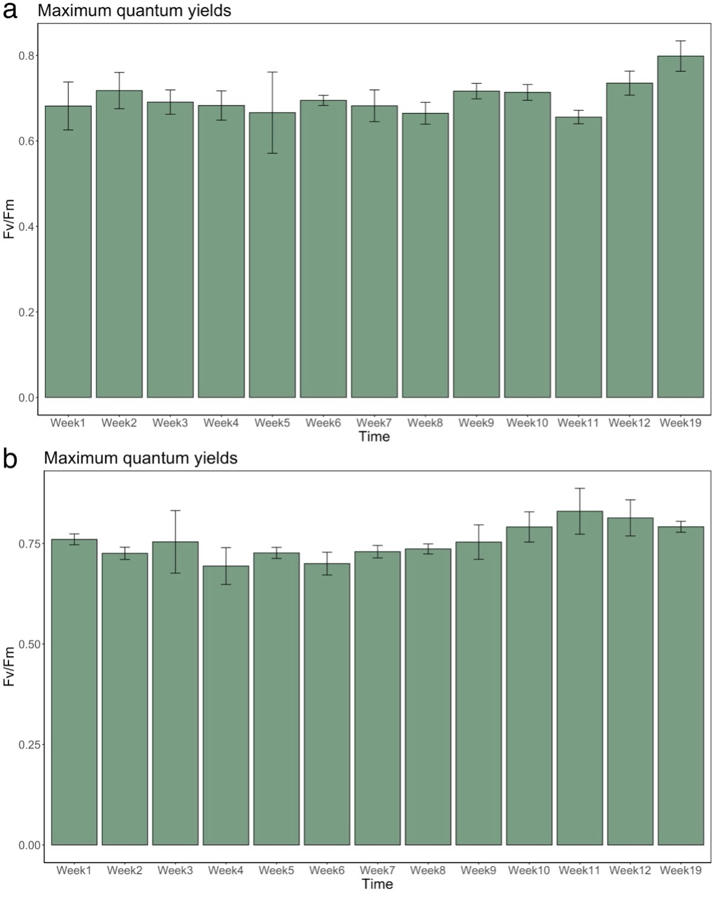
Supplementary Figure 1
Maximum dark-adapted quantum yields (Fv/Fm) of (a) Lobophytum sp., (b) Sclerophytum sp. holobiont across different weeks.
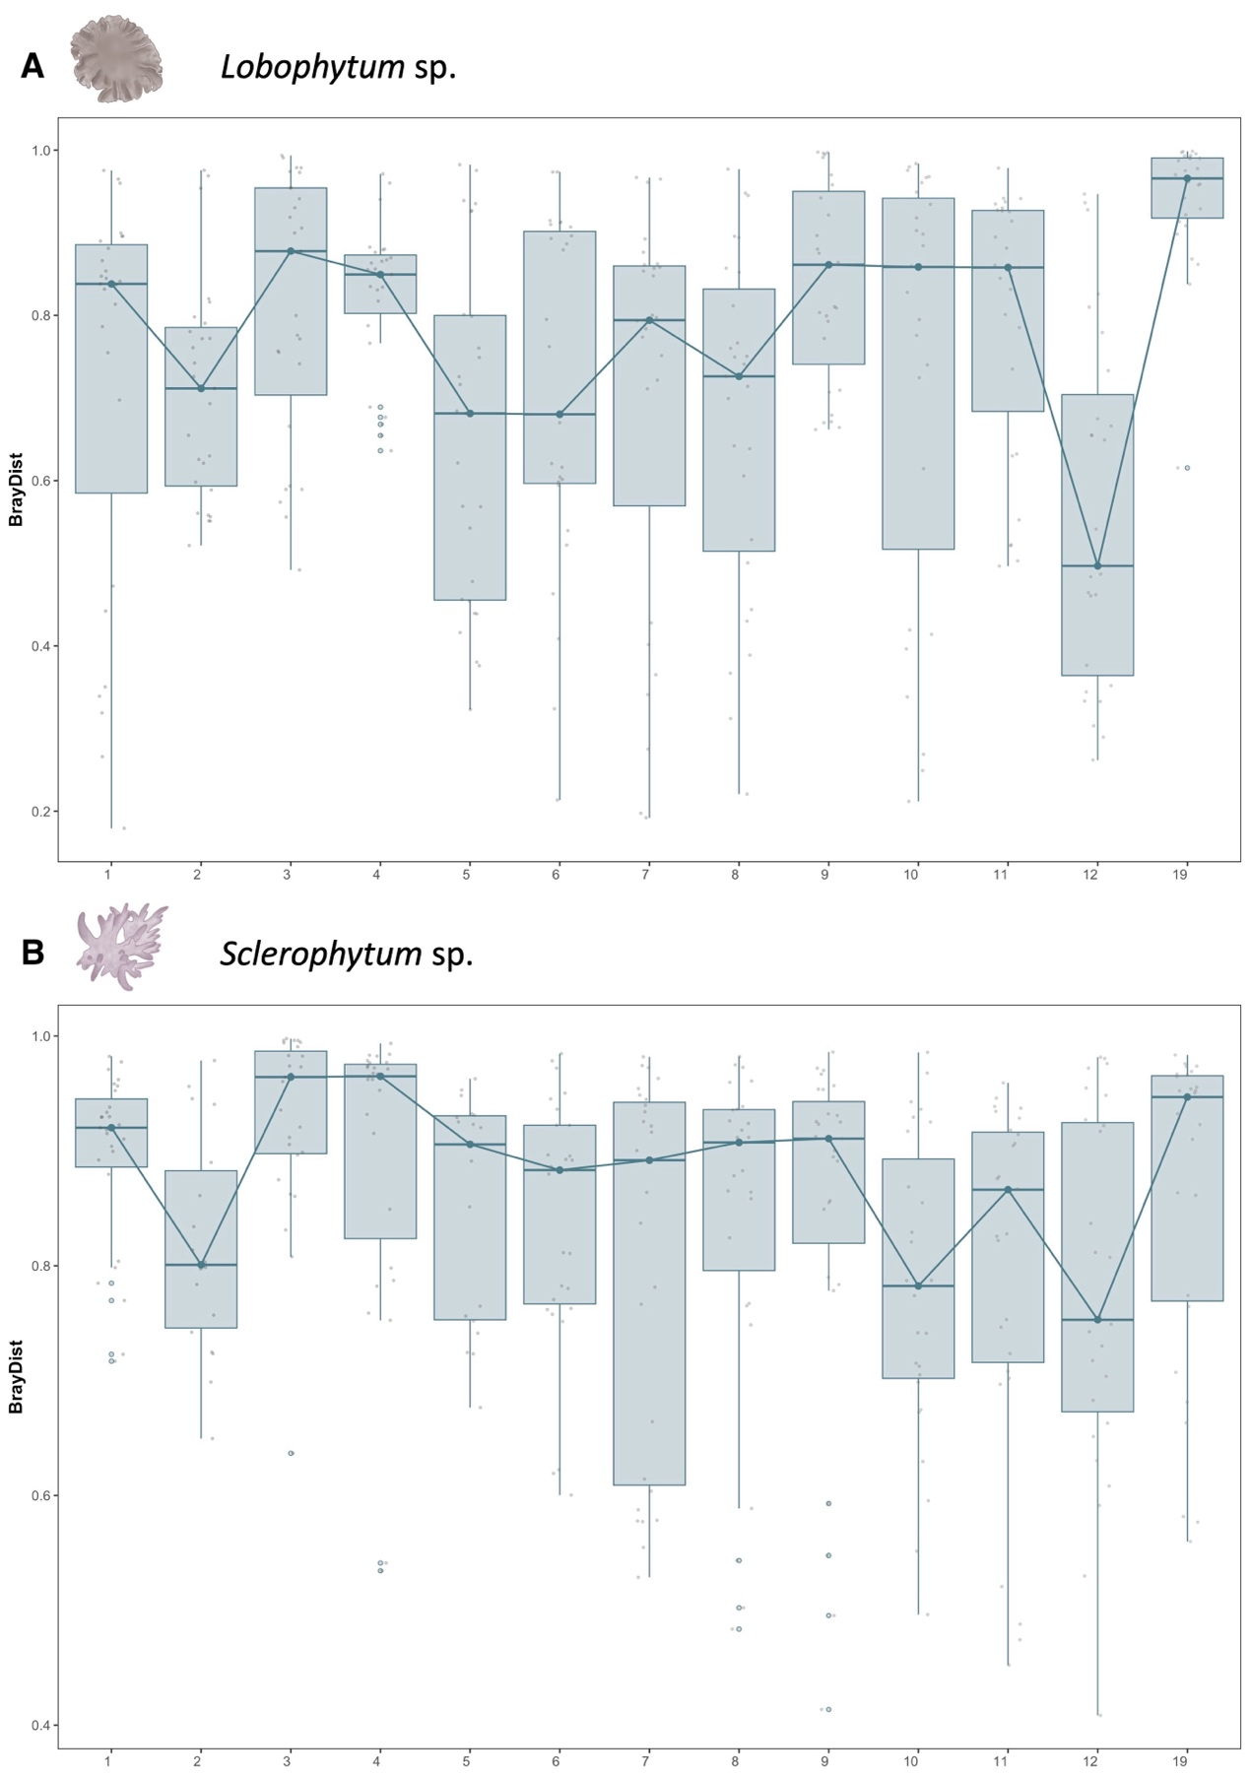
Supplementary Figure 2
Bray–Curtis distances between bacterial community dissimilarity in soft corals. a, b, Bray–Curtis distances between wild and tank samples over the 19-week experimental period for Lobophytum sp. (A) and Sclerophytum sp. (B). Each boxplot shows the distribution of pairwise distances between wild and tank samples at each time point. Dots represent individual pairwise comparisons; the line connects the median values across time to illustrate temporal trends in community dissimilarity.
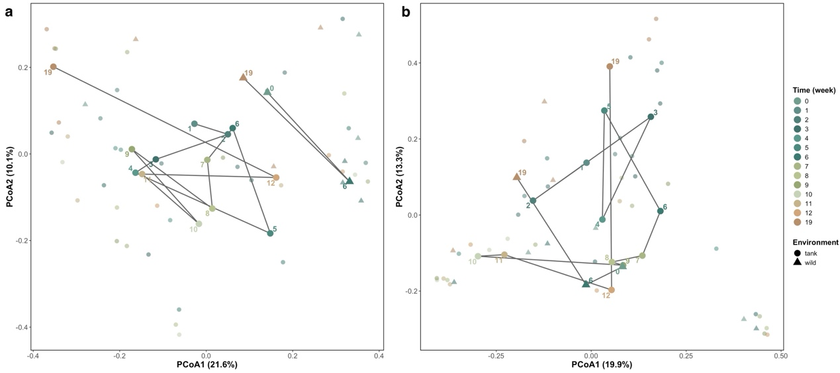
Supplementary Figure 3
Temporal trajectories of microbial community composition in soft corals under tank and wild conditions.
Principal coordinates analysis (PCoA) based on Bray–Curtis dissimilarity showing temporal dynamics of bacterial communities in (a) Lobophytum sp. and (b) Sclerophytum sp. Each point represents an individual sample, colored by sampling time (weeks) and shaped by environment (tank vs. wild). Solid lines connect centroid positions of samples within each environment across time, illustrating temporal trajectories of community shifts. Numbers adjacent to centroid points indicate sampling time points.

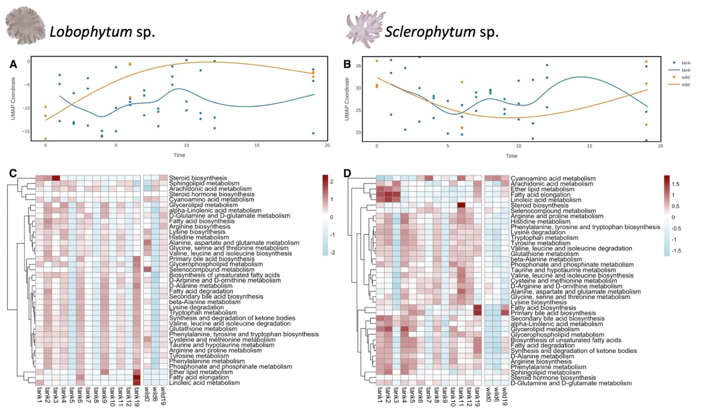
Supplementary Figure 4
Temporal trajectories and functional shifts in predicted bacterial metabolic pathways in Lobophytum sp. and Sclerophytum sp. under tank and wild conditions. a, b, UMAP coordinates of PICRUSt2-based bacterial functional predictions for Lobophytum sp. (A) and Sclerophytum sp. (B) over 19 weeks in wild (orange) and tank (blue) environments. Each point represents one biological replicate; lines represent loess smoothing with 95% confidence intervals. c, d, Hierarchical clustering heatmaps displaying z-score transformed relative abundance of predicted KEGG pathways specifically related to lipid and amino acid metabolism for Lobophytum sp. (C) and Sclerophytum sp. (D). Clustering was performed using tank samples to highlight temporal restructuring under artificial conditions.
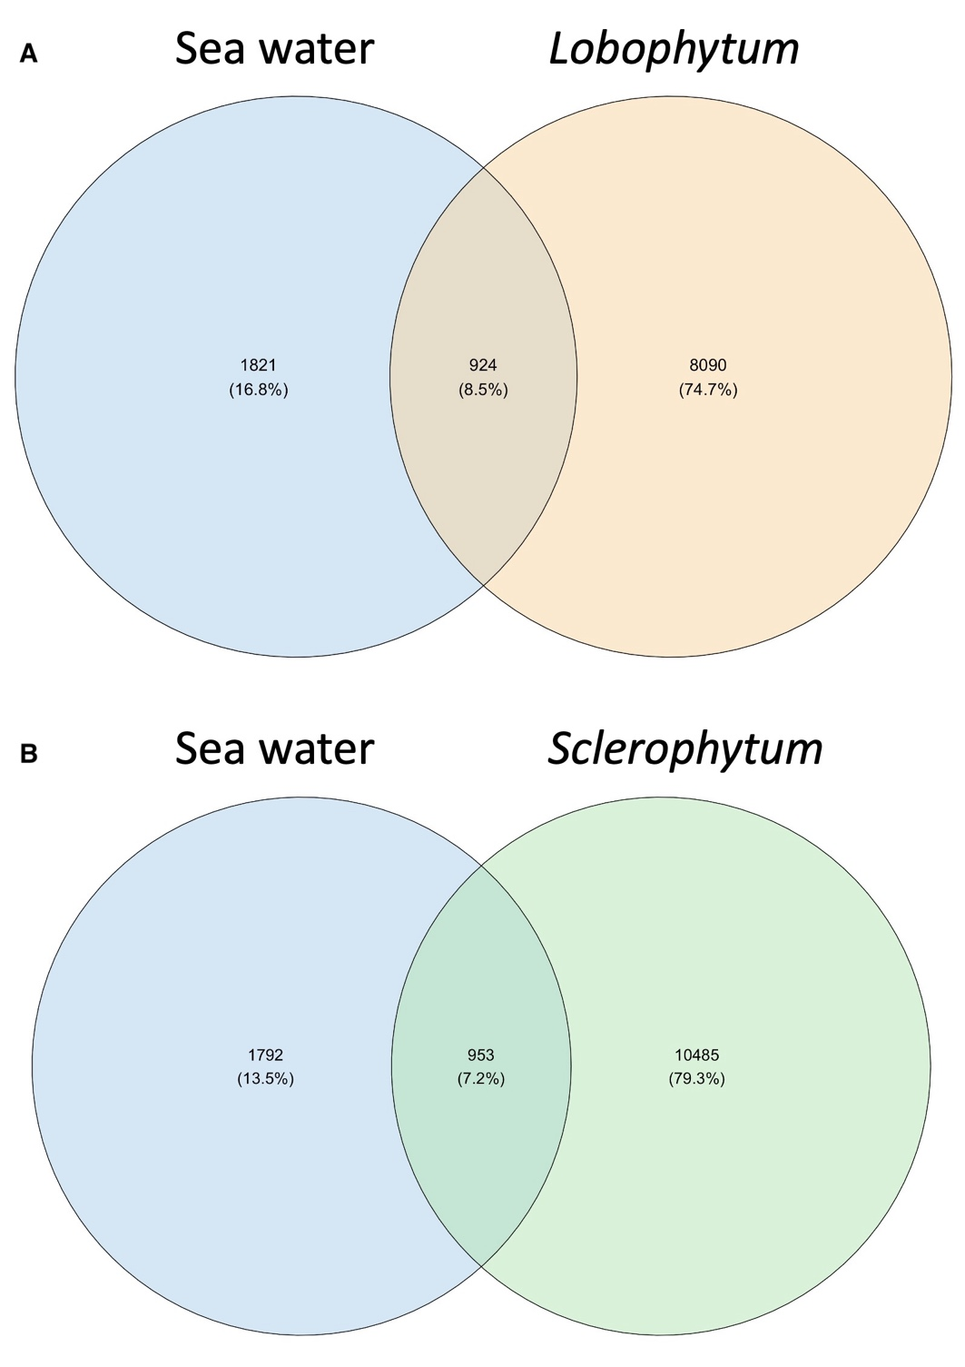
Supplementary Figure 5
Shared and unique ASVs between seawater microbiomes and coral‑associated ASVs under tank conditions. a, b, Venn diagrams comparing seawater ASVs with those in Lobophytum sp. (A) and Sclerophytum sp. (B) across all tank time points. Values denote ASV counts with the percentage of the combined total in parentheses.
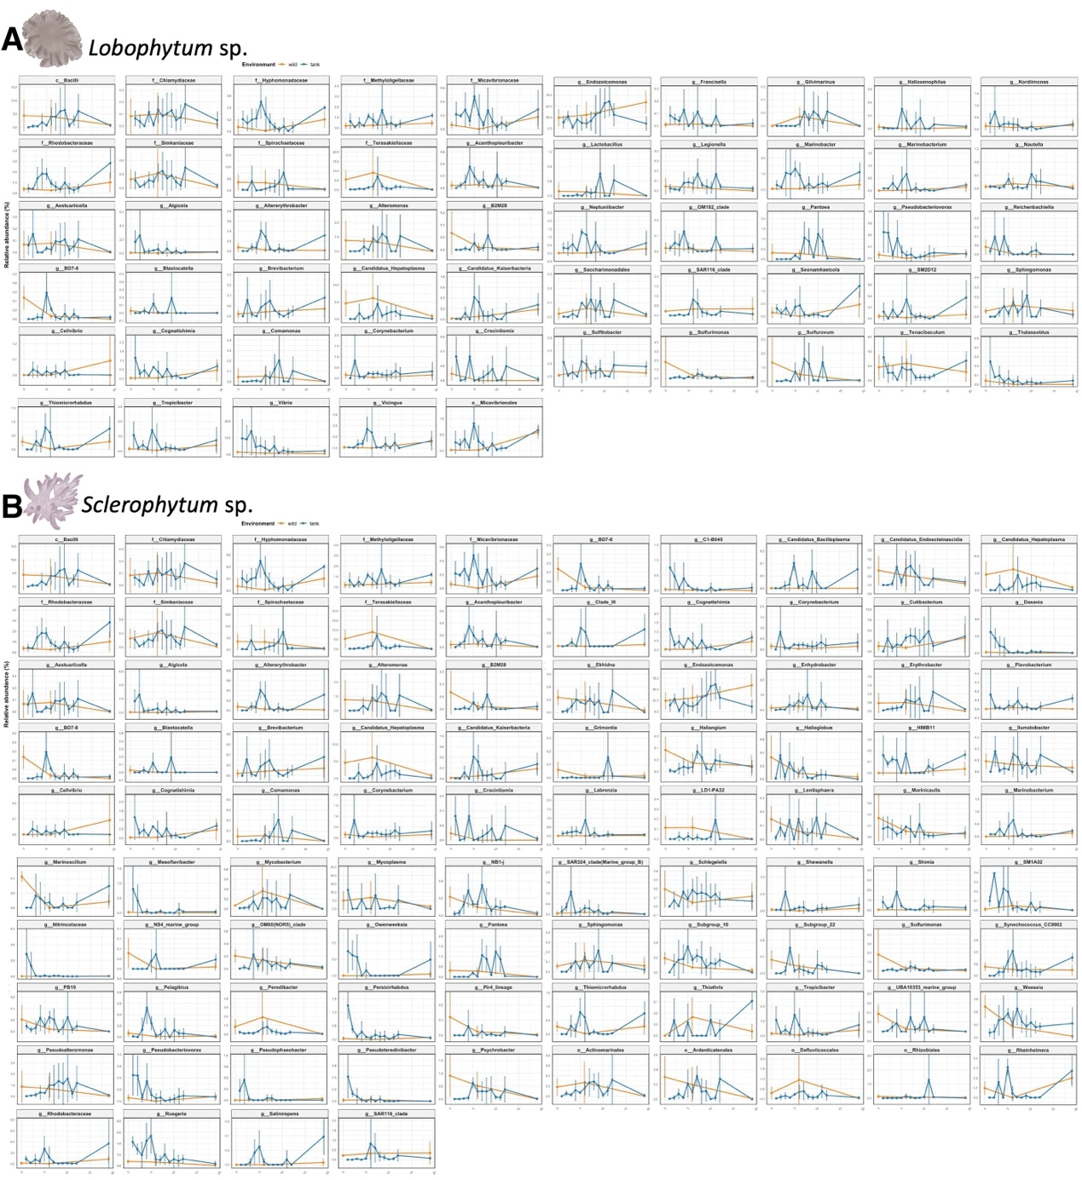
Supplementary Figure 6
Temporal trajectories of LEfSe-identified bacterial genera enriched in wild and tank environments. Time-series plots showing the relative abundance dynamics of bacterial genera significantly enriched in Lobophytum sp. (A) and Sclerophytum sp. (B) based on LEfSe analysis. Blue and orange lines represent the tank and wild environments, respectively. Each subplot corresponds to a specific LEfSe-identified genus, plotted over the 19-week sampling period. Smoothed lines indicate temporal trends. Error bars indicate s.e.m.

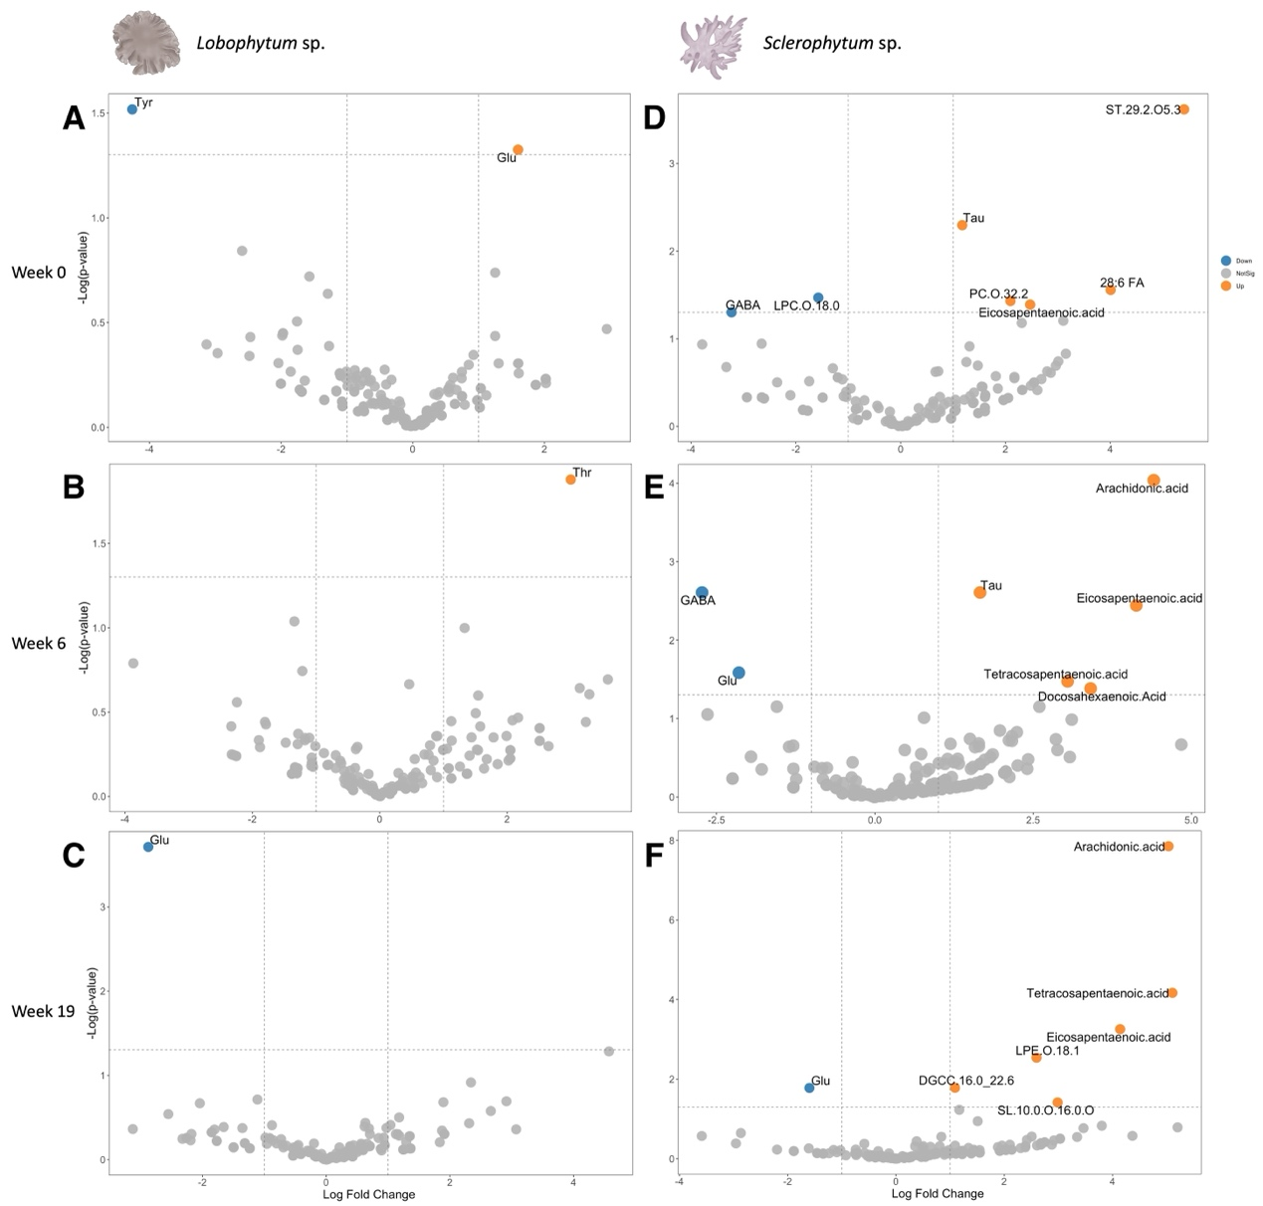
Supplementary Figure 7
Differential metabolite abundance between wild and tank environments over time. a–f, Volcano plots showing differential abundance of amino acids and lipids between wild and tank samples in Lobophytum sp. (A–C) and Sclerophytum sp. (D–F) at weeks 0, 6, and 19, respectively. Each point represents a metabolite with a |log₂ fold change| > 1 and p < 0.05. Orange and blue points indicate higher relative abundance in wild and tank samples, respectively. For clarity, some metabolite names were abbreviated. Full names are provided in Supplementary Table 2.

