Supplementary Information

Set III mortar samples experiment
The mixing, casting and cracking procedure for the Set III mortar prisms was identical to the method described in Bagga et al [1]. After 28 days of curing, the top third of each prism was wrapped with carbon fibre-reinforced polymer (CFRP) to prevent complete fracture and inducing a 0.5 mm crack width through three-point bending using a 100 kN Dartec-Instron hydraulic loading frame. Two points along the crack were marked equidistant from the edge using a waterproof pen for subsequent monitoring. A baseline measurement of crack width was taken using an optical microscope before the prisms were placed under healing conditions.
The self-healing evaluation of Set III mortar prisms was conducted exclusively under laboratory conditions. The different mixes of Set III (i.e., SIII_R, SIII_R+GM_II_ACG-Ø and SIII_R+GM_II_ACG-S) were placed in independent plastic containers with local tap water (Bath, UK) and kept open to the atmosphere. The water level was maintained 10 mm below the top of the specimen, keeping the crack humid and exposed to air. The mortar prisms were kept at 20°C ± 3°C and the crack healing was visually inspected weekly for the 28 days of healing using a digital microscope (VHX-6000, Keyence, Japan). The crack images were obtained directly using the microscope’s automated image stitching function.
The complete crack images of all mortar prisms from Set III, obtained immediately after cracking (day 0) and after the 28 day healing process, are presented in Figures A1 – A6.
Figures A1 to A6. Representative samples of SIII_R, SIII_R+GM_II_ACG-Ø and SIII_R+GM_II_ACG-S immediately after cracking (i.e., Day 0) (Left) and after 28 days of being exposed to tap water (Right).

Crack width reduction was quantified on all mortar prisms at two designated locations marked with a permanent blue pen (with two measurements per location), thereby evaluating their self-healing efficacy when exposed to clean tap water during the healing process. In Fig. A7, the crack-width healing percentage (CAH%) results for the mortar prisms of Set III when exposed to clean tap water are presented. Consistent healing was not observed for mortar prisms composed solely of plain mortar mix (SIII_R). In contrast, mortar mixes containing GM, with or without encapsulated bacterial spores (SIII_R+GM_II_ACG-S and SIII_R+GM_II_ACG-Ø, respectively), exhibited consistently high healing values. Since the mortar prisms were not maintained under sterile conditions, mirroring real-world scenarios more accurately, the observed healing efficiency for mortar prisms not containing encapsulated bacteria likely originated from the presence of environmental bacteria. These bacteria could have utilised the purposely embedded nutrients and calcium precursors within the mortar matrix [2].
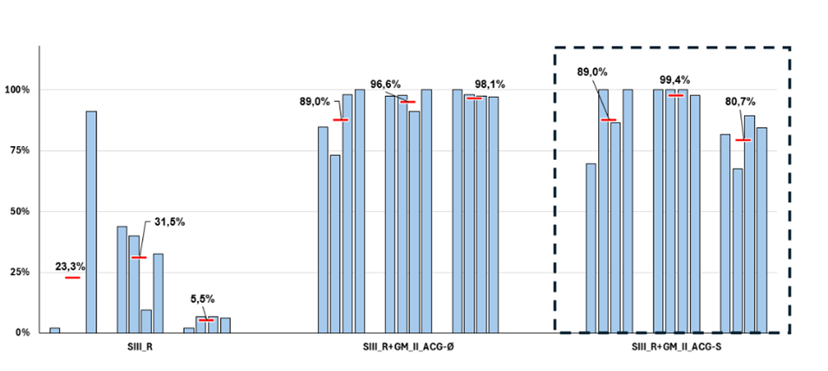
Figure A7. Crack-width healing percentage for Set III mortar specimens after 28 days of healing. Bars represent the % of healing obtained relative to the reduction in crack width of individual mortar prisms exposed during the healing process to clean tap water. The dotted box highlights the mortar prisms containing encapsulated bacterial spores. Horizontal bars indicate the average values for each triplet of mortar prisms.

Figure A8. Compressive strength of Conc_R (plain concrete) and Conc_R+GM_II_ACG-Ø concrete mixes after 28 days of curing submerged in tap water. Concrete cylinders (50 mm x 100 mm) values shown in the graph were corrected with a 11.5% reduction factor to account for the difference in size with standard concrete cylinders (150 mm x 300 mm). Horizontal bars show the average values of each triplet of concrete cylinders.

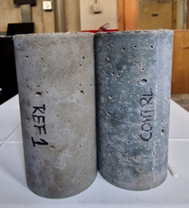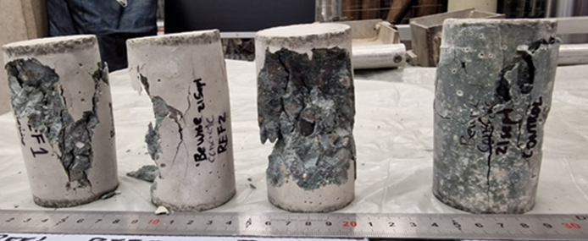
Figure A9. Images of representative cylinders of Conc_R and Conc_R+GM_II_ACG-Ø concrete mixes after executing the compressive strength test.

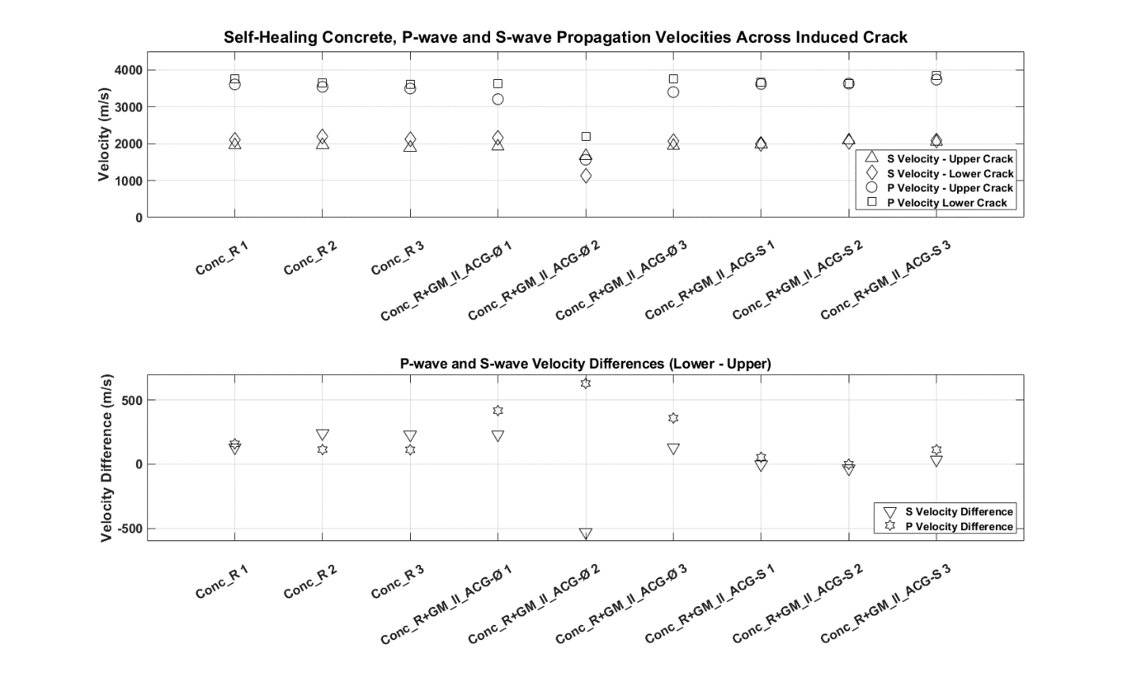
(a)
(b)
Figure A10. P-wave and S-wave velocities traversing the upper and lower parts of the induced crack in each of the concrete samples. (a) Propagation velocities shown for the upper and lower part of the samples. (b) velocities differences between the upper and lower part of the samples.

1. Bagga, M., et al., Assessing the potential application of bacteria-based self-healing cementitious materials for enhancing durability of wastewater treatment infrastructure. Cement and Concrete Composites, 2023. 143: p. 105259.
2. Justo-Reinoso, I., et al., Evaluation of cyclic healing potential of bacteria-based self-healing cementitious composites. Sustainability, 2022. 14(11): p. 6845.

